

DEPARTMENT OF COMPUTER SCIENCE AND ENGINEERING 2026 – 2027 (ODD SEMESTER)
CS2307 – INTERNET PROGRAMMING LAB

Online Book Store

Abstract
The Online Book Store is a web-based application developed to provide a simple and user-friendly platform for browsing, searching, and purchasing books online. The system allows users to view books based on categories, register and login, add books to a shopping cart, place orders, and view their order history.
The application is developed using HTML, CSS and JavaScript for the frontend and Java Servlet for backend processing. A database concept is considered for maintaining user details, book information, and order records. The system also provides an admin module for adding, editing, and deleting books and managing order information.
The main aim of the project is to reduce manual book purchasing activities and provide a convenient online shopping experience.

Introduction
The Online Book Store is designed to automate the process of buying books through a web application. In a traditional book store, users need to visit the store physically, search for books, check availability, and complete the purchase manually.
This project provides an online solution where users can browse available books, search for required books, select books, add them to the cart, and place orders. The system also provides different categories to make book searching easier.
The backend is implemented using Java Servlet, which handles user registration, login, book management, and order processing. The project can be extended with a database such as MySQL to permanently store users, books, and orders.

Objectives of the Project
- To develop a simple and user-friendly online book shopping system.
- To allow users to browse and search for books easily.
- To provide different book categories for easy navigation.
- To provide user registration and login functionality.

- To allow users to add books to the shopping cart.
- To calculate quantity, price and total order amount.
- To provide an online checkout and order placement facility.
- To allow users to view their previous orders.
- To provide an admin module for book management.
- To maintain user, book and order information systematically.
- To reduce manual work involved in traditional book purchasing.
- To provide a system that can be integrated with a database for permanent data storage
- Modules Description

Home Module
The Home module provides the main interface of the application. It contains information about the BookNest online book store, special offers, and navigation options.

Book Module
The Book module displays the available books with details such as:
    - Book Name
    - Author
    - Category
    - Price
    - Rating
Users can select a book and add it to the shopping cart.

Search and Category Module
Users can search books using the book name or author name. Books can also be filtered based on categories such as:
    - Programming
    - Database
    - Business
    - Science
    - Fiction
This helps users find the required books quickly.

User Registration Module
New users can create an account by entering:
    - Name

    - Email
    - Password
    - Mobile Number
The registration information can be stored in the user database.

User Login Module
Registered users can login using their email and password. The login module validates the entered credentials before providing access to the application.

Shopping Cart Module
The Shopping Cart module allows users to add selected books and manage their quantity. The system automatically calculates the total price based on the selected quantity.

Checkout and Order Module
The Checkout module collects customer details, delivery address, phone number and payment method. After confirmation, the selected books are converted into an order.

My Orders Module
The My Orders module displays order details such as:
    - Order ID
    - Book Name
    - Quantity
    - Price
    - Total
    - Status
    - Date
This allows users to track their previous purchases.

Admin Module
The Admin module is used to manage books in the system. The administrator can:
    - Add new books
    - Edit book details
    - Delete books
    - View available books
    - Manage order information

Database Module

Maintains records of users, books, orders, and order details.

Methodology / Approach
The project follows a simple modular development approach.

Step 1 – Requirement Analysis
The required features of an online book store were identified, including book browsing, search, registration, login, cart, checkout, orders and admin management.

Step 2 – Frontend Design
HTML was used to create the structure of the web pages. CSS was used to provide a professional and responsive interface. JavaScript was used for search, filtering, cart management and user interaction.

Step 3 – Backend Development
Java Servlet was used to implement the backend functionality. The servlet handles requests related to registration, login, books, orders and admin operations.

Step 4 – Database Design
A database structure was planned to store users, books and order information. Tables can be created for Users, Books, Orders and Order Details.

Step 5 – Integration
The frontend communicates with the Java Servlet backend. The servlet processes the request and performs the required operation on the application data.

Step 6 – Testing
- The major modules were tested individually, including:
- User Registration
- User Login
- Book Search
- Category Filtering
- Add to Cart
- Checkout
- Order Placement
- Admin Book Management

Implementation Code

The Online Book Store is developed using HTML, CSS, JavaScript, Java Servlet and database. The frontend provides the user interface, while the Servlet handles backend operations.
- HTML: Creates the main sections such as Home, Books, Cart, Login and Orders.

<h1>BookNest</h1>

<section id="books">

<h2>Available Books</h2>

<div id="bookList"></div>

</section>

- CSS: Provides the basic design and layout. body {
font-family: Arial; background: #f5f7fa;
}

.book-card { background: white; padding: 15px; margin: 10px; border-radius: 8px;
}

button {

padding: 10px; border: none;

}

- JavaScript: Displays books and manages the cart. let books = [
{id:1, name:"Java Programming", price:450},

{id:2, name:"Python Basics", price:400},

{id:3, name:"Database Management", price:500}

];

let cart = [];

function addToCart(id) {

let book = books.find(b => b.id === id); cart.push(book);
displayCart();

}

- Search: Users can search books by name. function searchBooks() {
let text = search.value.toLowerCase(); let result = books.filter(b =>
b.name.toLowerCase().includes(text)

);

displayBooks(result);

}

- User Registration and Login: User details are collected and validated. function loginUser() {
let user = users.find(u =>

u.email === loginEmail.value && u.password === loginPassword.value
);

alert(user ? "Login Successful" : "Invalid Login");
}

- Java Servlet: Handles backend requests from the application. @WebServlet("/OnlineServlet")
public class Online extends HttpServlet { protected void doPost(
HttpServletRequest request, HttpServletResponse response) {
String action = request.getParameter("action")

}

}

- Database Connection: JDBC is used to connect the application with the database.

Connection con = DriverManager.getConnection( "jdbc:mysql://localhost:3306/booknest", "root",
"password"

);

- Insert Book: Book details are stored in the database.

String sql =

"INSERT INTO Books(name,author,category,price) VALUES(?,?,?,?)";

PreparedStatement ps = con.prepareStatement(sql); ps.setString(1, name);
ps.setString(2, author); ps.setString(3, category); ps.setDouble(4, price); ps.executeUpdate();
- Database Tables: The main tables used are Users, Books, Orders and Order_Details.

CREATE TABLE Books (

book_id INT PRIMARY KEY AUTO_INCREMENT, name VARCHAR(100),
author VARCHAR(100), category VARCHAR(50), price DECIMAL(10,2)
);

CREATE TABLE Orders (

order_id INT PRIMARY KEY AUTO_INCREMENT,

user_id INT,

total DECIMAL(10,2),

status VARCHAR(30), order_date DATE
);

These code snippets demonstrate the main implementation of the Online Book Store, including frontend design, user management, book management, database connectivity and order processing.

Screenshots
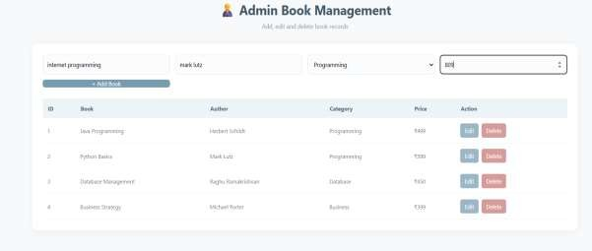

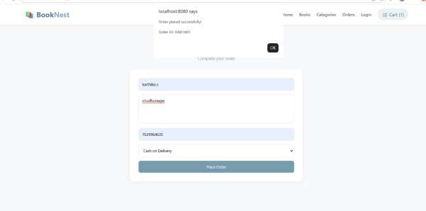

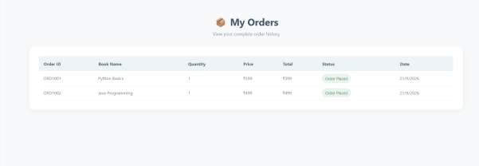
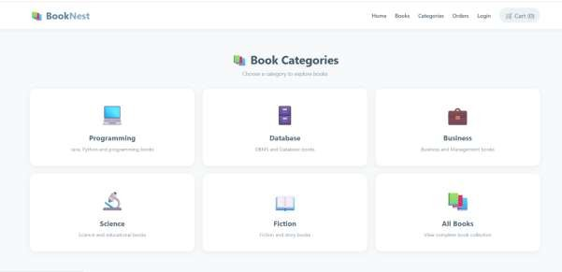

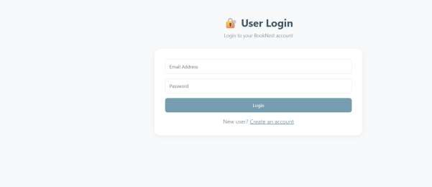

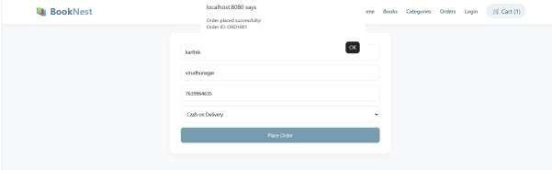

References

- Oracle Java Documentation – Java Servlet and Java EE concepts.
- Java Servlet API Documentation.
- HTML5 Documentation – Web page structure and forms.
- CSS3 Documentation – Styling and responsive web design.
- JavaScript Documentation – Client-side interaction and DOM manipulation.
- GlassFish Server Documentation – Java web application deployment.
- MySQL Documentation – Relational database and SQL concepts.

Conclusion

The Online Book Store project provides a simple and efficient platform for managing online book purchases. It provides important features such as book browsing, search, category filtering, user registration, login, shopping cart, checkout and order management.
The Java Servlet backend handles the major application operations, while HTML, CSS and JavaScript provide an interactive user interface. The system also includes an admin module for managing book information.
The database design provides a structured way to maintain user, book and order records. The project can be further enhanced by implementing a fully connected MySQL database, secure password storage, online payment integration, order tracking, email notifications and advanced search features.
Overall, the project demonstrates the development of a complete web-based Online Book Store using frontend technologies and Java Servlet backend architecture.

