Procedure For insatallin MavenMate

- Download and install MavenMate Desktop from the following link.
https://github.com/joeferraro/MavensMate-Desktop/releases
- Enter into Settings through Menu bar
- Change the workspace folder of your choice inside [ " /foldername"].
- Also set the Proxy as http://Webproxy.int.westgroup.com:80

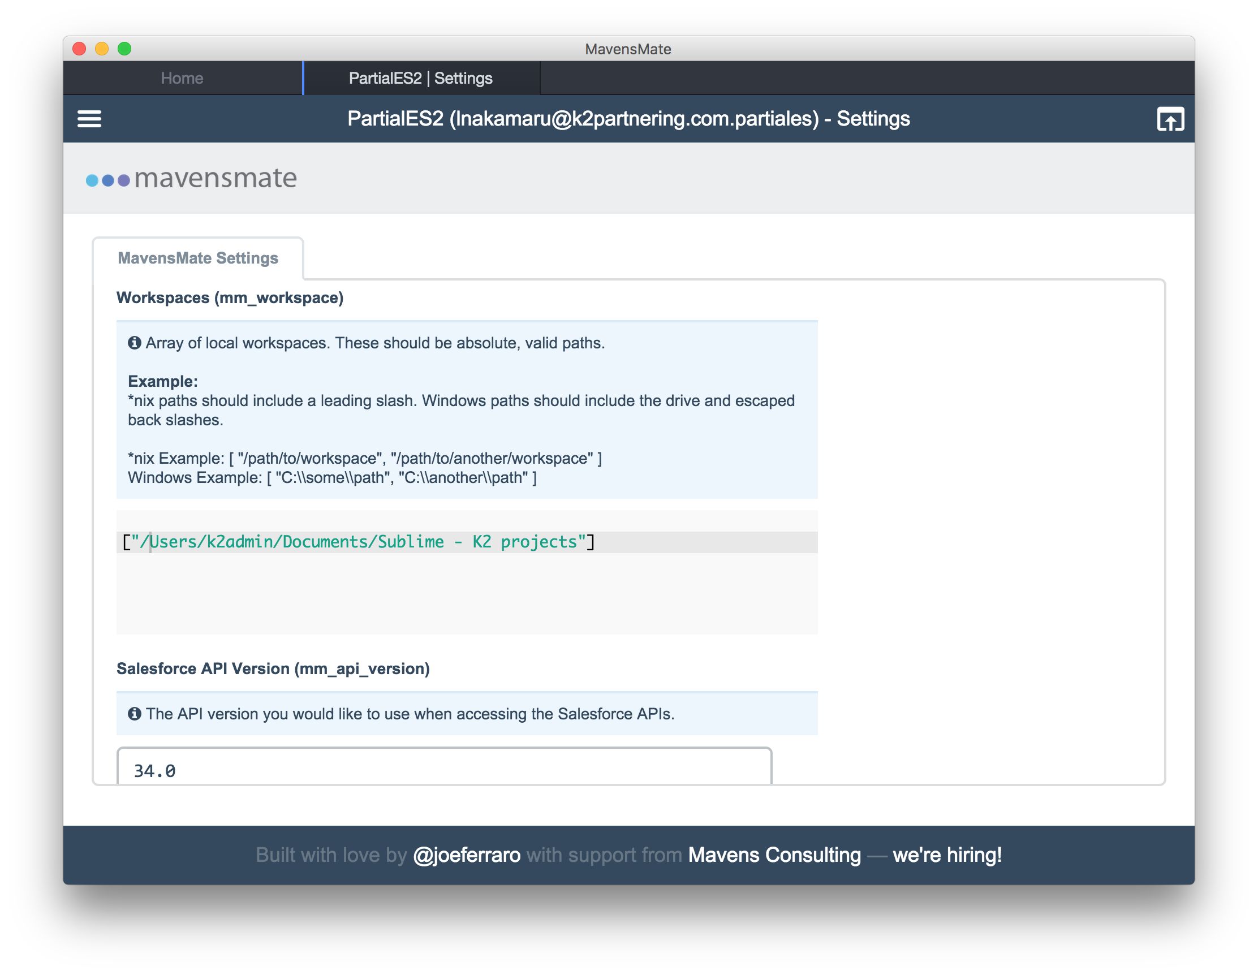
- Download and install Sublime Text 3 from the following link.
http://www.sublimetext.com/3

- You’ll need to install Package Control for Sublime Text in order to install the MavensMate package. This can be done by running the following inside the Sublime console:
import urllib.request,os,hashlib; h = '7183a2d3e96f11eeadd761d777e62404' + 'e330c659d4bb41d3bdf022e94cab3cd0'; pf = 'Package Control.sublime-package'; ipp = sublime.installed_packages_path(); urllib.request.install_opener( urllib.request.build_opener( urllib.request.ProxyHandler()) ); by = urllib.request.urlopen( 'http://sublime.wbond.net/' + pf.replace(' ', '%20')).read(); dh = hashlib.sha256(by).hexdigest(); print('Error validating download (got %s instead of %s), please try manual install' % (dh, h)) if dh != h else open(os.path.join( ipp, pf), 'wb' ).write(by)

- If for some reason the console installation instructions do not work for you (such as having a proxy on your network), perform the following steps to manually install Package Control:
  - Click the Preferences > Browse Packages… menu
  - Browse up a folder and then into the Installed Packages/ folder.
  - Download Package Control.sublime-package and copy it into theInstalled Packages/directory.
Link: https://packagecontrol.io/Package%20Control.sublime-package
  - Restart Sublime Text.

4. With Package Control installed, press Ctrl + Shift + P or go to Tools -> Command Palette in the toolbar. Type the following to install a package:
Package Control: Install Package
    - When a list of packages become presented, type MavensMate to install the package.
    - We are almost completely set up. With MavensMate installed, you should now see a new toolbar item for the package. Choose MavensMate -> Settings -> User from the toolbar and find mm_workspace near the top. Type a path that exists on your machine and this is where all new Apex projects will reside. If you’re on Windows, you must escape the slashes. So your workspace may look something like C:\\Users\\nraboy.
    - Restart Sublime Text for all the changes to take affect.
    - With Sublime Text open, choose MavensMate -> Project -> New Project…from the toolbar
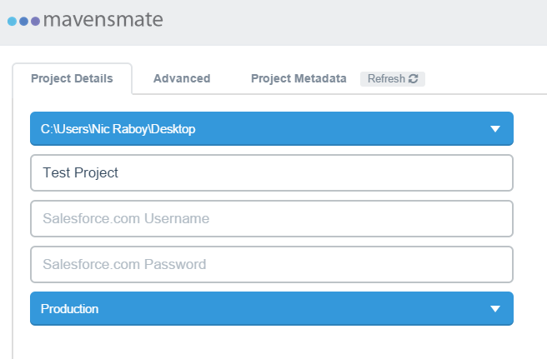
    - Choose a name for your new project and provide your Salesforce username and password. When you’ve done this, click the Create Project button to complete the process.
    - This should result in Sublime Text creating a new coding work space for you.

