**AIR QUALITY MONITORING USING IOT (PHASE 2)**

**DESIGN:**

In this project we made an **IoT Based Air Pollution Monitoring System** in which we will **monitor the Air Quality over a webserver using internet** and will trigger an alarm when the air quality goes down beyond a certain level, means when there are sufficient amount of harmful gases are present in the air like CO2, smoke, alcohol, benzene and NH3. It will show the air quality in PPM on the LCD and as well as on webpage so that we can monitor it very easily.

The block diagram below is the general design of our solution.

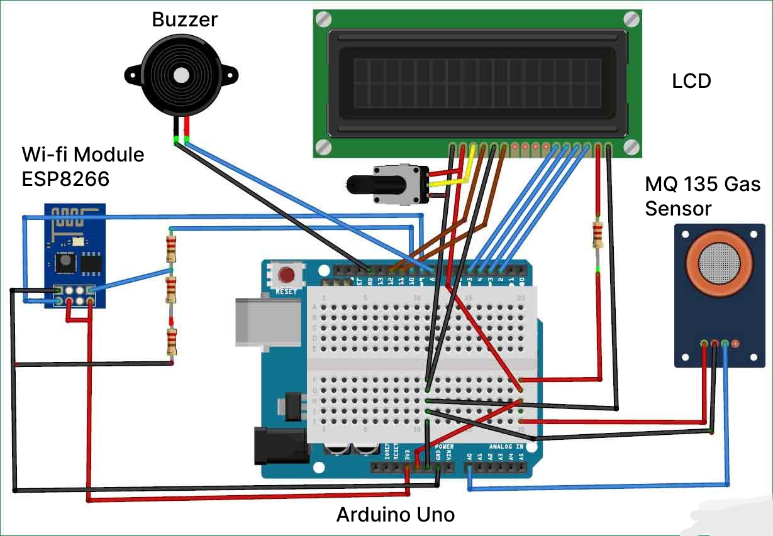

**Figure 1-Block Diagram of Air Quality Monitoring using Arduino**

**STEPS TO CREATE THE AIR QUALITY MONITORING IOT PROJECT:**

Creating an IoT-based air pollution monitoring system using an Arduino Uno involves several steps. Here's a high-level overview of the process:

**1. Gather Components:**

* Arduino Uno board
* Air quality sensor (e.g., MQ series)
* Wi-Fi module (e.g., ESP8266)
* Power supply
* Jumper wires
* Breadboard or custom PCB (Printed Circuit Board)

**2. Assemble Hardware:**

* Connect the air quality sensor to the Arduino Uno using the appropriate pins and power supply.
* Connect the Wi-Fi module to the Arduino Uno.

**3. Set Up Arduino IDE:**

* Install the Arduino IDE on your computer.
* Install the necessary libraries for the air quality sensor and the Wi-Fi module.

**4. Write Arduino Code:**

* Write code for the Arduino Uno to read data from the air quality sensor.
* Code should also include Wi-Fi connectivity to send data to a server or cloud platform.
* Ensure that your code is well-documented and handles error conditions gracefully.

**5. Create IoT Platform Account:**

* Sign up for an IoT platform or cloud service, such as AWS IoT, Google Cloud IoT, or Thing Speak.

**6. Set Up IoT Platform:**

* Create a new IoT device in your platform account.
* Retrieve API keys and credentials for your device.

**7. Configure Wi-Fi Module:**

* Program the Wi-Fi module with your network credentials and the IoT platform's server information.

**8. Test and Debug:**

* Upload the Arduino code to your Arduino Uno.
* Test the system to ensure its reading air quality data and sending it to the IoT platform correctly.
* Debug any issues you encounter.

**9. Data Visualization:**

* Set up data visualization and monitoring tools on your IoT platform. Create dashboards to display air quality data in real-time.

**10. Power Supply and Enclosure:**

* Make sure your system is powered properly. Consider placing the components in an enclosure for outdoor use.

**11. Deploy:**

* Install the monitoring system in the location where you want to measure air quality.

**12. Maintenance:**

* Regularly check and calibrate the air quality sensor. Monitor the system for any issues and perform updates as needed.

**WORKING EXPLANATION:**

* The MQ135 sensor can sense NH3, NOx, alcohol, Benzene, smoke, CO2 and some other gases, so it is perfect gas sensor for our Air Quality Monitoring Project.When we will connect it to Arduino then it will sense the gases, and we will get the Pollution level in PPM (parts per million).
* MQ135 gas sensor gives the output in form of voltage levels and we need to convert it into PPM. So for converting the output in PPM, here we have used a library for MQ135 sensor, it is explained in detail in “Code Explanation” section below.
* Sensor was giving us value of 90 when there was no gas near it and the safe level of air quality is 350 PPM and it should not exceed 1000 PPM.
* When it exceeds the limit of 1000 PPM, then it starts cause Headaches, sleepiness and stagnant, stale, stuffy air and if exceeds beyond 2000 PPM then it can cause increased heart rate and many other diseases.
* When the value will be less than 1000 PPM, then the LCD and webpage will display “Fresh Air”.
* Whenever the value will increase 1000 PPM, then the buzzer will start beeping and the LCD and webpage will display “Poor Air, Open Windows”.
* If it will increase 2000 then the buzzer will keep beeping and the LCD and webpage will display “Danger! Move to fresh Air”.

**FEATURES OF THE AIR QUALITY MONITOR:**

**1. Sensor Array:**

* Air quality monitoring systems typically consist of a variety of sensors that measure different air pollutants. These sensors can include those for measuring particulate matter (PM), gases (e.g., CO, NO2, SO2, and O3), volatile organic compounds (VOCs), and more.

**2. Data Logger:**

* A data logger or data acquisition system is used to collect and store data from the sensors over time. It records measurements at regular intervals and can store this data for analysis and reporting.

**3. Real-time Monitoring:**

* Many systems provide real-time monitoring capabilities, allowing users to access current air quality information on-site or remotely. This feature is crucial for immediate responses to air quality issues.

**4. Communication Interface:**

* Air quality monitoring systems often include communication interfaces to transmit data to a central server or cloud platform. Common communication methods include Ethernet, Wi-Fi, cellular, or satellite connectivity.

**5. Data Visualization:**

* To make the data more understandable, these systems often include data visualization tools, such as charts, graphs, and dashboards, which can display air quality trends and anomalies over time.

**6. Alarms and Alerts:**

* Air quality monitoring systems can be programmed to send alerts or alarms when pollutant levels exceed predetermined thresholds. These alerts can be sent via email, SMS, or other communication methods.

**7. Historical Data Analysis:**

* Systems usually store historical data, allowing for trend analysis, pattern recognition, and long-term assessments of air quality.

**8. Geographic Information System (GIS) Integration:**

* Some systems incorporate GIS to provide spatial information about air quality, which can be valuable for understanding regional variations in pollution.

**9. Weather Monitoring:**

* Weather conditions can significantly affect air quality. Some systems include weather monitoring sensors (e.g., temperature, humidity, wind speed, wind direction) to help correlate air quality data with meteorological factors.

**10. Calibration and Maintenance Alerts:**

* Sensors need regular calibration and maintenance to ensure accurate measurements. Monitoring systems may include features to schedule and track calibration and maintenance tasks.

**11. Remote Control and Configuration:**

* Users can often remotely configure and manage the monitoring system, adjusting settings, sensor calibrations, and data reporting parameters as needed.

**12. Data Storage and Backup:**

* Systems typically offer data storage options, including data backup to prevent data loss in case of system failure.

**13. Compliance Reporting:**

* Many air quality monitoring systems are used for regulatory compliance. They may include features to generate compliance reports and export data in standardized formats for regulatory authorities.

**14. Multiple Sensor Compatibility:**

* Some systems support a range of sensor types and brands, allowing for flexibility and customization based on specific monitoring needs.

**15. User Access Control:**

* To protect the integrity of the system and its data, access control and user authentication features may be included.

**16. Mobile Access:**

* Some systems offer mobile apps or mobile-responsive web interfaces to allow users to monitor air quality data on smartphones or tablets.

**17. Data Integration:**

* For comprehensive environmental monitoring, systems can integrate air quality data with data from other environmental sensors, such as water quality or noise level sensors.

**18. Remote Diagnostics:**

* Remote diagnostics can help identify and address system issues, reducing downtime and maintenance costs.

The specific features and capabilities of an air quality monitoring system can vary depending on the application, budget, and environmental conditions of the location where it is deployed. These systems are essential for assessing air quality, managing pollution, and making informed decisions to protect public health and the environment.