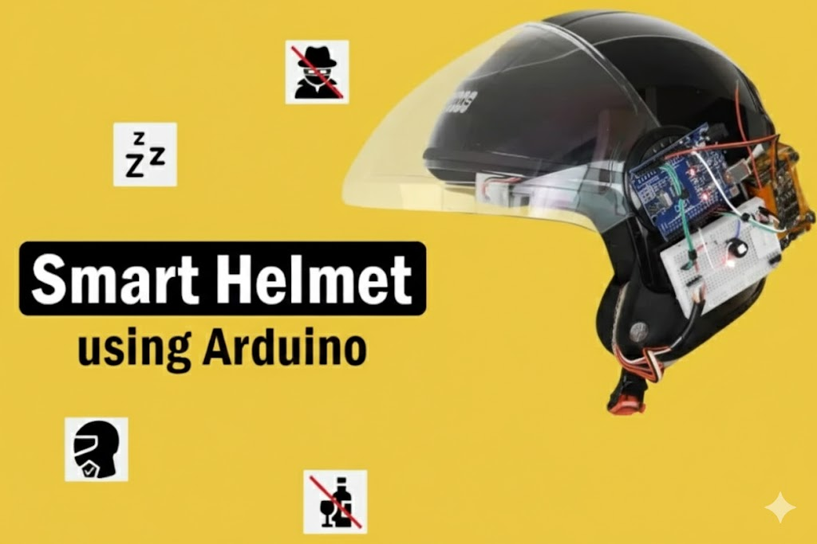
BY
KK
Implementation of an Arduino-Based Smart Helmet for Enhanced Road Safety and Alcohol Detection
Abstract:
This report is about the reduction of road accidents among riders through design and implementation of a 'Smart Helmet' The main aim of this device is to help in reducing accident caused through alcohol, drowsiness disappearance and carelessness while on the ride. It works on a dual unit architecture with a Transmitter Unit placed in the helmet and Receiver Unit mounted on the vehicle.
Using IR sensors for wear and drowsiness detection, an MQ-3 alcohol sensor, and RF 433 MHz for communication, the project makes sure that the vehicle’s ignition (simulated by a motor) turns on only when the user is using the helmet.
A special "time-window logic" is employed to differentiate natural eye blinking and micro-sleep. Results illustrate an economical, reliable safety measure that can be used to enforce the helmet law and eliminate the incidence of drunken driving.

Problem Statement:
1.Many riders flout safety protocols, despite strict laws. Existing helmets are passive, and they just provide protection during a collision, but do not control the unsafe driving of vehicle. An "active" safety system is required that:
2.Stops the engine from running without a helmet.
3.Determines if the driver is drunk.and Tracks the driver’s alertness in real time.

Table of Contents
- Components Required
- Circuit Diagram and Assembly
- └ Transmitter Section
- └ Receiver Section
- Transmitter Code Implementation
- Receiver Code Implementation
- Working
Components Required
Since this project has two different circuits (Transmitter and Receiver)
Transmitter Side
- Arduino UNO R3 - 1
- 433 MHz RF Transmitter - 1
- IR Sensor - 2 (one for wear detection and another for drowsiness detection)
- MQ-3 Sensor - 1 (for alcohol detection)
- LED & Buzzer - 1 each (for warnings)
- Any battery source for powering the setup
- Helmet for demo purpose
- Breadboard - 1
- Connecting wires - required quantity
Receiver Side
- Arduino UNO R3 - 1
- 433 MHz RF Receiver - 1
- 16x2 LCD Display with I2C Module - 1
- 1-Channel Relay Module - 1 (for turning the engine on & off)
- LED & Buzzer - 1 each (for warnings)
- Breadboard – 1 and Connecting wires - required quantity

TRANSMITTER SECTION:
Two IR obstacle detection sensors (for sleep detection and wear detection) and an MQ3 alcohol detection sensor. All three require a 5V DC input, so with the help of some external wires, I made a parallel connection between the VCC and GND of all the sensors, making it a single input.
The sensors’ outputs are connected to the analog input pins as follows:
- MQ3 (Alcohol Detection) → A0
- Wear Detection Sensor → A1
- Sleep Detection Sensor → A2
I connected the RF transmitter module, LED, buzzer, and all sensor connections. The RF transmitter module was powered with 5V, just like the sensor network.
- The 12th pin was connected to the data pin of the transmitter module.
- The LED and buzzer were connected to the same I/O pin, pin 7, with a 1KΩ current-limiting resistor. I used a 2-cell lithium battery. Finally, coming to the antenna of the transmitter module, I used an online calculator to determine the length of the antenna wire. The approximate value was 17 cm.

Receiver Section
Now, moving on to the receiver section, which is also a simple circuit. The main components used here are:
- LCD with I2C
- Arduino Uno
- RF receiver module
- Relay module
- Buzzer and LED

Transmitter Code Implementation
Here, the program continuously monitors sensor inputs, evaluates drowsiness based on a time-window logic, and alerts the user if drowsiness is detected.
The processed data is transmitted wirelessly at regular intervals.
Libraries Used
1.RH_ASK – Sub library of RadioHead that handles RF communication using the ASK (Amplitude Shift Keying) protocol. (External Library)
2.SPI – Required by the RadioHead library for low-level communication. (Built-in Library)

Variables and Constants
- Debugging
  - DEBUG_MODE – Enables/disables debug messages in Serial Monitor.
- Sensor Pins
  - alcoholSensorPin = A0 (Reads alcohol sensor input)
  - wearSensorPin = A1 ( Checks if the helmet is worn)
  - sleepSensorPin = A2 ( Detects micro-sleep events)
  - buzzerPin = 7 (Controls the buzzer)
- Drowsiness Detection
  - drowsinessThreshold = 5 (Number of sleep detections required within a time window to confirm drowsiness)
  - drowsinessTimeWindow = 10000 ms (10 seconds window for evaluating drowsiness)
  - resetTime = 5000 ms ( Resets drowsiness state if no sleep signals occur within 5 seconds)
  - sleepTimestamps[] – Stores timestamps of detected sleep signals
  - sleepIndex – Tracks the circular buffer index
  - isDrowsy – Stores the current drowsiness status

- RF Communication
  - rf_driver – RF communication object
  - lastSendTime – Tracks the last transmission time
  - sendInterval = 50 ms (Sends data every 50 milliseconds)

Receiver Code Implementation
The Receiver System communicates wirelessly using an RF module with the Transmitter System and displays status information on an LCD screen. If the rider is not wearing the helmet or has consumed alcohol, the vehicle ignition is disabled. A buzzer alerts the user in case of drowsiness or safety violations.
Libraries Used
- Wire.h: Used for I2C communication, essential for LCD operation.(Built-in Library)
- LiquidCrystal_I2C.h: Controls the 16x2 LCD display via the I2C interface. (External Library)
- RH_ASK.h: Enables communication with an RF module, using the RadioHead ASK (Amplitude Shift Keying) protocol. (External Library)
- SPI.h: Required for RF communication, used internally by RH_ASK. (Built-in Library)

Variables and Constants
- Hardware Configuration
  - ignitionRelay (Pin 4): Controls the vehicle ignition (ON/OFF state).
  - buzzerPin (Pin 5): Controls the buzzer for alerting the rider.
  - lcd (0x27, 16, 2): LCD initialization with I2C address 0x27.
  - rf_driver (2000, 11, 12, 0): Configures the RF module (2000 bps baud rate, RX on pin 11, TX on pin 12).
- Data Variables
  - str_helmet, str_alcohol, str_sleep: Store received sensor values as strings.
  - helmetStatus, alcoholLevel, sleepStatus: Store integer-converted sensor readings.
  - engineState: Boolean representing whether the engine should be ON or OFF.
  - lastReceivedTime: Tracks the last received RF data timestamp.
  - timeout: Defines the period (5000ms) before showing a system offline message.
  - page, lastPage: Manage the LCD page display system.
  - lastPageSwitch, pageInterval: Handle page switching every 3 seconds.

Setup Function
The setup function begins by initializing serial communication at a baud rate of 115200, ensuring efficient data transmission for debugging and monitoring. It then initializes the RF module, enabling wireless communication for receiving helmet, alcohol, and sleep status data. The LCD screen is also set up at this stage, displaying the startup message "Smart Helmet" to indicate that the system is powered on.

FLOWCHART FOR THE SMART HELMET
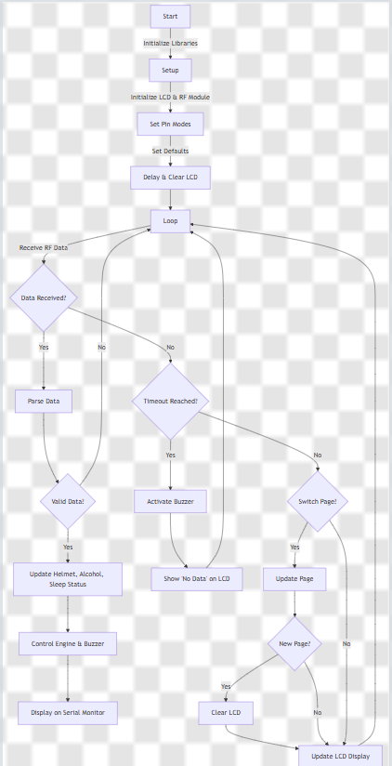

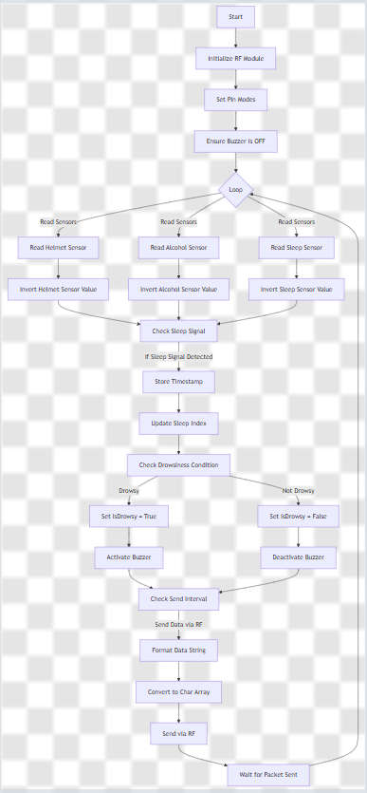

ANY DOUBTS SEE HERE
Links
- Tutorial: Smart Helmet using Arduino
- IDE: Arduino IDE
- Datasheet: MQ-3 Sensor Datasheet
- Interfacing Guides:
  - Arduino IR Sensor Interfacing
  - Arduino MQ3 Alcohol Sensor

CONCLUSION:
The development of the Arduino-Based Smart Helmet successfully demonstrates the integration of embedded systems with vehicle safety protocols. By shifting the role of a helmet from a passive protective shell to an active electronic safety interlock
Through testing, the following milestones we able to achieved:
- Reliable Interlocking: The vehicle ignition (simulated via relay) effectively remains disabled unless the IR sensor confirms the helmet is being worn.
- Accuracy in Detection: The MQ-3 sensor provided consistent readings, preventing engine start-up when alcohol vapours were detected.
- Effective Drowsiness Logic: The "time-window" algorithm proved superior to simple blink detection, as it successfully ignored natural blinking while identifying genuine micro-sleep patterns.
- Wireless Stability: The 433 MHz RF link maintained a stable connection within the typical range required for a rider and their vehicle, ensuring no lag in safety alerts.
In conclusion, this prototype serves as a cost-effective and scalable solution that could significantly reduce the burden of road accidents on society if integrated into commercial vehicle manufacturing.
Future Scope
- IoT and Cloud Integration: Integrating an ESP32 or GSM module would allow the helmet to send real-time location coordinates and accident alerts to emergency contacts or local police in the event of a crash.
- Solar Charging: To address power management, thin-film flexible solar panels could be curved over the helmet's surface to trickle-charge the Lithium-Ion battery during daytime rides.

