Assignment 1.2

1. Pwd: It displays the full path of your current directory.

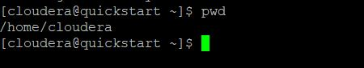

1. Vi : It is used to open the file in the vi editor.

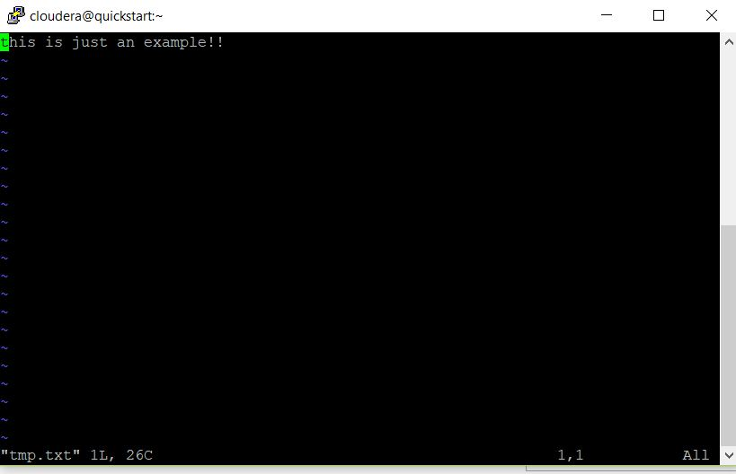

1. Touch: It is used to create new empty files.

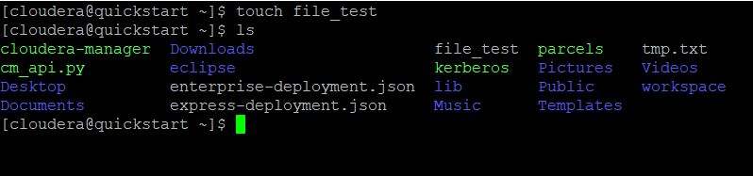

1. Mkdir: It is used to create a directory.

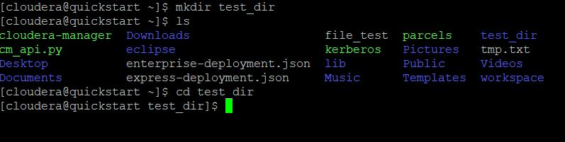

1. rm: It is used to remove file from the directory.

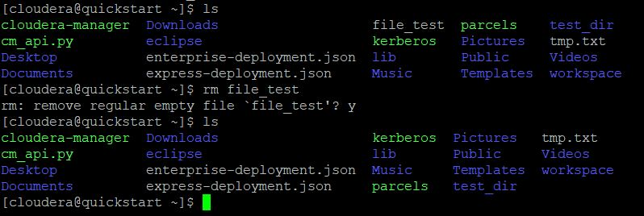

1. ls: It lists the file in the current directory.

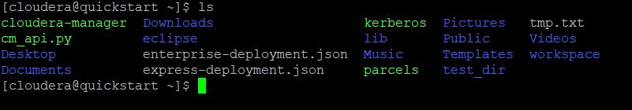

1. echo: Used to display a line of text or string on to the screen.

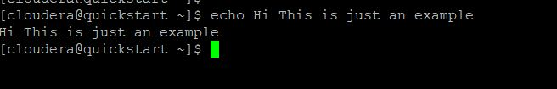

1. cat: It is used to create a file, view the contents of the file on the screen.

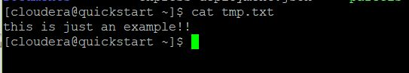

1. who: It displays the list of users who are currently logged on to the system.

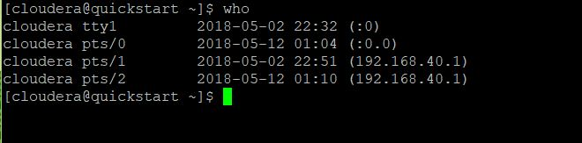

1. cd: It is used to change the current directory.

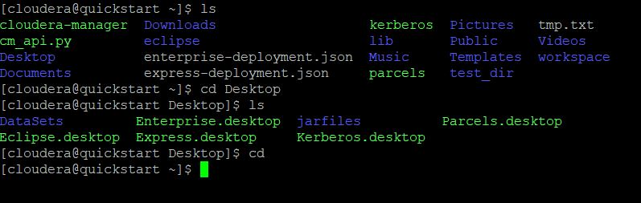

1. date: Display the Current date and time.

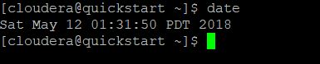

1. cal: Display the Calendar.

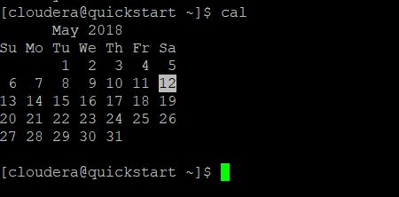

1. mv: It is used to move files or directories from one place to another.

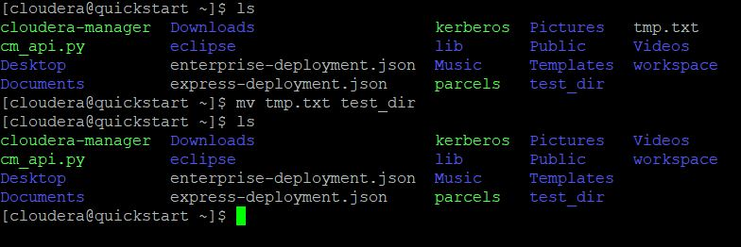

1. cp : It is used to copy the files or directories.

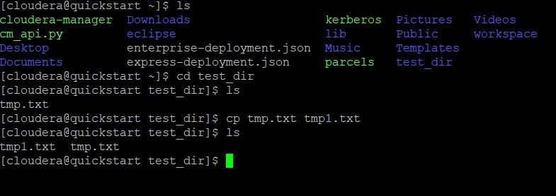

1. which: it is used to locate the executable file associated with the given command.

