**Session 2**

**Assignment 2.2**

Student Name: Karthik K

Course: Big Data Hadoop & Spark Training

**Assignment 2.2** –Create a sample dataset and implement the below Pig commands on the same dataset.

In this assignment we are going to use the below as Input Data set for the first **8** PIG commands.

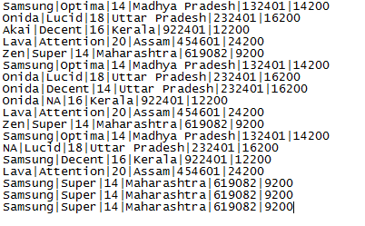

## 1) Concat():

The CONCAT() function of Pig Latin is used to concatenate two or more expressions of the same type.

Command:

***“baseRelation = LOAD '/home/acadgild/hadoop/television.txt' USING PigStorage('|') AS (company_name:chararray, unit_name:chararray, size:int, state:chararray, zip:int, price:int);***

***DUMP baseRelation;***

***DESCRIBE baseRelation;***

***company_unit_concat = FOREACH baseRelation GENERATE CONCAT(company_name, '-', unit_name);***

***DUMP company_unit_concat;”***

### Output:

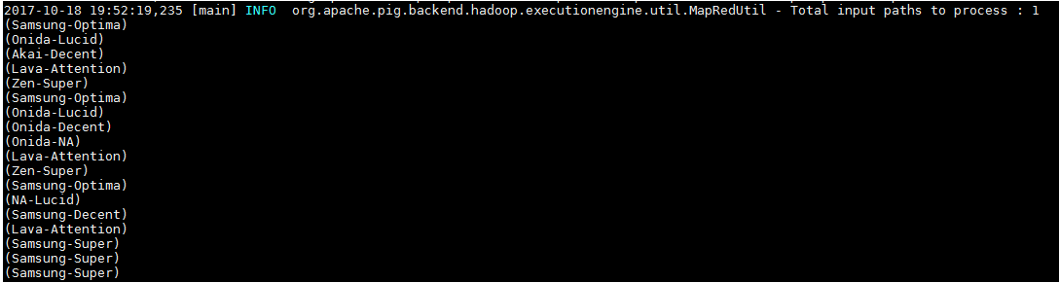

## 2) Tokenize()

The TOKENIZE() function of Pig Latin is used to split a string (which contains a group of words) in a single tuple and returns a bag which contains the output of the split operation.

Command:

**“company_unit_tokenize = FOREACH baseRelation GENERATE TOKENIZE(company_name);**

**DUMP company_unit_tokenize;”**

### Output:

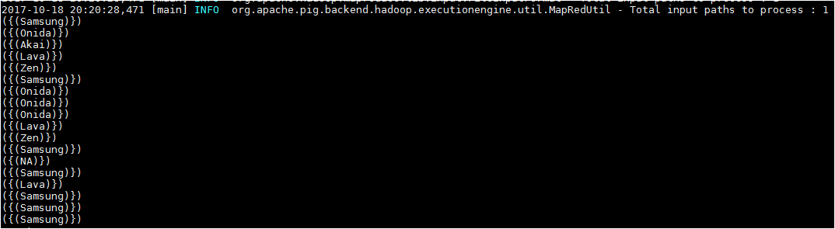

## 3) Sum():

You can use the SUM() function of Pig Latin to get the total of the numeric values of a column in a single-column bag. While computing the total, the SUM() function ignores the NULL values.

Note –

* To get the global sum value, we need to perform a Group All operation, and calculate the sum value using the SUM() function.
* To get the sum value of a group, we need to group it using the Group By operator and proceed with the sum function.

Command:

***“company_price = GROUP baseRelation ALL;”***

### Output:

(all,{(Samsung,Super,14,Maharashtra,619082,9200),(Samsung,Super,14,Maharashtra,619082,9200),(Samsung,Super,14,Maharashtra,619082,9200),(Lava,Attention,20,Assam,454601,24200),(Samsung,Decent,16,Kerala,922401,12200),(NA,Lucid,18,Uttar Pradesh,232401,16200),(Samsung,Optima,14,Madhya Pradesh,132401,14200),(Zen,Super,14,Maharashtra,619082,9200),(Lava,Attention,20,Assam,454601,24200),(Onida,NA,16,Kerala,922401,12200),(Onida,Decent,14,Uttar Pradesh,232401,16200),(Onida,Lucid,18,Uttar Pradesh,232401,16200),(Samsung,Optima,14,Madhya Pradesh,132401,14200),(Zen,Super,14,Maharashtra,619082,9200),(Lava,Attention,20,Assam,454601,24200),(Akai,Decent,16,Kerala,922401,12200),(Onida,Lucid,18,Uttar Pradesh,232401,16200),(Samsung,Optima,14,Madhya Pradesh,132401,14200)})

***“company_price_sum = FOREACH company_price GENERATE (baseRelation.company_name,baseRelation.price),SUM(baseRelation.price);”***

(({(Samsung),(Samsung),(Samsung),(Lava),(Samsung),(NA),(Samsung),(Zen),(Lava),(Onida),(Onida),(Onida),(Samsung),(Zen),(Lava),(Akai),(Onida),(Samsung)},{(9200),(9200),(9200),(24200),(12200),(16200),(14200),(9200),(24200),(12200),(16200),(16200),(14200),(9200),(24200),(12200),(16200),(14200)}),**262600**)



## 4) MIN():

The MIN() function of Pig Latin is used to get the minimum (lowest) value (numeric or chararray) for a certain column in a single-column bag. While calculating the minimum value, the MIN() function ignores the NULL values.

Note

* To get the global minimum value, we need to perform a Group All operation, and calculate the minimum value using the MIN() function.
* To get the minimum value of a group, we need to group it using the Group By operator and proceed with the minimum function.

Command:

“***company_price = GROUP baseRelation ALL;***

***company_price_min = FOREACH company_price GENERATE (baseRelation.company_name,baseRelation.price),MIN(baseRelation.price);”***

### Output

(({(Samsung),(Samsung),(Samsung),(Lava),(Samsung),(NA),(Samsung),(Zen),(Lava),(Onida),(Onida),(Onida),(Samsung),(Zen),(Lava),(Akai),(Onida),(Samsung)},{(9200),(9200),(9200),(24200),(12200),(16200),(14200),(9200),(24200),(12200),(16200),(16200),(14200),(9200),(24200),(12200),(16200),(14200)}),**9200**)



## 5)MAX()

The Pig Latin MAX() function is used to calculate the highest value for a column (numeric values or chararrays) in a single-column bag. While calculating the maximum value, the Max() function ignores the NULL values.

Note −

* To get the global maximum value, we need to perform a Group All operation, and calculate the maximum value using the MAX() function.
* To get the maximum value of a group, we need to group it using the Group By operator and proceed with the maximum function.

***“company_price = GROUP baseRelation ALL;***

***company_price_max = FOREACH company_price GENERATE (baseRelation.company_name,baseRelation.price),MAX(baseRelation.price);”***

### Output

(({(Samsung),(Samsung),(Samsung),(Lava),(Samsung),(NA),(Samsung),(Zen),(Lava),(Onida),(Onida),(Onida),(Samsung),(Zen),(Lava),(Akai),(Onida),(Samsung)},{(9200),(9200),(9200),(24200),(12200),(16200),(14200),(9200),(24200),(12200),(16200),(16200),(14200),(9200),(24200),(12200),(16200),(14200)}),24200)



## 6)LIMIT()

The LIMIT operator is used to get a limited number of tuples from a relation.

Command:

***“limit_data = LIMIT baseRelation 5;”***

### Output

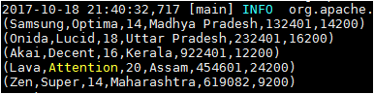

## 

## 7)STORE()

You can store the loaded data in the file system using the **store** operator.

Command:

***“STORE baseRelation INTO '/home/acadgild/hadoop/pigoutassignment' USING PigStorage('|');”***

Output***:***

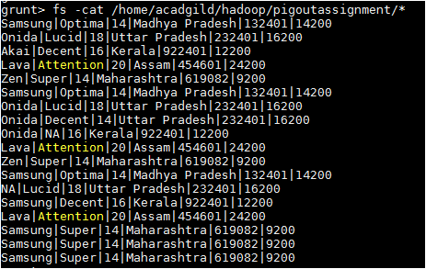

# 8)Distinct()

The DISTINCT operator is used to remove redundant (duplicate) tuples from a relation.

Command:

***“distinct_data = DISTINCT baseRelation;”***

### Output:

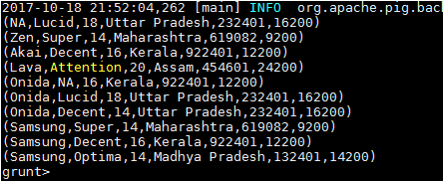

## 9)Flatten()

The FLATTEN operator looks like a UDF syntactically, but it is actually an operator that changes the structure of tuples and bags in a way that a UDF cannot. Flatten un-nests tuples as well as bags. The idea is the same, but the operation and result is different for each type of structure.

Input Dataset:

A.txt B.txt

 

Command:

***“A_Relation = LOAD '/home/acadgild/hadoop/A.txt' USING PigStorage(',') AS (a1:int,a2:int,a3:int);***

***B_Relation = LOAD '/home/acadgild/hadoop/B.txt' USING PigStorage(',') AS (b1:int,b2:int);***

***C_Relation = COGROUP A_Relation BY a1 inner, B_Relation BY b1 inner;***

***Dump C_Relation;***

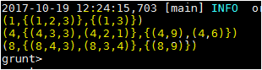

***FLATTEN():***

1. ***X_Relation = FOREACH C_Relation GENERATE group, FLATTEN(A_Relation);***
2. ***X_Relation = FOREACH C_Relation GENERATE group, FLATTEN(A_Relation.a3);***

### Output

In this example the FLATTEN operator is used to eliminate nesting.

1. 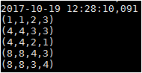
2. 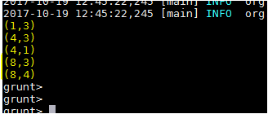

## 10)ISEMPTY()

The IsEmpty() function of Pig Latin is used to check if a bag or map is empty.

Input Data:

**Employee_Sales.txt** **Employee_bonus.txt**

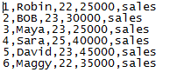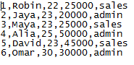

Command:

1. ***sales_relation = LOAD '/home/acadgild/hadoop/Employee_sales.txt' USING PigStorage(',') AS (id:int, name:chararray, age:int, salary:int, dept:chararray);***

***DUMP sales_relation;***

1. ***bonus_relation = LOAD '/home/acadgild/hadoop/Employee_bonus.txt' USING PigStorage(',') AS (id:int, name:chararray, age:int, salary:int, dept:chararray);***

***DUMP bonus_relation;***

1. ***cogroup_data = COGROUP sales_relation by age, bonus_relation by age;***

***DUMP cogroup_data;***

1. ***isempty_data = FILTER cogroup_data by IsEmpty(sales_relation);***

***DUMP isempty_data;”***

### Output

Below is the output of the command number 3.

1. (22,{(6,Maggy,22,35000,sales),(1,Robin,22,25000,sales )},{(1,Robin,22,25000,sales )})

(23,{(5,David,23,45000,sales ),(3,Maya,23,25000,sales ),(2,BOB,23,30000,sales )},{(5,David,23,45000,sales ),(3,Maya,23,25000,sales ),(2,Jaya,23,20000,admin )})

(25,{(4,Sara,25,40000,sales )},{(4,Alia,25,50000,admin )})

(30,{},{(6,Omar,30,30000,admin)})

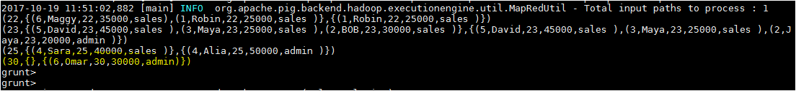

Output of the command number 4 **IsEmpty(),**The **sales_relation** holds the tuples that are not there in the relation **bonus_relation**.

