**Session 2**

**Assignment 2.5**

Student Name: Karthik K

Course: Big Data Hadoop & Spark Training

# Problem Statement 1

## Find out the top 5 most visited destinations

Codes:

1. **REGISTER '/home/acadgild/hadoop/piggybank-0.15.0.jar';**
2. **A = load '/home/acadgild/hadoop/DelayedFlights.csv' USING org.apache.pig.piggybank.storage.CSVExcelStorage(',','NO_MULTILINE','UNIX','SKIP_INPUT_HEADER');**
3. **B = FOREACH A GENERATE (int)$1 as year, (int)$10 as flight_num, (chararray)$17 as origin,(chararray) $18 as dest;**
4. **C = FILTER B by dest is NOT Null;**
5. **D = GROUP C BY dest;**
6. **E = FOREACH D GENERATE group, COUNT(C.dest);**
7. **F = ORDER E by $1 DESC;**
8. **Result = LIMIT F 5;**
9. **A1 = LOAD '/home/acadgild/hadoop/airports.csv' USING org.apache.pig.piggybank.storage.CSVExcelStorage(',','NO_MULTILINE','UNIX','SKIP_INPUT_HEADER');**
10. **A2 = FOREACH A1 GENERATE (chararray)$0 as dest, (chararray)$2 as city, (chararray)$4 as country;**
11. **joined_table = JOIN Result by $0, A2 by dest;**
12. **DUMP joined_table;**
13. 
14. 
15. 
16. 
17. 
18. 
19. 
20. 
21. 
22. 
23. 
24. 

## Output: the top 5 most visited destinations

Original Output:

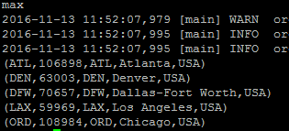

Executed Output:

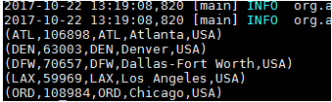

# Problem Statement 2

## Which month has seen the most number of cancellations due to bad weather?

Codes:

1. **REGISTER '/home/acadgild/hadoop/piggybank-0.15.0.jar';**
2. **A = load '/home/acadgild/hadoop/DelayedFlights.csv' USING org.apache.pig.piggybank.storage.CSVExcelStorage(',','NO_MULTILINE','UNIX','SKIP_INPUT_HEADER');**
3. **B = FOREACH A GENERATE(int)$2 as month,(int)$10 as flight_num,(int)$22 as cancelled,(chararray)$23 as cancel_code;**
4. **C = FILTER B by cancelled == 1 AND cancel_code =='B';**
5. **D = group C BY month;**
6. **E = FOREACH D GENERATE group, COUNT(C.cancelled);**
7. **F= ORDER E BY $1 DESC;**
8. **Result = limit F 1;**
9. **DUMP Result;**

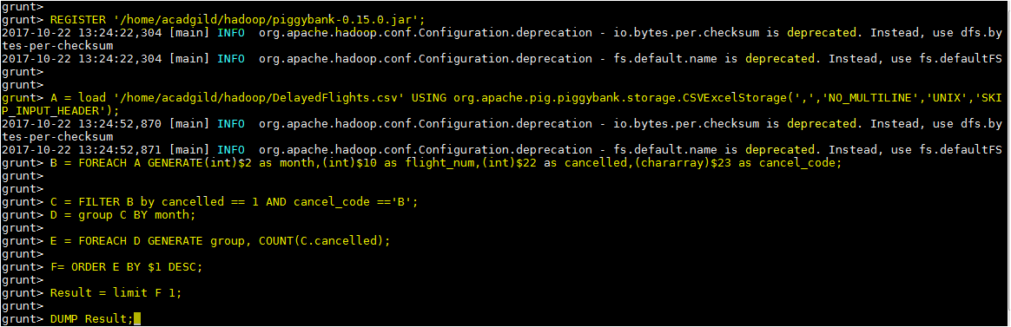

## Output: month has seen the most number of cancellations due to bad weather?

Original Output:

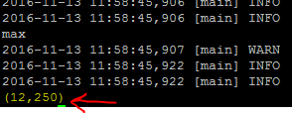

Executed Output:

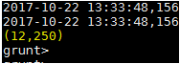

# Problem Statement 3

## Top ten origins with the highest AVG departure delay

Codes:

1. **REGISTER '/home/acadgild/hadoop/piggybank-0.15.0.jar';**
2. **A = load '/home/acadgild/hadoop/DelayedFlights.csv' USING org.apache.pig.piggybank.storage.CSVExcelStorage(',','NO_MULTILINE','UNIX','SKIP_INPUT_HEADER');**
3. **B1 = FOREACH A GENERATE (int)$16 as dep_delay, (chararray)$17 as origin;**
4. **C1 = FILTER B1 BY (dep_delay is not null) AND (origin is not null);**
5. **D1 = group C1 by origin;**
6. **E1 = FOREACH D1 generate group, AVG(C1.dep_delay);**
7. **Result = ORDER E1 by $1 DESC;**
8. **Top_ten = LIMIT Result 10;**
9. **Lookup = load '/home/acadgild/hadoop/airports.csv' USING org.apache.pig.piggybank.storage.CSVExcelStorage(',','NO_MULTILINE','UNIX','SKIP_INPUT_HEADER');**
10. **Lookup1 = FOREACH Lookup GENERATE (chararray)$0 as origin, (chararray)$2 as city, (chararray)$4 as country;**
11. **Joined = JOIN Lookup1 by origin, Top_ten by $0;**
12. **Final = FOREACH Joined GENERATE $0,$1,$2,$4;**
13. **Final_Result = ORDER Final by $3 DESC;**
14. **DUMP Final_Result;**

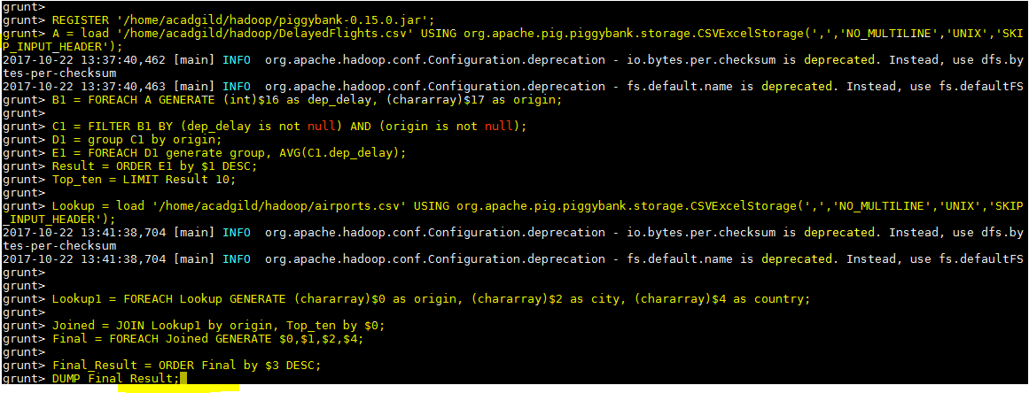

## Output Top ten origins with the highest AVG departure delay

Original Output

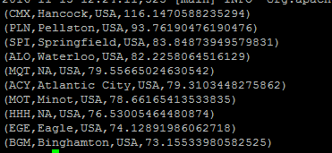

Executed Output:

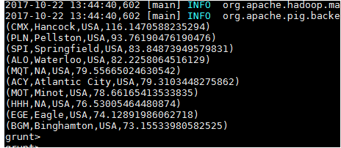

# Problem Statement 4

## Which route (origin & destination) has seen the maximum diversion?

Codes:

1. **REGISTER '/home/acadgild/airline_usecase/piggybank.jar';**
2. **A = load '/home/acadgild/hadoop/DelayedFlights.csv' USING org.apache.pig.piggybank.storage.CSVExcelStorage(',','NO_MULTILINE','UNIX','SKIP_INPUT_HEADER');**
3. **B = FOREACH A GENERATE (chararray)$17 as origin, (chararray)$18 as dest, (int)$24 as diversion;**
4. **C = FILTER B BY (origin is not null) AND (dest is not null) AND (diversion == 1);**
5. **D = GROUP C by (origin,dest);**
6. **E = FOREACH D generate group, COUNT(C.diversion);**
7. **F = ORDER E BY $1 DESC;**
8. **Result = LIMIT F 10;**
9. **DUMP Result;**

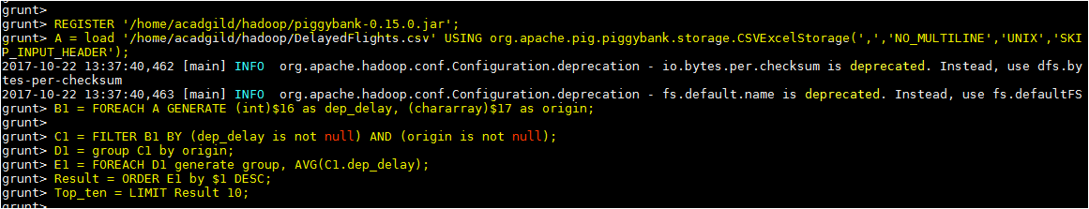

## Outputwhich route (origin & destination) has seen the maximum diversion?

Original output:

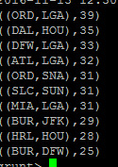

Executed output:

