**Session 3**

**Assignment 3.1**

Student Name: Karthik K

Course: Big Data Hadoop & Spark Training

# Problem Statement

Calculate the number of employees corresponding to each skill from the table 'employee' which is loaded in the Demo.

# HIVE Queries

1. ***CREATE DATABASE emp_details;***
2. ***USE emp_details;***
3. ***CREATE TABLE employee***

***(name STRING,***

***technology STRING,***

***nos INT,***

***location STRING)***

***ROW FORMAT DELIMITED***

***FIELDS TERMINATED BY ',';***

***LOAD DATA LOCAL INPATH '/home/acadgild/hadoop/emp_details.txt'***

***INTO TABLE emp_details.employee;***

1. Creating a Database named **emp_details**

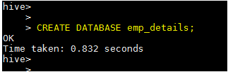

1. Create a Table **employee** with the columns **name**, **technology** and **location** as STRING type and **nos** as integer type. We are taking the input data from the location '/home/acadgild/hadoop/emp_details.txt'

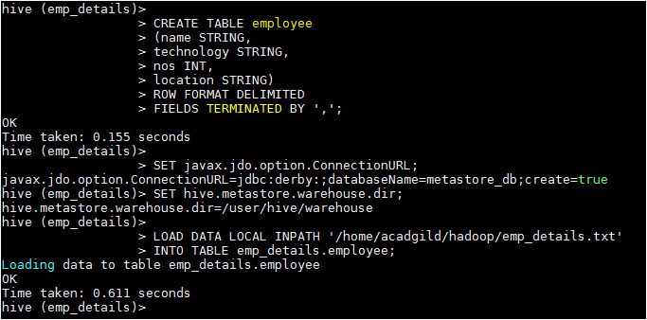

1. Data in the table **employee**

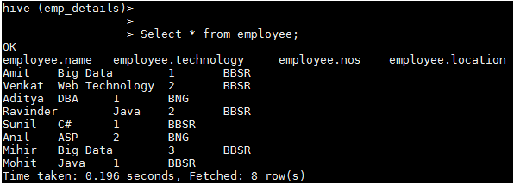

# Task

Now, calculate the number of employees corresponding to each skill from the table **'employee'**

## HIVE Query

***Select technology, SUM(t1.nos) as No_Of_Employee FROM(Select technology, nos FROM employee) t1 GROUP BY technology;***



# Expected Output

