**Session 3**

**Assignment 3.2**

Student Name: Karthik K

Course: Big Data Hadoop & Spark Training

# Problem Statement

1. Write a Hive program to find the number of medals won by each country in swimming.

2. Write a Hive program to find the number of medals that India won year wise.

3. Write a Hive Program to find the total number of medals each country won.

4. Write a Hive program to find the number of gold medals each country won.

# 

# Task1

Write a Hive program to find the number of medals won by each country in swimming.

## HIVE Query

***SELECT country, SUM(total_medals) as Total_Medals FROM olympic_data WHERE sport<=>'Swimming' GROUP BY country;***



Expected Output

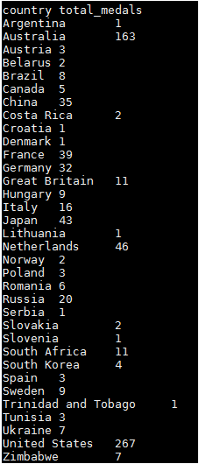

# TASK2

Write a Hive program to find the number of medals that India won year wise.

## HIVE Query

***SELECT year, SUM(total_medals) FROM olympic_data Where country<=>'India' GROUP BY year;***



Expected Output

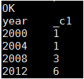

# TASK3

Write a Hive Program to find the total number of medals each country won.

## HIVE Query

***SELECT country, SUM(total_medals) as Total_Medals FROM olympic_data GROUP BY country;***

Expected Output

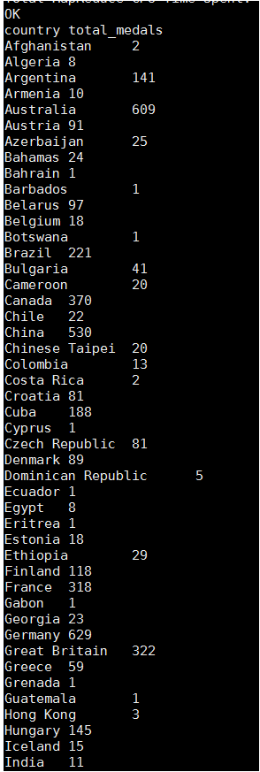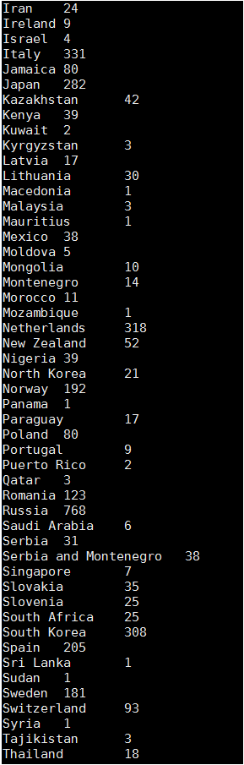

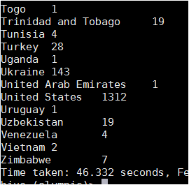

# Task4

Write a Hive program to find the number of gold medals each country won.

## HIVE Query

***SELECT country, SUM(gold_medals) as GOLD_Medals FROM olympic_data GROUP BY country;***

Expect Output

