**Session 3**

**Assignment 3.4**

Student Name: Karthik K

Course: Big Data Hadoop & Spark Training

# Problem Statement

Get a list of employees who receive a salary less than 100, compared to their immediate employee with higher salary in the same unit

List of all employees who draw higher salary than the average salary of that department

# Dataset

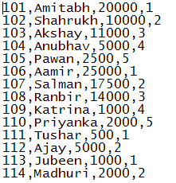

# Prerequisite – Create Database and Table

Using existing database **emp_details,**

## Table –

We are creating a table name called **emp** and we have columns as **emp_id, emp_name, sal** and **dept.**

### HIVE QL

***CREATE TABLE emp***

***(***

***Emp_id int,***

***Emp_name string,***

***Sal int,***

***Dept int***

***)***

***ROW FORMAT DELIMITED FIELDS TERMINATED BY ',';***

***LOAD DATA LOCAL INPATH '/home/acadgild/hadoop/employee_details_task1.txt'***

***INTO TABLE emp_details.emp;***

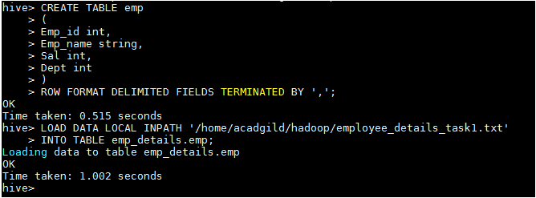

***Select * From emp;***

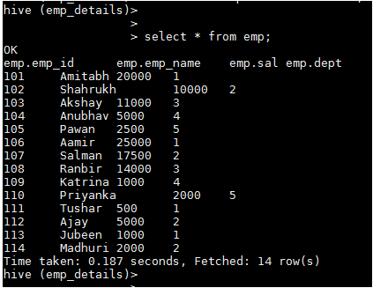

# Task 1

Get a list of employees who receive a salary less than 100, compared to their immediate employee with higher salary in the same unit

### HIVE QL

***with temp as(select emp_id,emp_name,sal,dept, LEAD(sal, 1) OVER(PARTITION BY dept ORDER BY sal) - sal as diff FROM emp) select emp_id, emp_name, dept, sal from temp where diff >100;***

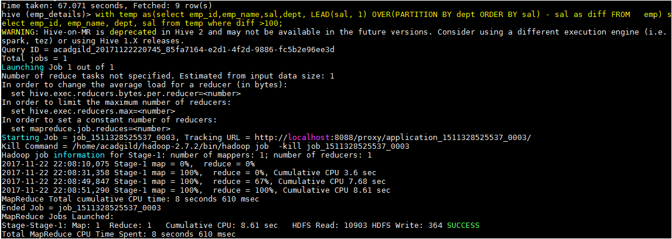

### Required Output

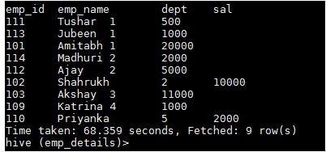

# Task 2

List of all employees who draw higher salary than the average salary of that department

### HIVE QL

***SELECT temp.emp_name, temp.sal, temp.dept, temp.avg_salary FROM (SELECT avg(sal) OVER (PARTITION BY dept) AS avg_salary, emp_id, emp_name, sal, dept FROM emp) temp WHERE temp.sal > temp.avg_salary;***

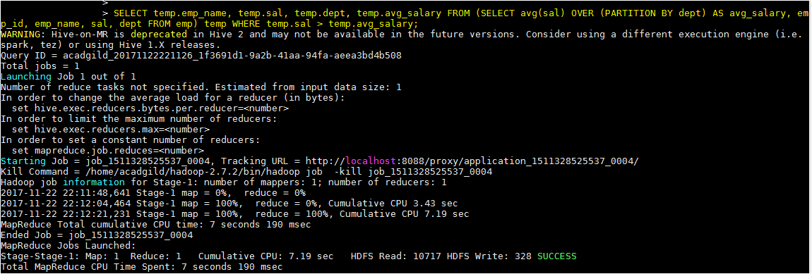

### Required Output

