**Session 3**

**Assignment 3.8**

Student Name: Karthik K

Course: Big Data Hadoop & Spark Training

# Problem Statement

Task1

Create an HBase table named 'clicks' with a column family 'hits' such that it should be able to store last 5 values of qualifiers inside 'hits' column family.

Task2

Add few records in the table and update some of them. Use IP Address as row-key. Scan the table to view if all the previous versions are getting displayed.

# Task1

Create an HBase table named **'clicks'** with a column family **'hits'** such that it should be able to store last 5 values of qualifiers inside **'hits'** column family.

Table name: ***clicks***

Column Family: ***hits***

Versions: 5

Command format:

Create <’table name’>,<’column family=>value’>,VERSIONS=>5

## HBASE Shell command

***hbase(main):007:0* create 'clicks',NAME=>'hits',VERSIONS=>5***



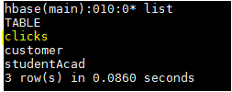

# Task2

Add few records in the table and update some of them. Use IP Address as row-key. Scan the table to view if all the previous versions are getting displayed.

Here we are using ip address ***'27.59.2.31'***  as a row key,

## HBASE shell command

***put 'clicks','27.59.2.31','hits:No_Of_Times','12'***

***scan ‘clicks’***

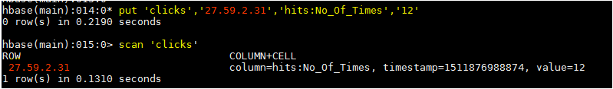

Update the row by adding some values,

***put 'clicks','27.59.2.31','hits:No_Of_Times','32'***

***put 'clicks','27.59.2.31','hits:No_Of_Times','8'***

***put 'clicks','27.59.2.31','hits:No_Of_Times','44'***

***put 'clicks','27.59.2.31','hits:No_Of_Times','99'***

We are going to see the last 5 qualifiers inside hits column family,

***scan 'clicks',{COLUMN=>'hits:No_Of_Times',VERSIONS=>5}***

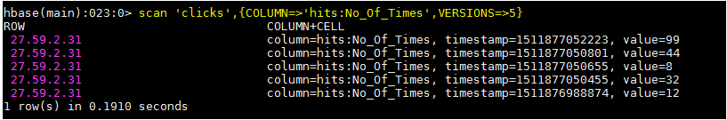

We can see the Ip address that how many number of times it was hits in a regular interval manner.