BIG DATA DEVELOPER ACADGILD

Session 4
Assignment 4.6
Student Name: Karthik K
Course: Big Data Hadoop & Spark Training
Introduction

In this assignment, we are going to import acadgild_spark vm.

Download the acadgild vm using the below link and save it into your system.

https://drive.google.com/open?id=0ByJLBTmJojjzY0pvVW9YUlFwLUk

Step1

Import the Acadgild VM,
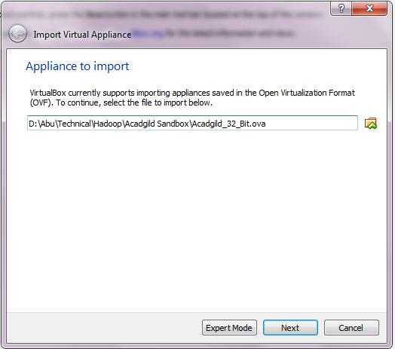

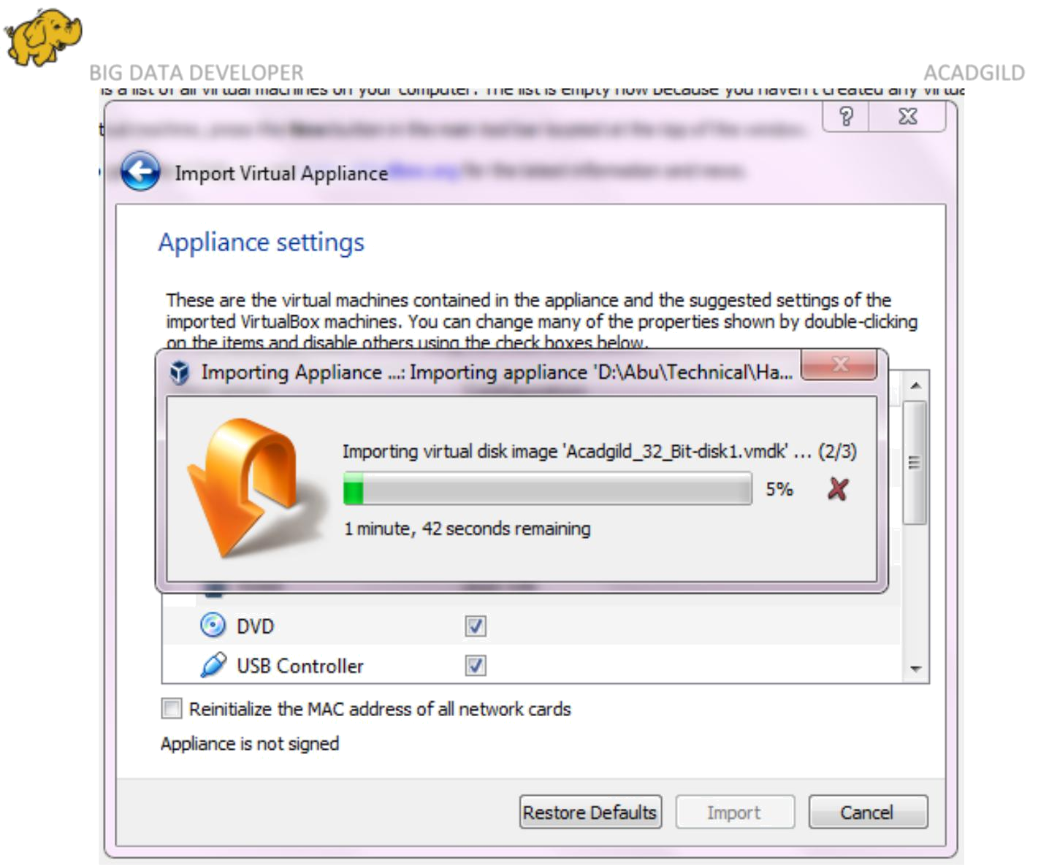

BIG DATA DEVELOPER ACADGILD

Step2

Implement the appliance settings,

3

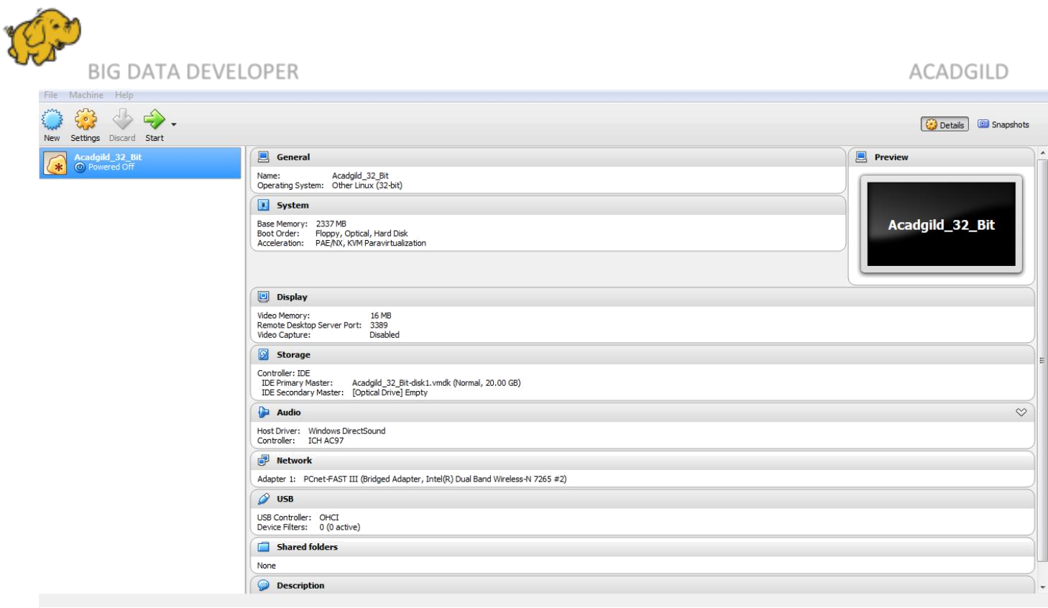
BIG DATA DEVELOPER ACADGILD
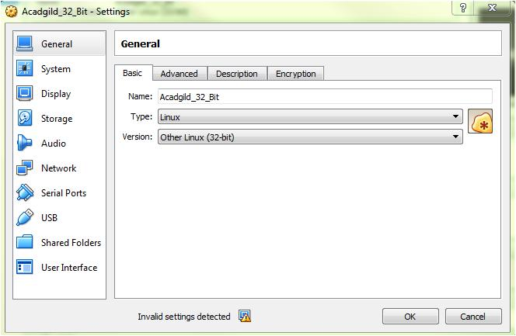

4

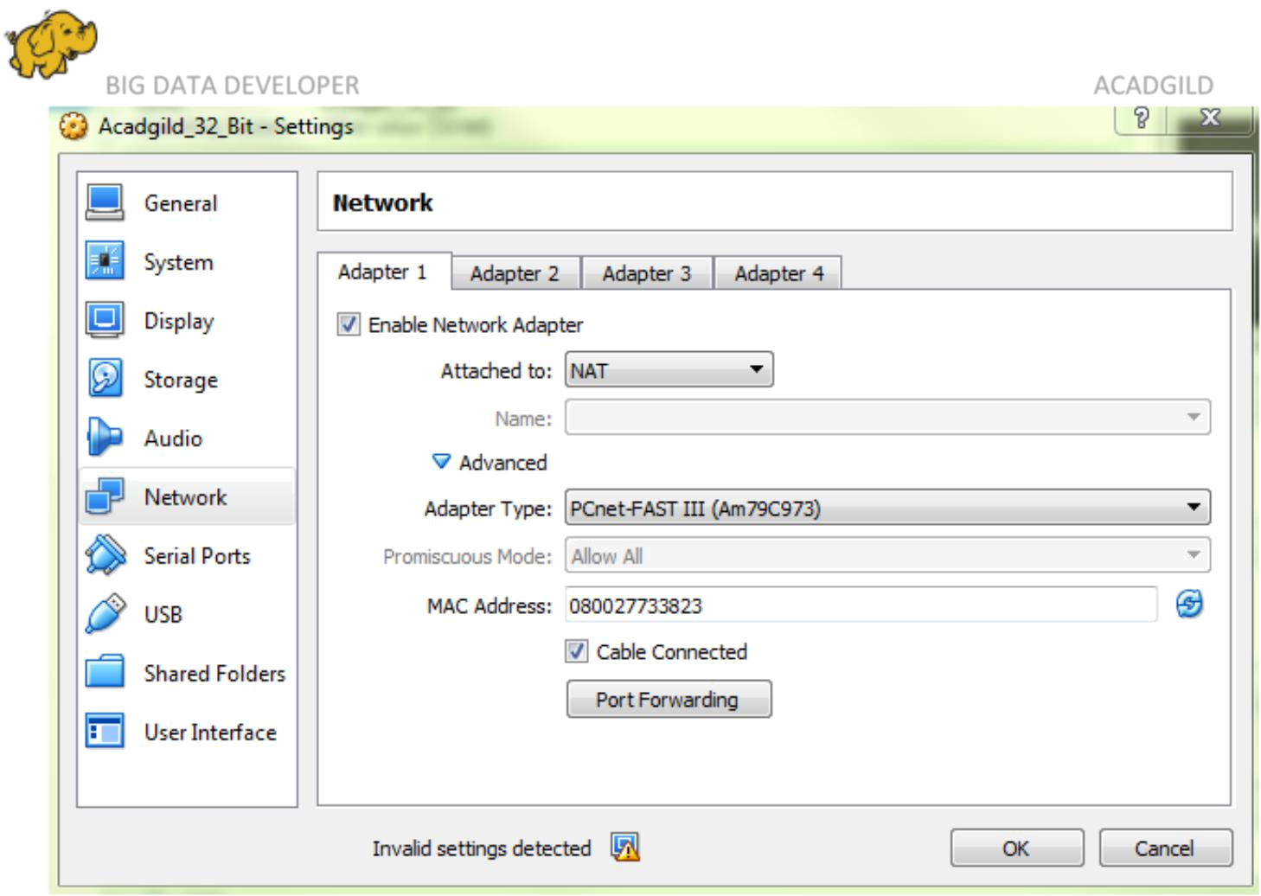
BIG DATA DEVELOPER ACADGILD

Step3

Logged in as user ACADGILD,

We need to give the password as acadgild.

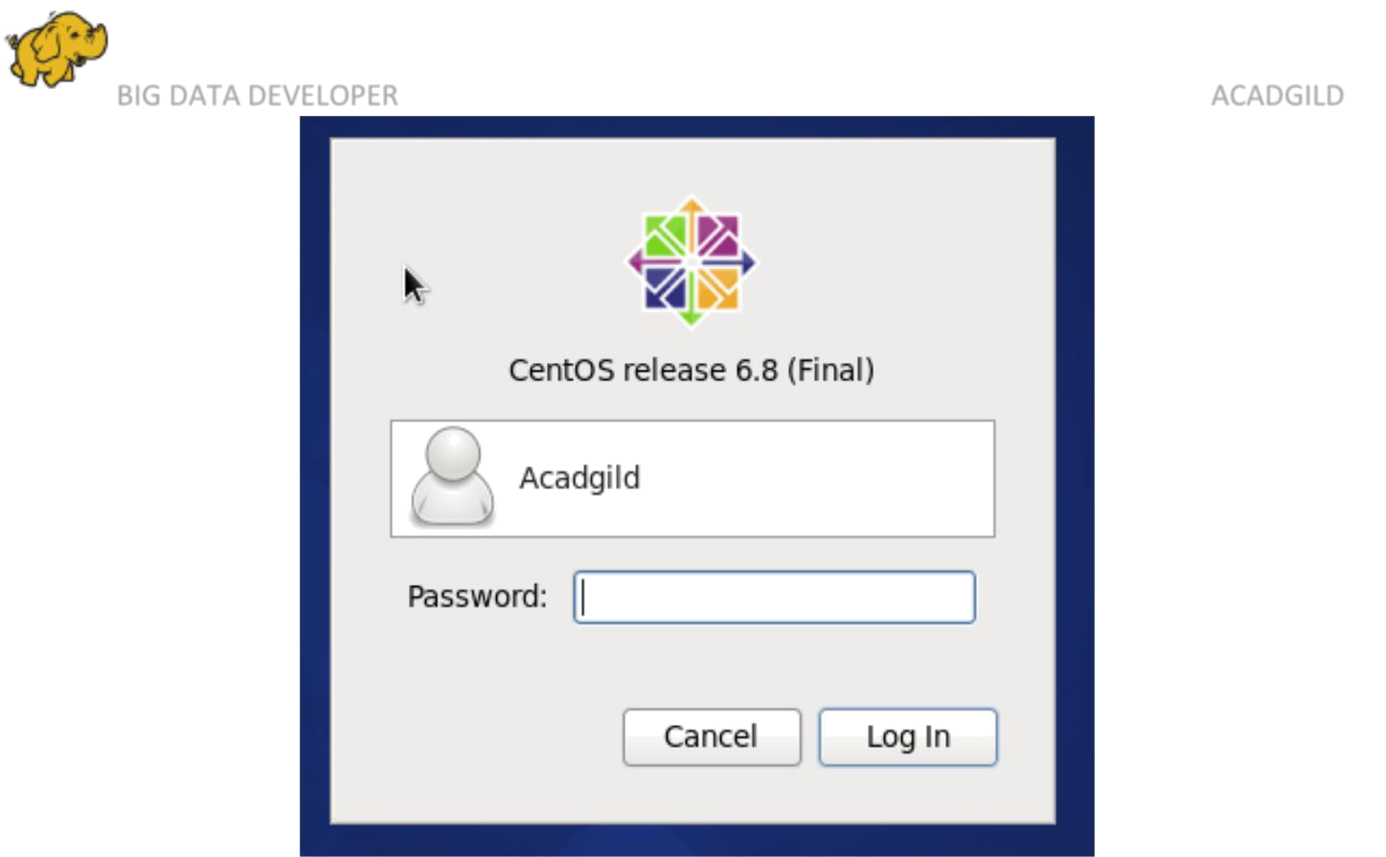
BIG DATA DEVELOPER ACADGILD

Step4

Use the MobaXterm to type the commands in the linux shell, Open the terminal and type the command jps to check the list of daemons, we need to start all the daemons for the first time.
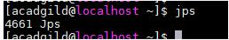

Starting Hadoop Daemons,

Start-all.sh
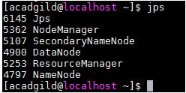

Step5

Starting spark daemons Master, Workers.

Move into the sbin folder of spark installed directory (Here spark is installed in /home/acadgild/spark-2.2.0-bin-hadoop2.7/sbin.)

Starting Master:

Command: ./start-master.sh

Starting Slaves:

Command: ./start-slaves.sh
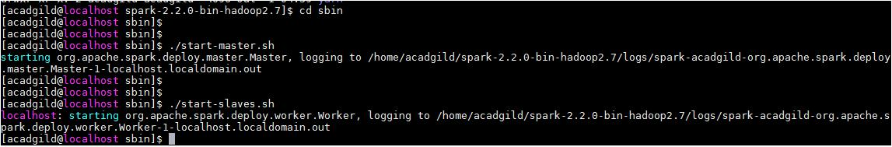

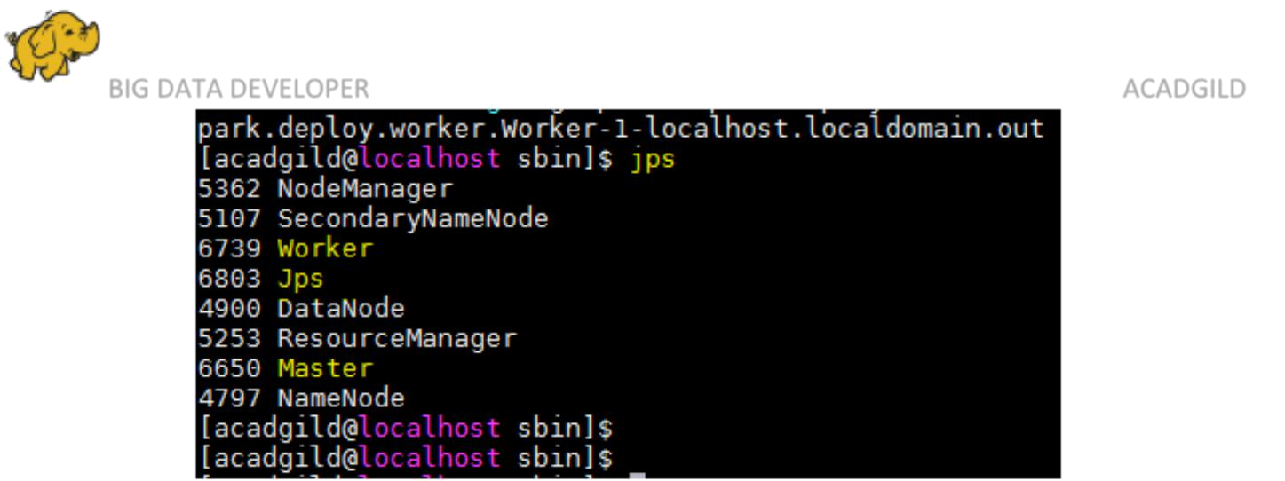
BIG DATA DEVELOPER ACADGILD

Now, the VM is ready for working in the Scala/spark shell.
