**Session 5**

**Assignment 5.1**

Student Name: Karthik K

Course: Big Data Hadoop & Spark Training

# Problem Statement

Create a Scala application to find the GCD of two numbers.

# Task: GCD of two numbers

Before going to create a SCALA application, we will just see the overview of GCD formula.

Greatest Common Divisor (GCD) of two or more integers, which are not all zero, is the largest positive integer that divides each of the integers.

For example, the **gcd** of **8 and 12 is 4.**

## Scala Application using IntelliJ

In the below scala code, we are going to find the gcd of the two numbers 12 and 8.

**package** Assignmane_13_1 *//package which we created*  
  
**object** GCD *//a new object GCD is created*  
{  
 **def** gcd(a: Int,b: Int): Int = { *// declaring a function gcd*  
 **if**(b == 0) a **else** *gcd*(b, a%b) *2 integer variables a,b*  
 }  
 **def** main(args: Array[String]) // Our main function takes in a named

{ parameter args which is an Array of String.  
 *println*(*gcd*(12,8)) // print the result  
 }  
}

## Required Output

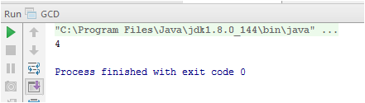

Screen Shot

