**Session 5**

**Assignment 5.2**

Student Name: Karthik K

Course: Big Data Hadoop & Spark Training

# Problem Statement

A Fibonacci series (starting from 1) written in order without any spaces in between, thus producing a sequence of digits.

Write a Scala application to find the nth digit in the sequence.

* Write the function using standard for loop
* Write the function using recursion

Before going in to the tasks, we will just see an over view that what is he Fibonacci number,

# The Fibonacci sequence is the series of numbers,

0, 1, 1, 2, 3, 5, 8, 13, 21, 34, ...

The next number is found by adding up the two numbers before it.

The 2 is found by adding the two numbers before it (1+1)

The 3 is found by adding the two numbers before it (1+2),

And the 5 is (2+3),

And so on!

Example: the next number in the sequence above is 21+34 = 55

|  |  |  |  |  |  |  |  |  |  |  |  |  |  |  |  |  |
| --- | --- | --- | --- | --- | --- | --- | --- | --- | --- | --- | --- | --- | --- | --- | --- | --- |
| n = | 0 | 1 | 2 | 3 | 4 | 5 | 6 | 7 | 8 | 9 | 10 | 11 | 12 | 13 | 14 | 15 |
| xn = | 0 | 1 | 2 | 3 | 5 | 8 | 13 | 21 | 34 | 55 | 89 | 144 | 233 | 377 | 610 | 987 |

Formula,

**xn = xn-1 + xn-2**

Example,

The 8th term is the 7th term plus the 6th term: X8 = X7+X6

From the above table,

The 8th term is 21, hence the 7th term 21+the 6th term 13 = 34.

# Task 1: write function using standard for loop

## Scala code

**package** Assignment13_2  
  
**object** fibseries  
{  
 **def** main(args: Array[String]): Unit ={  
  
 *println*(**"Enter a number: "**)  
 **var** num:Int = scala.io.StdIn.readLine().toInt  
  
 **var** n1=0  
 **var** n2=1  
  
 **var** a: Int=0;  
 **var** b: Int=0;  
  
 *println*(**"Standard For loop"**)  
 **for**(a <-1 to num){  
 **val** sumOfPrevTwo = n1+n2  
 n1=n2  
 n2 = sumOfPrevTwo  
 }  
 *println*(num +**"nth digit in the sequence is:"** +n2)  
 }  
}

Screen Shot:

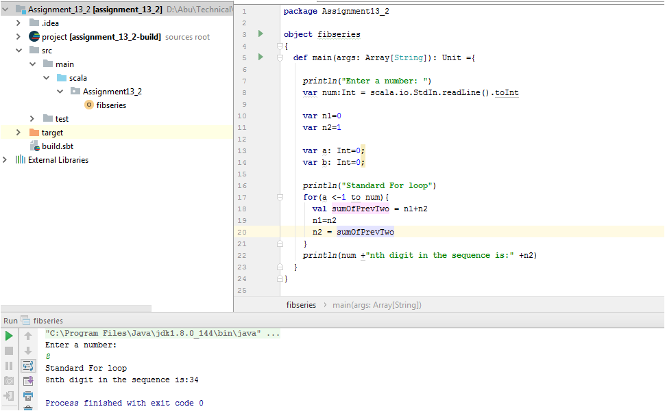

## Output

When we provide number 8 as input, the 8th digit in the Fibonacci sequence is 34.

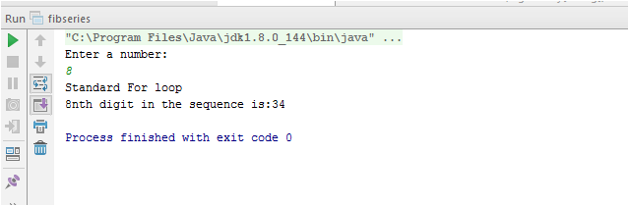

If we give the input as 10, the 10th digit of Fibonacci sequence is 89

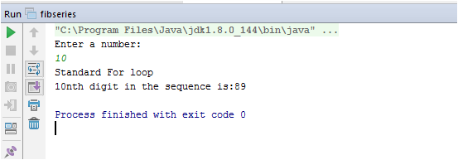

# Task2 - Write the function using recursion

## Scala code

**object** fibseriesrecursion  
{  
 **def** main(args: Array[String]): Unit ={  
  
 *println*(**"Enter a number: "**)  
 **var** num:Int = scala.io.StdIn.readLine().toInt  
 *println*(**"Using Recursion"**)  
 *println*(num + **"nth digit in the sequence is: "** +fib(num))  
  
 **def** fib(n:Int): Int =  
 **if** (n<2)  
 1  
 **else** fib(n-1+fib(n-2))  
 }  
}

Screen shot:

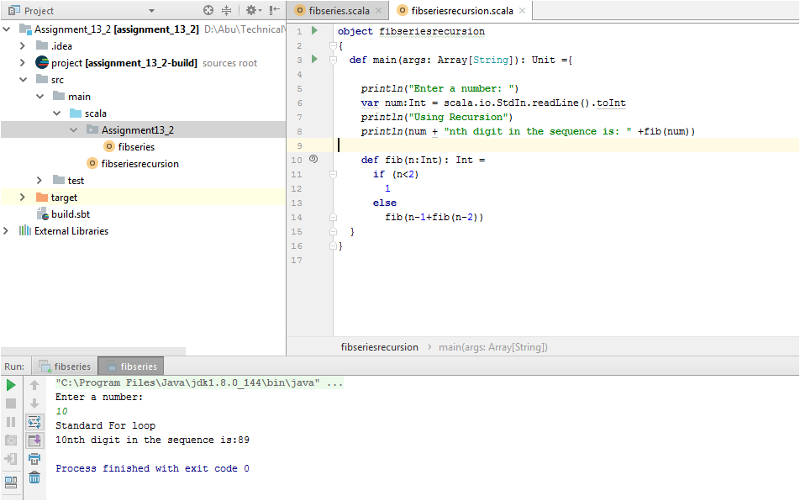

## Output

