**Session 5**

**Assignment 5.6**

Student Name: Karthik K

Course: Big Data Hadoop & Spark Training

Task 1

Write a **partial function** to add three numbers in which one number is constant and two numbers can be passed as inputs and define another method which can take the partial function as input and squares the result.

What is Partial Function?

A **partial function** is a function that does not provide an answer for every possible input value it can be given. It provides an answer only for a subset of possible data, and defines the data it can handle. In Scala, a **partial function** can also be queried to determine if it can handle a particular value

Scala Code

**package** Assignment15_2



**class** PartialClass



{



**def** squareFunc(x: Int): Unit ={



*println*(**"Squares = "**+ x*x) *// defined a function to square the input's*

**

}



**def** addition(x: Int,y: Int, z:Int)=x+y+z*//a function to add* ***constant+value1+value2* val** add =addition(**5**,_:Int,_:Int)*// the constant value = 5*

**

**def** partialFunc(a: Int, b: Int): Unit ={*// another method to define a value for**constant*

**

*println*(**"Addition = "**+add(a,b))



squareFunc(add(a,b))



}

}



**object** partialFunctionObj{*// singleton object to call the functions* **def** main(args:Array[String]): Unit ={



*println*(**"Enter the value of the numbers: "**)



**var** a:Int = scala.io.StdIn.readLine().toInt*// reading the input value* **var** b:Int = scala.io.StdIn.readLine().toInt **new** PartialClass().partialFunc(a,b)*//*

**

}



}



Here the constant is x and we defined the value of **x as 5**, we have two variables a and b, we pass **a=y=5** and **b=z=5**, we get the **x+y+z** = **5+5+5 = 15**.

15 is the output of the partial function is squared **15*15** in the **squareFunc** which is **225**.

Output

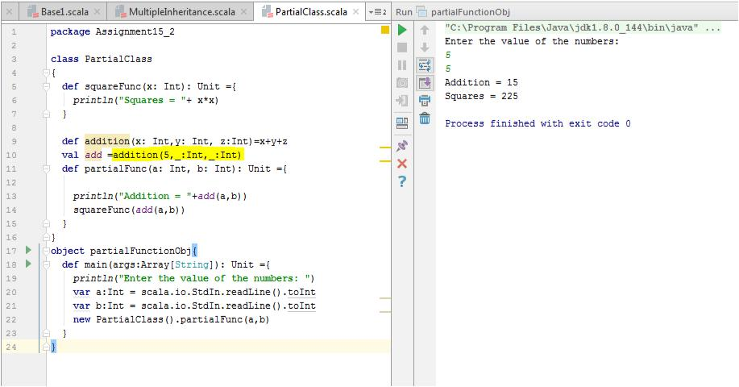

Task2

Write a program to print the prices of 4 courses of Acadgild: Android-12999, Big Data Development-17999, Big Data Development-17999, Spark-19999 using **match and add** a default condition if the user enters any other course.

Scala Code

**package** Assignment15_2



**object** patternmatch



{



**def** result(x:String):String= x **match**



{



**case "Android"** => (**"Android course price is 12999/-"**)



**case "Big Data Development"** => (**"Big Data Development price is 17999/-"**)



**case "Big Data Development"** => (**"Big Data Development price is 17999/-"**)



**case "Spark"** => (**"Spark prices is 19999/-"**)



**case** _=> (**"This course is not available"**)



}



**def** main(args: Array[String]): Unit =



{



*print*(*result*(**"Big Data Development"**))



}



}



Output

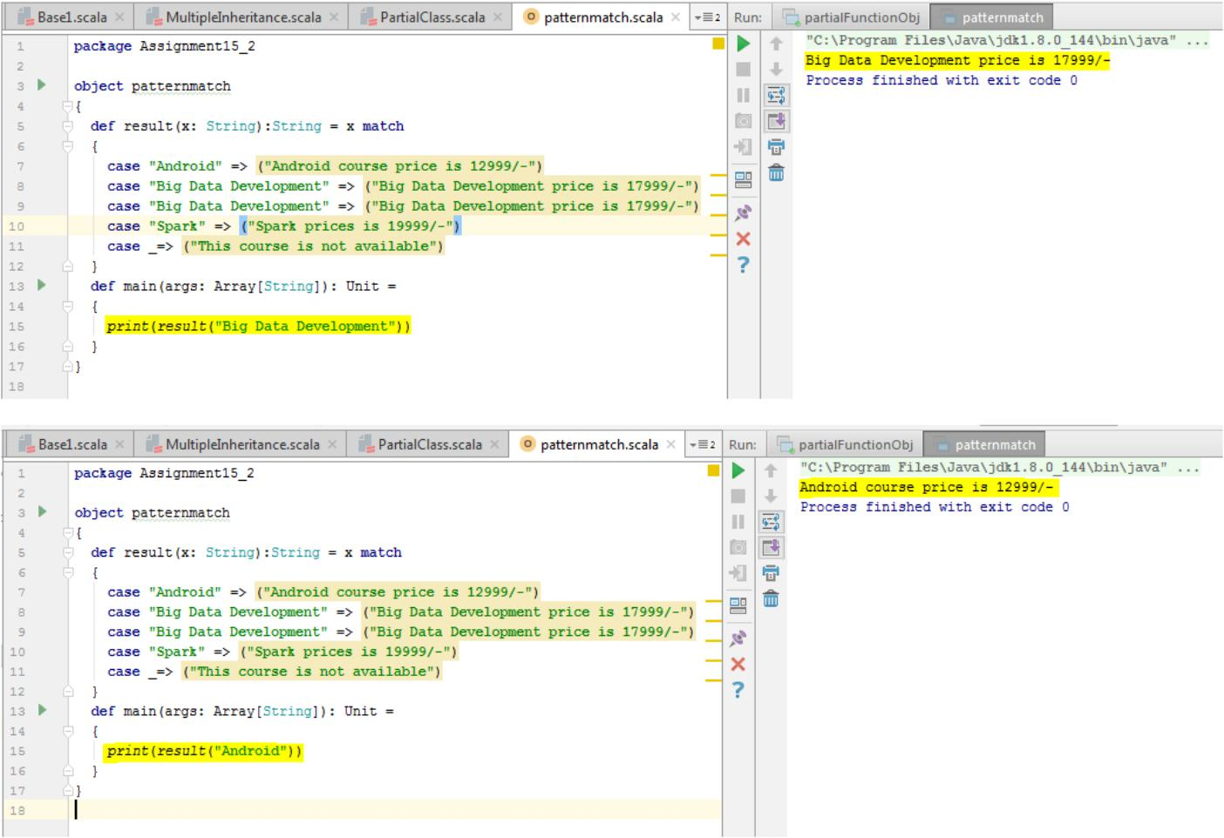

When we provide any other course, example Core Java we will get the default value as result like below.

