**Session 6**

**Assignment 6.1**

Student Name: Karthik K

Course: Big Data Hadoop & Spark Training

Problem Statement

1. Given a list of numbers - List[Int] (1, 2, 3, 4, 5, 6, 7, 8, 9, 10)
   * find the sum of all numbers
   * find the total elements in the list
   * calculate the average of the numbers in the list
   * find the sum of all the even numbers in the list
   * find the total number of elements in the list divisible by both 5 and 3.

# Task1 - Find the sum of all numbers

***val nums = sc.parallelize(List(1, 2, 3, 4, 5, 6, 7, 8, 9, 10))***

***val sum=nums.sum()***



# Task2 - find the total elements in the list

***val count = nums.count()***



# Task3 - calculate the average of the numbers in the list

***val average=nums.mean()***



# Task4 - find the sum of all the even numbers in the list

***val even=nums.filter(i=>(i%2==0))***



***val sum_even=even.sum()***



# Task5 - find the total number of elements in the list divisible by both 5 and 3.

***val divisible = nums.filter(i=>(i%3==0) || (i%5==0)) divisible.count()***

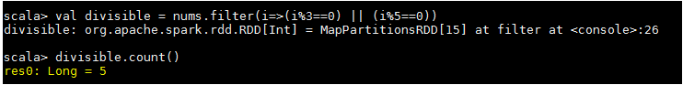

***divisible.foreach(println)***

