**Session 6**

**Assignment 6.3**

Student Name: Karthik K

Course: Big Data Hadoop & Spark Training

Problem Statement

1. Write a program to read a text file and print the number of rows of data in the document.
2. Write a program to read a text file and print the number of words in the document.
3. We have a document where the word separator is -, instead of space. Write a spark code, to obtain the count of the total number of words present in the document.

Task1 - Write a program to read a text file and print the number of rows of data in the document.

In this task, we are using a text file **“television.txt”** which has **72** rows as shown below

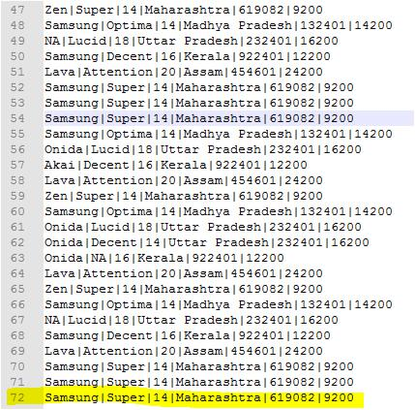

**Spark Operation**

Read the text file,

***scala> val rows= sc.textFile("/home/acadgild/hadoop/television.txt")***

***scala> rows.count()***

***res0: Long = 72***



Task2 - Write a program to read a text file and print the number of words in the document.

In this task, we are using a text file “***Spark_numberofwords.txt”*** which we created and it has number of words as 83, please see below,

***cat Spark_numberofwords.txt***

***wc -w Spark_numberofwords.txt***

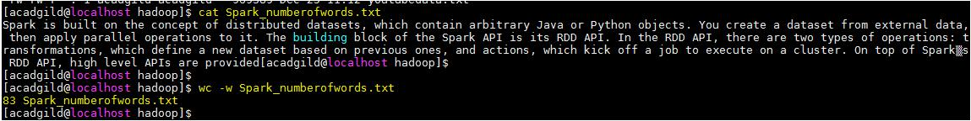

**Spark Operation**

Read the text file,

***scala> val base = sc.textFile("/home/acadgild/hadoop/Spark_numberofwords.txt")***

***scala> val words = base.flatMap(word=> word.split(" "))***

***scala> words.count()***

***res5: Long = 83***

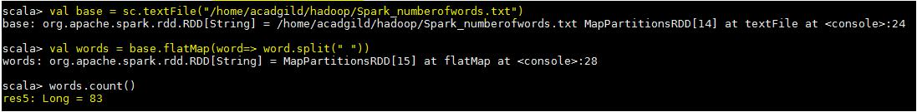

Task3 - We have a document where the word separator is -, instead of space. Write a spark code, to obtain the count of the total number of words present in the document.

The same file “***Spark_numberofwords.txt”*** has been modified by placing **“-“between** the words, please see below.

***scala> val base1 = sc.textFile("/home/acadgild/hadoop/Spark_numberofwords.txt")***

***scala> val words = base1.flatMap(word=> word.split("-"))***

***scala> words.count()***

***res12: Long = 83***

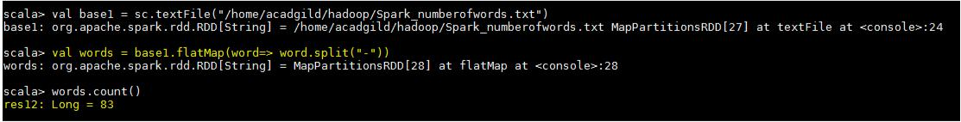

***words.collect()***

