**Session 6**

**Assignment 6.7**

Student Name: Karthik K

Course: Big Data Hadoop & Spark Training

Problem Statement

1. Considering age groups of **< 20 , 20-35, 35 >** ,Which age group spends the most Amount of money travelling.
2. What is the amount spent by each age-group, every year in travelling?

Before that, we are loading the dataset into the spark context,

1. ***val baseRDD1 = sc.textFile("/home/acadgild/hadoop/S18_Dataset_Holidays.txt")***
2. ***val baseRDD2 = sc.textFile("/home/acadgild/hadoop/S18_Dataset_Transport.txt")***
3. ***val baseRDD3 = sc.textFile("/home/acadgild/hadoop/S18_Dataset_User_details.txt")***

Importing the singleton object for controlling the storage of an RDD,

1. ***import org.apache.spark.storage.StorageLevel***
2. ***baseRDD1.persist(StorageLevel.MEMORY_ONLY)***
3. ***baseRDD2.persist(StorageLevel.MEMORY_ONLY)***
4. ***baseRDD3.persist(StorageLevel.MEMORY_ONLY)***

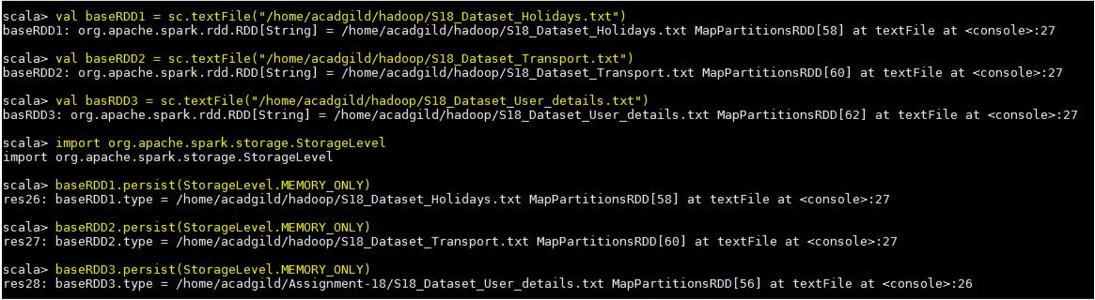

The given dataset’s have been loaded and we are creating the tuple RDD columns wise in the spark context,

We are loading the dataset’s in the name of **holidays**, **transport** and user **RDD’s**.

Task -1 - Considering age groups of < 20, 20-35, 35 >, which age group spends the most amount of money travelling.

In Order to considering particular age groups, we are using a below if, else logic to define a RDD **AgeMap** which gives you a set of age groups,

***val AgeMap = user.map(x=>x._1->***

***| {***

***| if(x._3<20)***

***| "20"***

***| else if(x._3>35)***

***| "35"***

***| else "20-35"***

***| })***

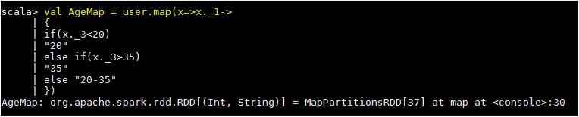

1. **val userMap = holidays.map(x => x._4 -> (x._1,x._5))**
2. **val transportmap = transport.map(x=> x._1 -> x._2)**
3. **val joinCost = userMap.join(transportmap)**
4. **val calCost = joinCost.map(x => x._2._1._1 -> x._2._1._2 * x._2._2)**
5. **val groupCost = calCost.groupByKey().map(x => x._1 -> x._2.sum)**
6. **val groupAgeCost = AgeMap.join(groupCost).map(x => x._2._1 -> x._2._2)**
7. **val finalCost = groupAgeCost.groupByKey().map(x => x._1 -> x._2.sum)**
8. **val maxVal = finalCost.sortBy(x => -x._2).first()**

**Step-1-** we are mapping the travel mode, user ID & the distance from the **holidays** RDD.

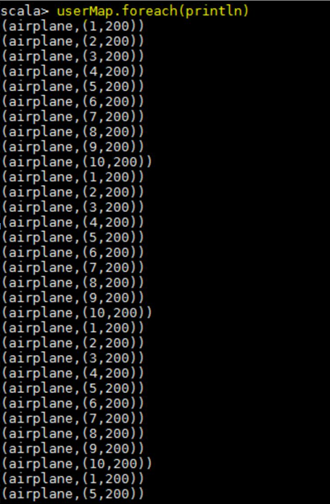

**Step -2 –** the new RDD has been created **transportmap** and the screen shot shown below,

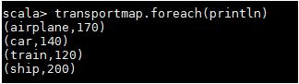

**Step -3 –** we are joining the 2 RDD’s we created in the step 1 and the step 2.

**Step -4 –** we are multiplying the distance and the total cost and making the **userID** as key and themultiplied value as value

**Step -5 –** the multiplied values are summed for each user ID.

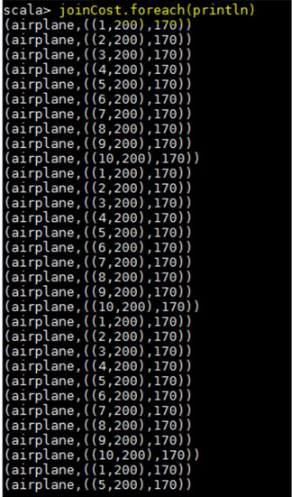

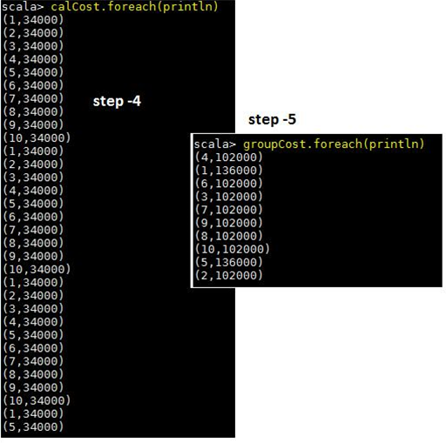

**Step – 6 –** we have joined the AgeMap RDD with the RDD created in the previous step. Now, the age groupwill be taken from the AgeMap RDD and grouped according to the ages using the user ID. **Step** **–** **7** **–** the Value is grouped based on the age group.

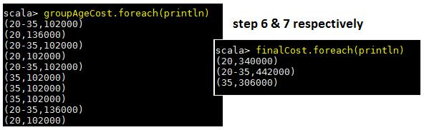

**Step-8 – at** this step, we achieved the required result by using the function first() by sorting the data inthe previous step.

**Expected output**



Task -2 - What is the amount spent by each age-group, every year in travelling?

The codes used,

1. **val UserHolidays = holidays.map(x => x._4 -> (x._1,x._5,x._6))**
2. **val usertransport = transport.map(x=>x._1->x._2)**
3. **val join1 = UserHolidays.join(usertransport)**
4. **val cost_dist_amt = join1.map(x=>x._2._1._1->(x._2._1._3,x._2._1._2*x._2._2))**
5. **val join2 = AgeMap.join(cost_dist_amt).map(x=>(x._2._1,x._2._2._1)->x._2._2._2)**
6. **val ExpEachAgeGroup = join2.groupByKey().map(x=>x._1->x._2.sum)**

**Step -1** –we are creating a tuple RDD where travel mode as Key, userID,distance & year as value bymapping the **holidays** RDD.

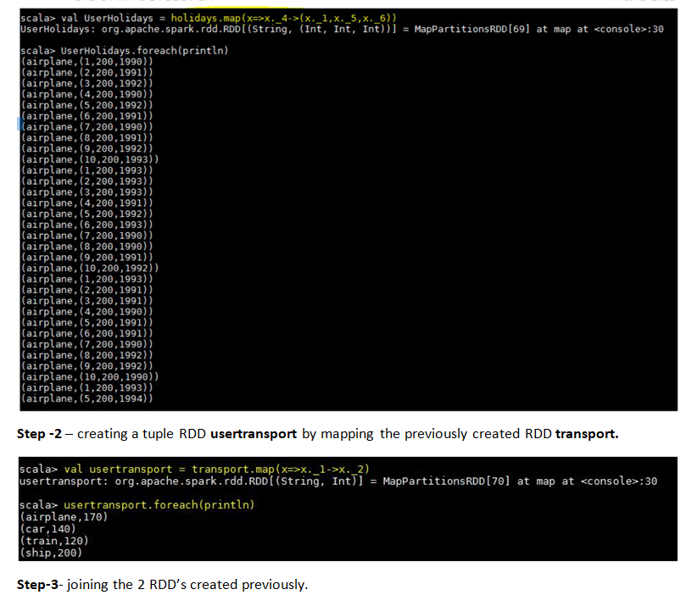

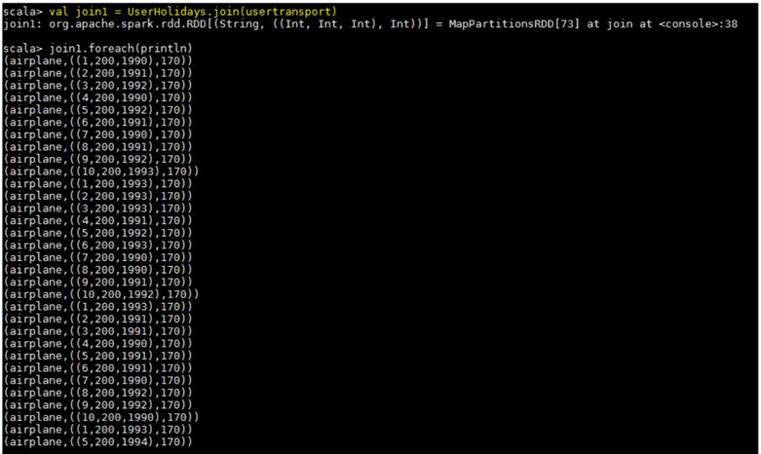

**Step -4** –In this step, we are eliminating the travel mode and mapping the user ID with the year and themultiplied value of the distance and the cost.

**Step -5** –we are creating the **AgeMap** RDD using the if, else logic in order to categories the Age Group. ***val AgeMap = user.map(x=>x._1->***

***| {***

***| if(x._3<20)***

***| "20"***

***| else if(x._3>35)***

***| "35"***

***| else "20-35"***

***| })***

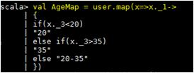

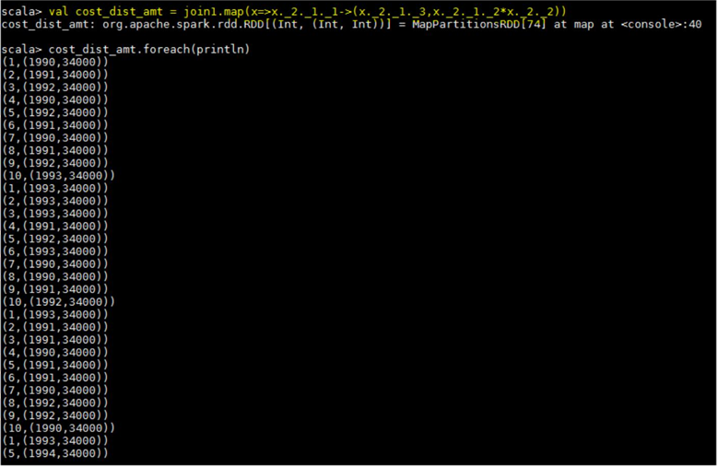

AgeMap output,

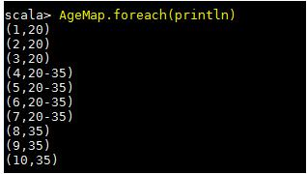

**Step – 6** –now we are joining the **AgeMap** & and the **cost_dist_amt** and mapping in such a way that weneed to get the **userID** gets its own age group categorization.

**Step -7** –in the step 7, we achieve the expected output by using the function **groupByKey** and summingthe value we have got in the previous steps year, age group wise.

