**Session 7**

**Assignment 7.5**

Student Name: Karthik K

Course: Big Data Hadoop & Spark Training

Problem Statement

Using spark-sql, Find:

1. What are the total number of gold medal winners every year
2. How many silver medals have been won by USA in each sport

**xSpark** SQL is a Spark module for structured data processing. A **DataFrame** is a **Dataset** organized intonamed columns. It is conceptually equivalent to a table in a relational database or a data frame in R/Python. **DataFrames** can be constructed from a wide array of sources such as: structured data files, tables in Hive, external databases, or existing RDDs.

A row in **DataFrame** is represented by Row object. Row can be used to create a row object by using named arguments, the fields will be sorted by names.

The fields in it can be accessed like attributes.

In 2.0, SparkSession is the entry point for creation of DataFrames.

Task – 1 - What are the total number of gold medal winners every year

Please see the codes used below,

1. ***val SportsData = sc.textFile("/home/acadgild/hadoop/Sports_data.txt")***
2. ***val schemaString =***

***"firstname:string,lastname:string,sports:string,medal_type:string,age:string,year:string,count ry:string"***

1. ***val schema = StructType(schemaString.split(",").map(x => StructField(x.split(":")(0),if(x.split(":")(1).equals("string"))StringType else IntegerType, true)))***
2. ***val rowRDD = SportsData.map(_.split(",")).map(r => Row(r(0), r(1), r(2), r(3), r(4), r(5), r(6)))***
3. ***val SportsDataDF = spark.createDataFrame(rowRDD, schema)***
4. ***SportsDataDF.createOrReplaceTempView("SportsData")***
5. ***val resultDF = spark.sql("SELECT year,COUNT (*) FROM SportsData WHERE medal_type = 'gold' GROUP BY year")***
6. ***resultDF.show()***

We will proceed with the tasks,

In order to proceed we need to import some dependencies as shown below,



***import org.apache.spark.sql.Row;***



***import***

***org.apache.spark.sql.types.{StructType,StructField,StringType,NumericType,IntegerType};***

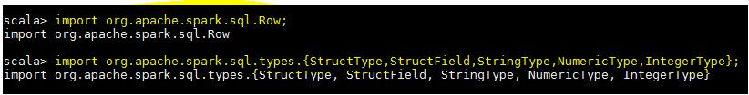

**Step -1** –we are creating a RDD from Input DataSet,

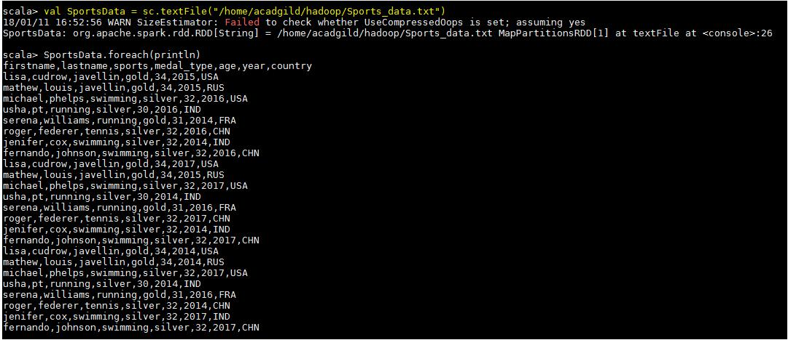

**Step -2** –we are defining a schema since it is a text file and splitting the input file using the delimiters andextracting the rows from it.

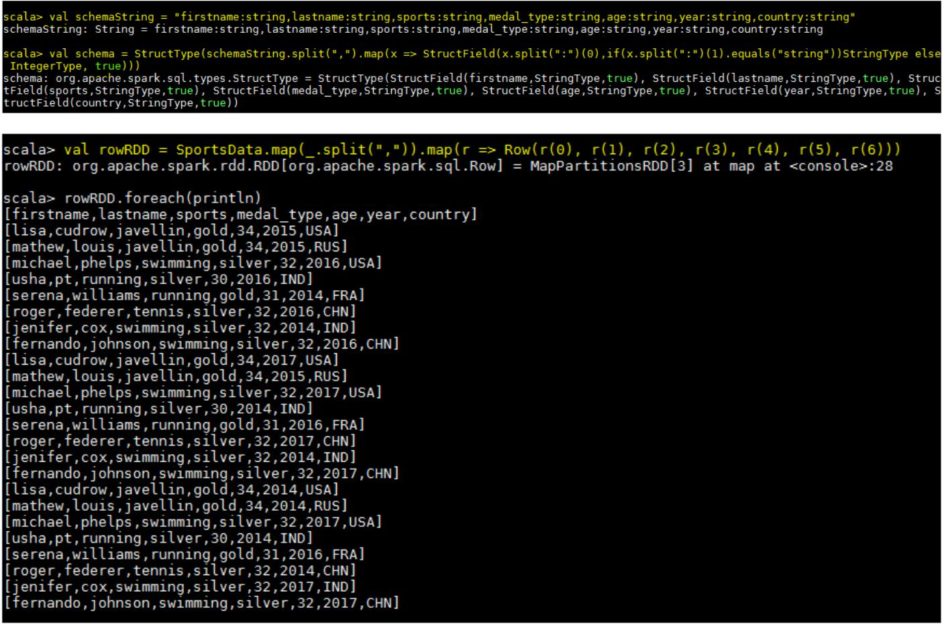

We have created the **dataframe** by passing the RDD which reads the file and schema to spark session object-

The schema of the created **Dataframe** can be seen below.

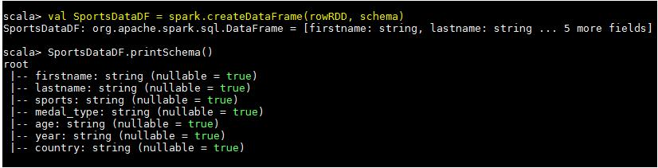

Expected Result

Now, we are using the simple SQL query so that we can execute our query by applying it on the temporary table created,

