Problem statement:

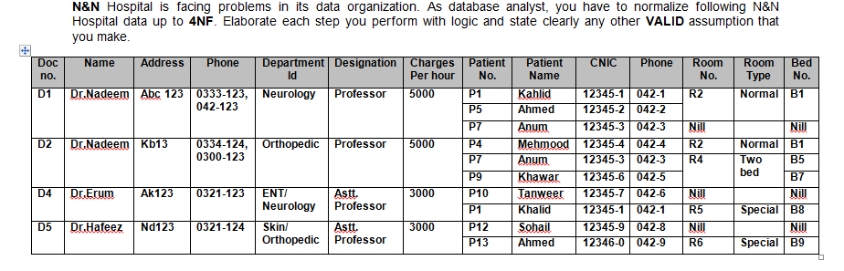

After 1NF:

The table will be in 1NF, if the table obeys following conditions:

1. Each column should be single valued attribute. i.e Multi-valued attributes shouldn’t be present.
2. Each entries of the column should be of same data-type.

|  |  |  |  |  |  |  |  |
| --- | --- | --- | --- | --- | --- | --- | --- |
| Doc No | Patient No | Patient name | CNIC | Phone | Room No | Room Type | Bed No. |
| D1 | P1 | Kahid | 12345-1 | 042-1 | R2 | Normal | B1 |
| D1 | P5 | Ahmed | 12345-2 | 042-2 | R2 | Normal | B1 |
| D1 | P7 | Anum | 12345-3 | 042-3 | Nil |  | Nil |
| D2 | P4 | Mehmood | 12345-4 | 042-4 | R2 | Normal | B1 |
| D2 | P7 | Anum | 12345-3 | 042-3 | R4 | Two bed | B5 |
| D2 | P9 | Khawar | 12345-6 | 042-5 | R4 | Two bed | B7 |
| D4 | P10 | Tanweer | 12345-7 | 042-6 | Nil |  | Nil |
| D4 | P1 | Khalid | 12345-1 | 042-1 | R5 | Special | B8 |
| D5 | P12 | Sohail | 12345-9 | 042-8 | Nil |  | Nil |
| D5 | P13 | Ahmed | 12346-0 | 042-9 | R6 | Special | B9 |

Table T1

|  |  |
| --- | --- |
| Doc No. | Phone No |
| D1 | 0333-123 |
| D1 | 042-123 |
| D2 | 0334-124 |
| D2 | 0300-123 |
| D4 | 0321-123 |
| D5 | 0321-124 |

Table T2

|  |  |
| --- | --- |
| Doc No | Department Id |
| D1 | Neurology |
| D2 | Orthopedic |
| D4 | ENT |
| D4 | Neurology |
| D5 | Skin |
| D5 | Orthopedic |

Table T3

|  |  |  |  |  |
| --- | --- | --- | --- | --- |
| Doc No. | Name | Address | Designation | Charges |
| D1 | Dr.Nadeem | Abc 123 | Professor | 5000 |
| D2 | Dr.Nadeem | Kb13 | Professor | 5000 |
| D4 | Dr.Erum | Ak123 | Asst.Professor | 3000 |
| D5 | Dr.Hafeez | Nd123 | Asst.Professor | 3000 |

Table T4

After 2NF:

The table will be in 2NF when:

1. The table should be in 1NF
2. There shouldn’t be any partial dependency.

Dependency in Table T1 are:

Patient No->Patient Name CNIC, PhoneNo.

DocNo, Patient No->RoomNo.

RoomNo->RoomType, BedNo.

Dependency in Table T4 are:

DocNo->Name, Address, Designation, Charges

Resolving T1 into T5 and T6

|  |  |  |  |
| --- | --- | --- | --- |
| Patient No | Patient name | CNIC | Phone |
| P1 | Kahid | 12345-1 | 042-1 |
| P5 | Ahmed | 12345-2 | 042-2 |
| P7 | Anum | 12345-3 | 042-3 |
| P4 | Mehmood | 12345-4 | 042-4 |
| P7 | Anum | 12345-3 | 042-3 |
| P9 | Khawar | 12345-6 | 042-5 |
| P10 | Tanweer | 12345-7 | 042-6 |
| P1 | Khalid | 12345-1 | 042-1 |
| P12 | Sohail | 12345-9 | 042-8 |
| P13 | Ahmed | 12346-0 | 042-9 |

Table T5

|  |  |  |  |  |
| --- | --- | --- | --- | --- |
| Doc No | Patient No | Room No | Room Type | Bed No. |
| D1 | P1 | R2 | Normal | B1 |
| D1 | P5 | R2 | Normal | B1 |
| D1 | P7 | Nil |  | Nil |
| D2 | P4 | R2 | Normal | B1 |
| D2 | P7 | R4 | Two bed | B5 |
| D2 | P9 | R4 | Two bed | B7 |
| D4 | P10 | Nil |  | Nil |
| D4 | P1 | R5 | Special | B8 |
| D5 | P12 | Nil |  | Nil |
| D5 | P13 | R6 | Special | B9 |

Table T6

After 3NF:

The table will be in 3NF when:

1. Table should be in 2NF
2. There shouldn’t be any transitive dependency.

Dependency in Table T6.

DocNo, Patient No->RoomNo.

RoomNo->RoomType, BedNo.

|  |  |  |
| --- | --- | --- |
| Doc No | Patient No | Room No |
| D1 | P1 | R2 |
| D1 | P5 | R2 |
| D1 | P7 | Nil |
| D2 | P4 | R2 |
| D2 | P7 | R4 |
| D2 | P9 | R4 |
| D4 | P10 | Nil |
| D4 | P1 | R5 |
| D5 | P12 | Nil |
| D5 | P13 | R6 |

Table T7

|  |  |  |
| --- | --- | --- |
| Room No | Room Type | Bed No. |
| R2 | Normal | B1 |
| R2 | Normal | B1 |
| Nil |  | Nil |
| R2 | Normal | B1 |
| R4 | Two bed | B5 |
| R4 | Two bed | B7 |
| Nil |  | Nil |
| R5 | Special | B8 |
| Nil |  | Nil |
| R6 | Special | B9 |

Table T8

Resultant tables:

|  |  |
| --- | --- |
| Doc No. | Phone No |
| D1 | 0333-123 |
| D1 | 042-123 |
| D2 | 0334-124 |
| D2 | 0300-123 |
| D4 | 0321-123 |
| D5 | 0321-124 |

|  |  |
| --- | --- |
| Doc No | Department Id |
| D1 | Neurology |
| D2 | Orthopedic |
| D4 | ENT |
| D4 | Neurology |
| D5 | Skin |
| D5 | Orthopedic |

|  |  |  |  |  |
| --- | --- | --- | --- | --- |
| Doc No. | Name | Address | Designation | Charges |
| D1 | Dr.Nadeem | Abc 123 | Professor | 5000 |
| D2 | Dr.Nadeem | Kb13 | Professor | 5000 |
| D4 | Dr.Erum | Ak123 | Asst.Professor | 3000 |
| D5 | Dr.Hafeez | Nd123 | Asst.Professor | 3000 |

|  |  |  |
| --- | --- | --- |
| Doc No | Patient No | Room No |
| D1 | P1 | R2 |
| D1 | P5 | R2 |
| D1 | P7 | Nil |
| D2 | P4 | R2 |
| D2 | P7 | R4 |
| D2 | P9 | R4 |
| D4 | P10 | Nil |
| D4 | P1 | R5 |
| D5 | P12 | Nil |
| D5 | P13 | R6 |

|  |  |  |  |
| --- | --- | --- | --- |
| Patient No | Patient name | CNIC | Phone |
| P1 | Kahid | 12345-1 | 042-1 |
| P5 | Ahmed | 12345-2 | 042-2 |
| P7 | Anum | 12345-3 | 042-3 |
| P4 | Mehmood | 12345-4 | 042-4 |
| P7 | Anum | 12345-3 | 042-3 |
| P9 | Khawar | 12345-6 | 042-5 |
| P10 | Tanweer | 12345-7 | 042-6 |
| P1 | Khalid | 12345-1 | 042-1 |
| P12 | Sohail | 12345-9 | 042-8 |
| P13 | Ahmed | 12346-0 | 042-9 |

|  |  |  |
| --- | --- | --- |
| Room No | Room Type | Bed No. |
| R2 | Normal | B1 |
| R2 | Normal | B1 |
| Nil |  | Nil |
| R2 | Normal | B1 |
| R4 | Two bed | B5 |
| R4 | Two bed | B7 |
| Nil |  | Nil |
| R5 | Special | B8 |
| Nil |  | Nil |
| R6 | Special | B9 |