Queries

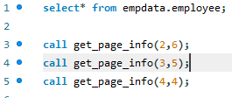

Pagination procedure

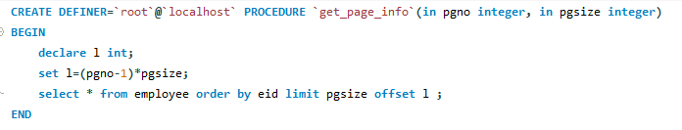

Select * from employee

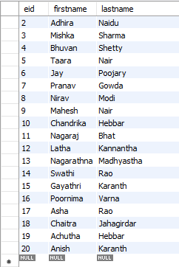

call get_page_info(2,6);

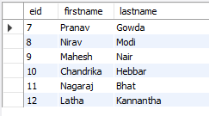

call get_page_info(4,4);

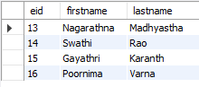

call get_page_info(3,5);

