Contents

**Cross Regional ${brandDescription} domains setup on UAT and UAT preview**  2

**ETC Map Configuration:** 3

**Creating Users for the dispatcher flush agents:** 3

**Adding the dispatcher flush agents:** 4

**SSL Configuration with self-signed certificates (informative):** 8

# **Cross Regional ${brandDescription} domains setup on UAT and UAT preview Dispatcher**

1. For adding Cross Regional ${brandDescription} sites to UAT and UAT preview, below files need to be added to the dispatcher configurations as detailed below.
2. Attached are the zip files with all relevant ${brandDescription} files that need to go in the conf.d and conf.dispatcher.d folders of UAT and UAT preview Dispatchers mentioned below.

* available_vhosts
* enabled_vhosts
* rewrites
* variables
* available_farms
* enabled_farms
* filters
* vhosts

**Dispatcher Config UAT file**: Dispatcher Config UAT ${brandLocale}.zip

**Dispatcher Config Preview file**: Dispatcher Config Preview ${brandLocale}.zip

1. For the document root folder of ${brandDescription} under /mnt/var/www/html/, create below folder in the table and change the ownership to apache in UAT and UAT preview Dispatchers.

For example, as mentioned below, commands in the table need to be executed:

*$mkdir /mnt/var/www/html/* *${folderName}*

*$chown apache:apache /mnt/var/www/html/* *${folderName}*

|  |  |  |  |  |
| --- | --- | --- | --- | --- |
| S.No. | Create Directory | Status | Permissions | Status |
| 1 | mkdir /mnt/var/www/html/${folderName} |  | chown apache:apache /mnt/var/www/html/${folderName} |  |

1. Restart apache and access the below domains:

UAT

|  |  |  |
| --- | --- | --- |
| S.No. | Domain | Status (Y/N) |
| 1 | ${uatUrl} |  |

UAT Preview

|  |  |  |
| --- | --- | --- |
| S.No. | Domain | Status (Y/N) |
| 1 | ${uatPreviewUrl} |  |

# **ETC Map Configuration:**

Please install the etc/map configuration package on UAT and UAT preview Dispatchers, as provided.

**UAT publisher package:** etc_map_${brand}_${country}.zip

**UAT Preview publisher package**: etc_map_${brand}_${country}_uatpreview.zip

# **Creating Users for the dispatcher flush agents:**

Please note that the screenshots could be used as reference for better understanding. They are been created in local AEM instances and do not depict the exact branch & site names.

These steps for flush user creation and permissions to be executed on UAT and UAT preview publisher.

1. Login to publisher useradmin and create below users with the provided name

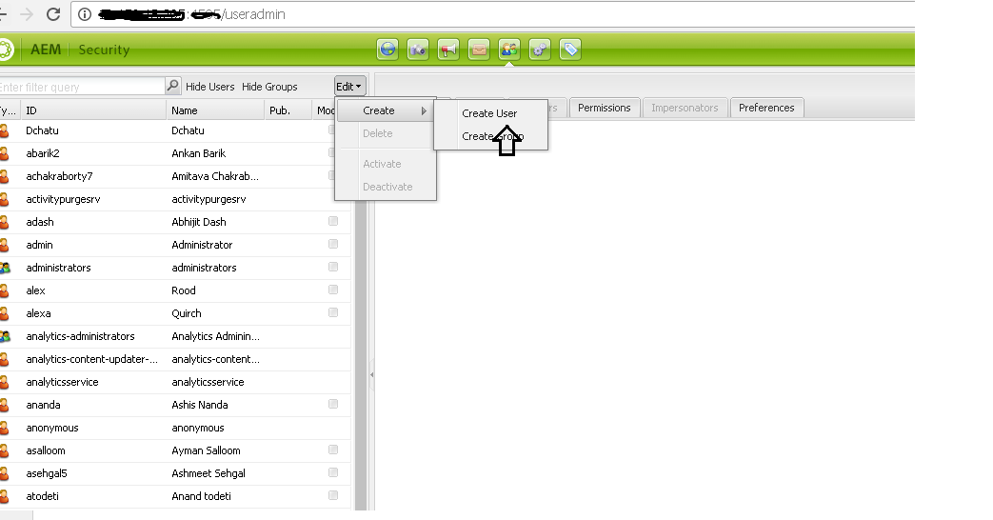

|  |  |  |
| --- | --- | --- |
| S.No. | Flush Users | Creation Status (Y/N) |
| 1 | ${brand}-${country}-flush |  |

1. Once the user is created, update the ACL of the user:
   1. Provide read access to the specified folder as mentioned below.

|  |  |  |  |
| --- | --- | --- | --- |
| **number** | **Flush User** | **Folder Path to provide Read permissions** | **Status (Y/N)** |
|  | ${brand}-${country}-flush-user | /content/cross-regional/${region}/${brand}/${locale} |  |
|  | ${brand}-${country}-flush-user | /content/dam/cross-regional/${region}/${brand}/${locale} |  |
|  | ${brand}-${country}-flush-user | /content/experience-fragments/cross-regional/${region}/${brand}/${locale} |  |
|  | ${brand}-${country}-flush-user | /content/dam/cross-regional/enhancedConfigurator/${brand}/${locale} |  |

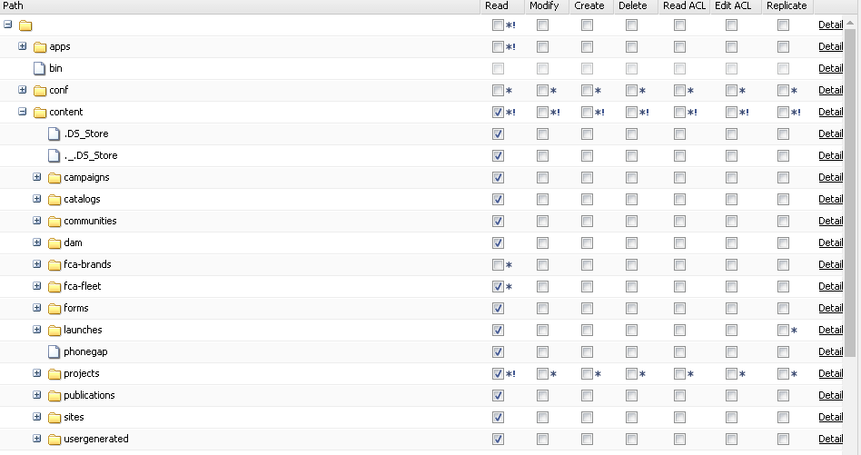

# **Adding the dispatcher flush agents:**

Install attached package for dispatcher flush agents in UAT publisher.

**Package name**: ${brand}_${country}_flush_uat.zip

Install attached package for dispatcher flush agents in UAT Preview publisher.

**Package name**: ${brand}_${country}_flush_uat-preview.zip

After installation, below properties need to be changed, and flush users need to be available with the specified read permissions before performing below steps?

Validation are needed for the below:

1. Serialization Type of the agent
2. Dispatcher IP in Transport tab
3. Host property in the Extended Tab
4. Enable the agent

For these validation, the steps are detailed in the below, along with the validation of the other properties.

1. Select the agent to modify the properties

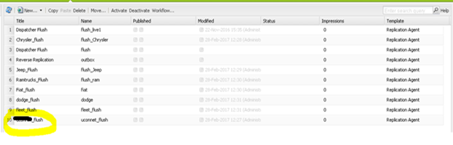

1. This opens a new tab and now click on edit which in turn will give a popup dialogue box.
2. Validate the properties. Change Serialization Type value and enable the agent.

|  |  |
| --- | --- |
| Property | Value |
| **Name** | **${brand}-${country}-flush** |
| Description | Agent that is triggered on modification and sends flush requests to the dispatcher. |
| Enabled | Tick |
| Serialization Type | Re-fetch Dispatcher Flush |
| Retry Delay | 60000 |
| **Agent user id:** | **${brand}-${country}-flush-user** |

**Note: Above highlighted values need to be as per the flush agent**

Flush agent and the user-id mapping:

|  |  |  |  |
| --- | --- | --- | --- |
| S.No. | **Name** | **Agent User Id** | Status |
| 1 | ${brand}-${country}-flush | ${brand}-${country}-flush-user |  |

1. Under the Transport tab of the agent settings, update the dispatcher IP according to the environment.

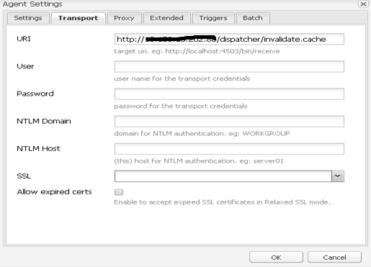

1. Under the extended tab, validate the values. Host value need to be according to the live publisher.

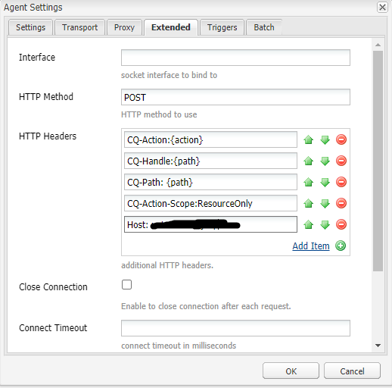

Host under the HTTP headers (last value) is the most important. Host value to be updated as per the agent name.

Below are Host values for the agent on UAT:

|  |  |  |  |
| --- | --- | --- | --- |
| S.No. | Flush Agent | **Host value (for the above)** | Status |
| 1 | ${brand}-${country}-flush-user | ${uatUrl} |  |

Below are Host values for the agent on UAT Preview:

|  |  |  |  |
| --- | --- | --- | --- |
| S.No. | Flush Agent | **Host value (for the above)** | Status |
| 1 | ${brand}-${country}-flush-user | ${uatPreviewUrl} |  |

1. Validate if the triggers for invalidation are according to the below. Update triggers if not matching. Click ok and save the changes.

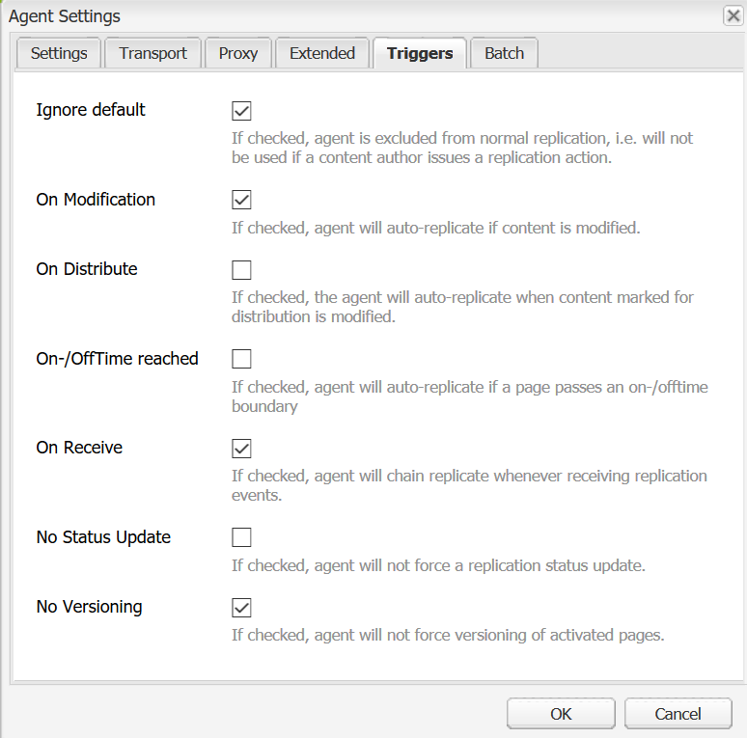

1. Test the connectivity by clicking on the Test connection and validate the setting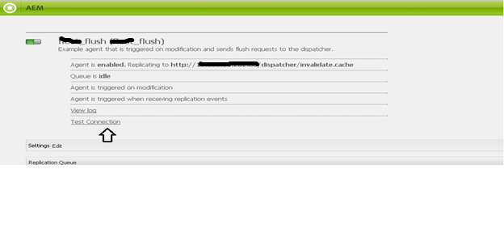

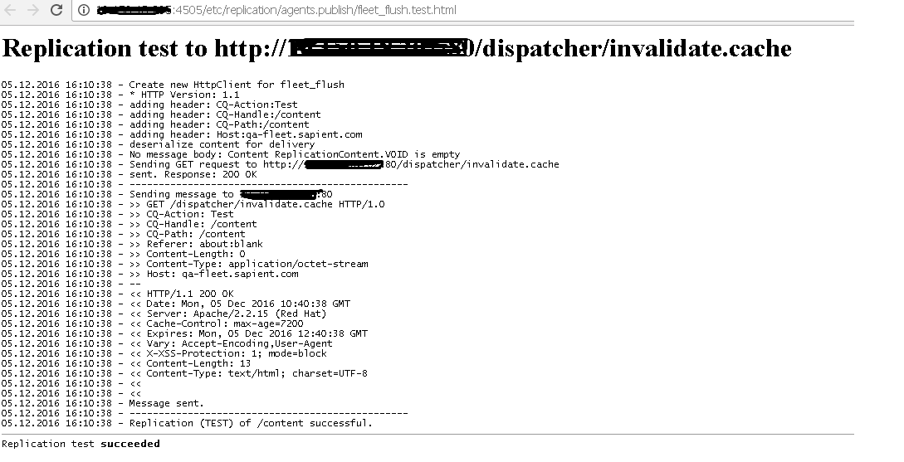

# **SSL Configuration with self-signed certificates (informative):**

All the domains would be setup on SSL instances.

Non-SSL domain to SSL domain redirects would be taken care through Akamai