Exercise -1

Step 1 — Configure Git
Git needs to know who you are.
Configure your username.
git config --global user.name "Grandhe Manikanta Sri Sai Kiran"
Configure your email.
git config --global user.email "your-email@gmail.com"
Example
git config --global user.email grandhemanikanta65@gmail.com

Verify Configuration
Run
git config --global --list
Output
user.name=Grandhe Manikanta
user.email=grandhemanikanta@gmail.com

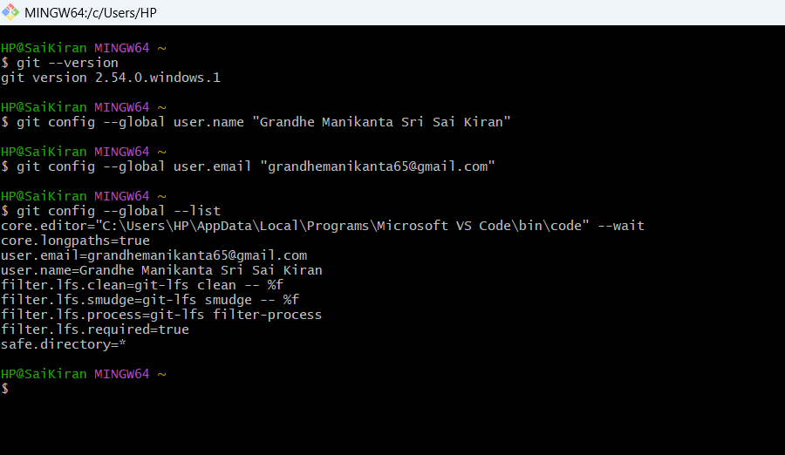

Step 2 — Install Notepad++
Download
https://notepad-plus-plus.org/downloads/
Install normally.

Step 3 — Add Notepad++ to Environment Variables
Open
Control Panel

↓

System

↓

Advanced System Settings

↓

Environment Variables
Under
User Variables
Edit
Path
Add
C:\Program Files\Notepad++\
Click
OK
Restart Git Bash.
This matches the lab instructions for adding Notepad++ to the PATH.

Step 4 — Verify Notepad++
Run
notepad++
If Notepad++ opens,
Everything is configured correctly.
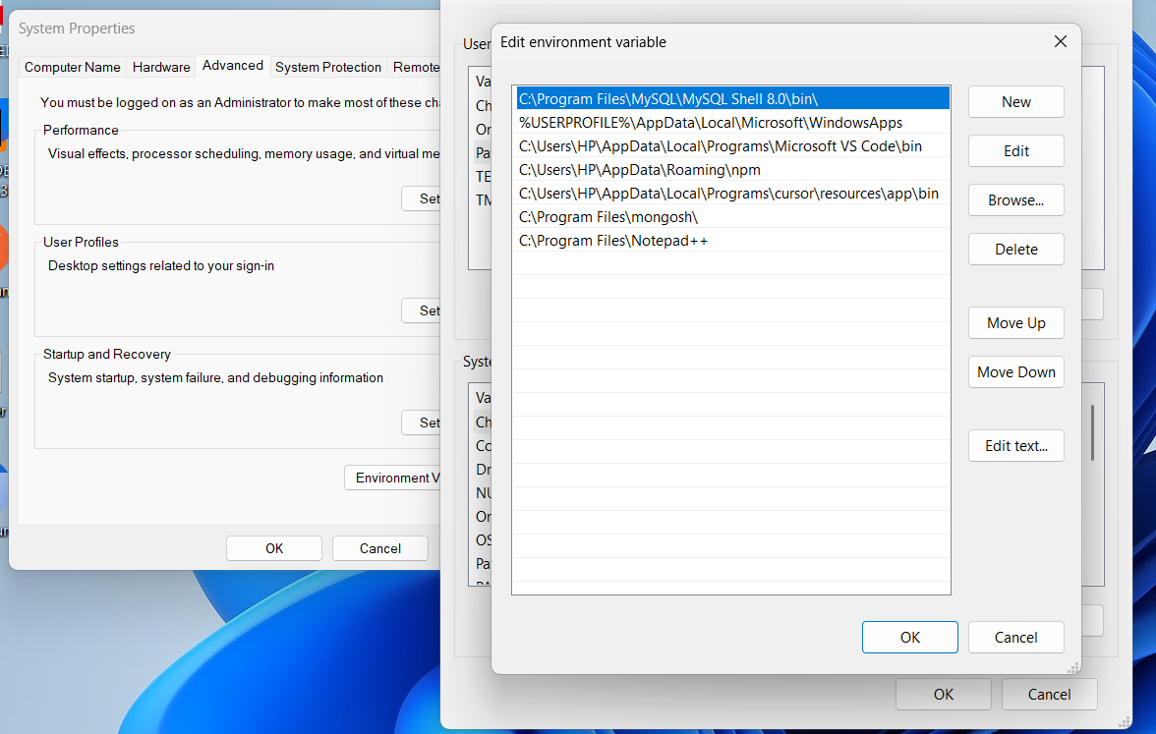

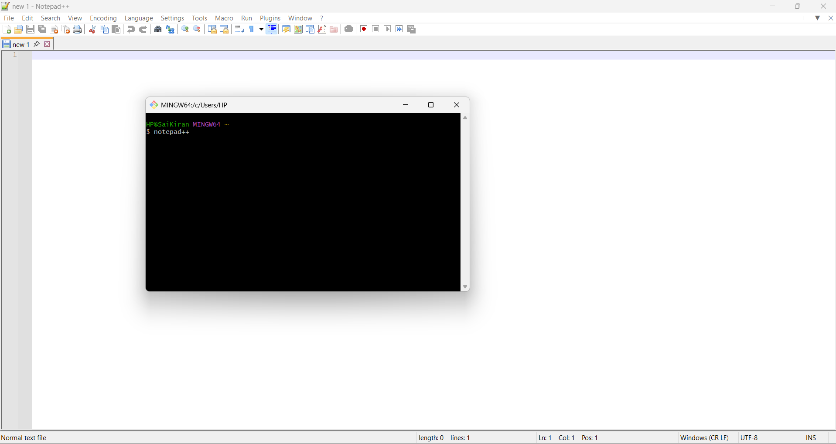

Step 6 — Configure Notepad++ as Git Default Editor
Run
git config --global core.editor "notepad++.exe -multiInst -nosession"
Now verify
git config --global -e
Git should open
.gitconfig
inside Notepad++.
You'll see
[user]
name = Grandhe Manikanta
email = your-email@gmail.com

[core]
editor = notepad++.exe -multiInst -nosession

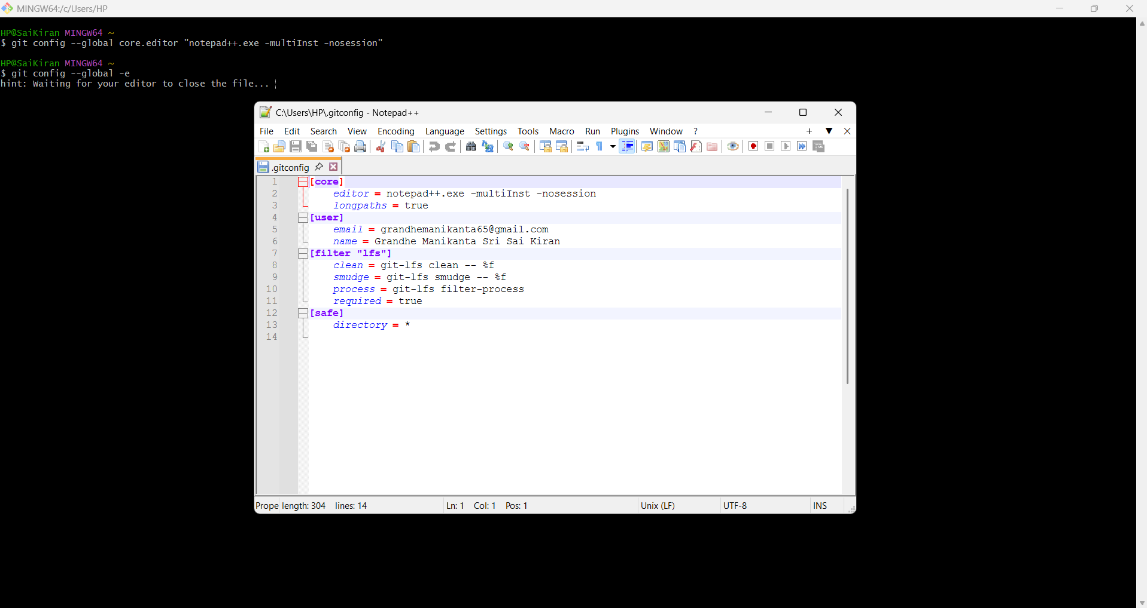

Git Initialisation

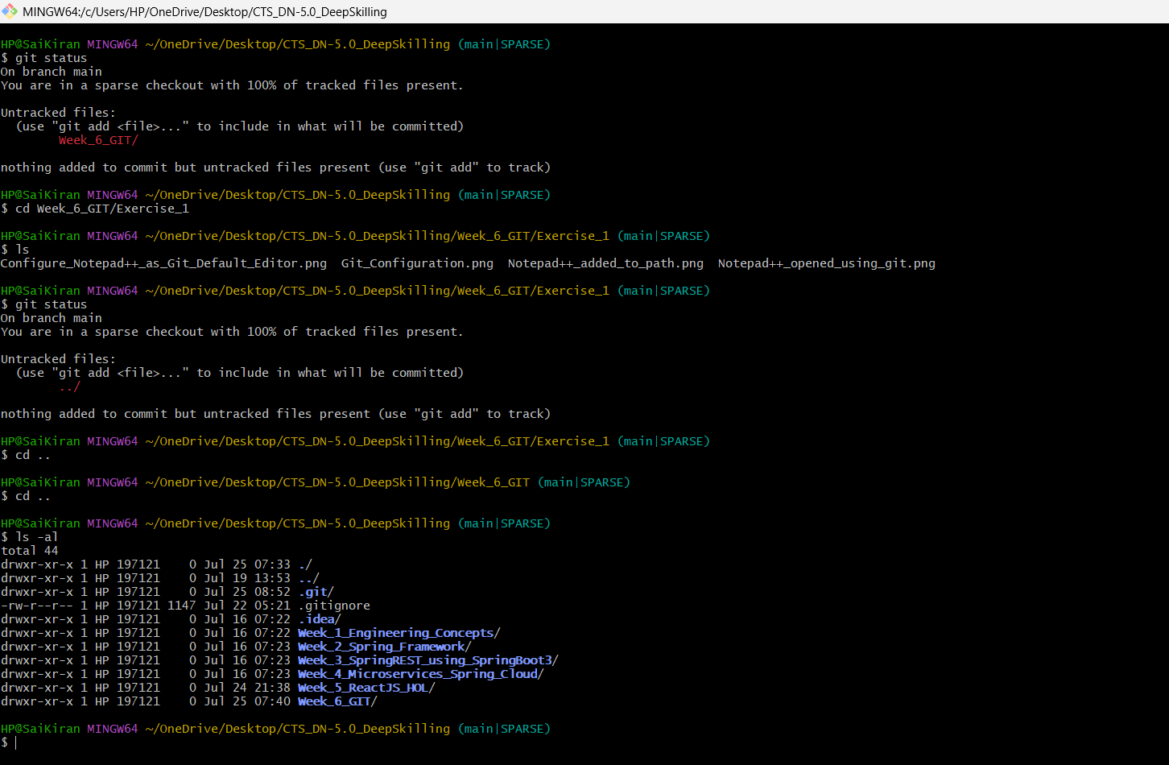

Step 7: Create welcome.txt
Run:
echo "Welcome to Version Control" > welcome.txt

Step 7: Verify the file
ls
You should now see:
Configure_Notepad++_as_Git_Default_Editor.png
Git_Configuration.png
Notepad++_added_to_path.png
Notepad++_opened_using_git.png
welcome.txt

Step 8: Check its contents
cat welcome.txt
Expected output:
Welcome to Version Control
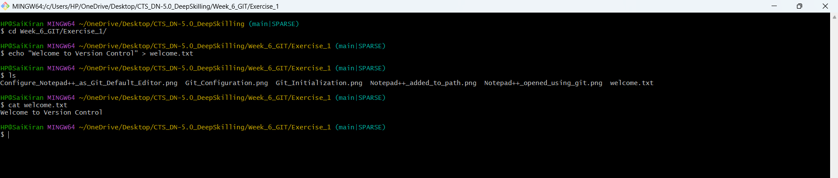

Step 9: Check Git status
Run:
git status
Now Git should detect welcome.txt.

Step 10: Stage everything inside Exercise_1
Since you're already inside Exercise_1, run:
git add .
This stages:
- welcome.txt
- all your screenshots (if they haven't already been tracked)

Step 11: Verify staging
Run:
git status
You should see:
Changes to be committed:

new file: Configure_Notepad++_as_Git_Default_Editor.png
new file: Git_Configuration.png
new file: Notepad++_added_to_path.png
new file: Notepad++_opened_using_git.png
new file: welcome.txt

Step 12: Commit
Since you're using VS Code as the Git editor, use the lab-style commit command:
git commit
VS Code should open the commit message file. Write something like:
Git Exercise 1

Configured Git user settings.
Configured VS Code as the default Git editor.
Created welcome.txt.
Added screenshots for Git configuration.
Save the file and close the editor.
Git will automatically create the commit.
If VS Code doesn't open, we can instead use:
git commit -m "Completed Git Exercise 1"

Step 13: Push to GitHub
git push origin main

Note
The original lab uses:
git add welcome.txt
because it only creates one file. Since you're maintaining a well-organized GitHub repository with screenshots and documentation, using:
git add .
inside Exercise_1 is perfectly appropriate—it stages all files in that folder without affecting the rest of your repository.
