NOISE CANCELLATION USING WINDOWING TECHNIQUE
by
Lekhya Tata
Karthik Govinda Raju

Motivation:
Many methods have been implemented for noise cancellation in audio signals. Mostly in software like MATLAB. Filters that are already in Verilog are confined to only small class of noise removal and no study proves that each method is completely efficient.

Tasks:
Project aim is to filter audio signal with noise in MATLAB and get the results. By taking MATLAB results as a reference, filter is designed in system verilog for the particular audio file with constrains that are used in MATLAB code. Compare both the results. To get faster results and reduce hardware mathematical computations in filter are improved. FFT, windowing and IFFT are used to filter noise signal.

Significance:
There is no formal study that shows which transforms method works better, that are employed in both speed and accuracy. The results of the design in this project are much cleaner than the MATLAB result

Table of Contents

1. Introduction 1
2. Noise 4
2.1. Hum 4
2.2. Rumble 5
2.4. Crackle 6
2.5. White noise 7
3. Filters 8
3.1. FIR filter 9
3.2. IIR filter 10
4. Windowing 11
4.1. Hann window 14
5. MATLAB 15
5.1. Generating plots 16
5.2. Initialization 17
6. System Verilog 27
7. Design 29
7.1. Test bench 30
7.2. Windowing 32
7.3. FFT 33
7.4. Comparing Design vs Simulation 44
8. Java Code for generating states of FFT and IFFT 47
9. References 54

FIGURES
Figure 1 Importance of ASIC projects [1] 1
Figure 2 Role of ASIC adoption in various industries [1] 1
Figure 3 Flow of the project 2
Figure 4 Flow of the project 3
Figure 5 Low frequency hum noise Hiss 4
Figure 6 Hiss noise plot 5
Figure 7 Rumble noise 6
Figure 8 Gramophone crackling noise 7
Figure 9 Plot showing white noise in an audio file 7

- Introduction
ASIC chips are leading in the industry of semiconductor technology because they are working at a quicker rate and as a result for better operation and task involving great technology, design is becoming more complex. It includes many challenges and trade-offs.


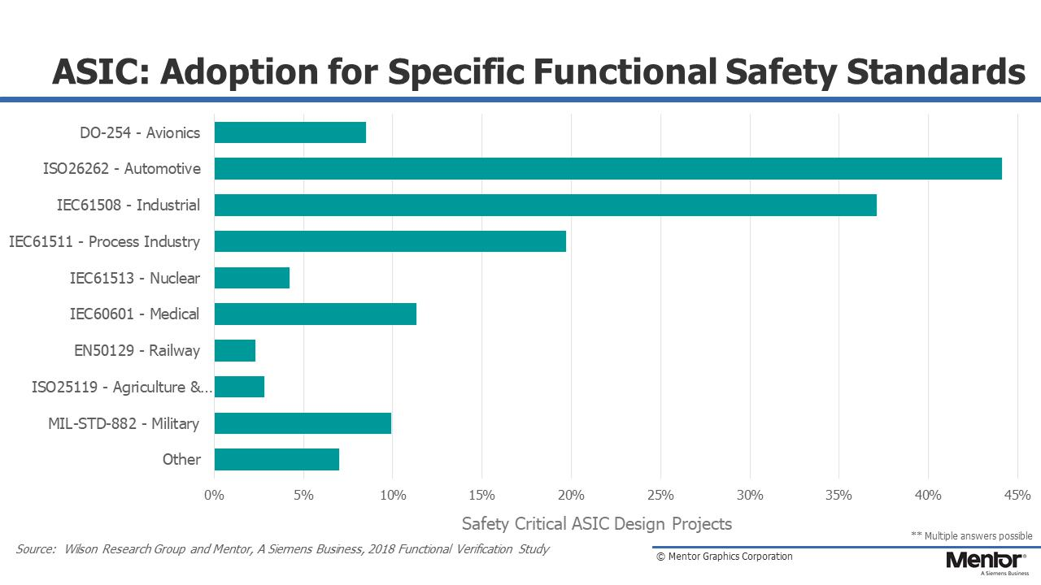
Figure 1 Importance of ASIC projects [1]

Figure 2 Role of ASIC adoption in various industries [1]
From the figure 2, it is clear, that ASIC is leading in various industries. Medical is the fourth leading industry. This project involves noise removal in the ultrasound of fetal heartbeat.

Aim of the project is to design a filter that performs better and reduce maximum noise in a faster way. Generally, noise can be eliminated in time domain and frequency domain. In this project design is made for frequency domain as speech and noise signals may be better separated in that space, which enables better filter estimation and noise reduction performance. Noise can be categorized in many ways. Additive noise (white noise) is selected for filtering.

When the audio signal with noise is been fed to MATLAB and cut off frequency of noise signal is known from magnitude spectrum plot. This cutoff frequency is used to calculate digital cut off using sampling frequency and analog cut off frequency.

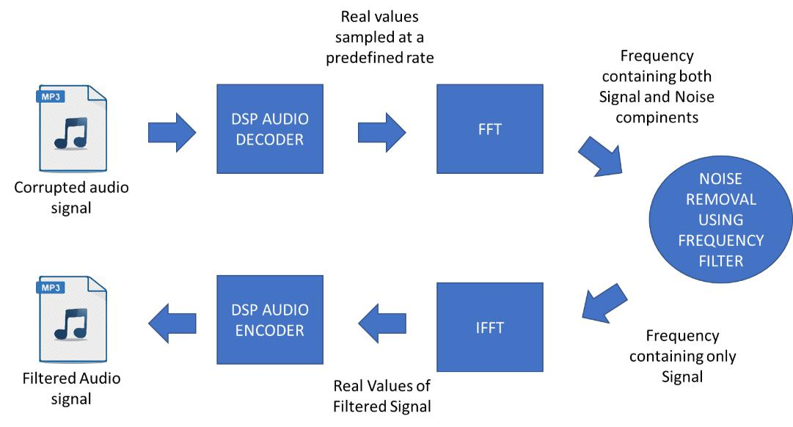

Figure 3 Flow of the project
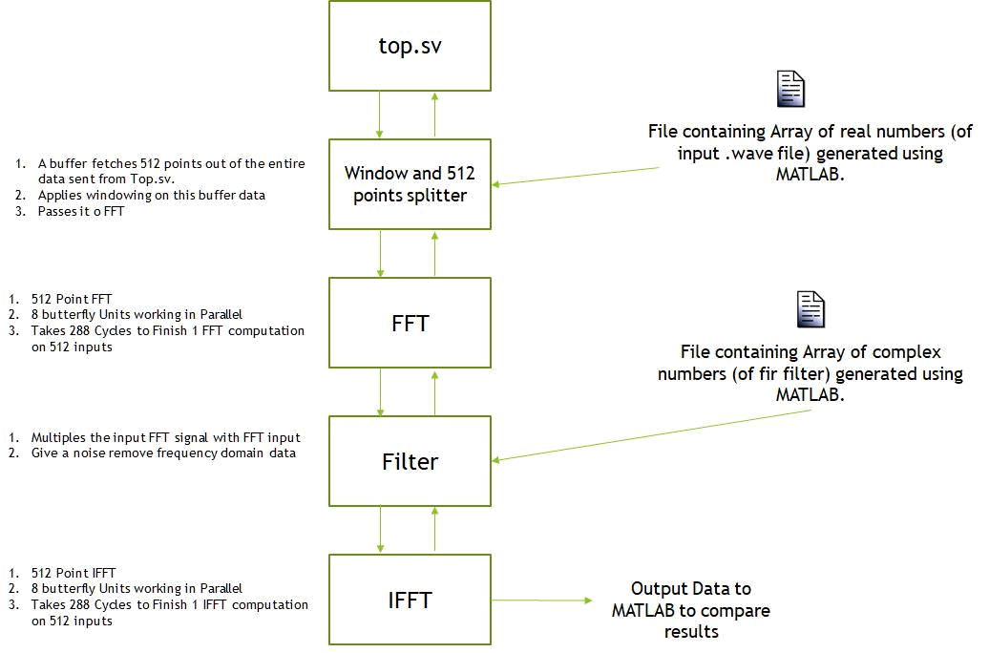

Figure 4 Flow of the project

Noise
Noise comes in all shapes, sizes and sounds. This is project concentrates on noise in the form of sound. Sound wave can be broken down to two fundamental characteristics, frequency and amplitude Any unwanted sound that is added to the original audio file is considered as a sound noise. During audio recording, noise gets included in Analog tapes or digital recordings. Among many files section of “hiss” noise found throughout the recording. Addition of noise into the recording also depends on the environment of recording and equipment. Below is the list of four major kinds of audio noises.

Hum

The sound which is at low frequency than the actual sound and whose frequency ranges between 40 – 80hz [2] is considered as hum. For example, whirring of low pitched motor. Hum usually occurs by electrical interferences or the ground wiring of recording equipment is not done properly.


Figure 5 Low frequency hum noise Hiss
This can be seen in devices that includes electronic components. Due to rise in temperature (compared to room temperature) path of electrons in the device is deviated as a results output is disturbed. This disturbance in the distorted output is considered as “hiss”. Hiss noise depends on the quality of recording equipment. This noise can also be a result of environmental factors like A/C, fans etc.,
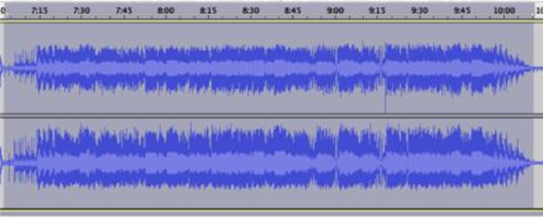

Figure 6 Hiss noise plot

Rumble

This is very common audio noise. Like hum noise this is also at low frequency. This can be seen only between specific points in a given bandwidth. It is most observable noise in mechanical devices. For example, ball bearings at a joint, gear rotation in a gear box, mechanical parts moving in the audio recording equipment creates this noise. There are filters that are inbuilt in a device to eliminate this kind of noise.



Figure 7 Rumble noise

Crackle

These are kind of discontinuous and non-musical. This kind of noise is similar to that sound heard during burning of wood. This is caused by explosion of air pockets inside the object. These are of two types fine crackles which are high pitched and last for less duration of time, coarse crackles which are of low pitched and last for longer duration.

Noise can be categorized by giving color names. This project involves an audio file that contains “white noise”. White noise generally comes to hiss noise category. It is present everywhere in the entire audio file. To put entire concept in a nutshell, it is a layer of sound that is considered as noise floor while processing it.

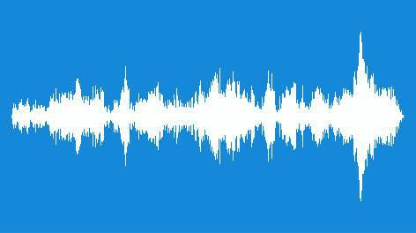

Figure 8 Gramophone crackling noise

White noise

White noise can be stated as the noise that contains many frequencies. sometimes white noise is used to mask the other unwanted frequencies.
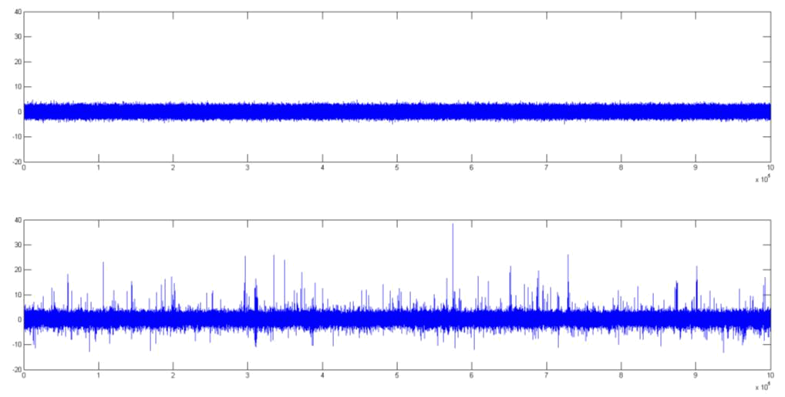

Figure 9 Plot showing white noise in an audio file

Filters
The main function of a filter is to pass desired frequencies and attenuate the unwanted frequencies. The four primary types of filters that can be listed down as
- Low-pass filter
- High-pass filter
- Band-pass filter
- Notch filter (band-stop filter)

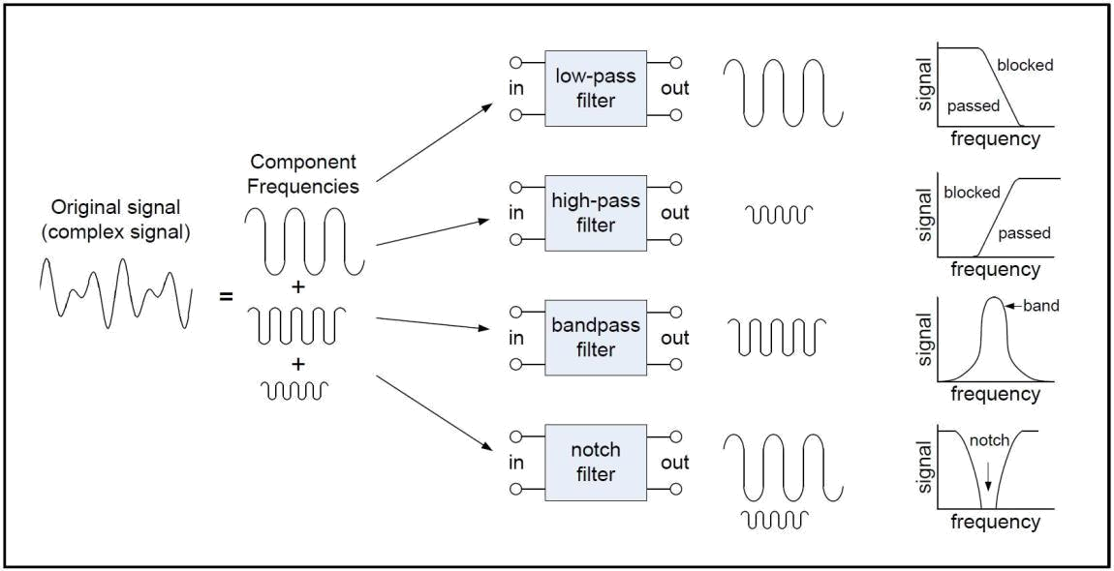

Figure 9. A basic depiction of four major filter types
There are two major digital filters. FIR filters and IIR filters.

FIR filter

The Fourier filter is a type of filtering function that is based on manipulation of specific frequency components of a signal. It works by taking the Fourier transform of the signal, then attenuating or amplifying specific frequencies, and finally inverse transforming the result. The main advantage of FIR filter is that they can easily be designed to be “linear phase”. FIR filter works better with 2^{N} sample points. Stability of FIR filter is very good which can also be framed as finite output can be obtained for every finite input.

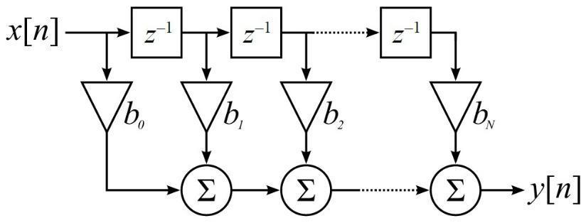

Figure 10. Butterworth filter representation [4]

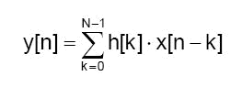

FIR filter formula [4]

IIR filter

Infinite impulse response filter. This filter is infinite because of presence of feedback in the filter. Desired filtering characteristics can be achieved using IIR filter consuming low memory and calculations when compared to an FIR filter. The main disadvantage is that implementation of filtering using fixed point arithmetic becomes slower and harder. They don’t offer the computational advantages of FIR filters for multi rate applications.

FIR filters are preferable over IIR filters as the response is a linear phase and non-recursive. IIR filter performance is good when dealing with analog filter responses. This project uses FIR filter for the input wave file selected.

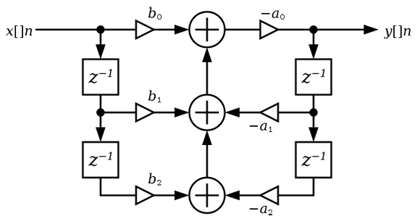
Figure 10. IIR Filter Z Transform [5]

Windowing
In most of the signal measurements, the signal doesn’t contain integer number of periods. Due to this finiteness is not perfect and result in loss of some part of waveform and characteristics of whole signal changes. This finiteness introduces sharp transition changes in the signal that is measured.

When the waveform’s period is non-integer, discontinuities are seen at the endpoints. These unwanted discontinuous components become high frequency harmonics in FFT which are not actually present in the original signal. The frequency of these unwanted components is higher than the Nyquist frequency value. Because of thse distortion the FFT spectrum is not the actual spectrum of actual signal. It appears as if there is a leakage of energy from one frequency component to other frequency component.
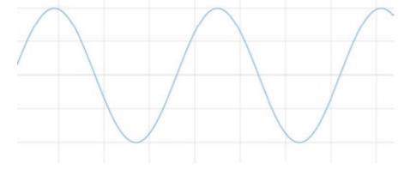

Figure 12. Signal with non-integer number of periods
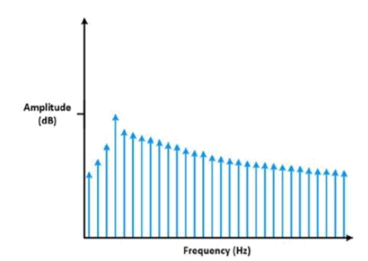

Figure 13. Spectral leakage to the FFT of signal in the figure

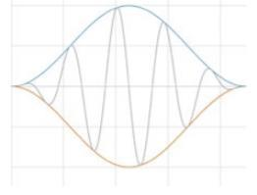
In a signal that contains non-integer periods, this distortion in FFT can be minimized by using a technique called “windowing”. Windowing basically reduce the amplitude of these discontinuities at starting and ending and gradually rolls of to zero of given boundary for a finite length.

Figure 14. Result of windowing

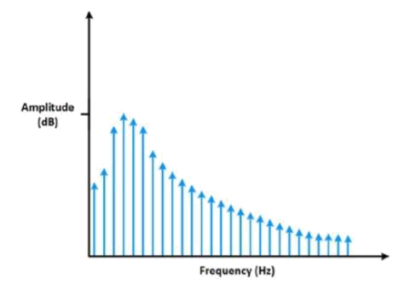

Figure 15. Applying a window minimizes spectral leakage.

There are several Widowing mechanisms that are possible like the Hann window, Ham window and so on. The Below window is used in our project as it has a better damping characteristic as desired for the FFT design.

Hann window
This window is used for a signal whose characteristics are unknown. Instead of doing tradeoff between amplitude and frequency accuracy a good compromise is provided between the both by using this windowing technique.

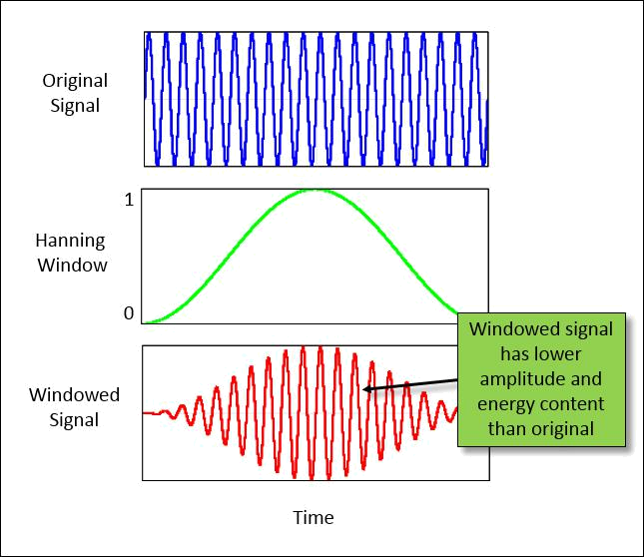

Figure 16. Multiplying a original signal by hanning window reduces the amplitude and energy in the signal[3]

MATLAB
This software is excessively used for computing. Integration of computation, visualization and programming is possible in this platform.

MATLAB software environment is user friendly. Mathematical notation type is used to express all kinds of problems and solutions. Main usage of MATLAB is application development. It makes usage of signal processing techniques easy by providing many predefined functions. It provides unified work flow for the development of embedded systems and streaming applications.

MathWorks provides design apps, DSP algorithm libraries, and I/O interfaces for real-time processing of streaming signals in MATLAB and Simulink. You can rapidly design and simulate streaming algorithms for audio, video, instrumentation, smart sensors, wearable devices, and other electronic systems

Entire filter design is first made in MATLAB and checked for output. Based on the results obtained cutoff frequency is determined and it is used in filter designing in Verilog.

Generating plots

The Generation of Graphs are critical part of simulation as it presents the expected output in a graphical manner for ease of understanding. In our scenario, we need to generate graphs for time and frequency domain at every point in simulation. Such as
- When the input signal arrives
- When the signal is chopped into 512 bits
- After windowing
- Post FFT and Filtering
- After IFFT
- Once the whole signal of merged data is obtained back

The below code presents two subplots, one for Time and the other for frequency. The frequency domain x axis is calculated as below
(-0.5:1/lengthOfSignal : 0.5-1/lengthOfSignal)*fs
The reason is because the signal has negative and positive axis corresponding to imaginary parts of the FFT output
The other parts of the code are self-explanatory.
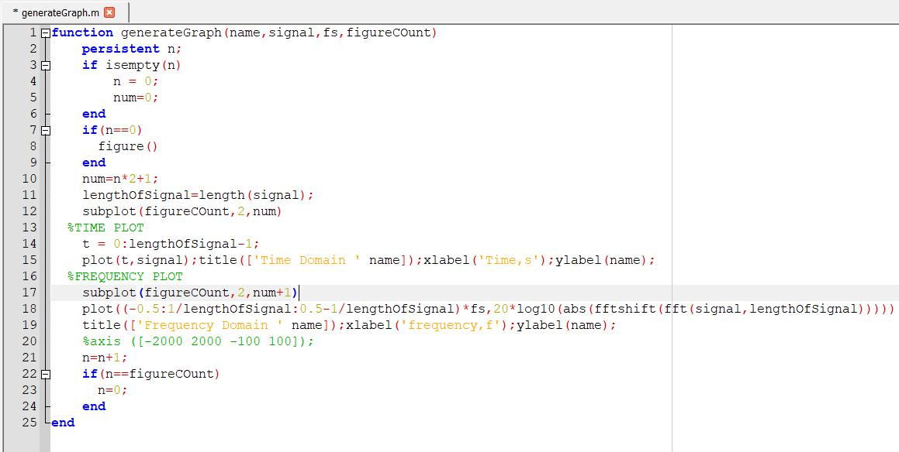

Figure 17. Code for generating plots

To maintain good clarity in the actual code, function “generategraph” is called into actual code. This gives plots in both time domain and frequency domain. Input signal is taken in the variable “signal” and it is plotted in time domain. After processing in the final stage frequency plot of filtered signal is obtained. True or false is set to generate graph function according the requirement. True is to generate plot and false is not to access the function.

Initialization
In the “audioread” function is used to fetch the input signal which is ultrasound heartbeat of a fetus. The input is in the wave format. Sampling frequency is given as 22050 hz. BS (512) is the block size for which the filtering is performed. This is nothing but 512 point FFT which is further designed in Verilog. The length of input file is 13782600.
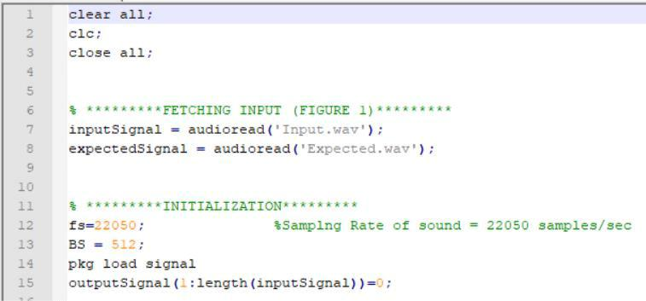

Figure 18. Code for reading input and setting FFT points
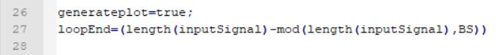

Figure 19. For loop constraints

Figure 20. Filter design

FIR filter of 900 order and 0.05 roll off which is a low pass filter is used. So, the entire signal length is divided into chunks whose length is of 512.
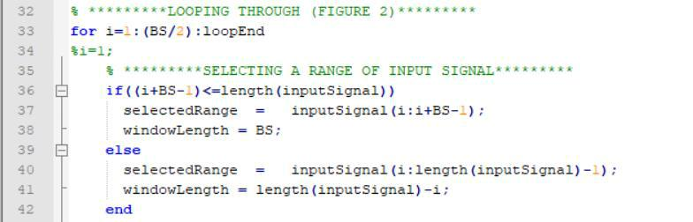

Figure 21. Looping Through Each 512-point chunk

A for loop is made which includes which gives the portion of input signal which starts from 1 and end at 512. The next block starts from 512. For loop constraints are selected in such a way that only one fourth portion of first block sized input signal is removed and last one fourth portion of last block sized input signal. Due to application of hann window on the input signal, in every one block sized input signal first one fourth and last one fourth signal is removed to reduce the spectral leakage. This leakage is considered as spectral leakage. Due to this lot of input signal is removed and there is a chance of losing the original signal. To avoid such condition, after every block size filtering last one fourth of the signal is added to next block size signal and then rest all computations are performed.
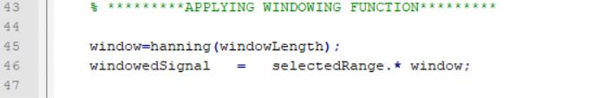

Figure 22. Hann window

Hanning window is applied to window length which is of block size (initial size of window length is block size). Windowed signal is magnitude of vector product of selected range of input signal and the window. To perform this operation array and order size of both the elements should match.

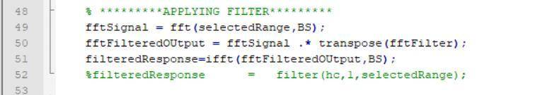

Figure 23. Applying filter

Predefined function “fft” is used to perform 512 point FFT. This function needs two parameters. “select range” is the range of processed signal and “BS” specifies the number of FFT points. When multiplying FFT signal of FFT of filter transpose is taken to match the order of the two variables.

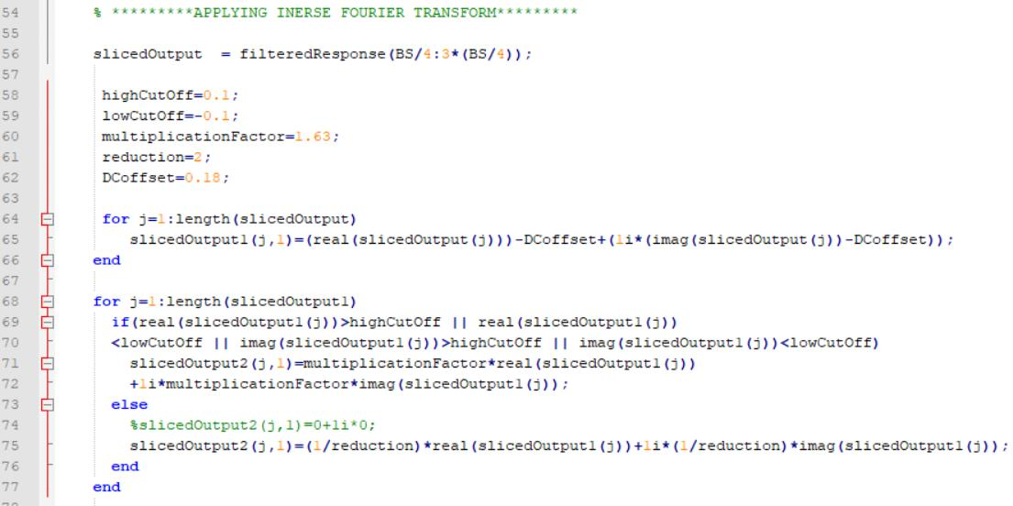
Figure 24. Inverse fourier transform

FFT is performed for the windowed signal and because of windowing, DC offset is introduced, and amplitude of original signal is reduced. So, multiplication factor is selected as 1.63 [3] to bring back the amplitude of filtered signal to the original.
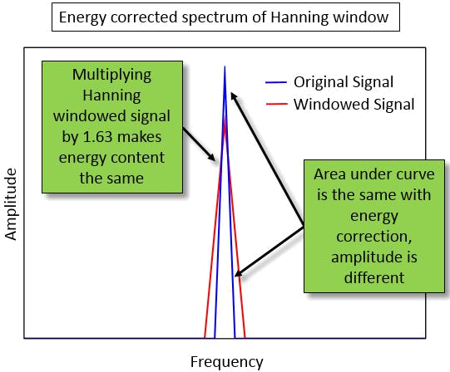
Figure 25. Selection of multiplication factor for hanning window

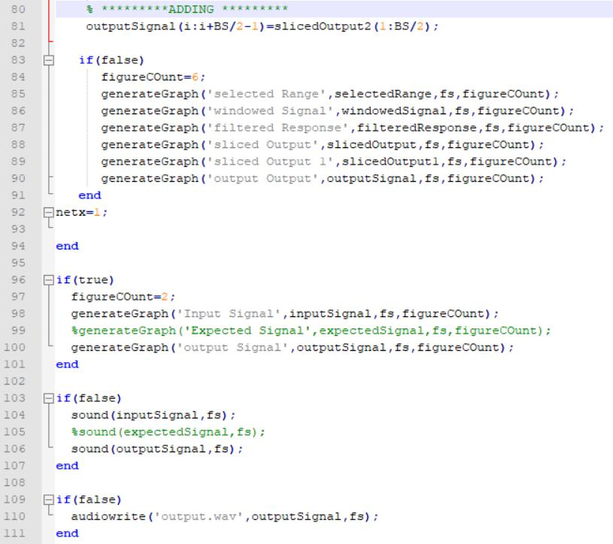
Figure 26. Producing final filtered output

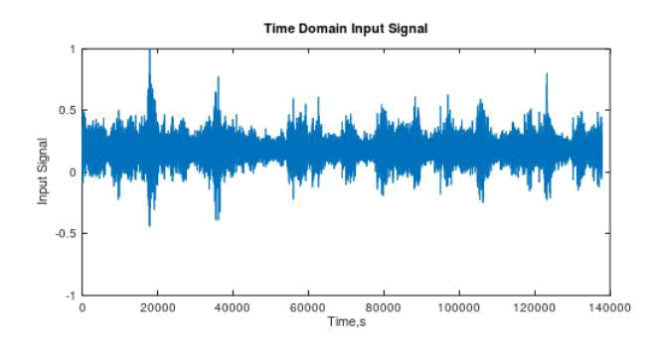
Figure 27. Plot of Input signal in time domain
Input signal plot in time domain. This contains lot of noise whose frequency can’t be determined from time domain plot. The spikes indicate heartbeat and as you the signal is low frequency (Occurs at a lesser rate than the noise signal). Main aim is to remove all other frequency components which all are considered as noise components.

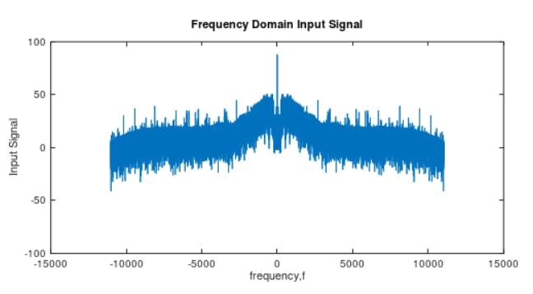Figure 28. Plot of input signal in frequency domain

In figure 27 the frequency component at zero frequency determines the Doppler heartbeat frequency. The maximum noise floor ranges from -30db to 50db. To eliminate those frequencies low pass FIR filter of order 900 and roll off 0.05 is selected.

Few Considerations for Noise Removal
- The signal is low frequency. So, we need to design a low pass filter with a cutoff frequency (which is to be selected based on trial and error and brute force method)
- An assumption of an error on Window to be 50 percent was made. Meaning, if we window 512 samples, only the mid 256 Samples will be valid data. Remaining should be dumped as they will be grounded to zero.

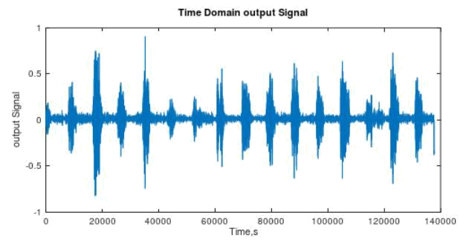
Figure 29. Plot of output signal in time domain

Before getting plot in figure 29, DC offset of 0.18db is observed and amplitude was reduced to nearly 2. So appropriate code is made to overcome that error and the desired output is obtained.
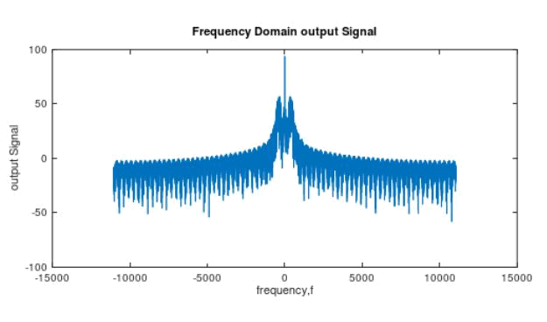
Figure 30. Plot of output signal in frequency domain

The noise floor in the above figure is pushed down to 0db. The output of this is heard and the noise is eliminated.

System Verilog
System Verilog is a good platform to provide a detailed design specifications of a digital circuit. . Creation of design specifications is trivial when compared to the amount of work required to translate the specification to a schematic based structural description needed to fabricate a device.
Because of system Verilog design engineer’s productivity is increased in very few years. CAD tools that are used in digital design can be categorized into two as “front end” tools that allows capturing and simulating the design and “back end” tools that are used to synthesize a design, link it to a technology and analyzes its performance
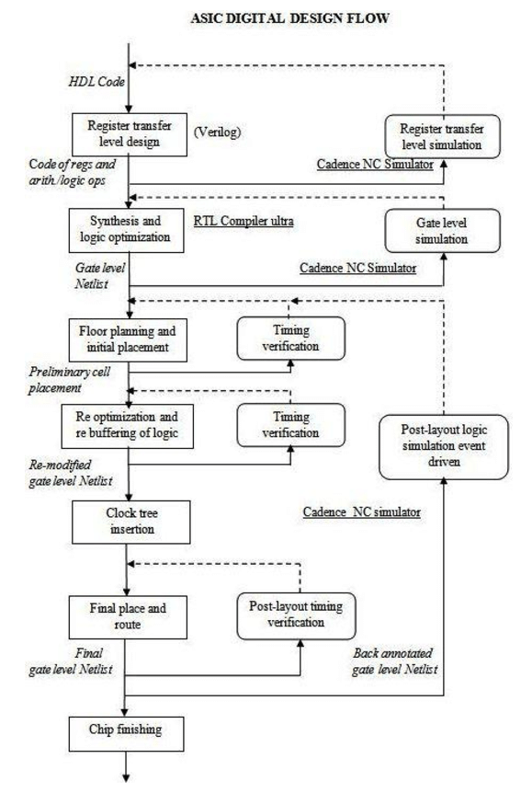
Figure: Digital design flow

Design

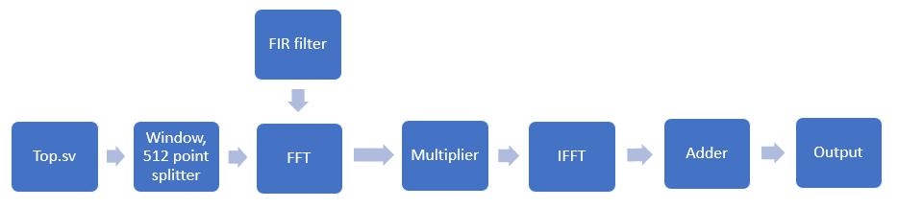
Figure 31. Design flow in system Verilog

After getting filtered results of input signal from Matlab for ultrasound of heartbeat of fetus, the input.wav file is converted into text file, hann window is converted to text file and fir filter co ordinates is converted into text file. All these files are used to perform filtering of input and resultant output values matches with the output from MATLAB.

Test bench
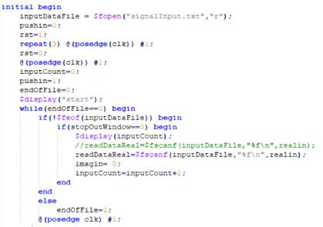

Figure 32. Fetching input

Input “fetal doppler” is in .wav format. to convert this into digital form which is a vector representation, MATLAB is used. This is of size 1307800. Audio file in .wav format is easy to convert to digital form. So any audio file which is any other format is first converted into .wav file for representing it in digital format.

After converting input into text file that contains real and imaginary values, at every posedge of the clock real values are read in a variable calle “realdata” and imaginary values are read in a variable “imagindata”.
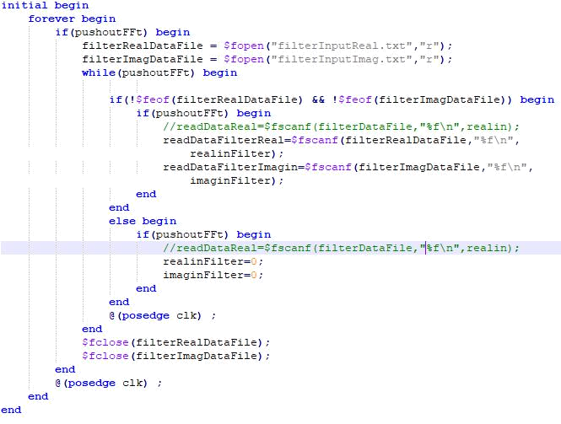

Figure 33. fetching filter data

Like how the real and imaginary parts of input data is read, in the same manner low pass FIR filter vector representation text file is loaded into design using similar code in system verilog. Here FIR filter is of order 900, roll 0ff 0.05 and its a low pass filter. These numbers are selected by trial and error method. The white noise floor is way below the frequency level of required heart beat. So low pass Filter is selected for filtering.

Windowing

Windowing technique is used to eliminate the spectral leakage in the signals. Usually the signals which are not periodic contains frequency harmonics in FFT which are not actually present in the signal. These are of high frequency components. the signal frequencies seem like as if the energy been transferred from one harmonic to other harmonic. To eliminate this spectral leakage windowing is applied to the signal which rolls down the signal at starting and at ending to zero, this is been performed because spectral leakage is usually observed at the starting and ending of the recorded non-periodic signal. Hann window is used. The hann window’s vector representation is obtained using the MATLAB.
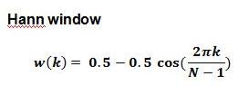

Hann window formula [5]

FFT
Fast Fourier transform concept is used to convert time domain input signal into frequency domain. If the input to FFT are two to the race N then it works better. Input signal is a continuous signal in time vs amplitude. In frequency domain signal is plotted between normalized frequency and magnitude response (dB) of signal. The harmonic that is at higher magnitude is determined as heartbeat of fetus.
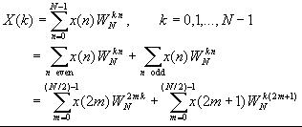

FFT formula [6]

The formula in above figure is used to compute FFT of filter co-ordinates and hann window co-ordinates. The weight components that are used in computation are called twiddle factors or butterflies. These twiddles contains both real and imaginary values. Real values and imaginary values are of floating-point format and they are saved in arrays in system verilog.

We first save input to a buffer which is of size 512. This takes 512 clock cycles. Once this data is transferred, the data is moved completely to a working buffer which is used to compute FFT. The below figure shows how data is transferred into input buffer
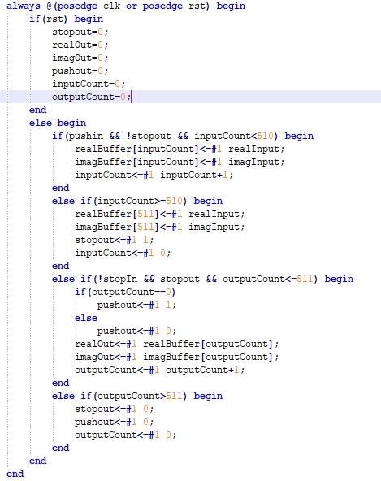

Figure 36. Saving 512 Inputs to Buffer
The data transferred should be assigned to each address which is reverse of the count in which the data is received. For Example, if the received data is at count 6, the binary of the same is 110. However, this is stored to input buffer at location 011, which is 3. The reason for the same is that the inputs are twisted as per the theory of FFT as shown in figure 37. If we see the inputs are 0 4 (which is inverted 001) 2 (inverted 010) and it goes on in the same fashion.

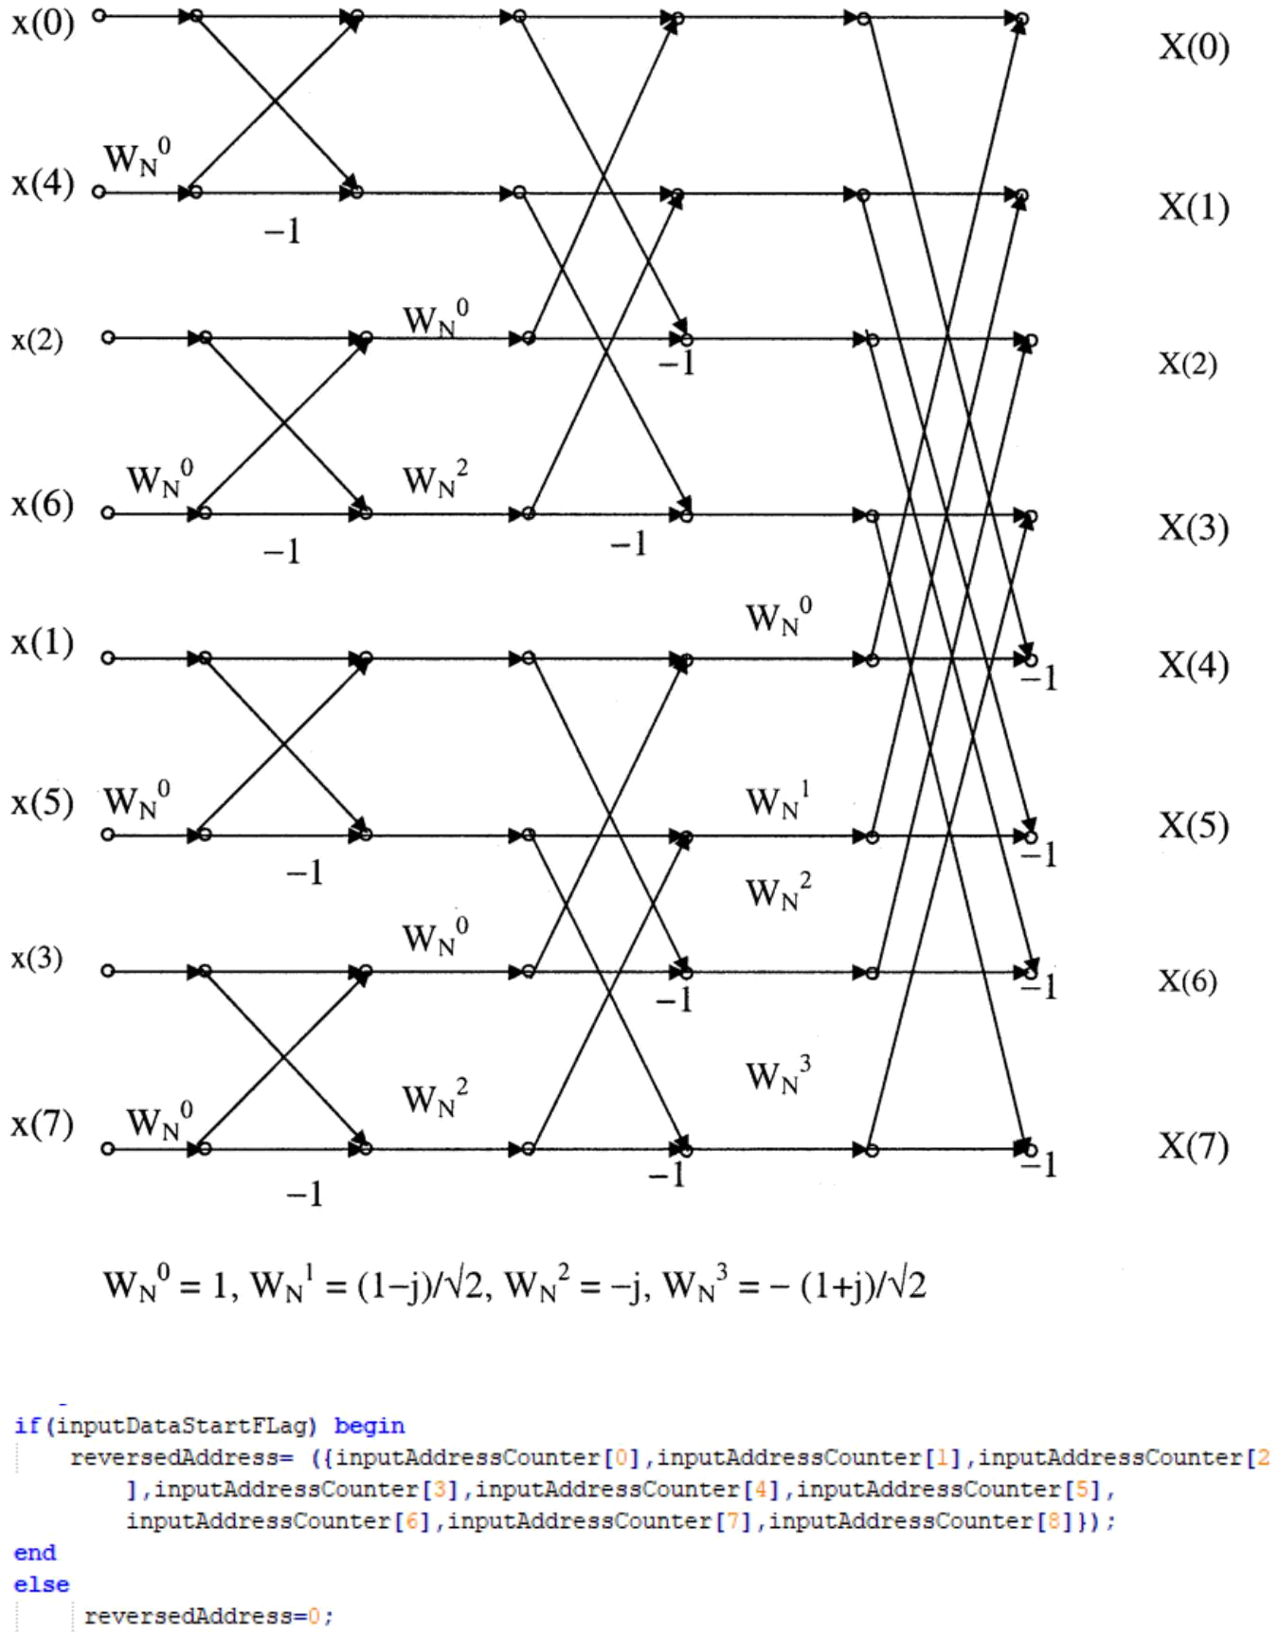

Figure 37. Calculating address for input Buffer (100 -> 001)

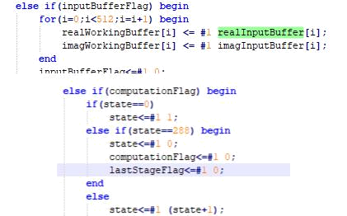

Figure 38. Transferring Data to Working Buffer and increment states of FFT calculation thereafter

Once we get data into working buffer the states of FFT are incremented as shown below. Each state of FFT contains inputs to 8 buffers and twiddles to these butterflies. All these states are generated using a Java program which is written such that the entire states are generalized. On changing constants to 1024, the states for 1024-point FFT can also be generated. The below code shows the first state of the entire 288 states.

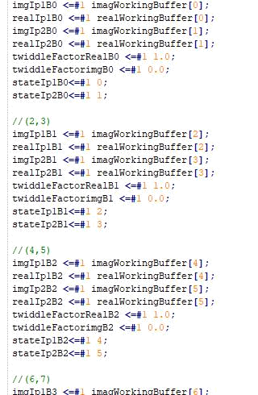

Figure 39. Writing data from working buffer to butterfly inputs

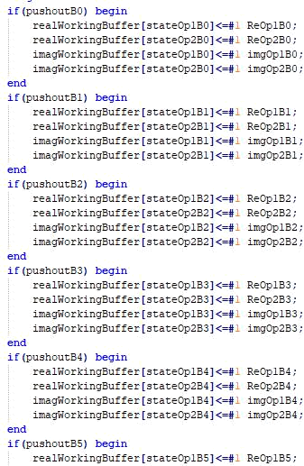

Figure 40. Writing output of Butterflies to Working Buffer
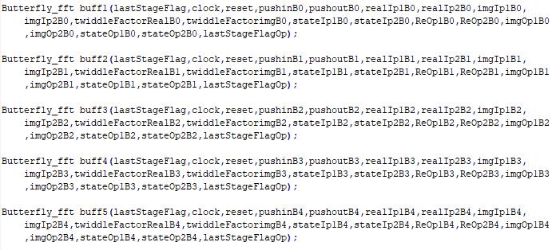

Figure 41. Butterfly units running in Parallel

6.4 IFFT

Inverse Fast Fourier transform concept is used to convert frequency domain input signal into time domain. If the input to IFFT are two to the race N, then it works better. Input signal is a Frequency Signal vs Frequency spectrum. In frequency domain signal is plotted between normalized frequency and magnitude response (dB) of signal. The harmonic that is at higher magnitude is determined as heartbeat of fetus.
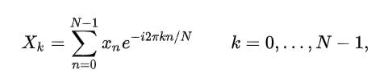

Figure 42. IFFT formula

The formula in above figure is used to compute IFFT of Frequency response of filtered signal. The weight components that are used in computation are called twiddle factors or butterflies. These twiddles contain both real and imaginary values. Real values and imaginary values are of floating-point format and they are saved in arrays in system Verilog.

Data is saved in input buffer, which is of size 512. This takes 512 clock cycles. Once this data transferred, the data is moved completely to a working buffer, which is used to compute FFT. The figure 43 shows how data is transferred into input buffer

Figure 43. Saving 512 Inputs to Buffer

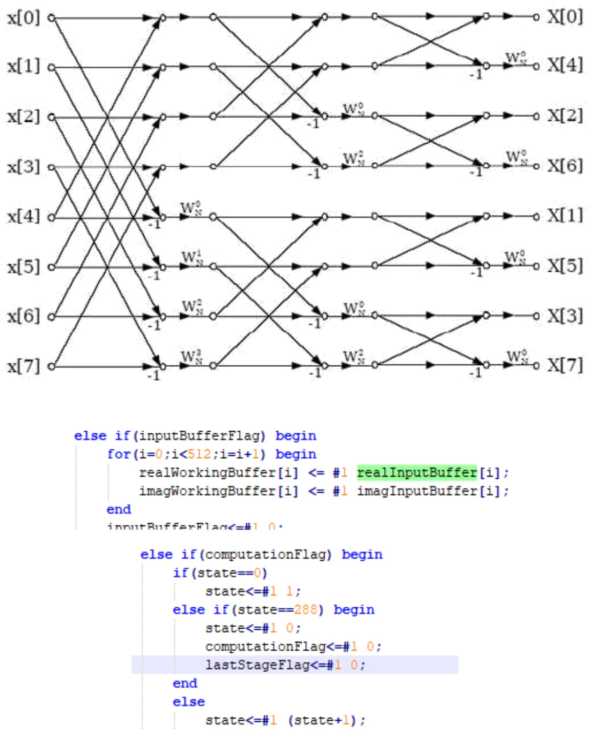

Figure 44. Transferring Data to Working Buffer and increment states of FFT calculation thereafter

Once the data is transferred to working buffer the states of FFT are incremented as shown below. Each state of FFT contains inputs to 8 buffers and twiddles to these butterflies. All these states are generated using a java program which is written such that the entire states are generalized. On changing constants to 1024, the states for 1024-point IFFT can also be generated. The below code shows the first state of the entire 288 states.

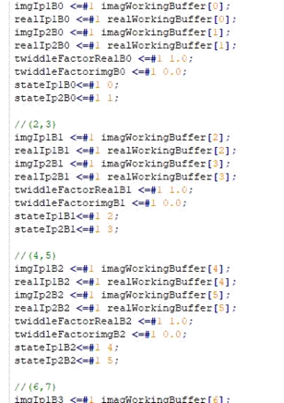

Figure 45. Writing data from working buffer to butterfly inputs
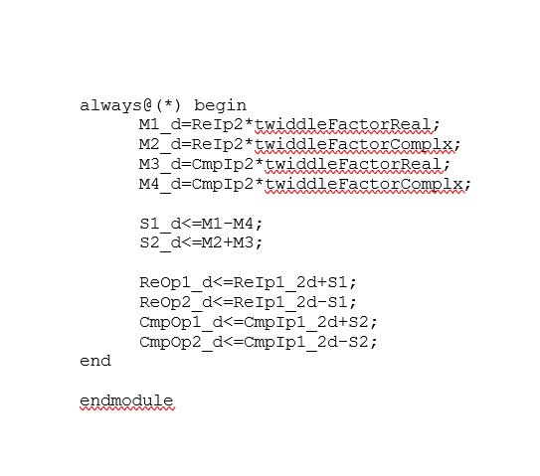

Figure 46. Writing output of Butterflies to Working Buffer

Figure 47. Butterfly units running in Parallel

Comparing Design vs Simulation

Input Signal (With Noise)
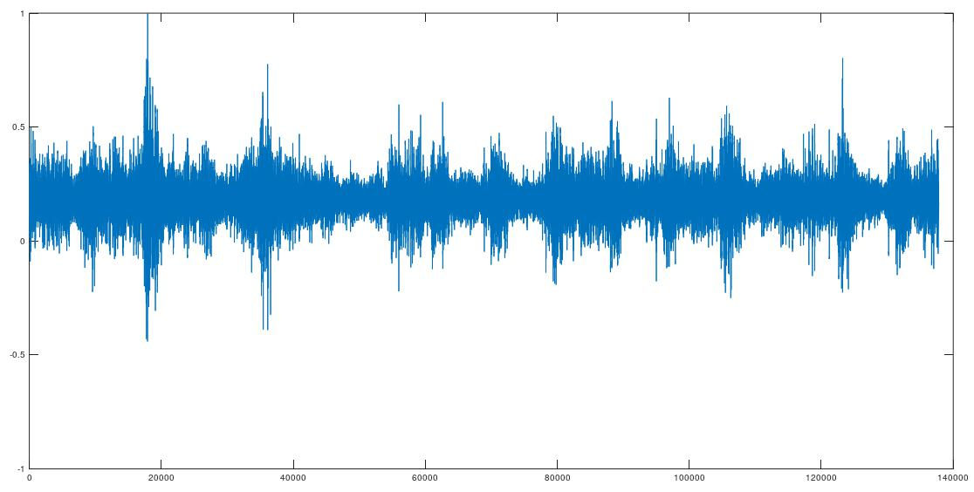

FFT output of the First 512 Points
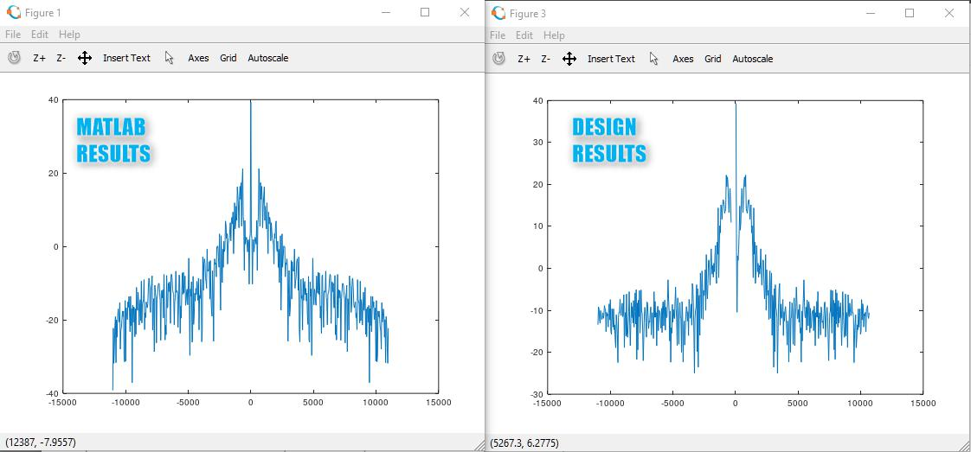

Filtered output of the First 512 Points
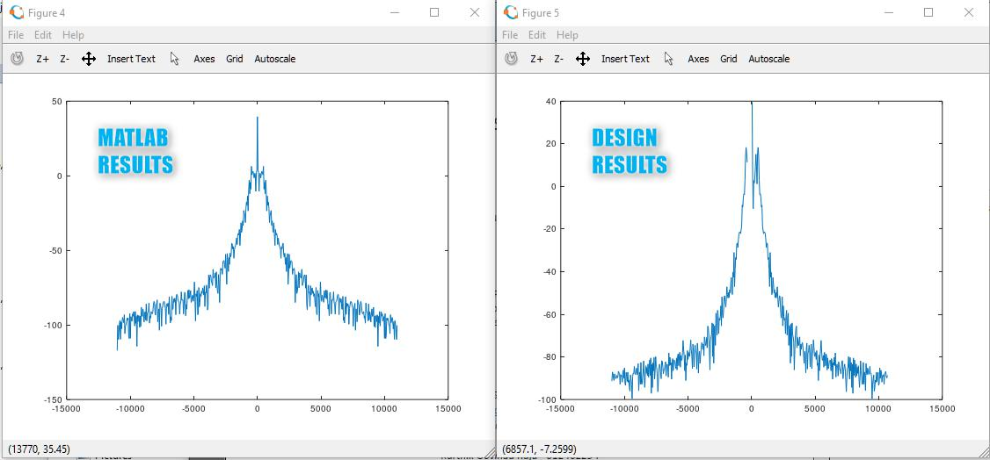

Final output of Entire Signal After IFFT
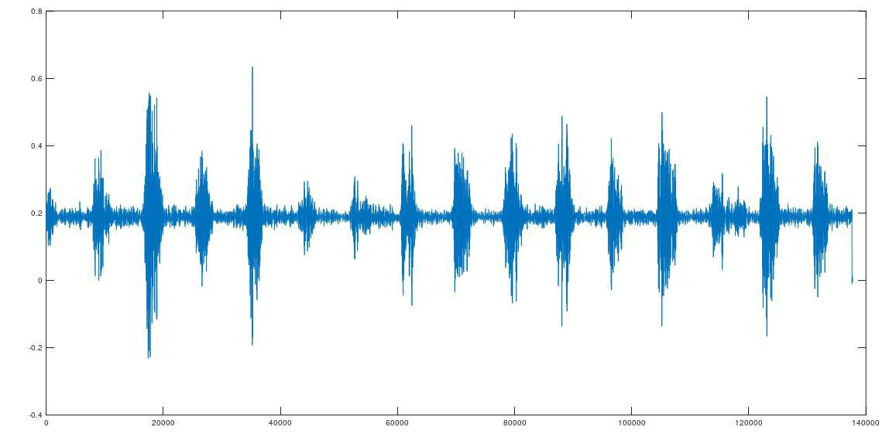

Java Code for generating states of FFT and IFFT
The coding for this project involved trial and error method with various FFT designs such as 256 points, 512 points, 1024 points and so on. Writing the code for all of these was a tedious job. So instead we designed a java application which was intelligent enough to generate System Verilog files customized for each FFT and IFFT design.
The inputs to the java program defined the design parameters. The same are as below
- Number of Multipliers
The Design contains several multiplier units working in parallel to get the FFT work done. The number of multipliers high the rate of output generation. But this comes at a cost of larger synthesized area. Thus, as a tradeoff different numbers needed to be tried.
- Number of points (256, 512, …)
As explained in the start of this page, we need to design a system where we can easily switch between different FFT and IFFT designs and do a trial and error method to obtain the same precision of noise cancellation as seen in simulation. Thus, we designed a java program which was robust such that we could easily generate the entire code for different points as per the input.

The number of points combined with Number of multipliers decided the max number of states of the Design state diagram

- FFT or IFFT
FFT and IFFT design are only a small change with twiddles varying as shown below
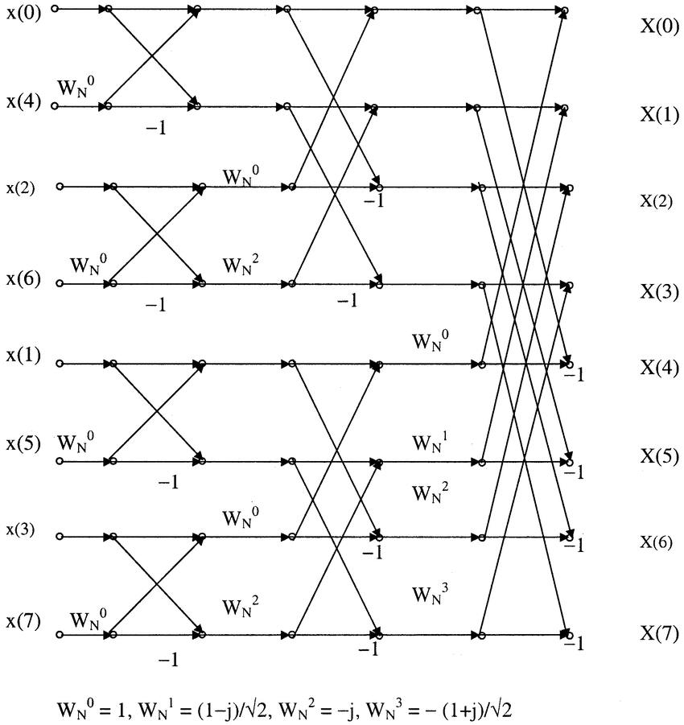
FFT Butterflies

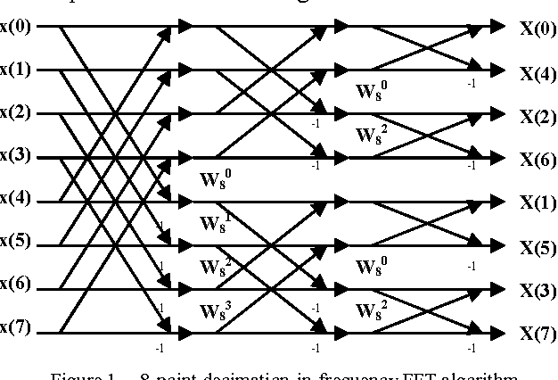

IFFT Butterflies

The main differences between an FFT and IFFT are
- Twiddles are calculated before the execution of the butterfly operation for a fft. Whereas the Twiddles are computed after butterfly operation of IFFT
- Twiddle factors a slight calculation change. In FFT, the imaginary part come with negative sign whereas in IFFT the imaginary part come with Positive sign.
- The initial set of addresses as you see above are reversed for FFT. Whereas for IFFT the initial is sequential, whereas the output is reversed.

The following code shows all the above points in code

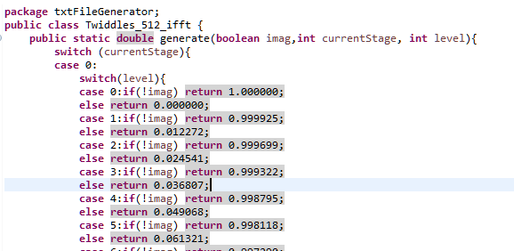
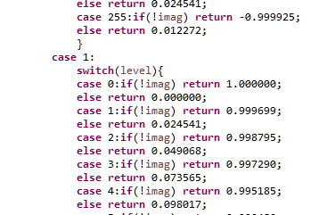
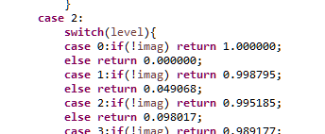
Twiddle Generation showing different stages of Twiddle

The above twiddles were further generated using another Octave snippet shown below
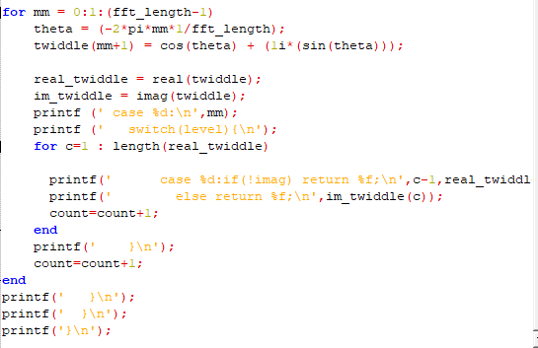
Twiddle Value Generation

These twiddle values were further used to generate the states of the FFT and IFFT as below
- Calculation the number of states and looping accordingly
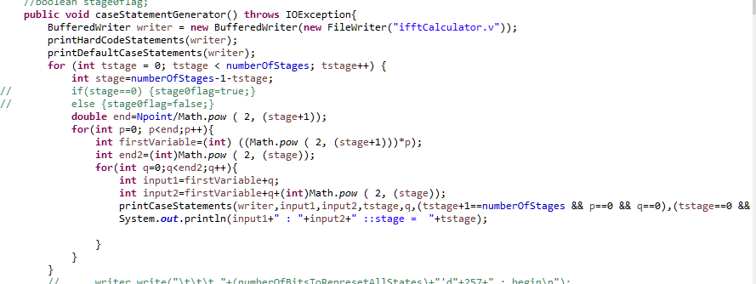
As we see above, the number of states need for computation is calculated as below
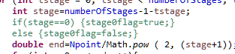

Once we know the number of states, we need to generate the code for each state. And this takes the below looping logic

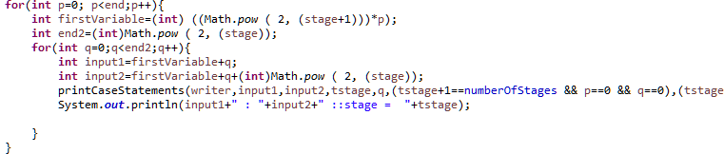

Here the looping condition takes care of the below
- The number of states
- Number of multipliers in each state
- Calculating the number of stage in each state
- Then once we drill down to one stage of one state, we generate the state variable which include
  - Twiddles from twiddle generator
  - Variable address from memory
Once we have all the data, we need to generate the statements. This is done by printing the data into a text file and saving the same as with .sv extension.
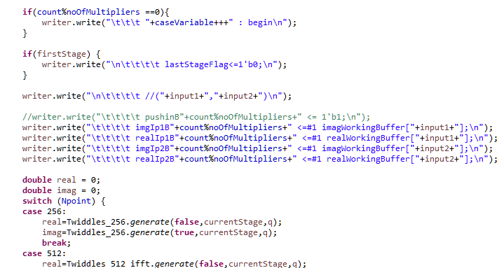

The above code shows the same. Where you see the writer object writing System Verilog Code into text file.
This approach somewhat looks like a java to system Verilog converter. But in simpler manner, the java script generates System Verilog design files which are compilation free and easily customizable

References
- https://blogs.mentor.com/verificationhorizons/blog/2019/01/22/part-7-the-2018-wilson-research-group-functional-verification-study/
- https://www.audioshapers.com/blog/audio-noise.html
- https://community.plm.automation.siemens.com/t5/Testing-Knowledge-Base/Window-Correction-Factors/ta-p/431775
- https://www.mikroe.com/ebooks/digital-filter-design/finite-impulse-response-fir-filter-design-methods
- https://www.crystalinstruments.com/dynamic-signal-analysis-basics
- http://www.cmlab.csie.ntu.edu.tw/cml/dsp/training/coding/transform/fft.html
- https://ieeexplore.ieee.org/stamp/stamp.jsp?tp=&arnumber=6701859.
- https://ieeexplore.ieee.org/stamp/stamp.jsp?tp=&arnumber=625606
- https://ieeexplore.ieee.org/stamp/stamp.jsp?tp=&arnumber=6096796
- https://ieeexplore.ieee.org/document/5109763
- Y. Ephraim and D. Malah "Speech enhancement using a minimum-mean square error
- short-time spectral amplitude estimator" Acoustics Speech and Signal Processing IEEE Transactions on vol. 32 no. 6 pp. 1109-1121 1984.
- R. McAulay and M. Malpass "Speech enhancement using a soft-decision noise suppression filter" Acoustics Speech and Signal Processing IEEE Transactions on vol. 28 no. 2 pp. 137-145 1980. (Pubitemid 10487373)
- P. J. Wolfe and S. J. Godsill "Efficient alternatives to the Ephraim and Malah suppression rule for audio signal enhancement" EURASIP Journal on Advances in Signal Processing vol. 2003 no. 10 p. 910167 2003.
- R. Martin "Speech enhancement based on minimum meansquare error estimation and supergaussian priors" Speech and Audio Processing IEEE Transactions on vol. 13 no. 5 pp. 845-856 2005. (Pubitemid 41558900)
- S. Doclo and M. Moonen "On the output SNR of the speechdistortion weighted multichannel Wiener filter" Signal Processing Letters IEEE vol. 12 no. 12 pp. 809-811 Dec. 2005. (Pubitemid 41800439)
- T. Den Bogaert J. Wouters S. Doclo and M. Moonen "Binaural cue preservation for hearing aids using an interaural transfer function multichannel Wiener filter" in ICASSP 2007 Proceedings vol. 4 April pp. IV-565-IV-568.
- B. Cornelis M. Moonen and J. Wouters "Performance analysis of multichannel Wiener filter-based noise reduction in hearing aids under second order statistics estimation errors" Audio Speech and Language Processing IEEE Transactions on vol. 19 no. 5 pp. 1368-1381 2011.
- https://terpconnect.umd.edu/~toh/spectrum/FourierFilter.html

