AGRIRENT PLATFORM
Next-Generation Agricultural Equipment Rental Marketplace
Comprehensive Project & Feature Documentation
Project Name | Agrirent - Agricultural Equipment Rental System
Technology Stack | Next.js 15 (App Router), TypeScript, Supabase PostgreSQL, Tailwind CSS
Authentication & RBAC | Supabase Auth with Role-Based Access Control (Admin, Owner, Customer)
Key Architecture | Server Actions, Row Level Security (RLS), Cloud Storage, Responsive Base UI
Document Version | Version 2.0 (Complete Feature Specification with Screenshots)

1. Executive Summary & Overview
Agrirent is a modern, full-stack digital marketplace created to solve agricultural mechanization challenges by connecting local equipment owners (tractors, harvesters, tillers, rotavators, sprayers) directly with farmers and customers. The platform eliminates middle-men, offers transparent hourly/daily pricing, prevents double-booking through interactive availability calendars, and incorporates end-to-end identity verification and administrator moderation.

System Architecture
- Frontend Framework: Next.js 15 (App Router) leveraging React Server Components (RSC) for lightning-fast initial load times and client components for real-time reactivity.
- Database & Auth Engine: Supabase PostgreSQL with Row Level Security (RLS) policies, programmatic auto-confirmation, and automated PostgreSQL triggers.
- Cloud Document & Media Storage: Supabase Storage buckets for high-resolution equipment listings, customer avatars, and Aadhaar identity verification files.
- Role-Based Access Control (RBAC): Strict multi-tenant privilege separation dividing users into Customer, Equipment Owner, and Platform Administrator tiers.
- Design System: Tailwind CSS paired with modern Base UI primitives, Lucide icons, glassmorphic headers, and dedicated mobile viewports with bottom navigation.

2. Landing Page & Equipment Marketplace
The Agrirent landing page provides an inviting, high-converting entry point for farmers and equipment owners. It features dynamic hero search by category, location, and price, along with direct highlights of top-rated machinery.
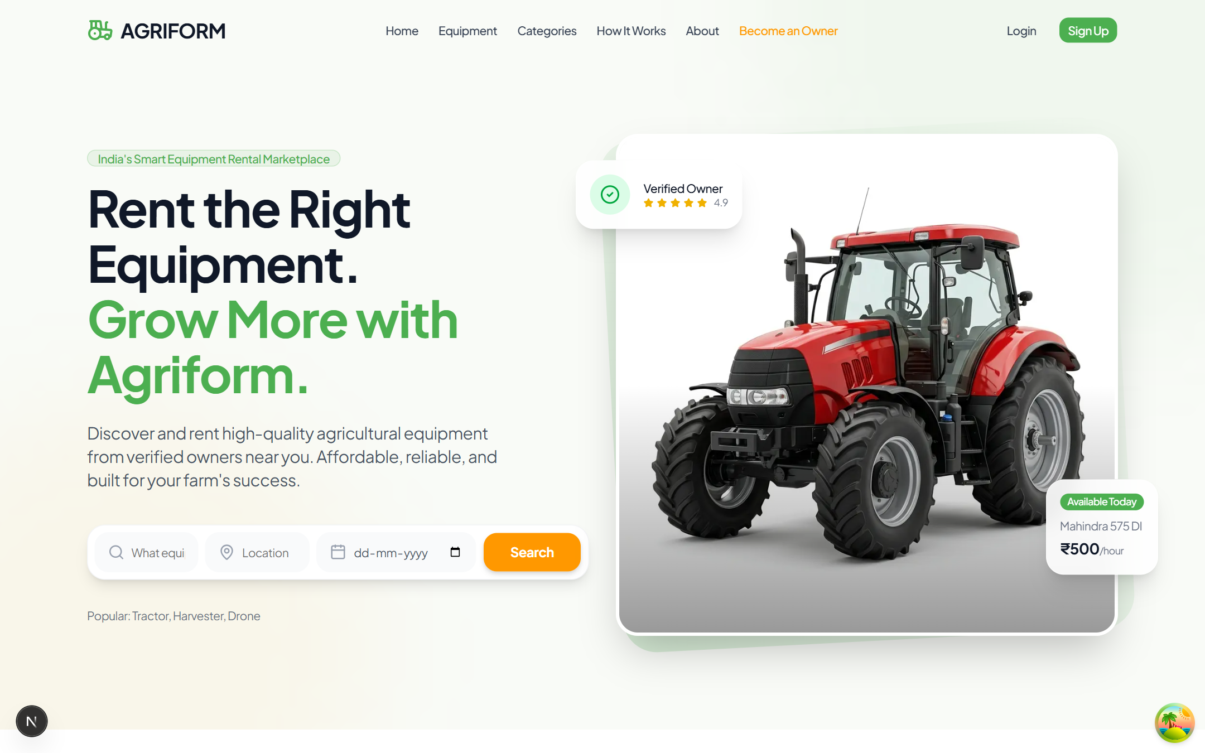
Figure: Agrirent Landing Page Hero & Modern Header

Marketplace & Filter Engine
The Equipment Marketplace (/equipment) lets farmers browse through tractors, harvesters, and attachments. Key capabilities include:
- Real-Time Multi-Filter: Filter by machinery category, daily rental rate range, owner rating, and geolocation.
- Instant Booking Modal: Direct booking dialog displaying equipment specifications, rental terms, and total price calculation.
- Owner Self-Management Integration: When an equipment owner visits their own listing, the system automatically detects ownership and displays a 'Manage & Edit Equipment' button instead of 'Request to Rent'.
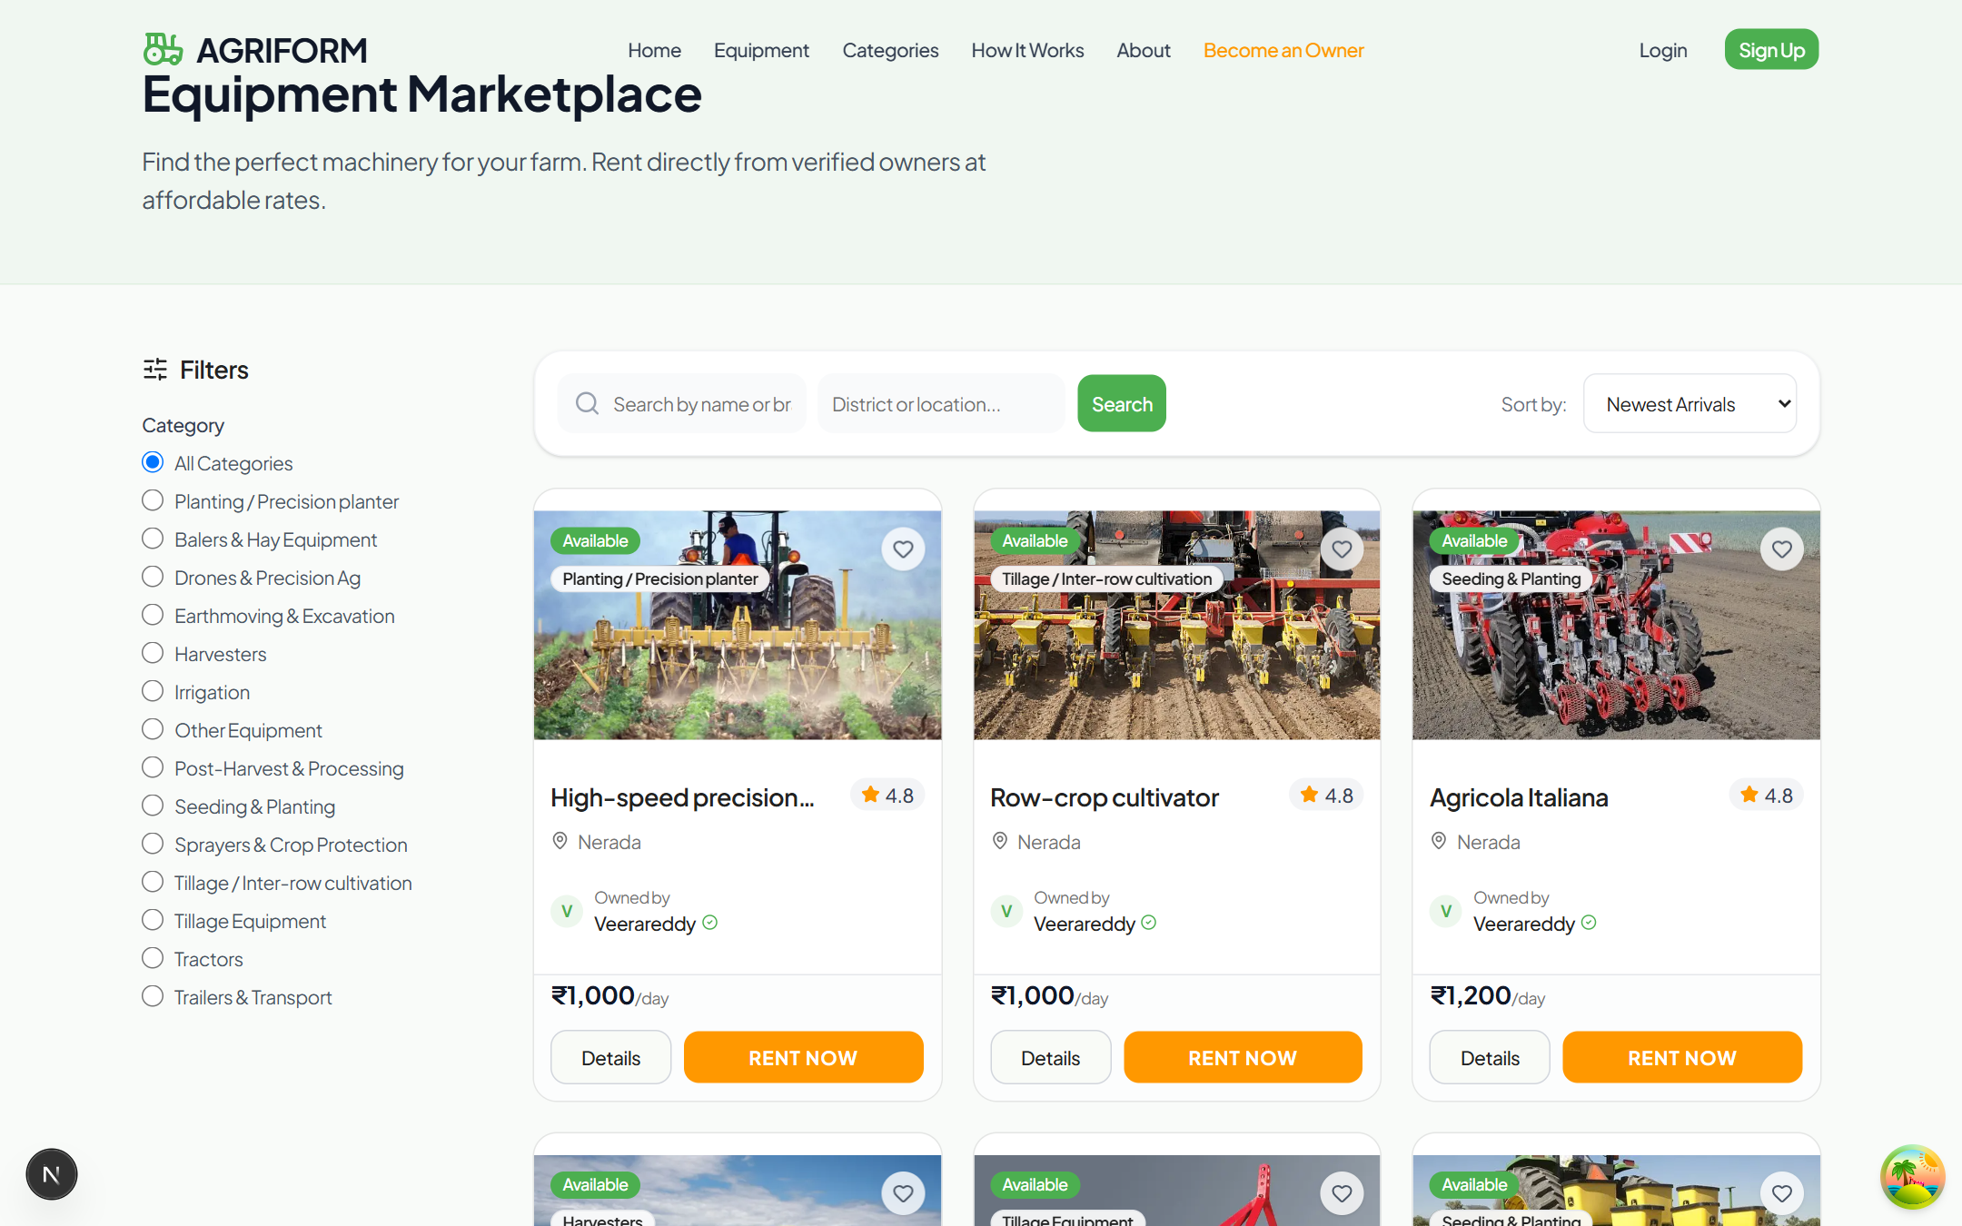
Figure: Equipment Marketplace with Search & Live Categories

3. Authentication & Owner Aadhaar Verification
Agrirent features a robust authentication flow supporting dual registration paths for Customers and Equipment Owners. All user registrations capture Full Name, Email, Phone Number, and Secure Passwords with server-side validation.

Customer vs. Owner Signup Tabs
- Customer Registration: Instant onboarding allowing users to explore equipment, save favorites, and place booking requests.
- Owner Registration with Aadhaar Upload: Equipment owners are required to upload an official Aadhaar Card / Identity Proof document (.jpg, .jpeg, .png, .pdf) up to 10MB during registration.
- Automated Profile & Phone Sync: PostgreSQL database triggers sync the phone number and metadata into the public profiles table upon registration.
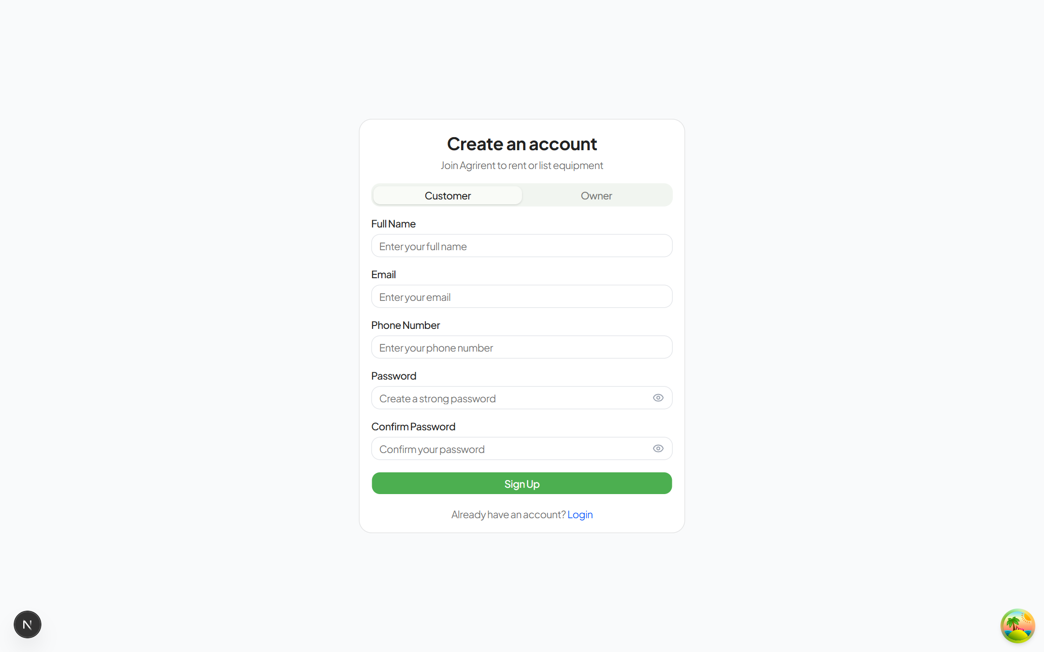
Figure: Customer Registration Form Tab
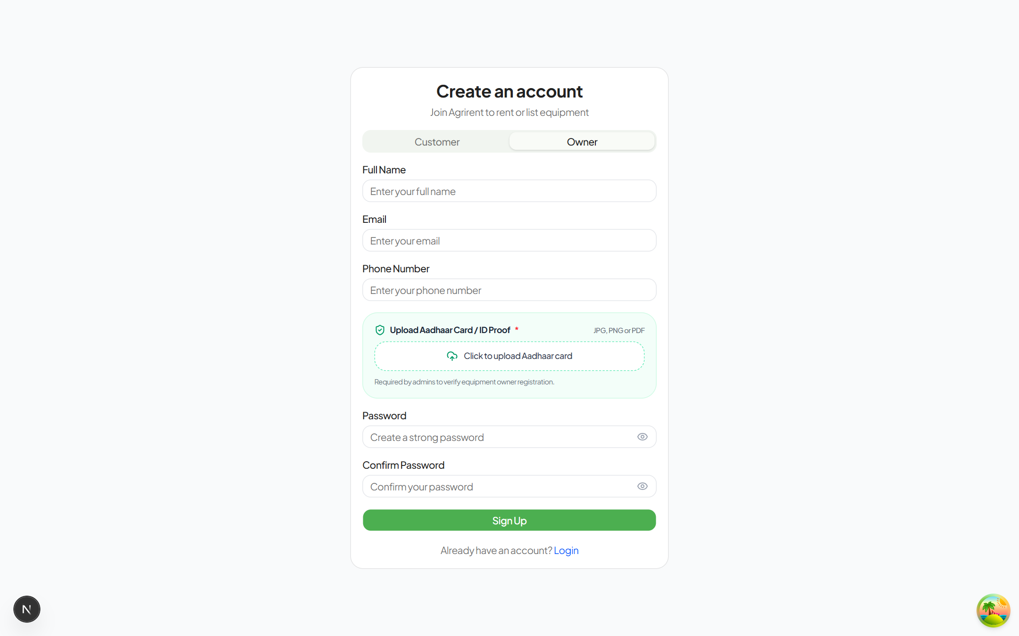
Figure: Owner Registration with Integrated Aadhaar Document Upload
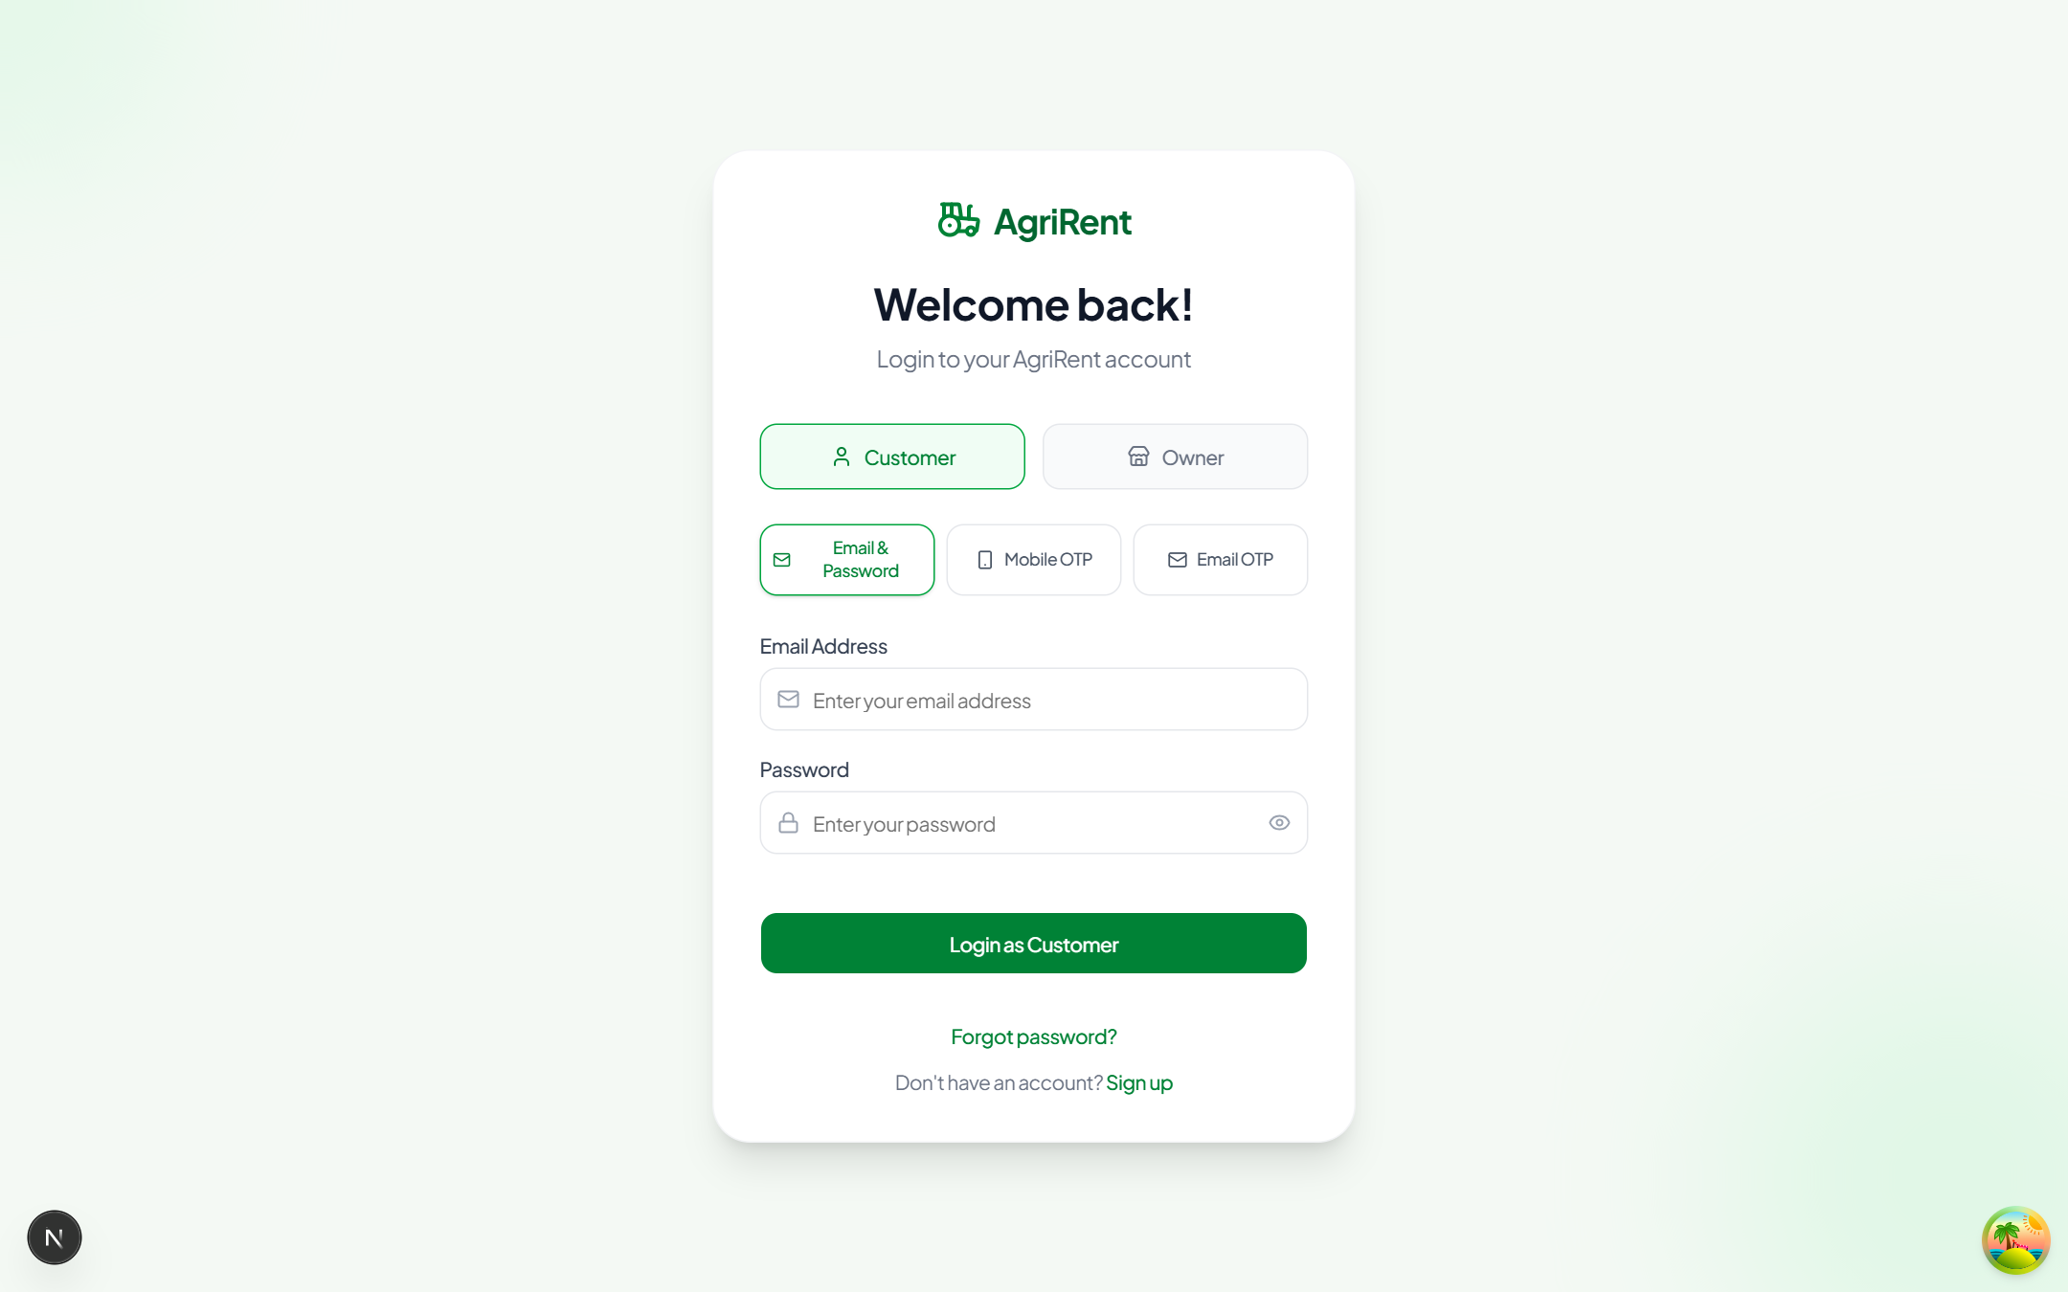
Figure: Secure Sign-in & Authentication Portal

4. Administrator Dashboard & Platform Controls
The Agrirent Admin Dashboard (/dashboard/admin) provides centralized governance, moderation, and analytics across all platform operations. It features live KPI metrics, prominent action items, and dedicated management interfaces.

Admin Features & Visual Red Logout Button
- Platform Operations Banner: One-click shortcuts to Verifications, Equipment Approvals, and Financial Transactions.
- Real-Time Financial & Booking KPIs: Color-coded cards displaying Platform Revenue (INR), Total Bookings, Total Users, and Pending Approvals compared against previous day metrics.
- Red Logout Button: Prominent red logout button with high-contrast icon for quick, secure administrative session termination.
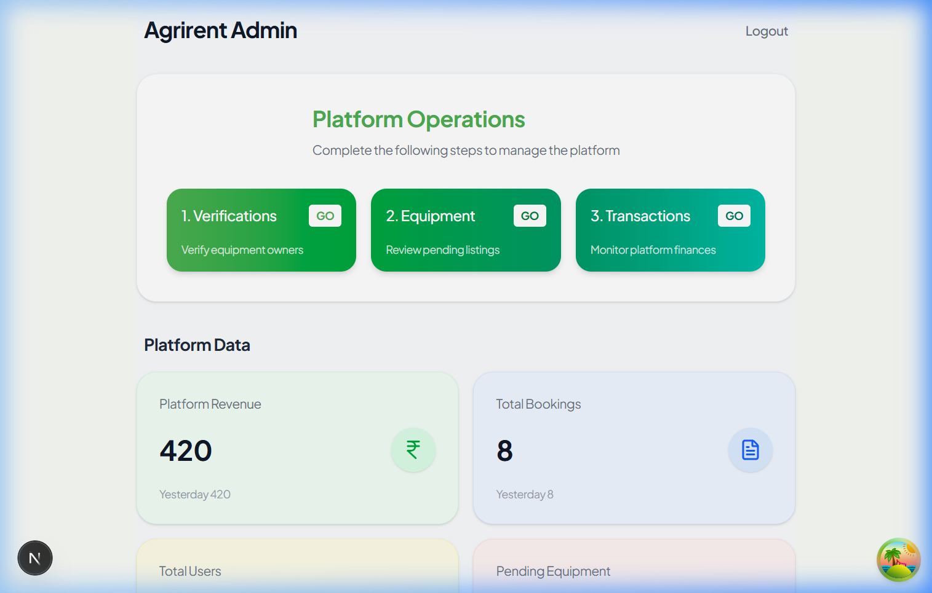
Figure: Administrator Dashboard with KPI Analytics and Operations Center

Owner Verifications & Aadhaar Document Inspector
On the Admin Owner Verifications page (/dashboard/admin/owners), administrators inspect owner applicants and verify their credentials before granting listing privileges:
- Direct Aadhaar Viewer: Clicking 'View Aadhaar Card ↗' opens the uploaded Aadhaar document in full resolution.
- Approve & Reject Workflow: Admins can approve or reject applications in one click. Approving automatically grants the owner role and unlocks fleet management.
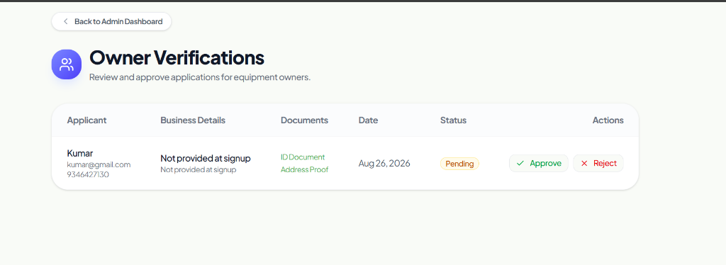
Figure: Owner Verifications Screen with Direct Aadhaar Inspection

User Management & Admin Edit User Dialog
The User Management panel (/dashboard/admin/users) provides total visibility over all registered accounts. Admins have full capability to edit user details directly through a Base UI interactive modal:
- Edit Contact Information: Admins can update email addresses and phone numbers when users request phone or email changes.
- Role Management: Admins can seamlessly switch account roles between Customer, Equipment Owner, and Admin.
- Dual Table & Card Representation: Full tabular presentation on desktop and compact card view on mobile.

5. Equipment Owner Fleet & Booking Management
Verified equipment owners have access to the Owner Dashboard (/dashboard/owner) to manage equipment listings, track incoming booking requests, and visualize booking schedules.

Fleet Management & Booking Calendar
- Add & Edit Machinery: Upload multiple photos, set daily/hourly rates, specify operating location, and define equipment technical specs.
- Optimized Booking Calendar: Compact, responsive calendar view allowing owners to see reserved vs. available dates at a glance on both desktop and mobile.
- Booking Approval Flow: Owners can accept or reject rental requests with live status updates and automatic SMS/Email notifications.
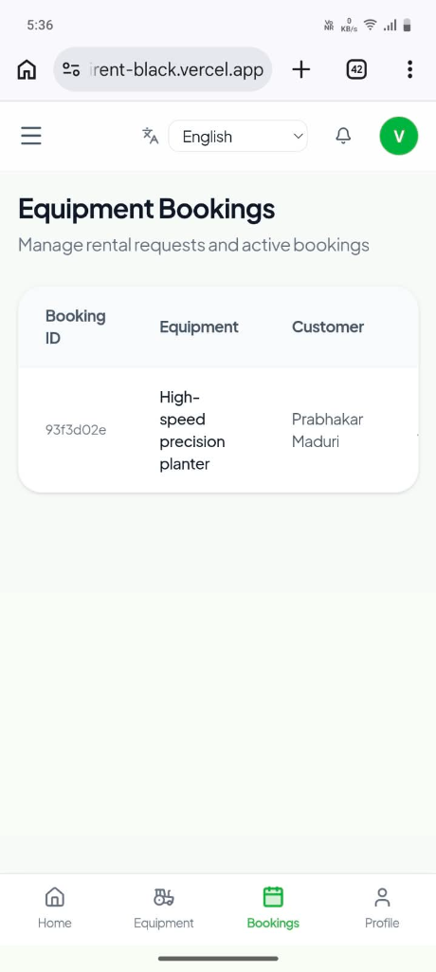
Figure: Owner Dashboard with Booking Schedule and Fleet Summary
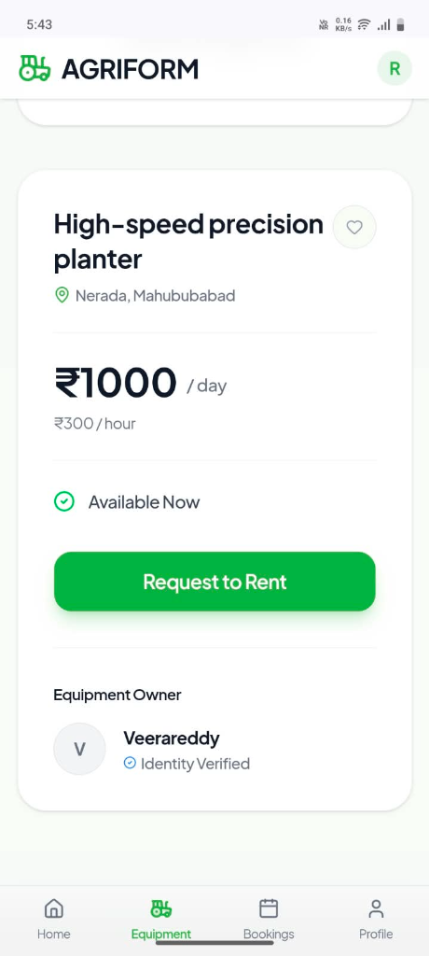
Figure: Owner Fleet Management on Mobile Viewport

6. Mobile Responsive Design & Role-Aware Navigation
Because agricultural machinery owners and farmers frequently access the platform from smartphones in the field, Agrirent is built with a mobile-first philosophy.
- Role-Aware Bottom Navigation Bar: Fixed bottom navigation bar automatically alters its tabs based on the logged-in role (Explore/Bookings/Favorites for Customers; Dashboard/My Fleet/Bookings/Profile for Owners).
- Smart Top-Level Page Routers: Dedicated server-side handlers for /profile, /bookings, and /favorites ensure 100% reliable navigation without 404 errors.
- Responsive Data Cards: Complex desktop tables on Admin, Owner, and User pages dynamically transform into clean mobile cards with action buttons and badge indicators.
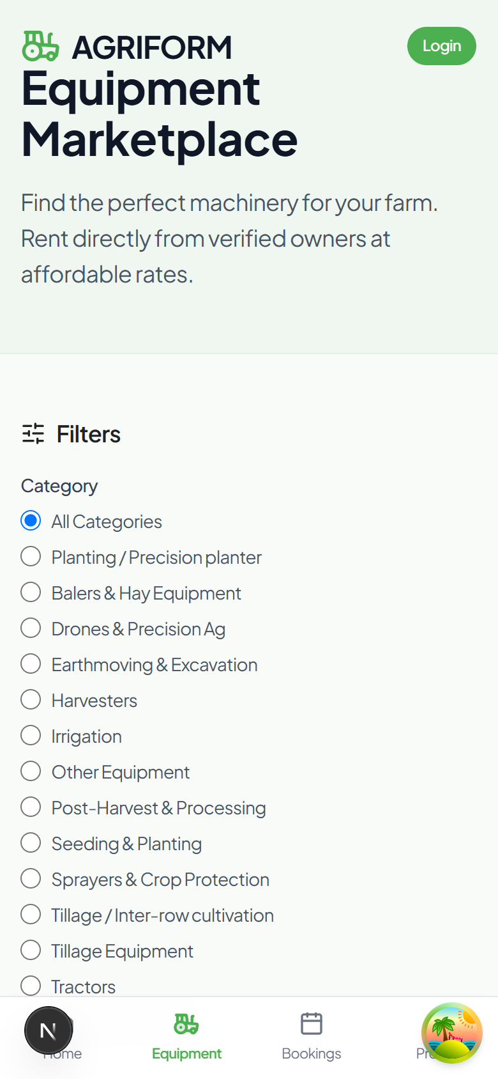
Figure: Mobile Marketplace View with Quick Category Filtering
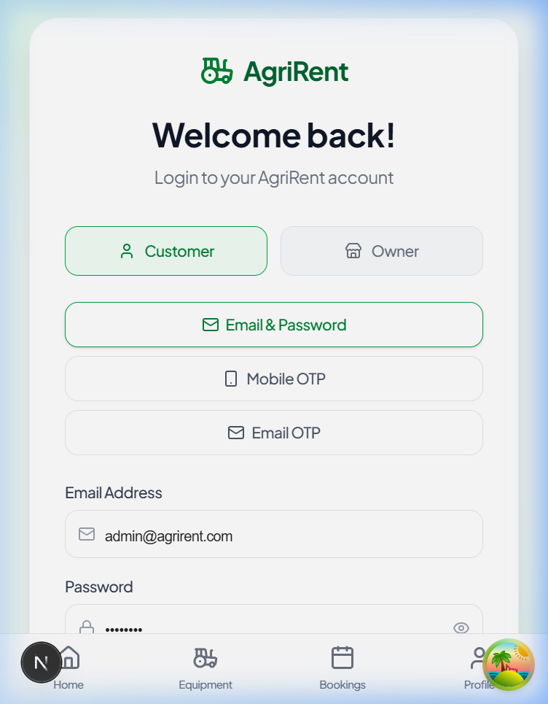
Figure: Admin Dashboard in Mobile View

7. Database Schema & Security Policies
Agrirent is backed by PostgreSQL tables in Supabase with strict foreign keys, cascade rules, and Row Level Security (RLS):
Table Name | Key Columns | Description & Security
profiles | id, full_name, email, phone, role, avatar_url | Stores user profile data synced with auth.users. Read public, update owner/admin.
equipment | id, owner_id, title, category_id, daily_rate, location, status | Agricultural machinery listings. Public read approved, owners manage own.
bookings | id, equipment_id, customer_id, start_date, end_date, total_price, status | Rental reservations. Customers manage own; equipment owners manage received requests.
owner_requests | id, user_id, business_name, identity_document_url, status | Owner verification records storing Aadhaar card URL. Admin review & update.
payments | id, booking_id, amount, payment_method, status | Transaction records storing platform commission and owner payouts.
reviews | id, equipment_id, user_id, rating, comment | Customer feedback and ratings displayed on machinery cards.

8. Conclusion & Git Repository Summary
Agrirent delivers an enterprise-grade, high-performance web platform tailored for the modern agricultural ecosystem. With full role-based permissions, automated Aadhaar document verification, intuitive booking calendars, and mobile-first optimization, the application ensures security, scalability, and ease of use for all stakeholders.

