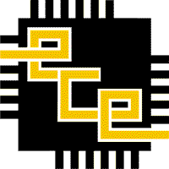 

**Shreyas R ECE, 4th Semester**

**Praphul Gowda ECE, 4th Semester**

**Karthik K Bhat ECE, 4th Semester**

**Guide: Dr. Anuradha M**

**Shreyas R ECE, 4th Semester**

**Praphul Gowda ECE, 4th Semester**

**Karthik K Bhat ECE, 4th Semester**

**Guide: Dr. Anuradha M**

**Data Transmission through Ultrasonic Sound**

**Data Transmission through Ultrasonic Sound**