**Table of Contents**

[**Abstract:** 2](#_Toc7221763)

[**Introduction:** 2](#_Toc7221764)

[**Problem Statement:** 3](#_Toc7221765)

[**Literature Survey:** 4](#_Toc7221766)

[**Applications:** 5](#_Toc7221767)

[**Approach:** 6](#_Toc7221768)

[**Block Diagram:** 6](#_Toc7221769)

[**Components used:** 6](#_Toc7221770)

[**Choice of components:** 7](#_Toc7221771)

[**Working of HC-SR04:** 7](#_Toc7221772)

[**Circuit Design:** 9](#_Toc7221773)

[**Transmitter Circuit** 9](#_Toc7221774)

[**Receiver Circuit** 10](#_Toc7221775)

[**Simulation Results:** 11](#_Toc7221776)

[**Codes:** 13](#_Toc7221777)

[**Transmitter Code:** 13](#_Toc7221778)

[**Receiver Code:** 15](#_Toc7221779)

[**Flowchart and Algorithm:** 17](#_Toc7221780)

[**Transmission:** 17](#_Toc7221781)

[**Reception:** 18](#_Toc7221782)

[**Result:** 19](#_Toc7221783)

[**Hardware Design:** 20](#_Toc7221784)

[**Future Scope:** 21](#_Toc7221785)

[**Conclusion:** 21](#_Toc7221786)

[**References:** 22](#_Toc7221787)

# **Abstract:**

The rapidly increasing technologies of communication or data transmission have a common purpose of increasing data rates and a hack proof communication. In the world of modern-day communication, many technologies have been invented for a secure and fast data transmission. Out of many ideas for data transmission, “data transmission through ultrasonic sound” is the least explored. This project is an approach towards establishing a secure data transmission using ultrasonic sound. This approach is a line-of-sight communication where the access to the transmitter is restricted in the line of sight of the transmitter. High-frequency sound does not pass through walls (most energy is reflected), so identified devices are constrained to approximately the same room, “within earshot” of one another. Ultrasonic sound has a frequency greater than 20kHz which is inaudible to human ears. This makes this technology more environment-friendly. This prototype consists of a basic transmitter and receiver circuit which employs ultrasonic transducers. This project deals in transmission of text from the transmitter to receiver. Our project was inspired by “sound pay” technology introduced by “Google Pay (Tez)”.

# **Introduction:**

We develop a communication protocol for transmitting small amounts of data as inaudible near-ultrasonic sound over short distances, using signals concentrated in 40kHz. The system is based on amplitude modulation of a square wave to match the current levels of the transducers used. Devices conventionally transmit data using Bluetooth or Wi-Fi. Yet there are several advantages to using sound as a communication medium instead:

1.Establishing a Bluetooth or Wi-Fi connection takes multiple seconds, whereas sound playback or recording can start in tens of milliseconds.

2.Unlike Bluetooth and Wi-Fi, high-frequency sound does not pass through walls, which is useful for co-presence to constrain the transmitter and receiver to approximately the same room, “within earshot.”

3.Bluetooth is often disabled and is otherwise problematic.

These properties of sound enable quick, localized exchanges, which are attractive for interactive mobile applications like device pairing, broadcasting a resource or sharing content based on proximity.

In typical indoor environments, sound reflects from walls and surrounding objects. There are usually multiple propagation paths from the transmitter to the receiver, even when devices have line of sight, and these interfere in complicated ways. Sound reflects more than radio signals do from most indoor building materials. Hard smooth surfaces like gypsum wallboard and glass windows are very reflective at higher frequencies.

Data can be transmitted with standard speakers and microphones. Ultrasonic bypasses the physical limitation of short-range RF. Like other communication protocols, data can be encrypted and transmitted. Properties of sound enable quick localized data transfers which is key factor in sharing resources based on proximity. This technology we describe is a component of Google's Nearby platform, which uses this technology and other media to discover and send messages between nearby devices. Variants of the described protocol are used in Chromecast guest mode to authenticate a guest's mobile device automatically, in Google Play Games to find nearby players, and are behind Audio QR in Google Tez for discovering and pairing parties in a cash transaction. Our approach can be extended to developing an interface with smart phones and various other devices. This prototype is reliable to distances of 2m to 10m. Further extension of this prototype is to make the system work and respond properly for dynamic ranges.

## **Problem Statement:**

**“Design a prototype that is able to transfer digital data using ultrasonic sound”**

These were the design parameters that the prototype had to achieve:

|  |  |  |  |
| --- | --- | --- | --- |
| **#** | **Details** | **Value** | **Unit** |
| 1 | Transmission Length | 20 | centimeter |
| 2 | Transmitter Power | 100 | milli Watt |
| 3 | Power Supply | 5 | Volts |
| 4 | Transmission Speed | 80 | bps |
| 5 | Ultrasonic Sound frequency | 40 | kHz |

# **Literature Survey:**

**Jonny Biguenet, “Ultrasonic data transmission”, 2016**

This paper gives us an insight about the problems faced during the design of transmitter and receiver circuit.

Audio hardware limitations include transmission of binary data (square wave) through normal speakers is not possible as they do not respond to such signals. This problem led us to explore about the possibilities of using other transducers to transmit binary data.

**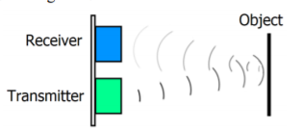V A Zhmud, N O Kondratiev, K A Kuznetsov, V G Trubin, L V Dimitrov, “Application of ultrasonic sensor for measuring distances in robotics”, 2018**

This paper gives an idea about working and internal circuitry of ultrasonic sound sensor particularly HC-SR04. The ultrasonic transducers used in this sensor respond to binary data (square wave). This led us to designing of a receiver and transmitter circuit using the ultrasonic transducer. This paper gives us a solution to the problems faced which was mentioned in the previous paper discussed. In our project the same transducers of HC-SR04 is used to transmit the data by varying with of square wave. Width is 2 milli-seconds if the bit is 1 and width is 4 milli-seconds if the bit is 0.

**Kerry D. Wong, “A Sensitive DIY Ultrasonic range sensor”, 2011**

This paper discusses about ultrasonic transducers. This paper also introduces us to the transmitter circuit. It uses a bridge circuit produces an output voltage roughly twice the Vcc, for longer measurements the driving voltage can be increased to 12V. The transistors 2N3904 and 2N3906 cannot be used for voltages above 6V as it heats up.

**Pascal Getreuer, Chet Gnegy, Richard F. Lyon, Life Fellow, IEEE, and Rif A. Saurous. “Ultrasonic Communication Using Consumer Hardware”, 2018**

The following points are inferred from this paper. This paper discusses about Wi-Fi and Bluetooth connection and its disadvantages for small data transmission as it takes longer time to pair. The 18.5 to-20 kHz is inaudible to most humans and yet realizable with commodity speakers and microphones in mobile devices. Speakers of common phone produces 74 dB SPL at 18 kHz whereas the threshold is 86 dB SPL to be audible.

# **Applications:**

1. **Under water data transmission:**

Radio waves cannot travel through water without attenuation. What limits transmission is conduction, and sea water is very conductive, and largely, in the case of sea water, absorption. Together they severely limit high frequency (short wavelength) transmissions; however, low frequency (long wavelength) radio does travel through a little better. the conductivity of water with a relative permittivity of 81 can greatly affect its electromagnetic propagation. Radio waves get progressively weaker the deeper they penetrate into salt water, and that attenuation is a function of salinity. Submarines needs to send and receive data from underwater to the nearest camp quickly and efficiently. Ultrasonic communication is used to receive and send data to sonic communication equipment in the seabed of areas frequently travelled by their submarines and connected it by [underwater communications cables](https://en.wikipedia.org/wiki/Submarine_communications_cable) to their land stations.

1. **Short range resource sharing between devices:**

A Bluetooth or Wi-Fi connection takes multiple seconds for establishing a connection. Here sound playback or recording can start in tens of milliseconds, making it more suitable for data transfer between devices when the data to be transferred is not large. An application named Google Pay now uses ultrasonic sound to transfer money. Here the phones of payer and payee are paired using ultrasonic. This feature is called audio QR code.

1. **Secure Data Communication:**

These days data security is the most important aspect of any data transfer. Bluetooth and Wi-Fi pass through the walls unlike ultrasonic sound. This feature of ultrasonic sound can be used to keep the data secure as the data does not pass through the walls and the signal of the transmitter is constrained to the same room.

1. **Electromagnetic Sensitive Area:**

Electromagnetic sensitive areas (petrol pumps, hospitals etc.) have a problem to transmit data. Electromagnetic radiation emitted by our mobile phones can ignite the petrol vapor directly and causing explosions and it can induce currents in nearby metallic objects which can also cause explosions. Most hospitals don’t recommend using phones because of electromagnetic radiations on the patients. In such sensitive areas ultrasonic sound can be employed thereby by preventing hazardous accidents.

# **Approach:**

**Block Diagram:**

Our approach towards designing the prototype of “data transmission using ultrasonic sound” includes the data that is text to be transmitted from transmitter end to receiver end. Data from transmitter end is sent to a microcontroller. Further, microcontroller converts the data into its corresponding ASCII values. These ASCII values are sent serially to the transmitter circuit in binary form. Pulses of sound are transmitted through the medium between transmitter and receiver by the ultrasonic transducer in the transmitter circuit.

At the receiver end, the ultrasonic transducer converts the change in sound pulses into corresponding change in the current levels of the circuit. But the transducer also responds to frequencies in and around 40kHz. We use a band-pass filter to filter out all other frequencies except that of 40kHz. Now the corresponding voltage levels are sent to the microcontroller serially. Further, the microcontroller converts this binary value into corresponding characters.

## **Components used:**

|  |  |  |
| --- | --- | --- |
| **#** | **Components** | **Number** |
| 1 | 2N3904 NPN Transistor | 3 |
| 2 | 2N3906 PNP Transistor | 2 |
| 3 | Arduino Uno | 4 |
| 4 | Ultrasonic Transducer | 2 |
| 5 | LM393 Op-amp IC | 1 |
| 6 | LM386 Op-amp IC | 1 |
| 7 | Resistors | 9 |
| 8 | Capacitors | 1 |
| 9 | LED | 1 |

## **Choice of components:**

Transducer: 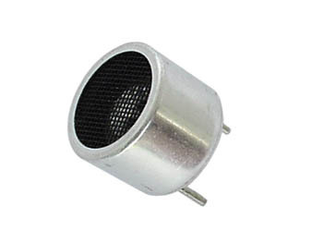

The transducer is a device that converts electrical signal to physical quantity or vice versa. The main criteria to choose an ultrasonic transducer are the resonant frequency, radiation pattern and sensitivity. Sensitivity affects the efficiency of the transducer and attributes to the SNR. For the receiver and transmitter, we would be using 40 kHz ultrasonic transducer.

Transistors:

2N3904 NPN Transistor and 2N3906 PNP Transistor - A high DC current gain is required for the transmitter circuit to amplify current signals. Both the transistors have a DC current gain of 100 at Ice = 10mA and VCE = 1V.

Op-amps:

LM386: The receiver circuit requires the sound signal to be amplified. This amplification should consume less power so to make the circuit energy-efficient. LM386 IC is a low power amplifier which consumes power of 120mW.

LM393: The receiver circuit uses a voltage comparator. It has a precision voltage comparator with an offset voltage specification as low as 2.0 mV max which is designed specifically to operate from a single power supply over a wide range of voltages.

# Image result for HC Sr04**Working of HC-SR04:**

First thing to understand is that the order of events is

1. Microcontroller sends a trigger pulse to the unit to start a measurement, which INSIDE the unit

* Sends a burst of 8 x 40 kHz pulses via Ultrasonic sender
* Sets an Echo output signal HIGH
* In the real world the sound wave is sent out and reflected off objects and the FIRST reflection back (echo) is deemed as the NEAREST object (other echoes may be received further oscillations of the sensor RX and possibly TX, are seen after this, but are ignored).
* 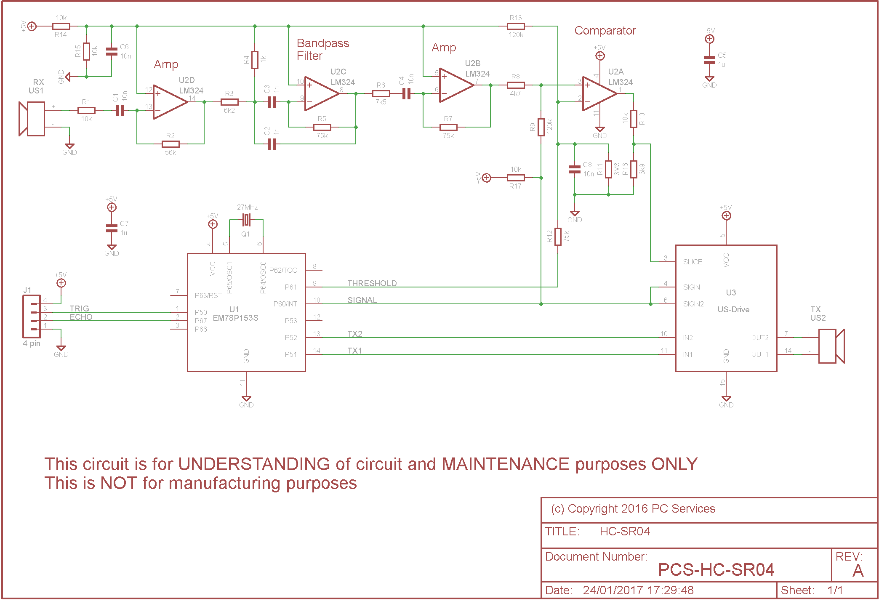The first echo oscillations will hopefully at end of 8th cycle cause the unit to set the Echo output signal LOW

HC-SR04 internal circuit diagram

1. Microcontroller has to time how long the Echo signal from the unit is high to determine the time of the echo
2. Microcontroller can then convert time of echo to distance away, knowing the time is time to the NEAREST object and back again (round trip).

Scope shot of signal timing
(Source: pcserviceselectronics.co.uk)Output of sensor on oscilloscope

# **Circuit Design:**

## **Transmitter Circuit**

**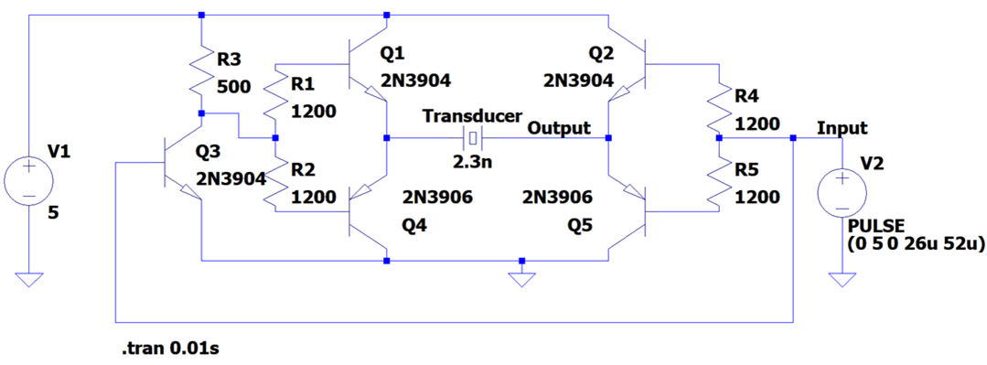**

**Explanation:**

The current flowing through the transducer should be like the input signal given by the microcontroller with suitable gain for the transducer to respond to given input signal. This circuit consists of two push-pull amplifiers. Each time when either the input goes high or low, one of the amplifiers pulls more current and the other pushes more current.

1. When the pulse input goes high Q2, Q3, Q4 are switched on. Since Q3 acts like an inverter, the push pull amplifier on the left side pulls in more current and the push pull amplifier on the right side pushes more current. This gives a path for the current to flow from Q2 to Q4 through the transducer. More current flows through the transducer as the current signal coming from the input is amplified.
2. When the pulse input goes low Q1 and Q5 transistors are switched on. All other transistors are switched off. This leads to a path for the current to flow from Q1 to Q5 through the transducer. This current is small when compared with the previous case as the only source is from the battery which has a less current rating.

## **Receiver Circuit**

**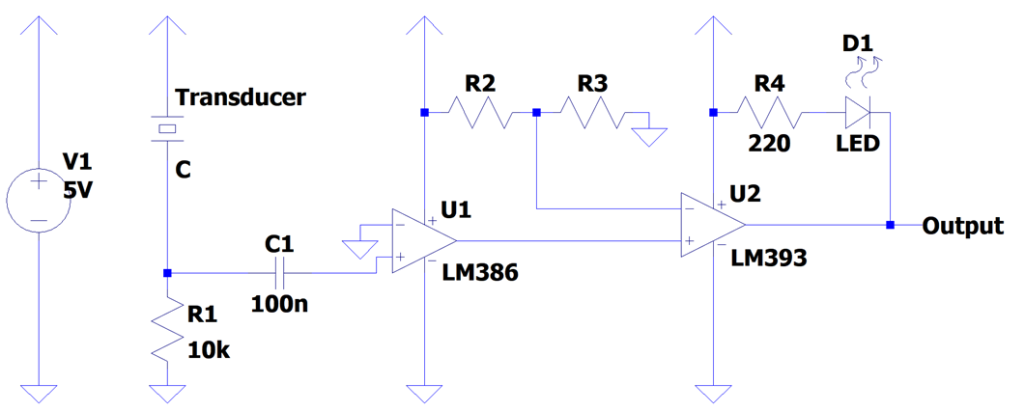**

**Explanation:**

The output should go high when the current flowing through the ultrasonic transducer is maximum and the output should go low when the current flowing through the ultrasonic transducer is minimum. LM386 IC is used as an op-amp amplifier to increase the current levels of the signals received. Further, output from this stage is given to a comparator LM393 IC. Resistors values are chosen in such a way that the output is high when the current flowing into the non-inverting terminal of the op-amp is maximum and output is low when the current flowing into the non-inverting terminal of the op-amp is minimum. The transducer here acts as a current source. The input to the op-amp is the voltage signal that is derived from the current flowing through the resistor.

# **Transmitter_simulationSimulation Results:**

Simulation of Transmitter Circuit done on LTSpice

**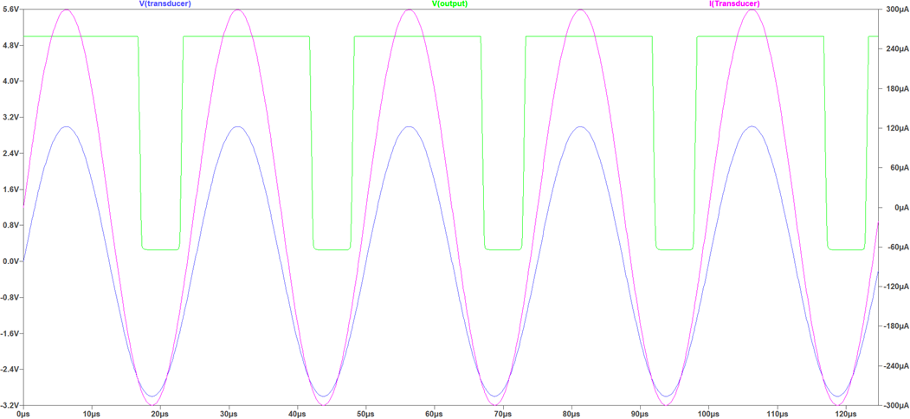**

Simulation of Receiver Circuit done on LTSpice

**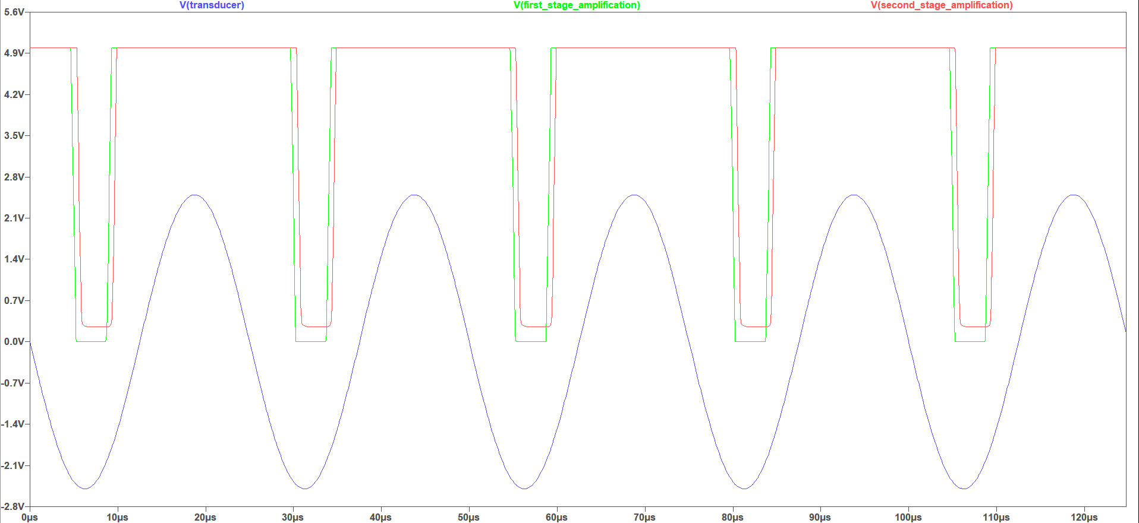**

Receiver circuit-Output from each stage

# **Codes:**

## **Transmitter Code:**

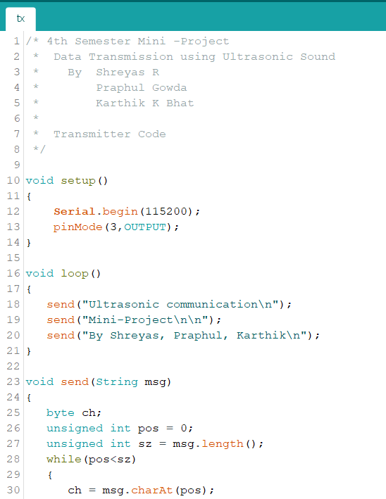

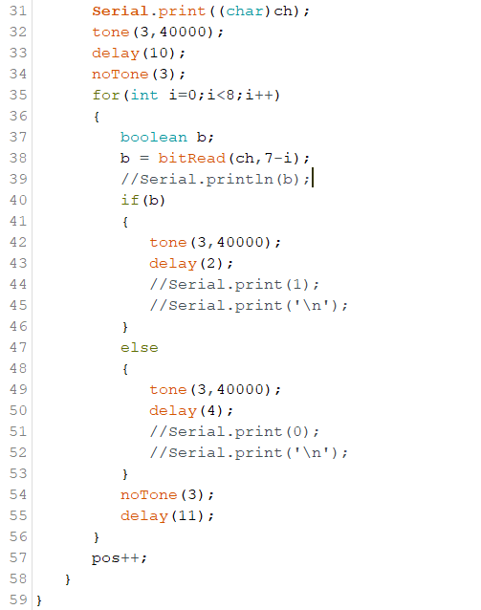

## **Receiver Code:**

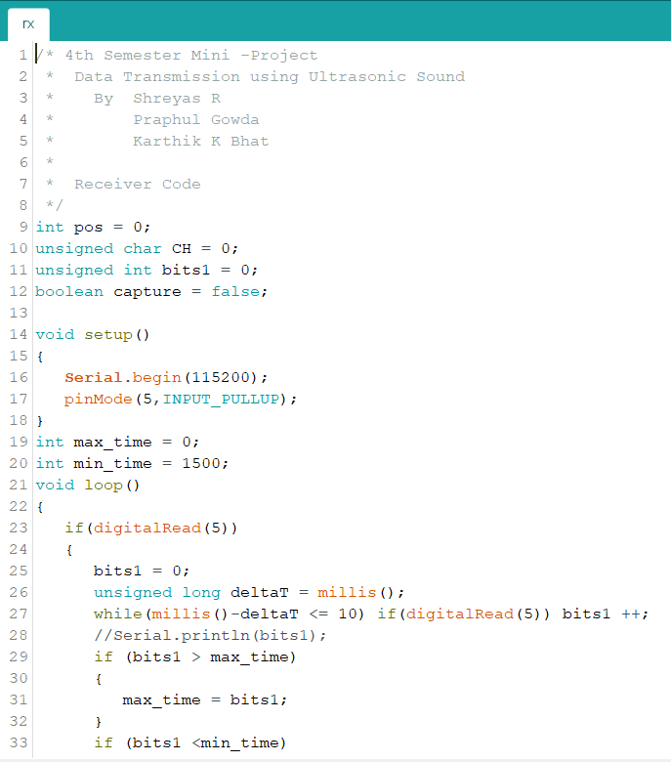

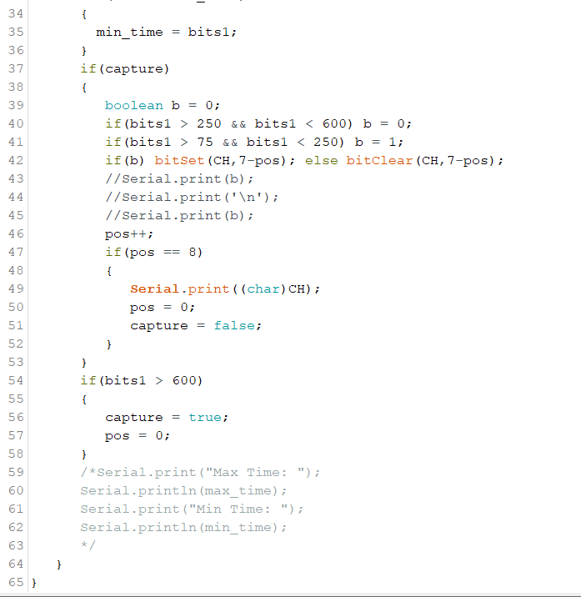

# **Flowchart and Algorithm:**

## **Transmission:**

**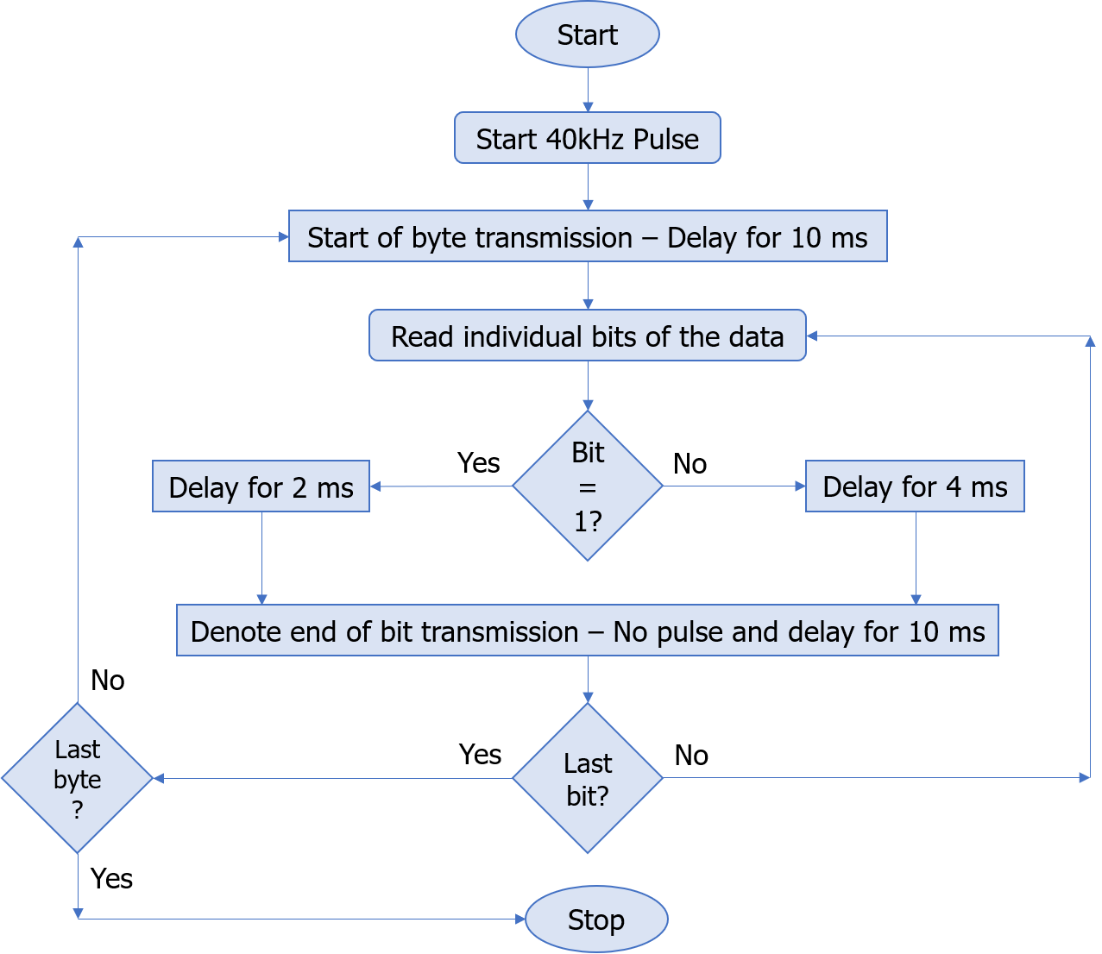**

**Flowchart for Transmission Algorithm**

**Transmission Algorithm:**

1. A square wave of 40 kHz is used for transmission.

2. Denote the start of the transmission of a byte by sending the square wave for a duration of 10 milli-seconds.

3. Read individual bits of the data.

4. If the bit is 1, then send the square wave for 2 milli-seconds.

5. If the bit is 0, then send the square wave for 4 milli-seconds.

6. Wait for 10 milli-seconds before transmitting the next bit.

## **Reception:**

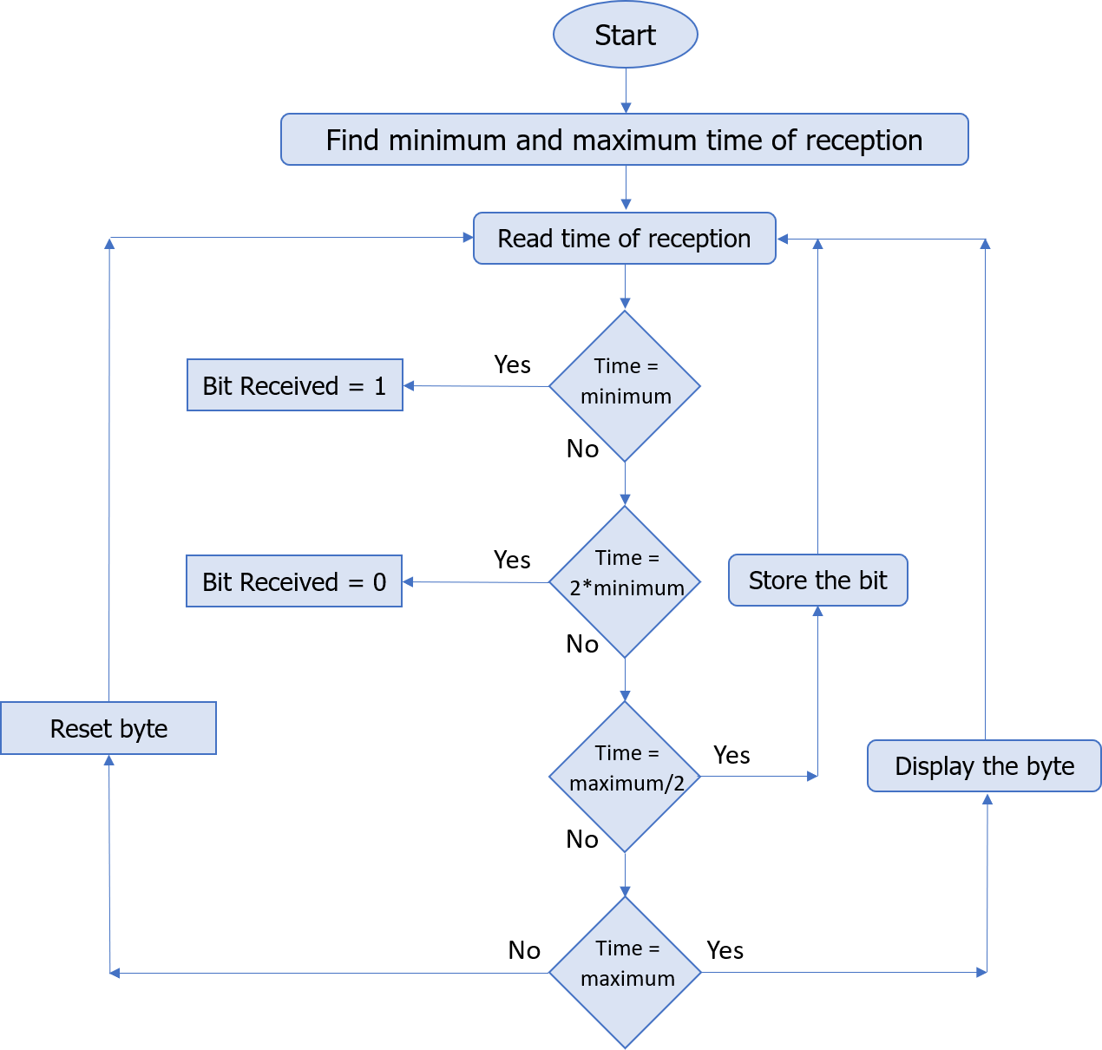

**Flowchart for Reception Algorithm**

**Reception Algorithm:**

1. Find the maximum time of reception and minimum time of reception.
2. The minimum time of reception refers a high bit.
3. Twice the minimum time of reception refers a low bit.
4. Half the maximum time of reception refers to reception of next bit
5. The maximum time of reception refers to reception of a new byte.
6. Have some threshold for the reception time to accommodate small variation in the length of transmission.
7. Encode the time in terms of bits and read the characters.

# **Result:**

**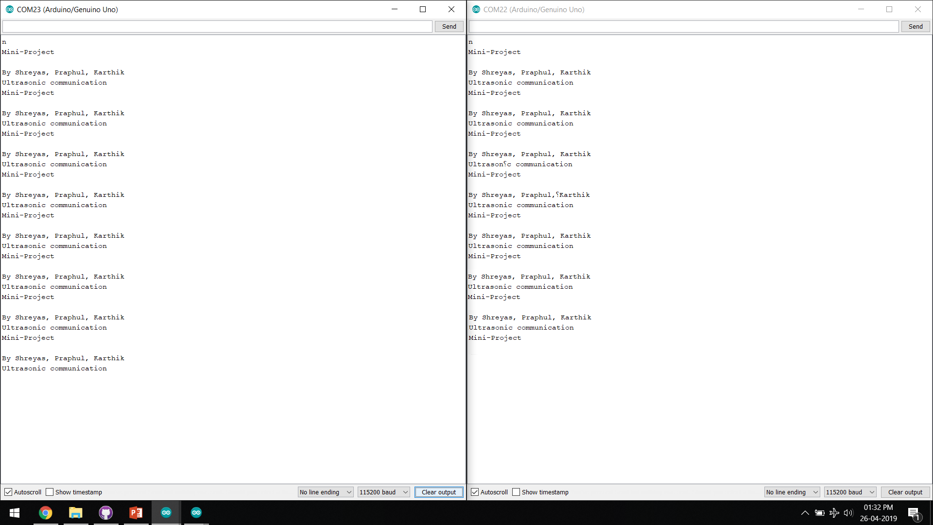**

Transmission Side Receiver Side

Output on Serial Monitor (Arduino IDE)

# **IMG_9466Hardware Design:**

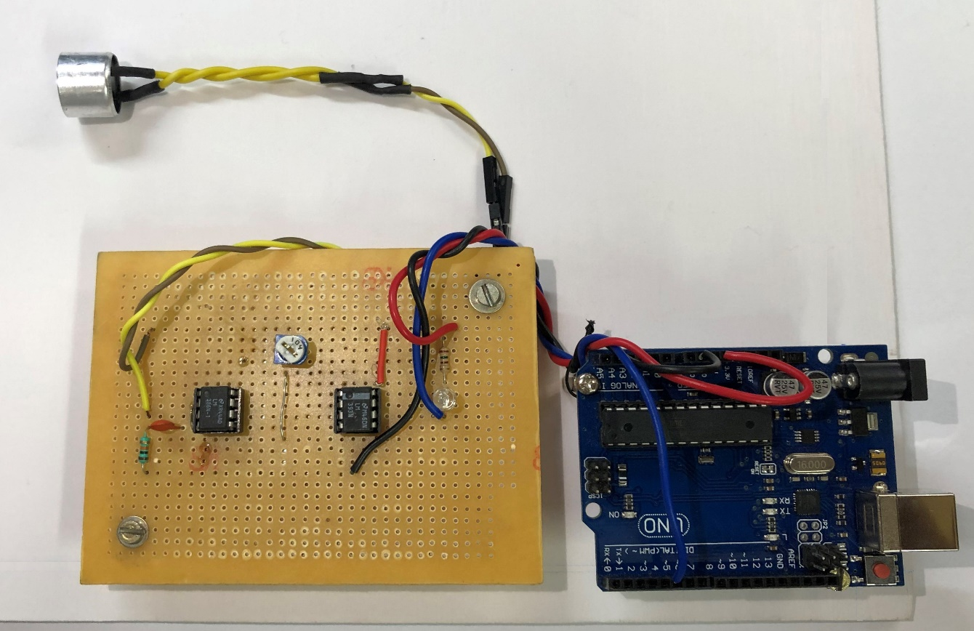Transmitter Circuit

Receiver Circuit

# **Future Scope:**

1. To improve the prototype for dynamic length of transmission

2. Find better, efficient algorithm to increase the speed of transmission

3. Interface with smartphones

I. To help in transfer of data in electromagnetic sensitive zones.

II. To help in pairing of devices.

# **Conclusion:**

1. Data can be effectively transmitted with ultrasonic sound with considerable transmission speed.

2. Data Transmission through ultrasonic sound can be employed for short ranges and small data packets.

3. The designed prototype works only when transmitter and receiver transducers are in line-of-sight.

# **References:**

1. Pascal Getreuer, Chet Gnegy, Richard F. Lyon, Rif A. Saurous, “Ultrasonic Communication Using Consumer Hardware”, IEEE Transactions on Multimedia, Volume: 20, Issue: 6, pages: 1277 – 1290, 2017.
2. Igor Bisio, Alessandro Delfino, Aldo Grattarola, Fabio Lavagetto, Andrea Sciarrone, "Ultrasounds-Based Context Sensing Method and Applications Over the Internet of Things", Internet of Things Journal IEEE, vol. 5, no. 5, pp. 3876-3890, 2018.
3. Jafar Saniie, Boyang Wang, Xin Huang, "Information Transmission Through Solids Using Ultrasound Invited Paper", Ultrasonic Symposium (IUS) 2018 IEEE International, pp. 1-10, 2018.
4. Thuy Ong, The Verge, “Google’s new payment app for India uses sound to transfer money”, 2017.
5. TeamLisnr, “How Ultrasonic Data Transmission Compares to RF Protocols”, 2018.
6. Kerry D. Wong, “A Sensitive DIY Ultrasonic Range Sensor”, 2011.