**Working With Databases in Talend:**

**Metadata:**

The Talend repository supports database metadata. This allows you to define connections to databases and then import schema objects such as tables. Setting up this metadata allows you to test your database connectivity, as well as making it convenient to work with databases within your Jobs.

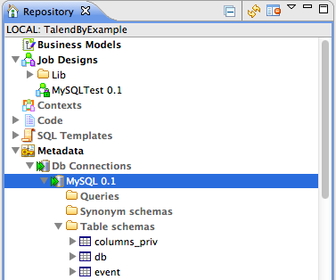

**Creating a Repository database connection:**

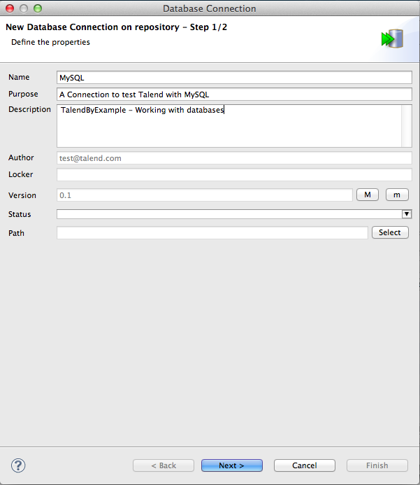

**Database Connection Parameters:**

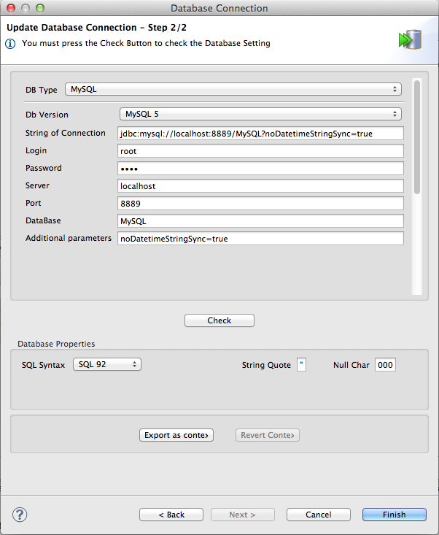

## **Retrieve Schema**

Now that your repository database connection has been established, *right-click* your **Database Connection** and select**Retrieve Schema** from the *pop-up* menu. This will display the **Schema** dialog. Step 1 of this dialog allows you to set your **Filter Conditions** and your **Selection Types**.

### Select Types

The **Select Types** option allows you to specify the database object types to choose from. You may select tables, views and synonyms.

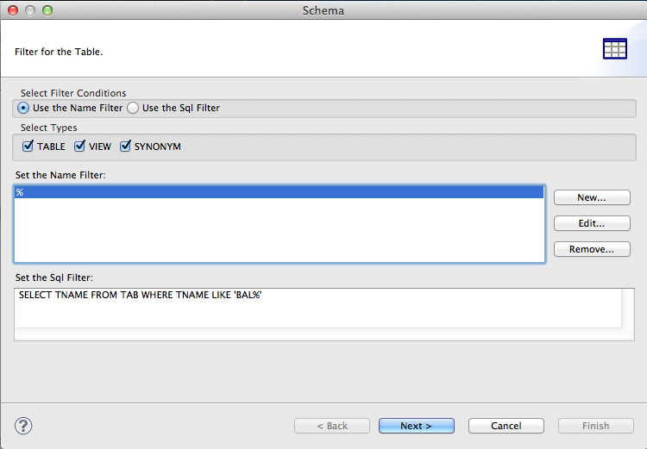

### Choose Objects

Stage 2 allows you to choose objects. You may expand a node in the list by pressingImage 6. **Name Filter** allows you to hide objects from view. Select the objects that you would like to import, using the *check boxes* to the left of each node. When completed, hit **Next**. Note that you may need to allow Talend time to retrieve information from the database, before this button becomes available.

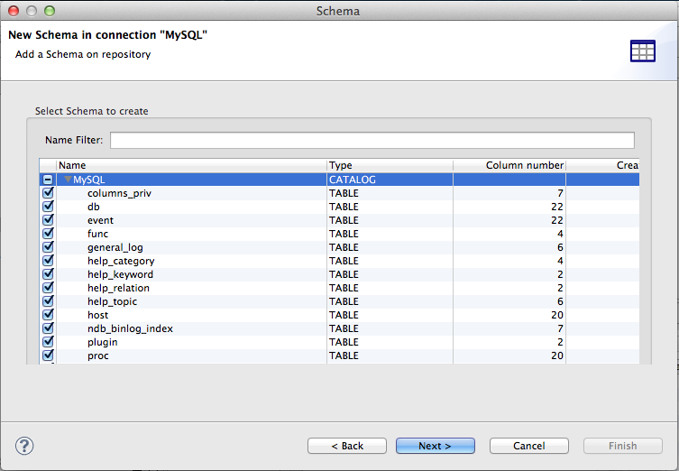

### Fine Tuning

Stage 3 allows you to make some final amendments before you import. This is more useful when you are reviewing previously imported objects

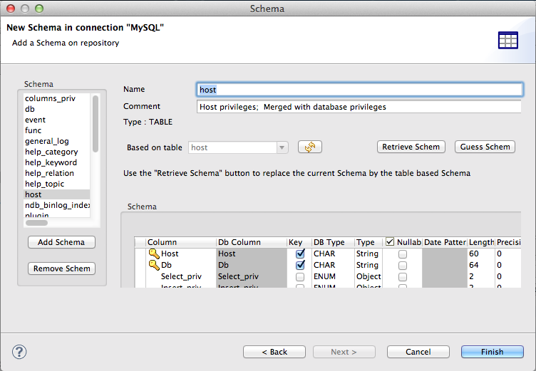

## **A Simple Job:**

Importing table with predefined schema.

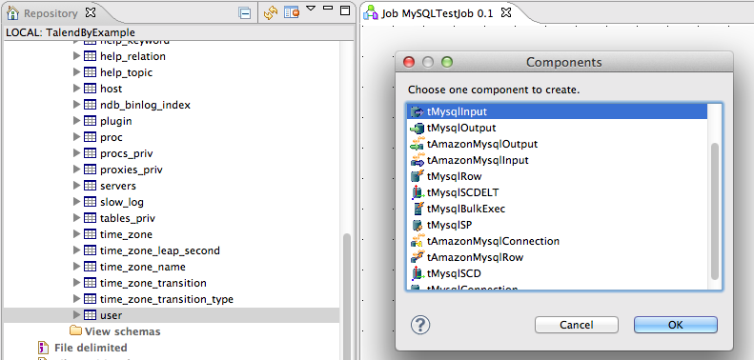

If you want to use a repository connection in a job, you can directly use it as shown in the below SS:

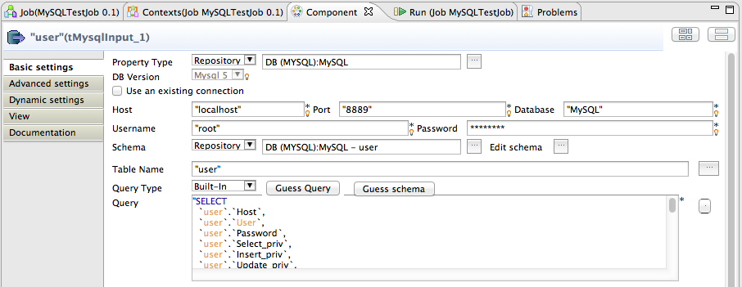

**Built-In**

Built-In allows you to hard-code the connection parameters within this component (don't do this), use Context Variables, or use globalMap Objects.

In the above picture for Property Type, select Built-In from drop down, which will allow you to hardcode connection parameters.

**Using Existing Connection:**

Incase you want to use single connection multiple times, you can define connection once, in the job and use the same connection multiple times, by selecting ''Use an existing connection'' check box and pointing it to the desired connection from drop down button.

