**Creating and managing global contexts and variables:**

**Sample Job for working with global contexts & Variables:**

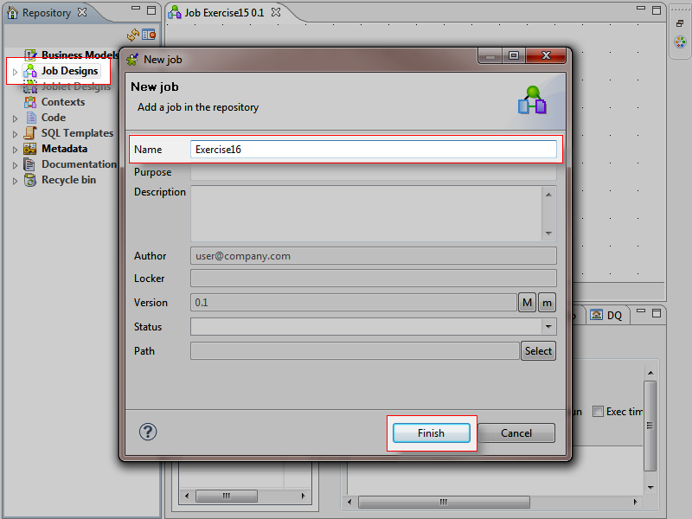

**RowGenerator – tFileOutputDelimited.**

**Loading data from Row generator to OutputFile.**

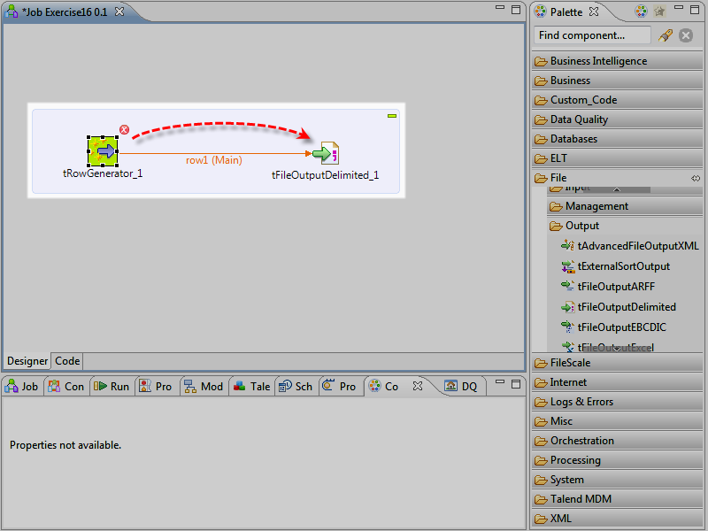

**Defining Schema for RowGenerator:** To set the company column, select String in the **Type** field, select ... in the **Functions** field, go to the **Function parameters** view at the bottom and type in "Client" in the **Value** column.

To set the randomnumber column, select Integer in the **Type** field, select random in the **Functions** field, and keep the default values.

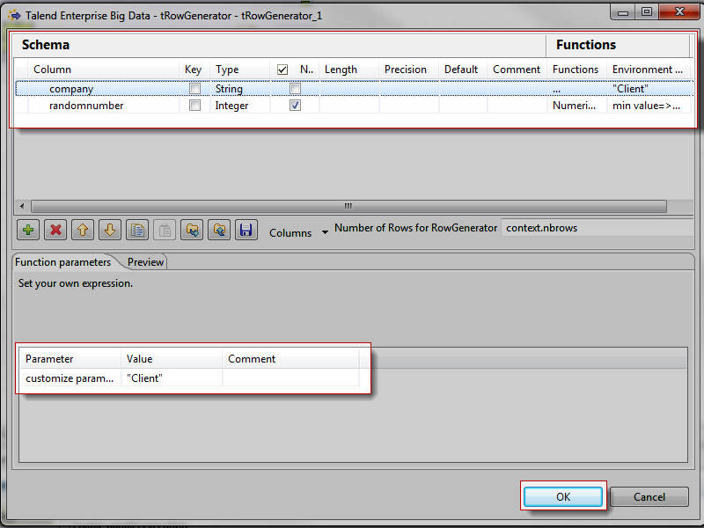

Click **[...]**next to the **File Name** field to specify the path and the name of the file you are creating. Name it: client1.csv

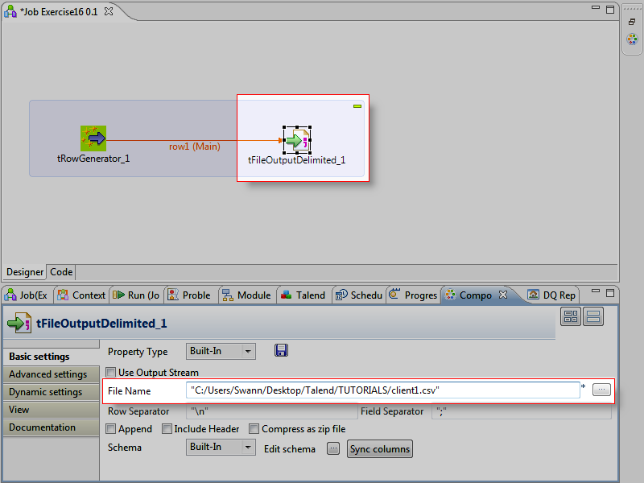

**RUN THE JOB**

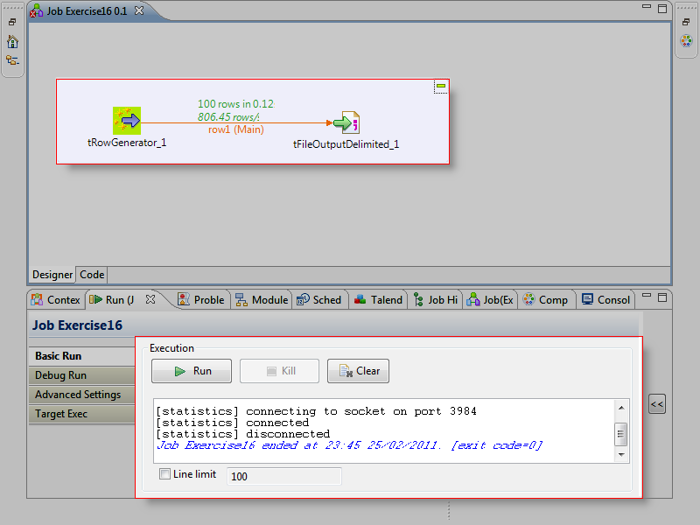

**OUTPUT**

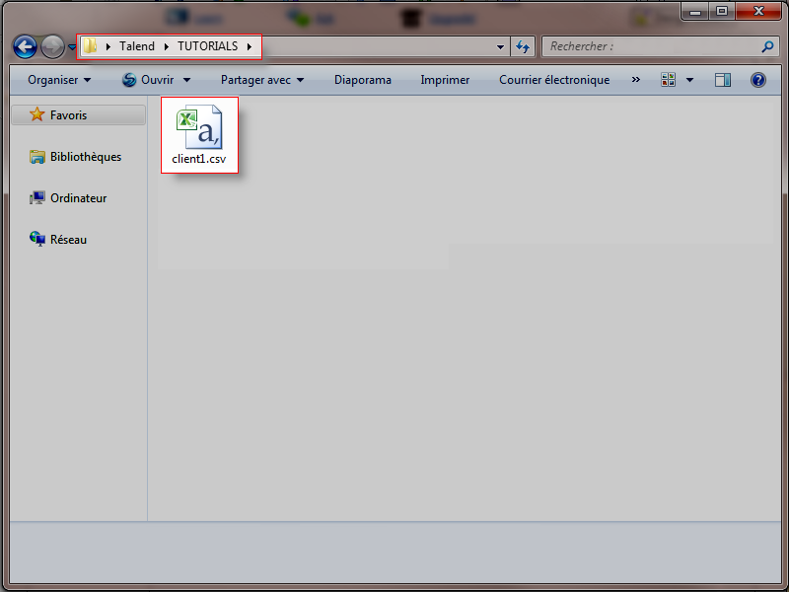

**Now For the above job we will create CONTEXT Groups & Select different CONTEXT Groups to see the output.**

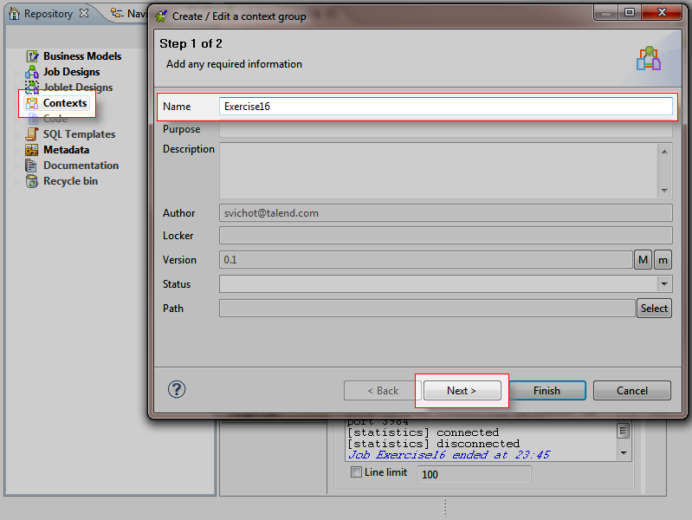

**Create three VARIABLES in the GROUP.**

**Company, directory, nbrows.**

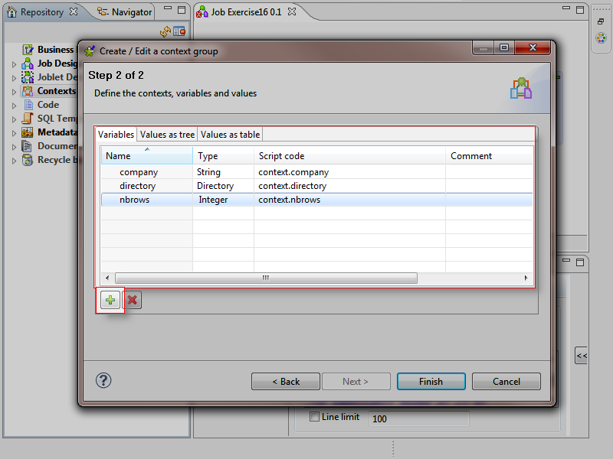

**Create two CONTEXT GROUPS.**

**contextClient1**

**contextClient2**

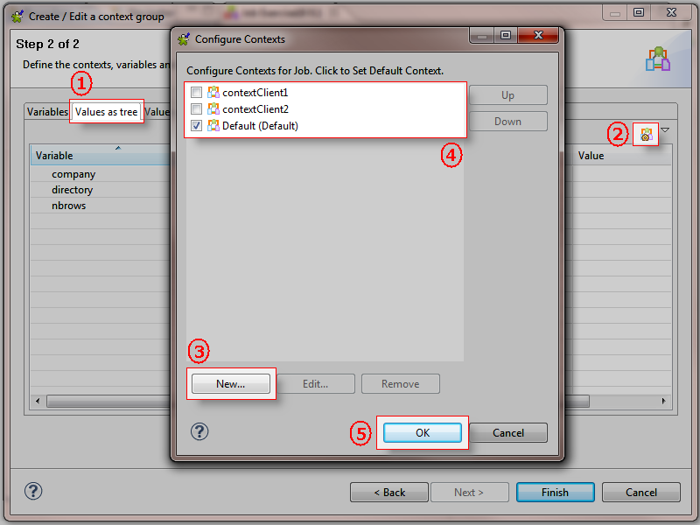

**Define the values for each CONTEXT VARIABLE in the CONTEXT GROUP.**

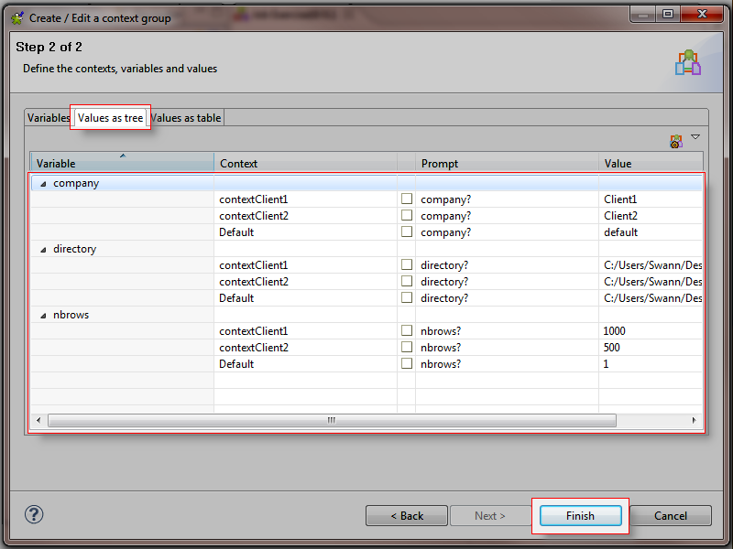

**IMPORT the CONEXT GROUP in the job.**

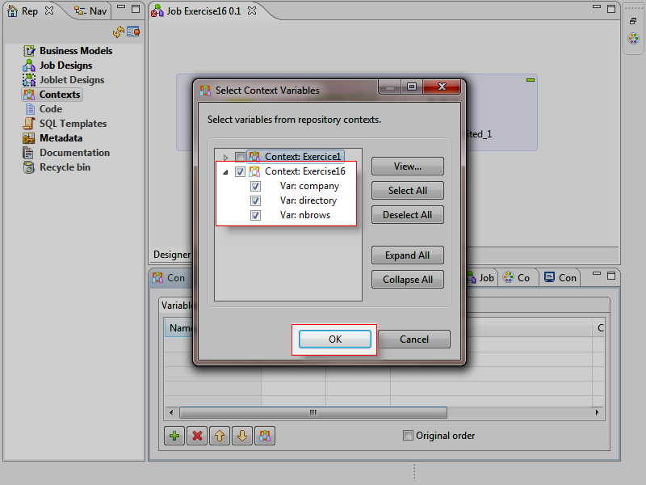

**CONTEXT GROUPS are now available in the job.**

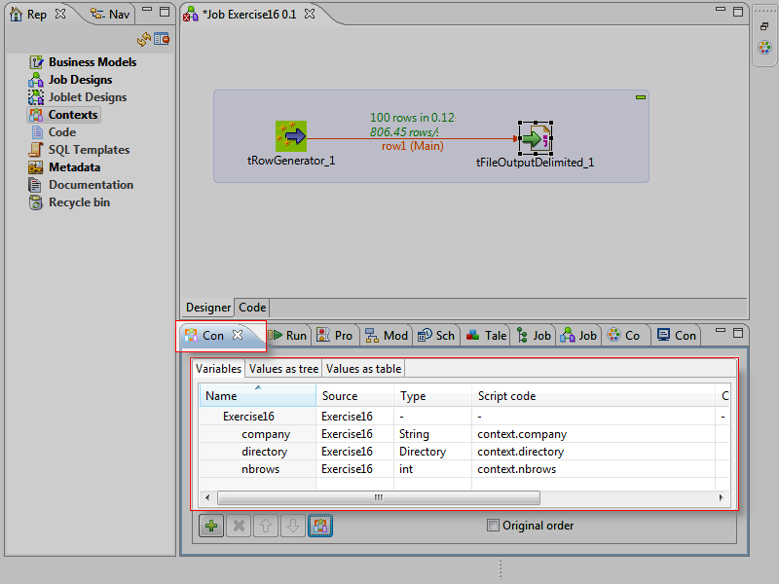

**Use the context variables in the job which are created: company and randomnumber.**

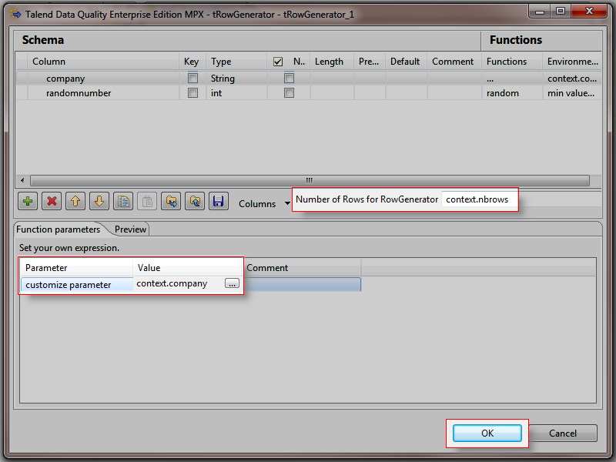

**For filename:**

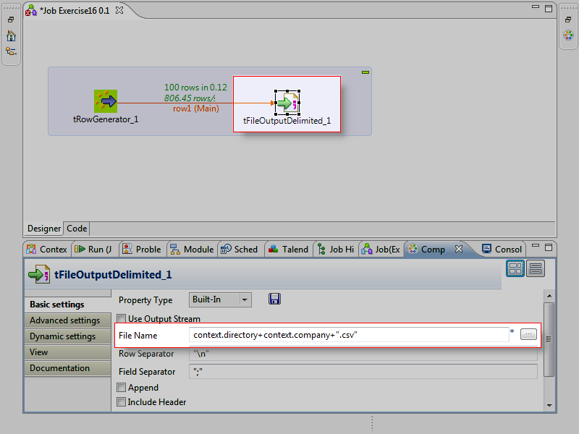

**Select the CONTEXT GROUP: One context group at a time and run the job.**

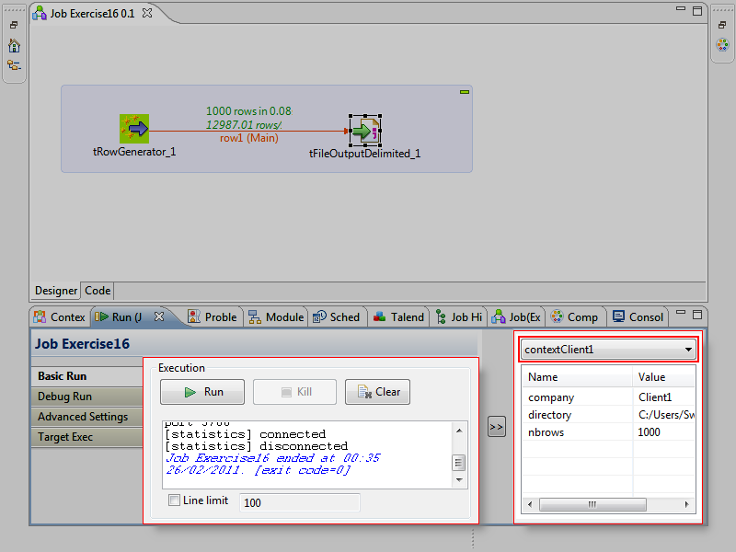

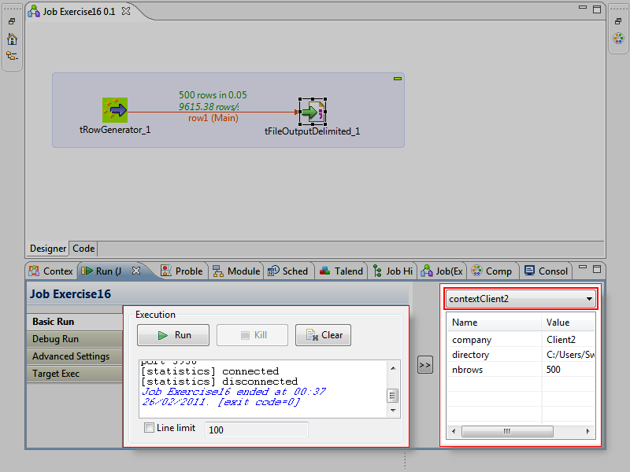

**OUTPUT:**

