Identifying Birds using songs and calls

Ralph Lippert

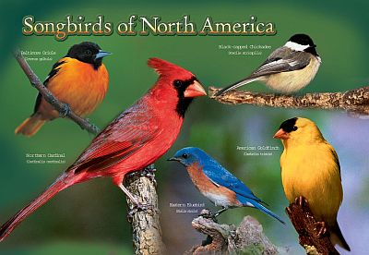

# North American Song Bird Audio Classifier

The project will take an input of sound files obtained from a number of sites then fed through a recurrent neural net in combination with a convolutional neural net to classify North American birds species based on their songs. A hierarchical classification will be used and if time permits then a subspecies classification. Often we only hear a bird and it would be nice to have an idea of which species we are looking for based on it’s sound. Ideally, a mobile app would capture the sound and submit it for identification. After analysis an image of the bird species or a selection of likely species would be presented to the user.

# Overview

Sites including

https://nationalzoo.si.edu/scbi/migratorybirds/education/nasongkey.pl

https://www.bird-sounds.net/

http://www.birds.cornell.edu/Page.aspx%3Fpid%3D1059

https://search.macaulaylibrary.org/catalog

would be used as sources of song bird audio files.

The files will be changed into wav files and using tensorflow to create a RNN it will be trained on a 70% split of gathered audio files. It will then be tested for precision and accuracy on the remaining 30%. Feature extraction of the power of the sound profiles will be used along with waveform data created from sound files. A number of additional features would be extracted from the audio file as needed for best classification.

# Limitations:

Finding sufficient audio for each species may pose a problem. I believe 200-600 audio files could be obtained representing about 100 species. A subset of birds with available audio may have to be chosen. A web app may not be possible with time constraints.

# Deliverables:

Deliverables would be code of a trained Neural Net, presentation explaining the creation, cleaning of data, feature synthesis, mention of problems encountered and overcome, next steps, if I had more time and git hub project repository of all items.

# Alternate:

Use city of Boulder data on emails of city council members to analyze for key political issues.

# Overview:

Approximately seven years of city council emails are publicly available at http://list.ci.boulder.co.us/pipermail/bouldercouncilhotline/

These would be used as input for Natural Language Processing to identify issues as well as any patterns in topics by time or member. Could the output of the topics be enough to influence constituents to become more involved in council meetings or to turn out and vote on non-presidential years? These would be possible issues to explore if this project was selected.

Deliverables would be the same as stated for the first project adapted for this project.