**ARCHITECTURE OF OUR PROJECT**

START

DATA COLLECTION

DATA PREPROCESSING

DATA STORAGE

DATA ANALYSIS

DATA STORAGE

GENERATE REPORTS

INTERPRET RESULTS

IMPLEMENT CHANGES

MONITOR AND OPTIMIZE

END

In the digital landscape, understanding website traffic is pivotal for optimizing user experience and bolstering online presence. This project follows a systematic approach encompassing data collection, preprocessing, analysis, report generation, and interpretation of results.

**Data Collection and Preprocessing:**  
Raw data is sourced from diverse channels, including analytics tools and user interactions. This data undergoes rigorous cleaning and preprocessing, ensuring accuracy and reliability. Normalization and categorization refine the dataset for effective analysis.

**Analysis and Reporting:**  
Advanced statistical methods and machine learning algorithm(LINEAR REGRESSION) are employed to extract valuable insights from the pre-processed data. Patterns and trends in user behaviour, popular content, and visitor demographics are identified. The findings are compiled into a comprehensive report, featuring visual representations and key performance indicators.  
  
**Interpretation and Implementation:**The report is interpreted to draw actionable suggestions. Website owners are presented with these insights, guiding them in implementing changes ranging from redesigning elements to optimizing loading speeds. Implementation is key to enhancing user experience and overall satisfaction.  
  
**Monitoring and Optimization:**Post-implementation, continuous monitoring is imperative. Regular analyses and real-time user feedback drive further optimizations. This iterative process ensures websites remain user-friendly, meeting evolving expectations and trends in the digital sphere.  
  
In essence, this project empowers website owners with data-driven decision-making, enabling them to create engaging platforms that attract and retain satisfied visitors, ensuring sustained success online.

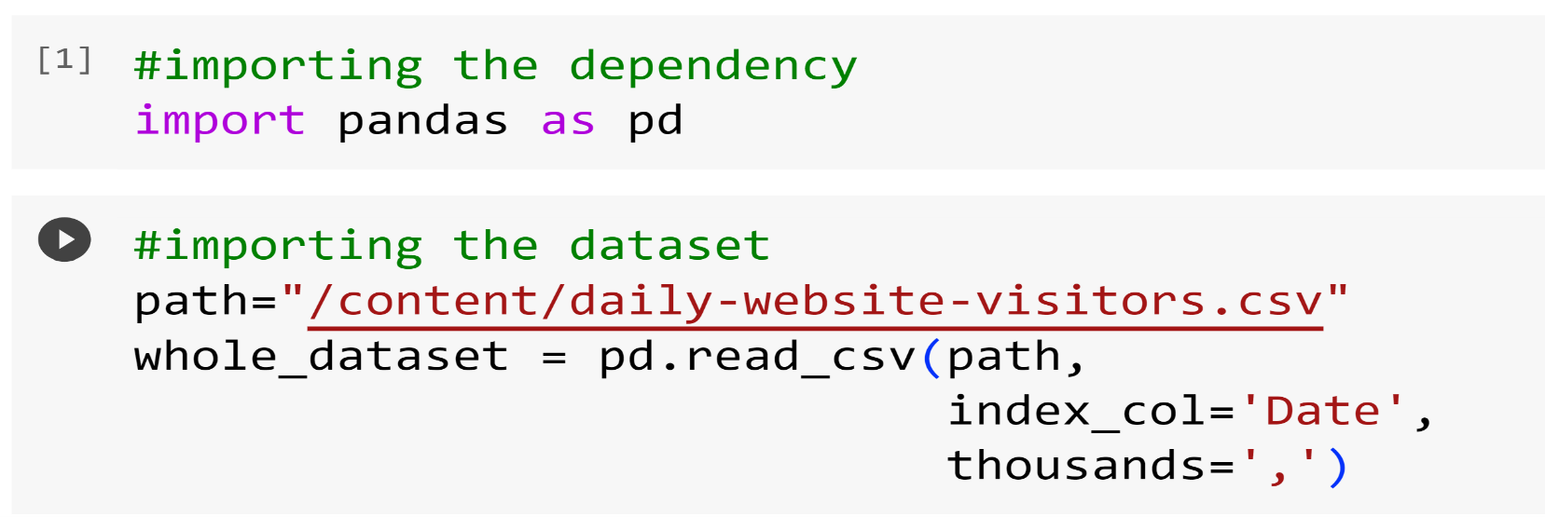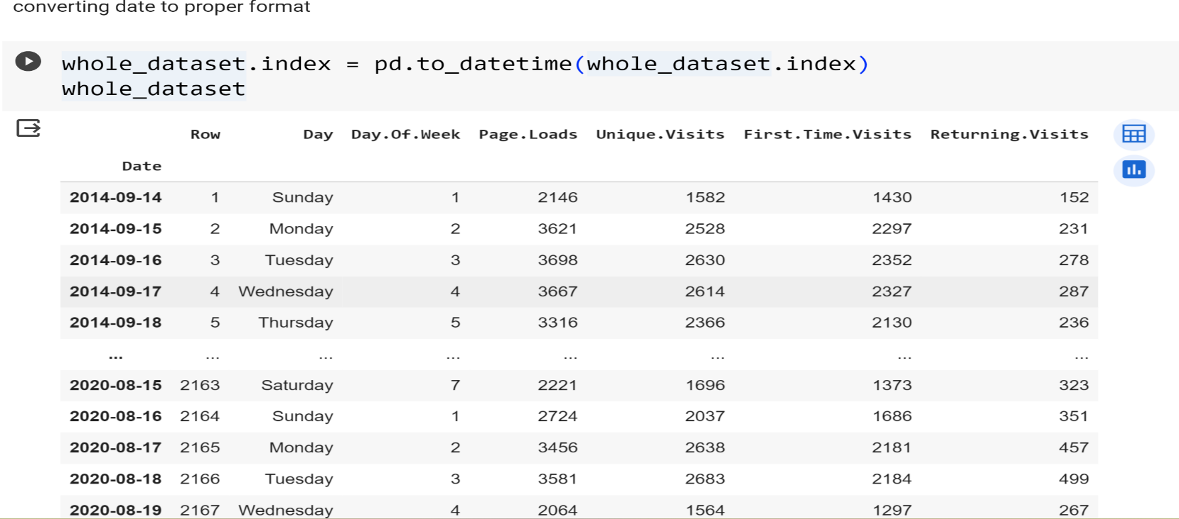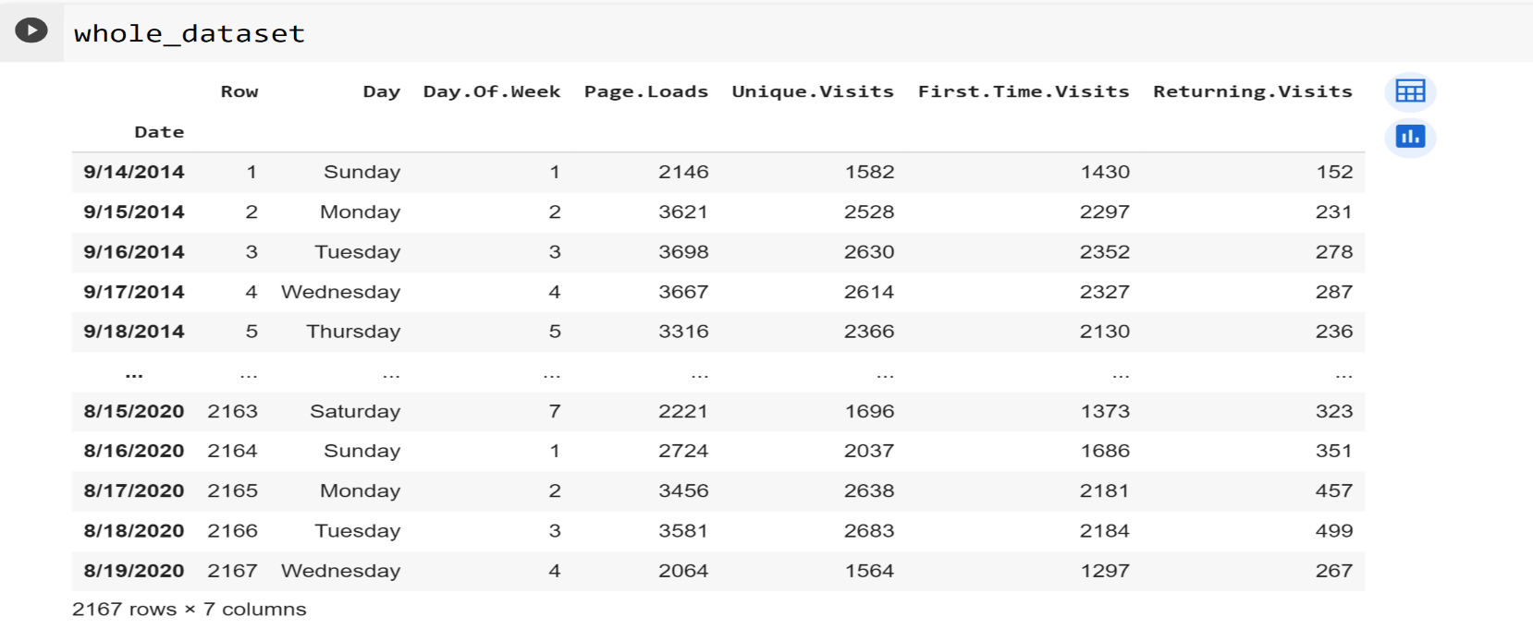DATA CLEANING AND ANALYSIS

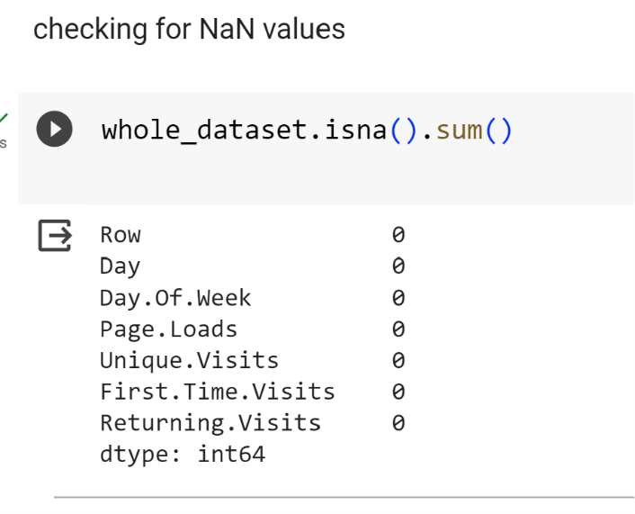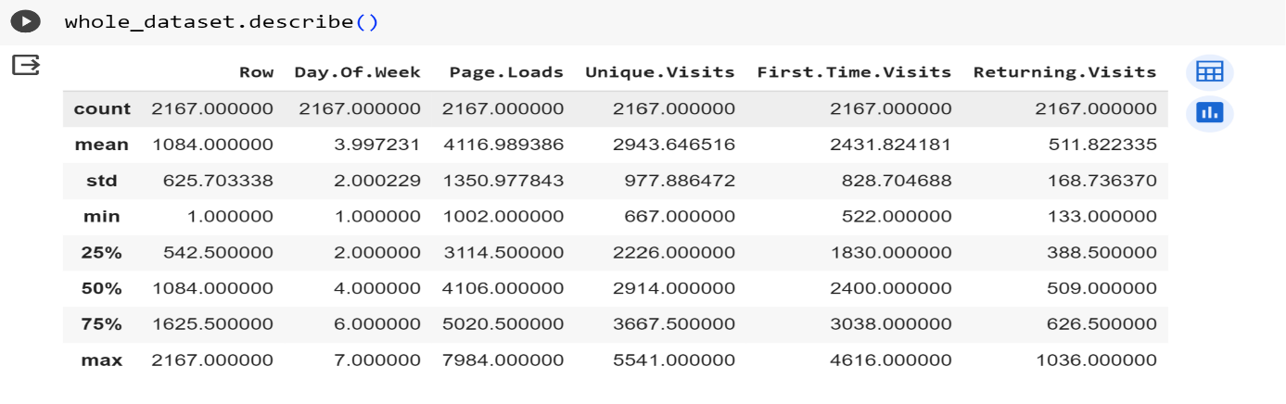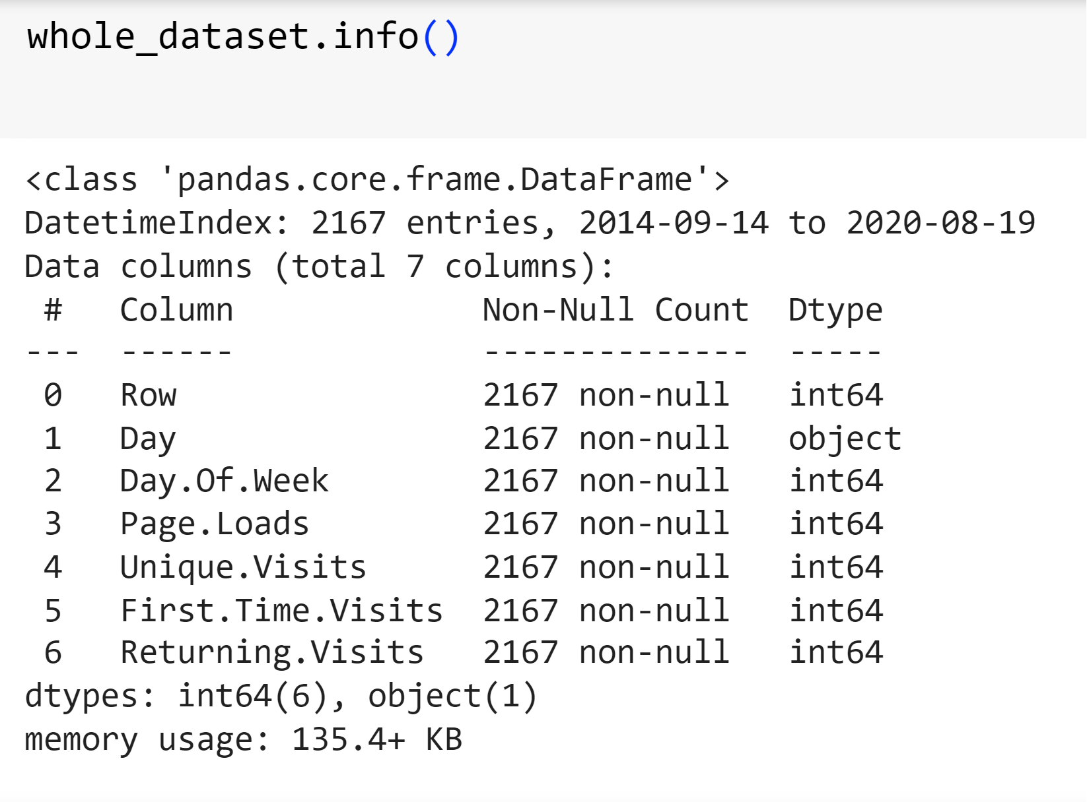DESCRIPTION AND INFORMATION

