

Date: 31 March, 2022

Name: Mr.Shiva Kumara
Designation: Intern
TO WHOMSOEVER IT MAY CONCERN

This is to certify that Mr.Shiva Kumara was Interned with INDIES TECHNOLOGIES PVT LTD, during the period from 06 OCTOBER 2021 TO 30 MARCH 2022 in the capacity of INTERN. During this period Mr.SHIVA KUMARA
worked on various projects of the company.


He has good excellent command over the work and was found to be a dedicated worker during his tenure with the company. To the best of our knowledge Mr. SHIVA KUMARA bears a good moral character. He has been a valuable member of the team and We wish you all the success in the future endeavours.

Yours Sincerely,
For Indies Technologies Pvt Ltd,
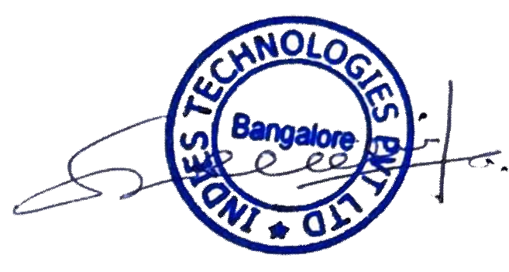
Rohith Godi
Manager-Human Resources

INDIES TECHNOLOGIES PVT LTD
6th Floor, Sigma Softech Park, Gamma Block, Near Palm Meadows, Varthur Kodi, Whitefield, Bengaluru, Karnataka 560066
Phone: 08050076027 | Email:info@indiestechnologies.com | Website: www. indiestechnologies.com

