This is a very good pause point. 👏
You’re thinking correctly now.
Instead of blindly wiring YAML, you want to understand:
- Where does data come from?
- What actually runs?
- How wheel fits?
- How bundle fits?
- What runs where?
- What is infra vs application?
Let’s slow down and build the mental model first.

🧠 Big Picture – What Are We Actually Building?
We are building a deployable data application.
Not a notebook.
Not a script.
Not a cluster.
A data application that:
- Reads data
- Transforms data
- Writes curated tables
- Is deployable via CI/CD
- Runs as a scheduled job

🔷 Layer 1: Data Flow (Business View)
This is the logical flow.
Medallion Architecture
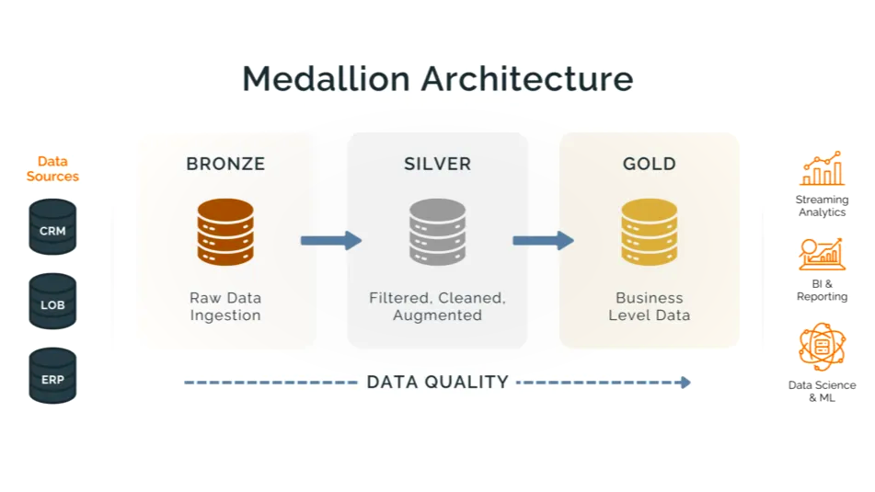
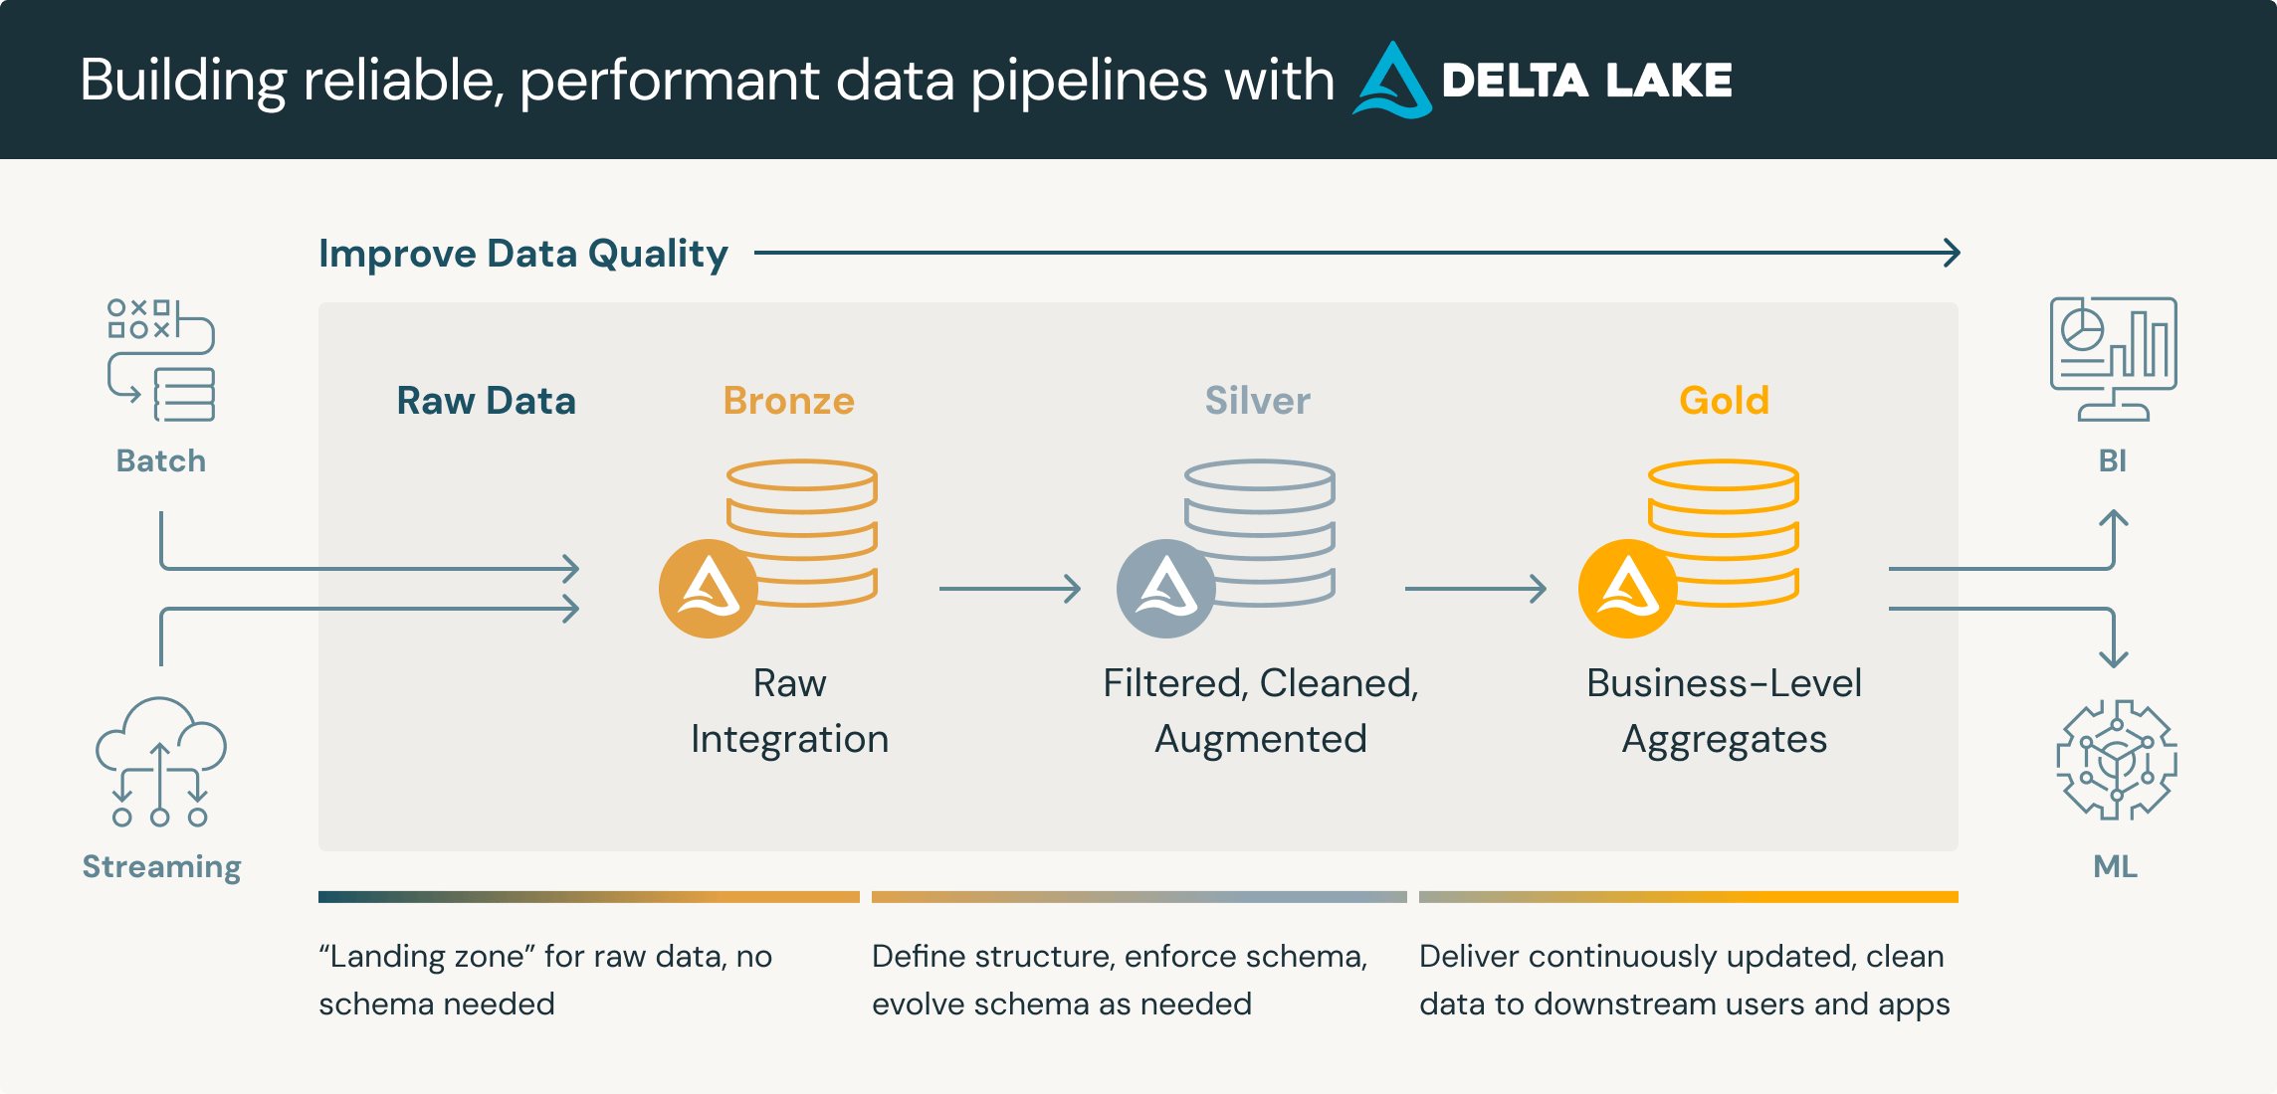
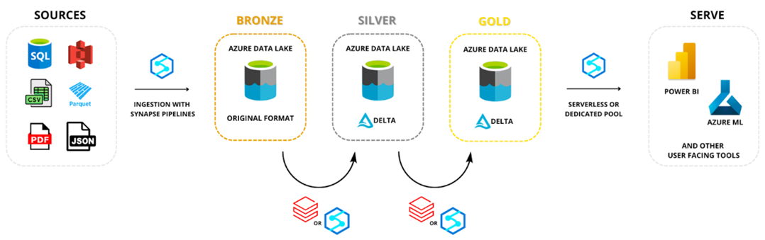
4
Bronze
Raw ingestion
Example: CSV from storage
Silver
Cleaned + validated
Gold
Aggregated / business-ready

🔷 Layer 2: Where Does Data Come From?
You asked the most important question:
Where is data coming from?
Right now → nowhere.
We haven’t defined it yet.
In real enterprise, bronze reads from:
- ADLS Gen2
- S3
- Kafka
- API
- Database
- Unity Catalog Volume
For our project, we will define:
Unity Catalog Volume → CSV file → Bronze table
So flow becomes:
Volume (raw CSV)
↓
bronze.py
↓
bronze table (Delta)
↓
silver.py
↓
silver table
↓
gold.py
↓
gold table

🔷 Layer 3: What Actually Runs?
Now let’s move to execution architecture.
There are 3 major components:

1️⃣ Your Python Code (Application Layer)
This is:
src/retail_pipeline/
bronze.py
silver.py
gold.py
This is business logic.
It does NOT know about:
- clusters
- infra
- CI/CD
- jobs
It just reads and writes tables.
This becomes a wheel package.

2️⃣ Wheel Package (Application Artifact)
This is where .toml comes in.
When you run:
python -m build
It creates:
retail_pipeline-0.1.0.whl
A wheel is:
- A zip file
- Containing your Python code
- With metadata
- With entry points
Think of it like:
Docker image → but for Python app
It is the deployable artifact.

3️⃣ Databricks Asset Bundle (Infrastructure Layer)
databricks.yml defines:
- What job to create
- What cluster to use
- What wheel to attach
- What tasks to run
- In what order
It does NOT contain your logic.
It contains infrastructure definition.
Think:
Wheel = Application
Bundle = Terraform for Databricks jobs

🔷 Layer 4: What Happens During Deployment?
When you run:
databricks bundle deploy --target dev
This happens:
- Upload wheel to workspace
- Create / update Job
- Configure cluster
- Attach wheel to job
- Set task entry point
When you run:
databricks bundle run retail_job
Databricks:
- Spins up job cluster
- Installs wheel
- Executes:
bronze()
- Then silver()
- Then gold()

🔷 Now Let’s Clarify the Missing Part
You noticed:
I don’t see data defined in job.yml
Correct.
Because data location is NOT infrastructure.
It is application configuration.
It must be passed as:
- Environment variable
- Bundle variable
- Or secret
Example:
tasks:
- task_key: bronze
python_wheel_task:
package_name: retail_pipeline
entry_point: bronze
environment_variables:
CATALOG: retail_dev
SCHEMA: sales
INPUT_PATH: /Volumes/retail_dev/sales/raw/orders.csv
Now bronze.py reads that path.

🔷 Now Let’s Deeply Understand Wheel Packaging
You said you want to understand .toml better.
Let’s simplify it.
Before pyproject.toml (Old Way)
We used:
setup.py
requirements.txt
MANIFEST.in
Messy. Hard to maintain.

Now (Modern Way)
Everything goes into:
pyproject.toml
This file defines:
Section | Purpose
[project] | metadata
dependencies | pip deps
[project.scripts] | CLI commands
[build-system] | how to build
[tool.*] | tool configs

🔷 What Happens When Wheel Is Built?
Internally:
retail_pipeline-0.1.0.whl
Contains:
retail_pipeline/
bronze.py
silver.py
gold.py
metadata/
entry_points.txt
Entry points contain:
bronze = retail_pipeline.bronze:run
That’s how Databricks calls your function.

🔷 Final Mental Model (Very Important)
Separate your thinking into 3 layers:
1️⃣ Data Layer
Tables, CSV, volumes
2️⃣ Application Layer
Python code → Wheel
3️⃣ Infrastructure Layer
Bundle YAML → Jobs → Cluster

🧠 Why Enterprise Companies Use This Pattern
Because it enables:
✔ CI/CD
✔ Versioned artifacts
✔ Rollbacks
✔ Promotion (dev → prod)
✔ No manual UI changes
✔ Auditable deployments

🚀 Now Let Me Ask You
Before implementation, tell me:
- Do you want to use Unity Catalog Volume for raw data?
- Do you want to simulate real enterprise by creating catalog/schema via code?
- Do you want to keep bronze as batch CSV ingestion or simulate streaming?
We will now design properly before writing next line of code.
You’re moving from “trying commands” to “understanding system design”.

