CAPSTONE PROJECT REPORT
FitToLend
AI Loan Eligibility Checker
An AI-Powered BFSI Financial Decision Platform
Submitted by: Karthik
SkillWallet Capstone Project
GitHub: github.com/karthik069069/BFSI-Project

Table of Contents
1. Abstract
2. Introduction and Problem Statement
3. Objectives
4. Technology Stack
5. System Overview and Architecture
6. Module Descriptions
7. Algorithms and Formulas
8. User Interface Design
9. AI Integration and Data Storage
10. Testing and Sample Results
11. Limitations
12. Future Scope
13. Conclusion
14. Submission Links

1. Abstract
FitToLend is an AI-powered BFSI (Banking, Financial Services and Insurance) web platform that simplifies personal financial decision-making. It brings four core tools into one seamless interface: a Loan Eligibility Checker, a Credit Score Analyzer, an EMI Calculator and an AI Financial Tips module. The platform is built using HTML, CSS and JavaScript with a dark glassmorphism design, and uses a dual-layer AI design (a built-in offline BFSI Expert Engine, plus optional Anthropic Claude or Google Gemini) to generate plain-language financial guidance from the numbers a user provides.
Users can check how much a lender is likely to offer them, understand what is helping or hurting their credit score, plan monthly repayments with live sliders, and ask follow-up questions to an AI assistant, all before approaching a bank. All calculations run in the browser. Every result is saved to the browser local storage and, when the user connects a Google Apps Script web app URL, is also appended automatically to their own Google Sheet. All records can be exported as a CSV file.

2. Introduction and Problem Statement
Applying for a loan is a high-stakes decision. Many applicants approach banks without knowing how much they can borrow, how their credit score will influence the offer, or what the monthly burden will be. A rejected application can itself leave a hard inquiry on the credit report and lower the score further.
Existing bank calculators are usually isolated: one for EMI, another for eligibility, with no explanation of why a result was produced. First-time borrowers in particular lack financial literacy to interpret raw numbers.
Problem statement: There is no simple, private and explainable tool that lets an individual check loan eligibility, estimate credit health, plan EMIs and receive personalized financial guidance in one place before applying for a loan.

3. Objectives
- Provide an instant, explainable loan eligibility estimate based on income, obligations, age, employment type, credit score, and existing loans.
- Help users understand their credit score, either by analysing a known score or by estimating one from credit behaviour.
- Offer a real-time EMI calculator with total interest and a year-wise amortization table.
- Generate personalized, plain-language financial tips and answer follow-up questions using AI.
- Deliver a modern, responsive, accessible interface that works on desktop and mobile.

4. Technology Stack
Layer | Technology / Purpose
Structure | HTML5, semantic sections, single-page layout with view switching
Styling | CSS3 with custom properties, glassmorphism (backdrop-filter), responsive grid and flexbox, reduced-motion support
Logic | Vanilla JavaScript (ES6+), no external framework
Typography | Google Fonts: Sora (headings), Inter (body), JetBrains Mono (figures)
AI | Dual-layer AI: built-in offline BFSI Expert Engine (default), plus optional Anthropic Claude API or Google Gemini API using the users own API key
Storage | Browser localStorage for records and settings; Google Sheets through a Google Apps Script web app webhook; one-click CSV export
Backend / VCS | Google Apps Script (Sheets webhook); GitHub for source code. The app runs by opening index.html in any browser

5. System Overview and Architecture
FitToLend is a single-page application. A left navigation sidebar switches between five views (Overview and four modules) without reloading the page. A shared in-memory state object stores the latest result from each module so that the AI module can use it as context.
Component | Responsibility
Navigation shell | Sidebar, mobile drawer menu, page title and status indicator
Loan module | Validates inputs, computes eligibility, renders result with confidence meter and factor list
Credit module | Analyses a known score or estimates one from five behavioural factors
EMI module | Live two-way synced inputs and sliders, ring chart, KPI cards, amortization table
AI module | Builds a profile from user inputs and shared state, routes to the built-in engine, Claude or Gemini, and falls back to the built-in engine on any failure
Shared state | Holds loan, credit and EMI results; feeds the AI profile and activity feed
Storage layer | Saves every record to localStorage, posts it to the Google Sheets webhook if configured, restores recent activity on load, exports CSV
Settings modal | Stores the Sheets webhook URL, AI provider and API key in localStorage; includes a Test Sheets Connection button

Data flow: User input > client-side validation > calculation function > rendered result > shared state update > activity feed and storage > available as context for the AI module.

6. Module Descriptions

6.1 Dashboard / Overview
The landing page presents a hero section with animated statistics, four module cards that link to each tool, and a Recent Activity feed that lists the calculations performed in the session.
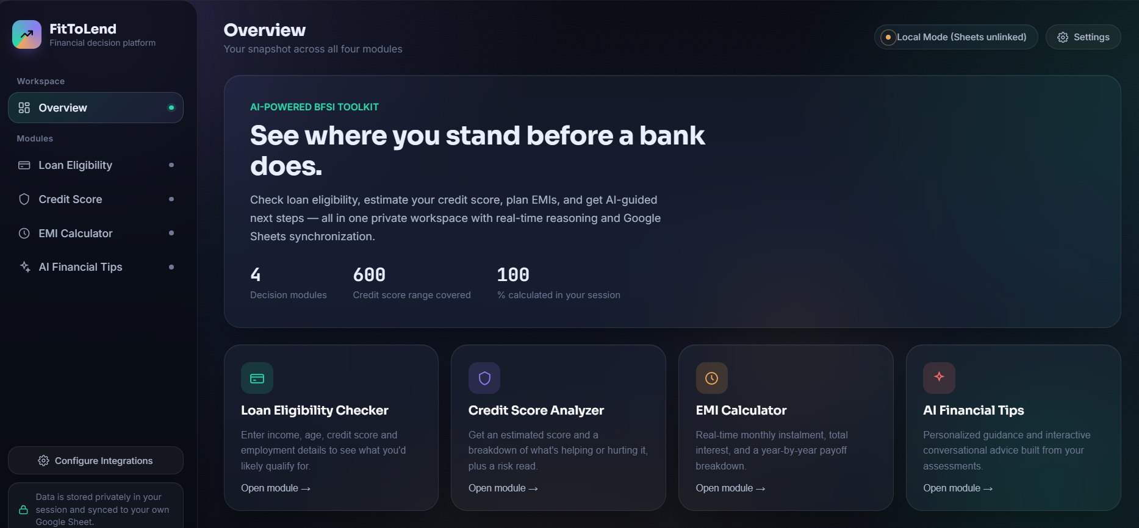

6.2 Loan Eligibility Checker
The user enters monthly net income, existing obligations, desired loan amount, tenure, interest rate, credit score (300 to 900), age, number of active loans and employment type. Every field is validated, with inline error messages. The result shows a status badge (Eligible, Conditionally Eligible or Not Eligible), the eligible amount, the estimated EMI, a 0 to 100 confidence meter and a list of factors, each marked positive, neutral or negative, explaining the outcome.
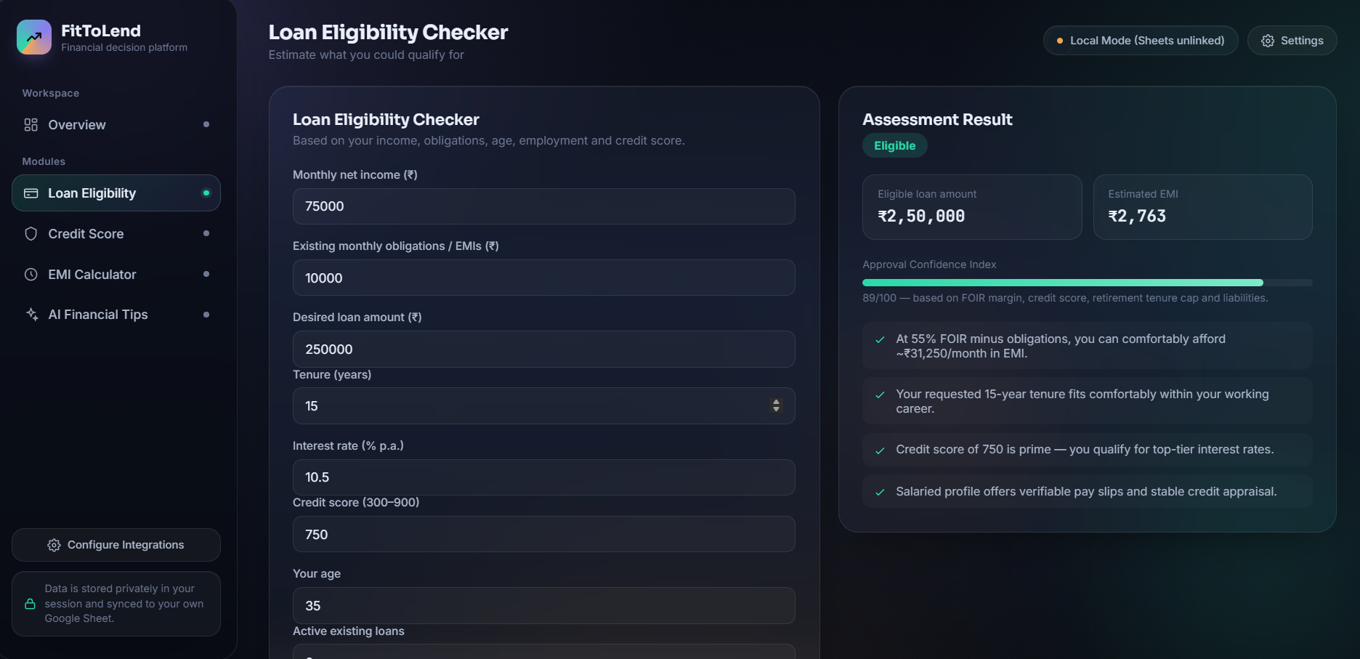

6.3 Credit Score Analyzer
Two modes are available. In "I know my score" mode, the score is categorized and tailored improvement tips are shown. In "Estimate it for me" mode, the user supplies payment history, credit utilization, credit history age, number of open accounts and recent hard inquiries; the app estimates a score between 300 and 900 and displays a factor-by-factor breakdown. The result appears as an animated gauge with a category badge.

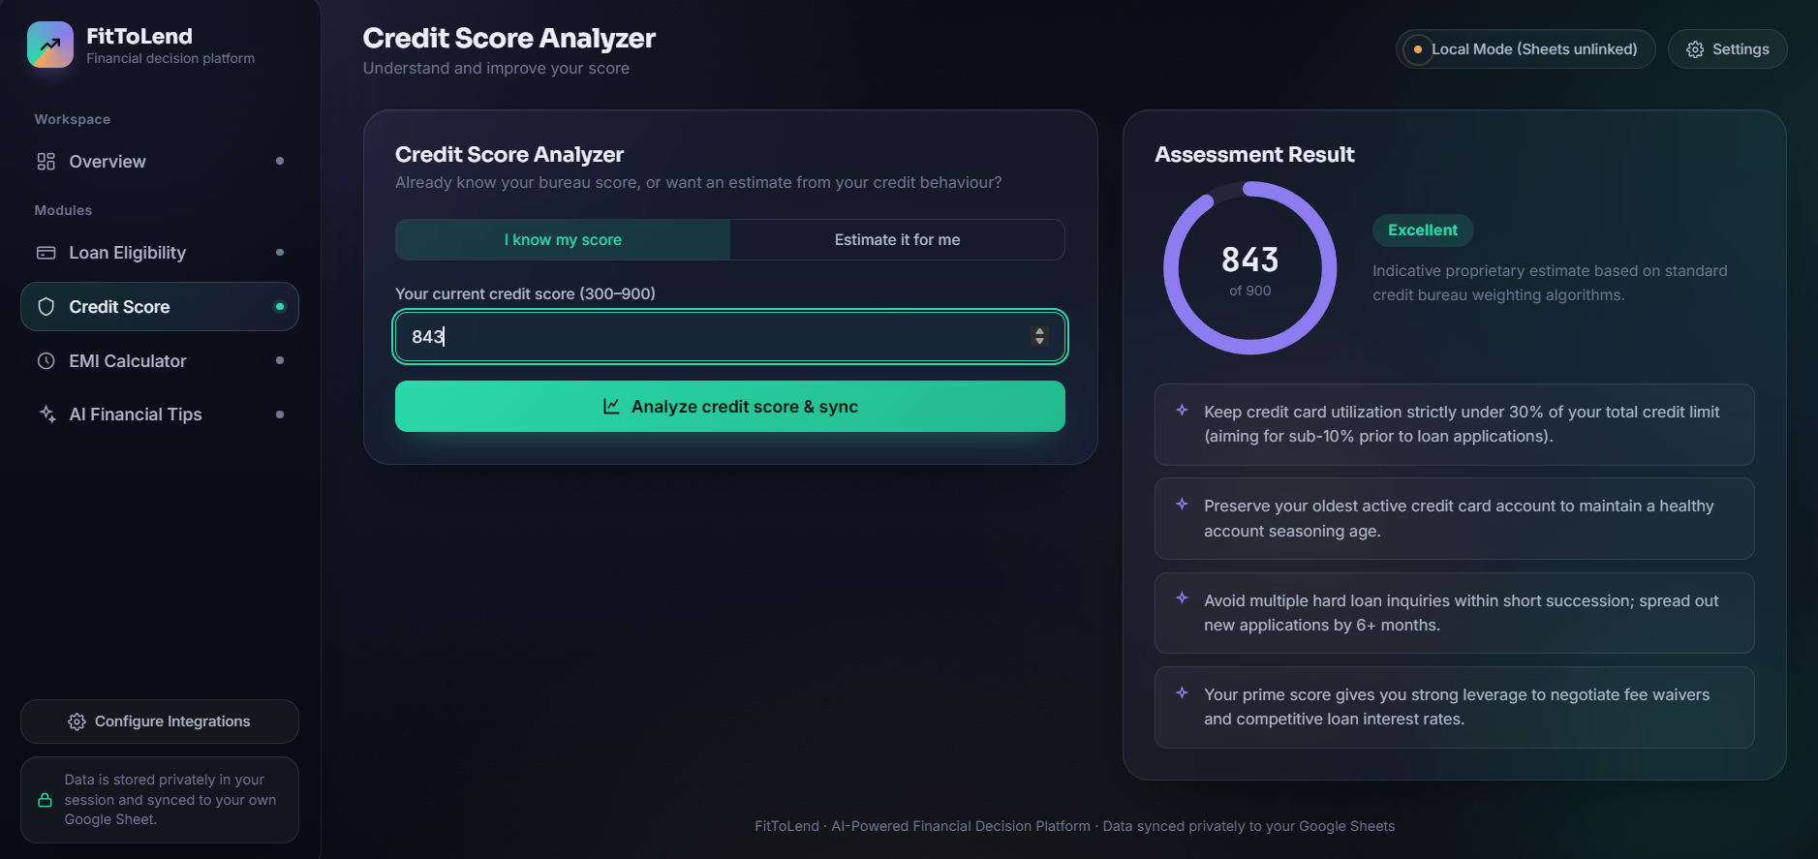

6.4 EMI Calculator
Loan amount, interest rate and tenure can be changed using number inputs or linked sliders, and results update instantly. Tenure can be switched between years and months. The module displays the monthly EMI, total interest, total payment, a principal-versus-interest ring chart, a guidance note and a year-wise amortization table. The user can save a calculation, which then becomes context for the AI module.
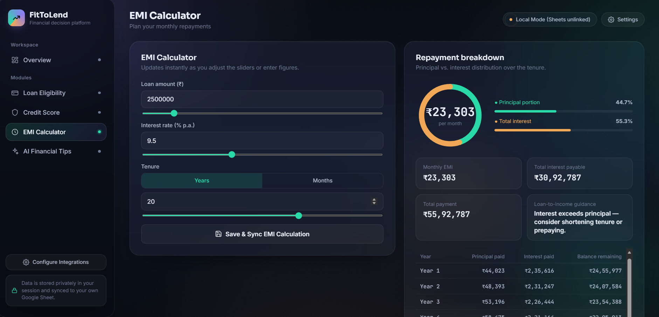

6.5 AI Financial Tips
The profile form is pre-filled from other modules where possible. "Get AI insights" returns short, specific tips, and the follow-up box answers questions such as whether to prepay a loan or invest the surplus. By default these come from the built-in BFSI Expert Engine, which works offline with no API key. If the user selects Claude or Gemini in Settings and enters a key, the same profile is sent to that provider instead, and if the call fails the built-in engine answers, so the module never appears broken.
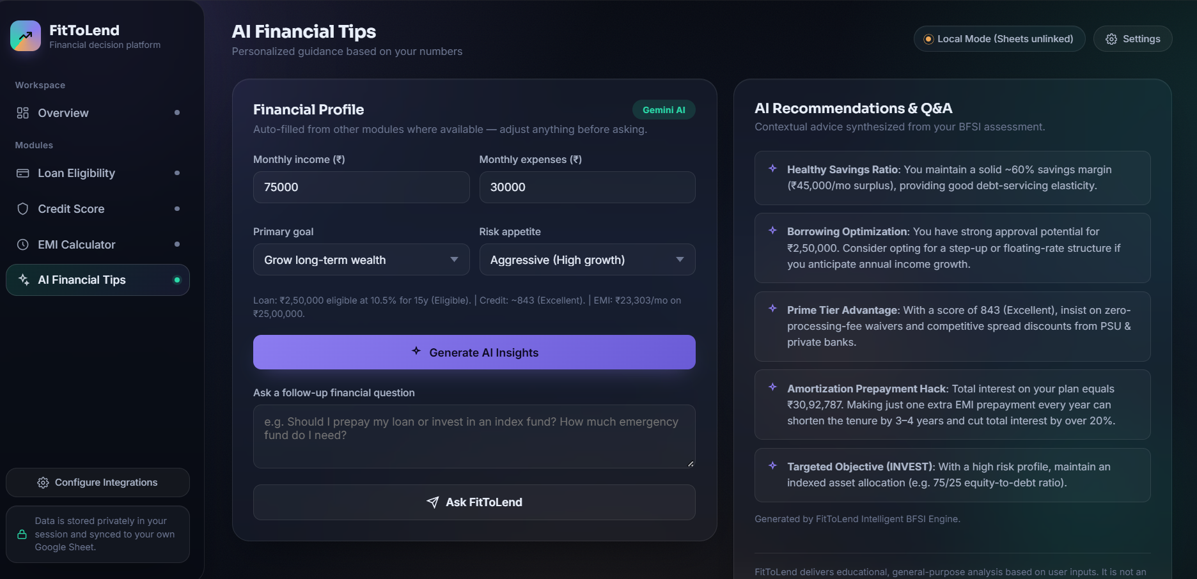

7. Algorithms and Formulas

7.1 EMI Formula
EMI = P x r x (1 + r)^n / ((1 + r)^n - 1)
where P is the principal, r is the monthly interest rate (annual rate / 12 / 100) and n is the number of monthly instalments. For a 0% rate, EMI = P / n. Total payment = EMI x n and total interest = total payment - P.

7.2 Loan Eligibility Logic
- FOIR band. The Fixed Obligation to Income Ratio (FOIR) limit depends on income: 40% below Rs. 20,000; 45% from Rs. 20,000; 55% from Rs. 50,000; and 65% from Rs. 1,00,000 per month.
- Affordable EMI. Maximum affordable EMI = income x FOIR limit - existing obligations.
- Age-based tenure cap. The tenure is capped so that repayment ends by age 60 for salaried applicants and 65 for self-employed applicants.
- Maximum principal. The maximum principal is the present value of the affordable EMI over the effective tenure, which is the EMI formula solved for P.
- Credit score multiplier. Credit score below 650 multiplies the amount by 0.55; 650 to 699 by 0.80; 700 to 749 by 0.92; 750 and above by 1.00.
- Existing loans. Four or more active loans reduce the amount by a further 15%.
- Employment gate. Unemployed or student applicants are marked Not Eligible because there is no verifiable income.
- Status rule. Eligible if the offer is at least 90% of the request and the score is at least 650; Conditionally Eligible if at least 35% of the request; otherwise Not Eligible.
- Confidence score. A 3 to 98 score combining credit score (35 points), income headroom (30), tenure fit (15), employment type (up to 10) and loan count (10).

7.3 Credit Score Estimation
Each factor is scored from 0 to 100 and weighted. The weighted sum is then mapped onto the 300 to 900 range.
Factor | Weight | Scoring approach
Payment history | 35% | On time = 100, 1-2 missed = 65, 3+ missed = 35, frequent defaults = 10
Credit utilisation | 30% | At most 10% = 100, up to 30% = 85, 50% = 60, 75% = 35, above = 10
Credit history age | 15% | 7+ years = 100, 4+ = 80, 2+ = 60, 1+ = 40, otherwise 20
Account mix | 10% | 2 to 5 accounts = 100; 1 or 6 to 8 = 70; otherwise 40
Recent inquiries | 10% | 0 = 100, 1-2 = 80, 3-4 = 50, 5+ = 20

Score = 300 + (weighted_total / 100) x 600
Score categories: below 580 Poor; 580 to 669 Fair; 670 to 739 Good; 740 to 799 Very Good; 800 and above Excellent.

8. User Interface Design
- Dark glassmorphism theme with translucent panels, blur, soft gradients and subtle ambient animation.
- Colour semantics: teal for positive, amber for caution, red for negative, violet for AI and credit features.
- Responsive layout: the sidebar collapses into a slide-in drawer on screens narrower than 900 px, and two-column layouts stack on tablets and phones.
- Accessibility: visible keyboard focus outlines, labelled form fields, inline error messages and support for the reduced-motion preference.
- Typography pairs Sora for headings, Inter for body text and JetBrains Mono for numeric values.

9. AI Integration and Data Storage

9.1 Dual-layer AI engine
The AI module builds a profile (income, expenses, goal, risk appetite and the saved loan, credit and EMI results). Three engines can answer from it. The built-in BFSI Expert Engine is the default: it is rule-based, runs offline with zero latency and needs no key. Optionally, the user can choose the Anthropic Claude API or the Google Gemini API in Settings and supply their own key; the app then sends the profile with an instruction to give concise, numbers-based advice. Any error from an external provider triggers an automatic fall back to the built-in engine.

9.2 Google Sheets persistence
Each loan check, credit analysis and saved EMI plan is sent as a JSON record to a Google Apps Script web app that the user deploys from their own Google account. The script appends one row per record to the active sheet, creating a formatted header row on first use, and uses a script lock to avoid concurrent write clashes. The browser sends the request in no-cors mode, so the page cannot read the response; the Test Sheets Connection button therefore confirms that the request was dispatched, and the user confirms success by checking the sheet.
Sheet column | Source
Timestamp, Module | Generated by the app (Loan_Eligibility, Credit_Analysis, EMI_Plan)
Monthly Income, Monthly Obligations | Loan module inputs
Requested Loan Amount, Tenure, Interest Rate | Loan inputs, or the saved EMI plan
Credit Score | Entered or estimated score
Eligible Loan Amount, Monthly EMI | Calculated results
Status / Grade, Notes | Eligibility status or credit category, plus a one-line summary

9.3 Local storage, export and privacy
Records are also kept in the browser localStorage as a backup, the most recent ones are restored to the activity feed on load, and all session logs can be downloaded as a CSV file. The Sheets URL, AI provider and API key are stored only in the same browser localStorage. Calculations run entirely on the client. An API key, if used, is sent only to the chosen provider with each AI request.

10. Testing and Sample Results
The following test cases were run through the same logic used by the application.
No. | Input | Expected behaviour | Result
1 | Private salaried; income Rs. 65,000; obligations Rs. 8,000; loan Rs. 25,00,000; 20 yrs; 10.5%; score 740; age 32; 1 loan | Full amount approved | Eligible; Rs. 25,00,000; EMI Rs. 24,959
2 | Unemployed; income Rs. 40,000; loan Rs. 10,00,000 | Rejected, no verifiable income | Not Eligible; Rs. 0
3 | Private; income Rs. 30,000; obligations Rs. 5,000; loan Rs. 15,00,000; 15 yrs; 11%; score 600; age 45; 2 loans | Heavily reduced: low score and low income headroom | Not Eligible; Rs. 4,11,316; EMI Rs. 4,675
4 | EMI: Rs. 25,00,000; 9.5%; 20 years | EMI and interest computed | EMI Rs. 23,303; interest Rs. 30,92,787
5 | Credit estimate: always on time; 30% utilisation; 4 yrs history; 3 accounts; 1 inquiry | High score | Estimated 843, Excellent
6 | Credit: known score 782 | Categorised correctly | Very Good
7 | Loan form submitted with blank or out-of-range fields | Inline errors; no calculation | Fields highlighted red with messages
8 | Open on a 375 px-wide screen | Sidebar becomes a drawer | Menu button appears; layouts stack
9 | Paste Apps Script URL in Settings, then run a loan check | New row appended to the sheet | Row with timestamp, module, status and EMI (verify in your sheet)
10 | Choose built-in engine, click Get AI insights | Tips shown with no API key | Rule-based tips generated offline

11. Limitations
- All outputs are indicative estimates. They are not official credit bureau scores or bank sanction decisions.
- Eligibility rules (FOIR bands, multipliers, age caps) are simplified models; real lenders use proprietary policies.
- External AI (Claude or Gemini) needs the user to supply an API key. Because the key is entered in the browser, it is suited to personal use and demos; a production system would route AI calls through a secure backend.
- Google Sheets sync uses a no-cors request, so the app cannot confirm that a row was written; success must be checked in the sheet. The Apps Script web app must be deployed with access set to Anyone.
- The credit estimator uses illustrative weights loosely inspired by common scoring factors, and is not calibrated to CIBIL, Experian or any other bureau.

12. Future Scope
- A secure backend or proxy for AI calls, so API keys never live in the browser.
- Authenticated Sheets sync that returns a confirmation to the app, and a database option such as Firebase.
- Loan comparison across banks, with live interest-rate data.
- Prepayment and part-payment simulation in the EMI calculator, plus charts of balance over time.
- Insurance and investment (SIP) planning modules to extend the BFSI coverage.
- User accounts, PDF report download and multilingual support (Hindi, Telugu, Tamil and others).

13. Conclusion
FitToLend demonstrates how a clean interface, transparent financial logic and AI guidance can be combined into a practical decision-support tool for borrowers. Each result is accompanied by an explanation of the factors behind it, which improves financial literacy and helps users approach lenders better prepared. The project covers the BFSI domain end to end, from eligibility and credit health to repayment planning and personalised advice and provides a foundation for the extensions listed under Future Scope.

14. Submission Links
Item | Link
Source code (GitHub) | https://github.com/karthik069069/BFSI-Project
Demo video (Google Drive) | https://drive.google.com/drive/folders/1Ymyg40SbyL0dvm4BzX-C0h3prW8K1H6X?usp=sharing

Disclaimer: FitToLend provides educational, general-purpose guidance based on user-supplied numbers. It is not a licensed financial advisor and does not constitute personalized financial, tax or legal advice.

