TRAFFIC DENSITY MONITORING
Using Background Subtraction and Contour Detection in OpenCV
Student Name: Karthik Mani Kumar
Batch No: 27
Student Id: 2362860
Course: Drone Technologies and its Transformative Applications
CIA 3 – Project Activity
GitHub Link: https://github.com/karthik07-pkt/Traffic-Density-Monitoring

1. Aim
To develop a computer vision system that detects vehicles from aerial drone footage using background subtraction and contour detection in OpenCV, and classifies traffic density as Low, Medium, or High based on vehicle count.

2. Problem Statement
Transport authorities require an automated system to monitor traffic conditions using aerial drone imagery. Manual monitoring is inefficient and time-consuming. The objective of this project is to detect vehicles in drone video frames and estimate traffic density levels based on the number of detected vehicles.

3. Objectives
• Detect moving vehicles from aerial video.
• Count the number of vehicles in each frame.
• Classify traffic density into Low, Medium, and High.
• Demonstrate classical computer vision techniques using OpenCV.

4. Methodology
Step 1: Video Input – The drone traffic video is loaded using OpenCV’s VideoCapture.
Step 2: Frame Preprocessing – Each frame is resized for faster processing.
Step 3: Background Subtraction – MOG2 is used to separate moving objects from static background.
Step 4: Thresholding – Binary thresholding removes gray shadow regions.
Step 5: Morphological Operations – Noise removal and object enhancement.
Step 6: Contour Detection – Contours extracted using cv2.findContours().
Step 7: Area Filtering – Small contours removed using area threshold.
Step 8: Vehicle Counting – Valid contours counted and bounded.
Step 9: Density Classification – Traffic density determined from vehicle count.

5. Traffic Density Classification Table
Less than 5 vehicles – Low Density
5 to 14 vehicles – Medium Density
15 and above – High Density

6. Tools Used
• Python 3.x
• OpenCV
• NumPy
• GitHub

7. Results
The system successfully detected moving vehicles, drew bounding boxes, counted vehicles per frame, and classified traffic density.

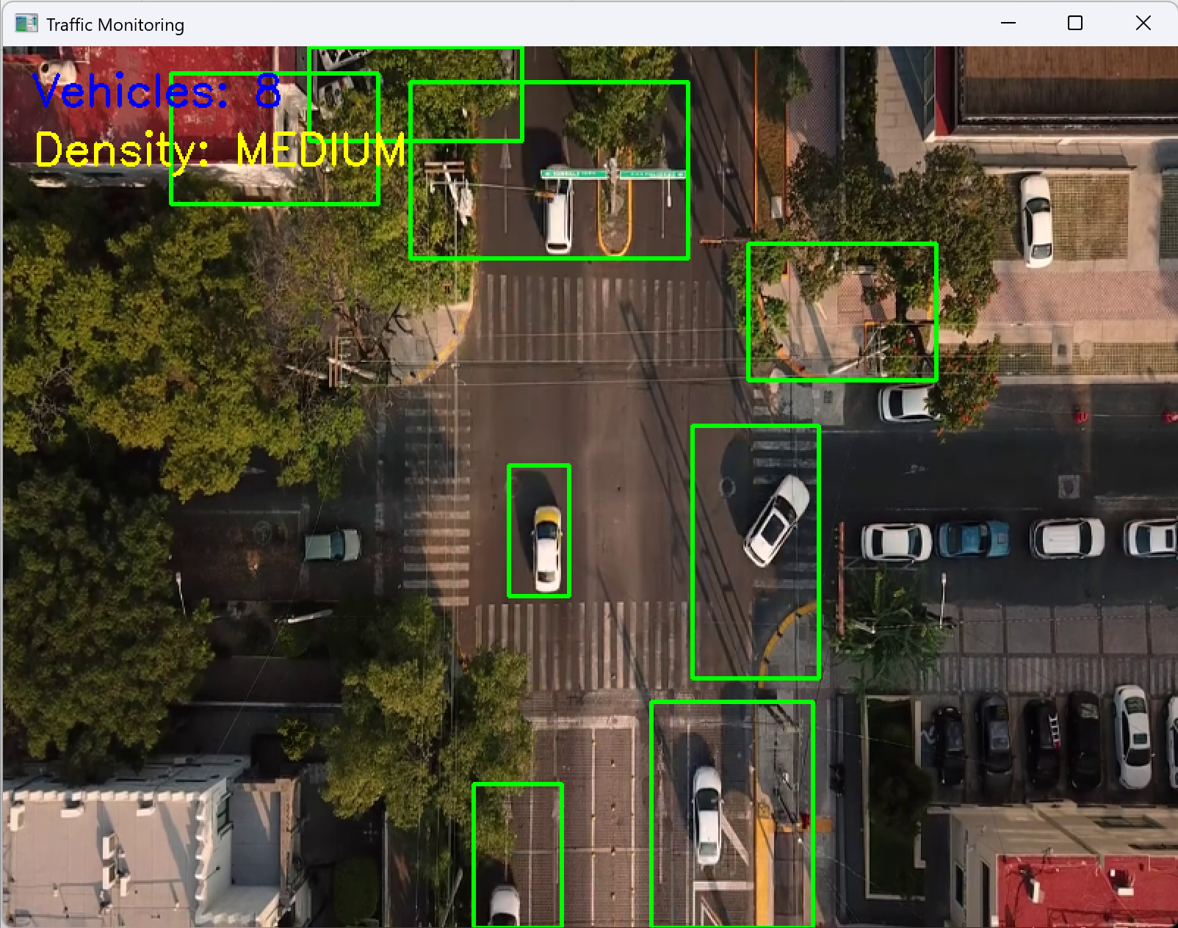

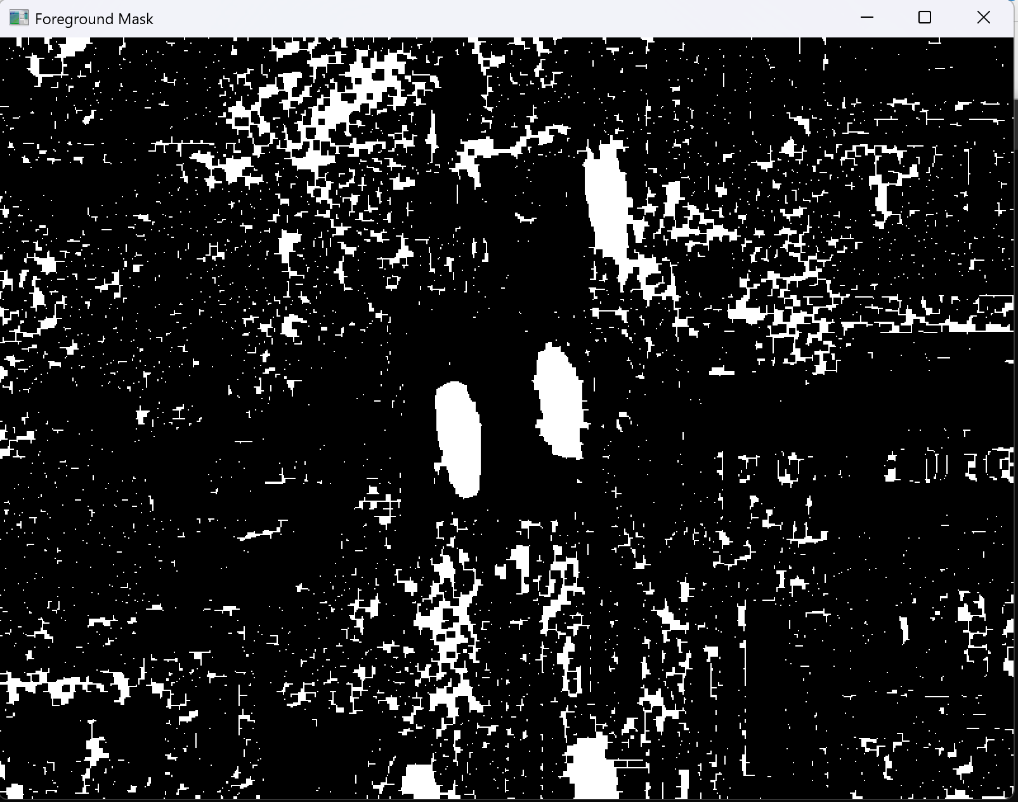

8. Limitations
• Background subtraction detects motion, not static vehicles.
• Performance depends on lighting and camera stability.
• Shadows and environmental noise may affect detection accuracy.

9. Conclusion
The proposed system demonstrates traffic density monitoring using classical computer vision techniques. While effective for detecting moving vehicles, it has limitations in complex scenarios. Advanced deep learning methods can improve robustness in real-world applications.

10. Future Scope
• Integration of deep learning-based vehicle detection.
• Vehicle classification (car, bus, truck).
• Real-time traffic analytics dashboard.

