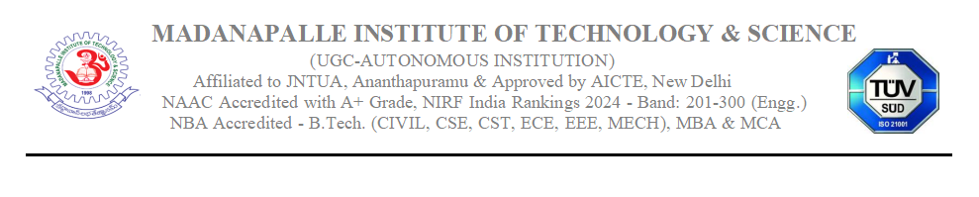DEPARTMENT OF COMPUTER SCIENCE & ENGINEERING

**Assignment 1**

**Set 1**

Roll Nos: 22691A0567 - 22691A0590

|  |  |  |  |
| --- | --- | --- | --- |
| S.No. | Question | CO | BL |
| 1 | Explain in detail about Agile Software Development Life Cycle methods with suitable diagrams. | CO1 | K2 |
| 2 | Discuss in detail about functional and non functional requirements with example. | CO2 | K3 |
| 3 | Describe in detail about Requirements elicitation and analysis with relevant diagram. | CO2 | K2 |

# Set 2

Roll Nos: 22691A0591 - 22691A05B5

|  |  |  |  |
| --- | --- | --- | --- |
| S.No. | Question | CO | BL |
| 1 | Describe in detail about Incremental process model with a neat sketch. | CO1 | K2 |
| 2 | Discuss in detail about Requirements validation and management with example. | CO2 | K3 |
| 3 | Explain in detail about the following:   1. Context models b) Object models | CO2 | K2 |

# Set 3

Roll Nos: 22691A05B6 - 23695A0513

|  |  |  |  |
| --- | --- | --- | --- |
| S.No. | Question | CO | BL |
| 1 | Explain in detail about Capability Maturity Model Integration with relevant diagram. | CO1 | K2 |
| 2 | Discuss in detail about Software Requirement Specification with example. | CO2 | K3 |
| 3 | Explain in detail about the following:   1. Behavioral models b) Data models | CO2 | K2 |