**DAILY ONLINE ACTIVITIES SUMMARY**

|  |  |  |  |  |  |  |  |  |
| --- | --- | --- | --- | --- | --- | --- | --- | --- |
| **Date:** | **01/06/22020** | | | | | **Name:** | **Karthik S** | |
| **Sem & Sec** | **4th sem A section** | | | | | **USN:** | **4AL18CS034** | |
| **Online Test Summary** | | | | | | | | |
| **Subject** | | **Complex analysis, probability and statistical methods.** | | | | | | |
| **Max. Marks** | | **30** | | **Score** | | | **29** | |
| **Certification Course Summary** | | | | | | | | |
| **Course** | **Detecting and mitigating cyber threads and attacks** | | | | | | | |
| **Certificate Provider** | | | **Coursera** | | **Duration** | | | **5 weeks** |
| **Coding Challenges** | | | | | | | | |
| **Problem Statement: Define a class Point with two fields x and y each of type double. Also , define a method distance(Point p1, Point p2) to calculate the distance between points p1 and p2 and return the value in double.. Use Math.sqrt( ) to calculate the square**  **root** | | | | | | | | |
| **Status: completed** | | | | | | | | |
| **Uploaded the report in Github** | | | | | **yes** | | | |
| **If yes Repository name** | | | | | <https://github.com/karthik0932/lockdown-coding> | | | |
| **Uploaded the report in slack** | | | | | **yes** | | | |

**Online Test Details: (Attach the snapshot and briefly write the report for the same)**

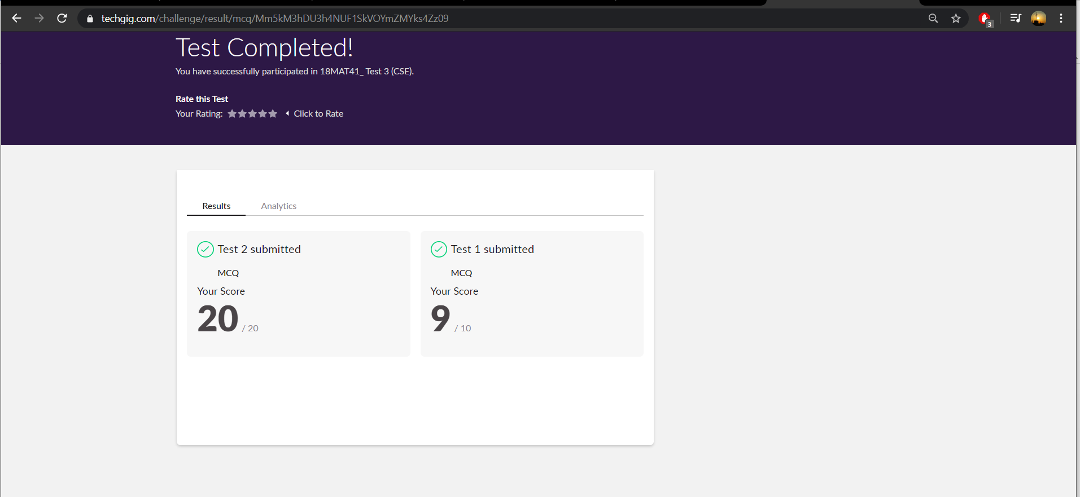

**COMPLEX ANALYSIS, PROBABILITY AND STATISTICAL METHODS internals was conducted. A total of 30 questions were there in which all the 30 of them were Multiple Choice Questions.**

**The above snapshot is the result sheet which was taken a screenshot.**

**Certification Course Details: (Attach the snapshot and briefly write the report for the same)**

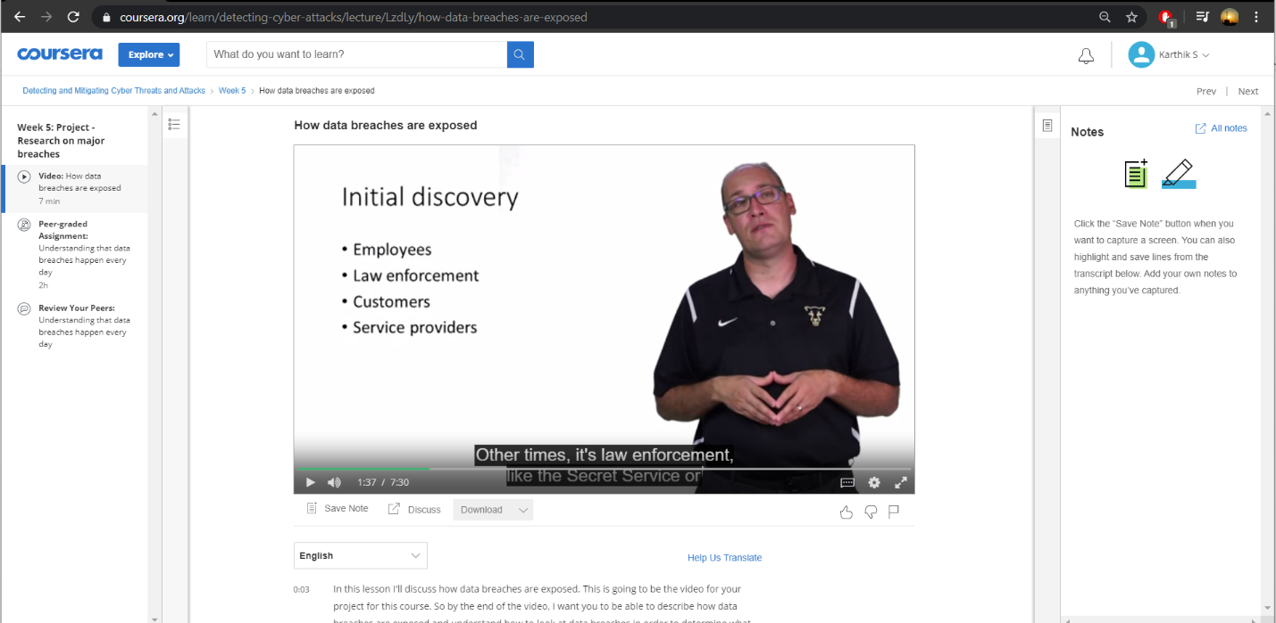

**The course I have chosen during the lockdown period is Detecting and mitigating cyber threads and attacks. Since I had learned about basics of cyber security last time so I am continuing this course.to know more about the securities**

**Coding Challenges Details: (Attach the snapshot and briefly write the report for the same)**

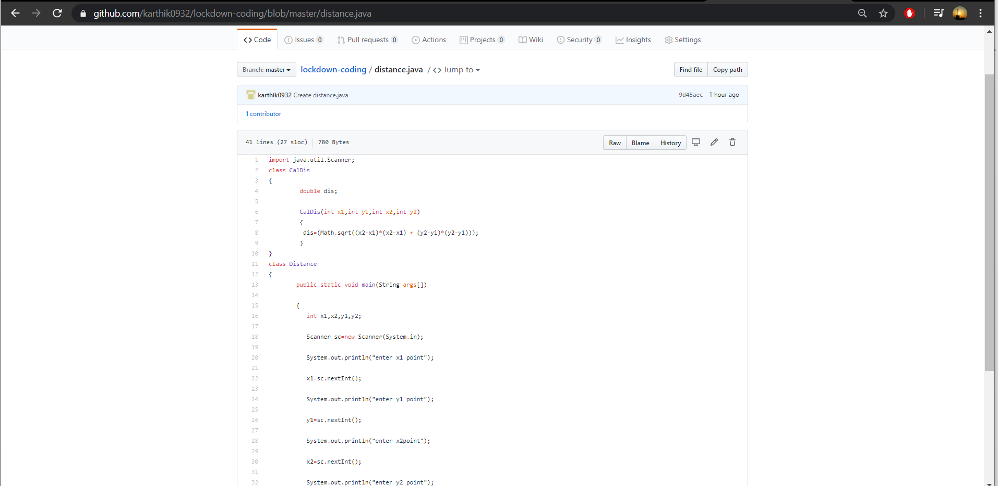

**Question : Define a class Point with two fields x and y each of type double. Also , define a method distance(Point p1, Point p2) to calculate the distance between points p1 and p2 and return the value in double.. Use Math.sqrt( ) to calculate the square**

**Solution : I have uploaded in my git hub repository.**

**Thank you**