**DAILY ONLINE ACTIVITIES SUMMARY**

|  |  |  |  |  |  |  |  |  |
| --- | --- | --- | --- | --- | --- | --- | --- | --- |
| **Date:** | **02/07/2020** | | | | | **Name:** | **Karthik S** | |
| **Sem & Sec** | **4th sem &A section** | | | | | **USN:** | **4AL18CS034** | |
| **Online Test Summary** | | | | | | | | |
| **Subject** | | **-** | | | | | | |
| **Max. Marks** | | **-** | | **Score** | | | **-** | |
| **Certification Course Summary** | | | | | | | | |
| **Course** | **Hadoop** | | | | | | | |
| **Certificate Provider** | | | **Great Learning** | | **Duration** | | | **5.5 hours** |
| **Coding Challenges** | | | | | | | | |
| **Problem Statement: Given an array of N elements, the task is to minimize the maximum difference of adjacent elements by inserting at most K elements in the array.** | | | | | | | | |
| **Status: completed** | | | | | | | | |
| **Uploaded the report in Github** | | | | | **yes** | | | |
| **If yes Repository name** | | | | | <https://github.com/karthik0932/lockdown-coding> | | | |
| **Uploaded the report in slack** | | | | | **yes** | | | |

**Course Details: (Attach the snapshot and briefly write the report for the same)**



**I have choosen this course to know about the Hadoop . it is an open-source software framework for storing data and running applications on clusters of commodity hardware. It provides massive storage for any kind of data, enormous processing power and the ability to handle virtually limitless concurrent tasks or jobs.**

**Coding Challenges Details: (Attach the snapshot and briefly write the report for the same)**

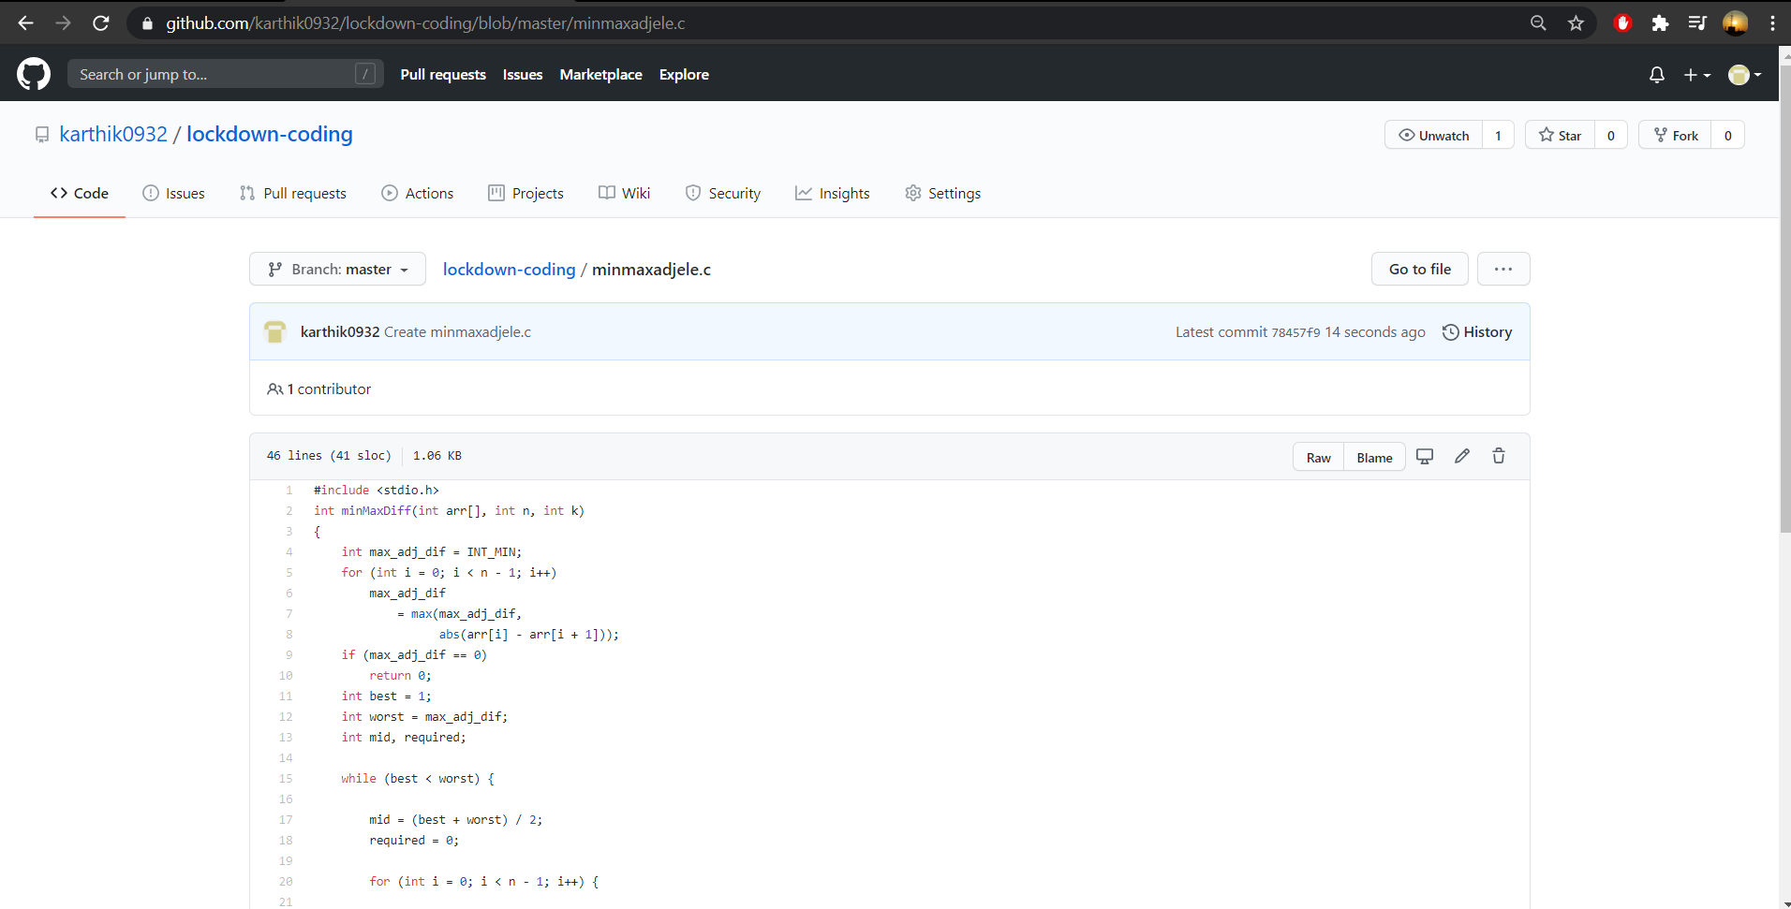

**Probem Statement :**

**Given an array of N elements, the task is to minimize the maximum difference of adjacent elements by inserting at most K elements in the array.**

**Code:The above snapshot is the code which I have uploaded in my github repository.**