**DAILY ONLINE ACTIVITIES SUMMARY**

|  |  |  |  |  |  |  |  |
| --- | --- | --- | --- | --- | --- | --- | --- |
| **Date:** | **02/06/2020** | | | | **Name:** | **Karthik S** | |
| **Sem & Sec** | **4th sem A section** | | | | **USN:** | **4AL18CS034** | |
| **Online Test Summary** | | | | | | | |
| **Subject** | | **__** | | | | | |
| **Max. Marks** | | **__** | | **Score** | | **__** | |
| **Certification Course Summary** | | | | | | | |
| **Course** | **Step into Robotic Process Automation** | | | | | | |
| **Certificate Provider** | | | **GUVI (In association with Ui Path)** | **Duration** | | | **3 Hours** |
| **Coding Challenges** | | | | | | | |
| **Problem StatementGiven an array arr[] of integers and an integer K, the task is to print all subsets of the given array with the sum equal to the given target K.**  **Examples:**  **Input: arr[] = {5, 10, 12, 13, 15, 18}, K = 30 Output: {12, 18}, {5, 12, 13}, {5, 10, 15} Explanation:**  **Subsets with sum 30 are:**  **12 + 18 = 30**  **5 + 12 + 13 = 30**  **5 + 10 + 15 = 30**  **Input: arr[] = {1, 2, 3, 4}, K = 5**  **Output: {2, 3}, {1, 4}** | | | | | | | |
| **Status: Completed** | | | | | | | |
| **Uploaded the report in Github** | | | | **YES** | | | |
| **If yes Repository name** | | | | <https://github.com/karthik0932/lockdown-coding> | | | |
| **Uploaded the report in slack** | | | | **YES** | | | |

**Certification Course Details: (Attach the snapshot and briefly write the report for the same)**

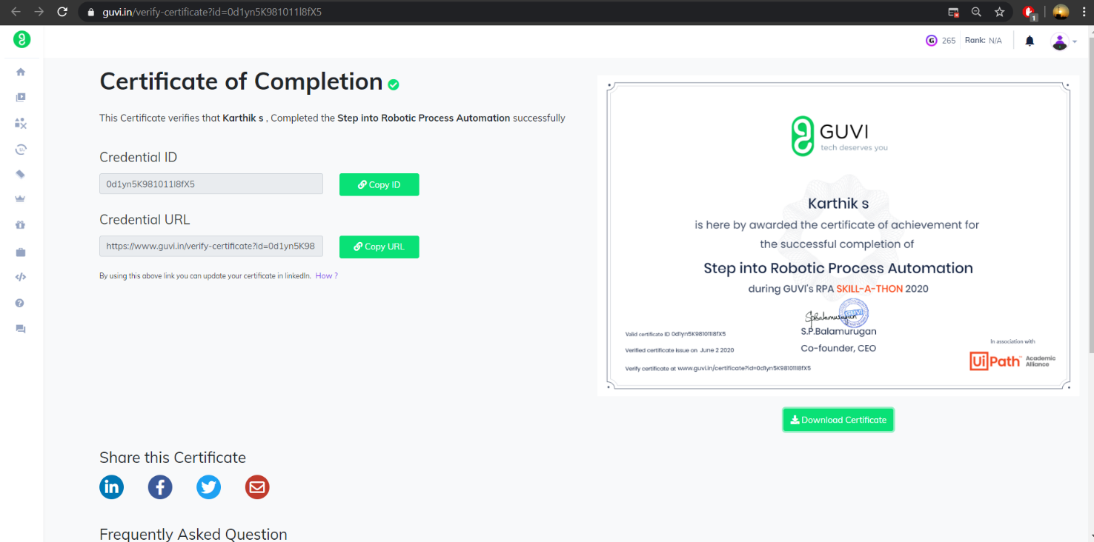

**The course I have completed today is Step into Robotic Process**

**Automation. Robotic Automation is one of the trending technologies in the IT sector. It has a bright future in the IT sector. Since Robotic Automation can change the trend in the IT sector I have done this course today.**

**Coding Challenges Details: (Attach the snapshot and briefly write the report for the**

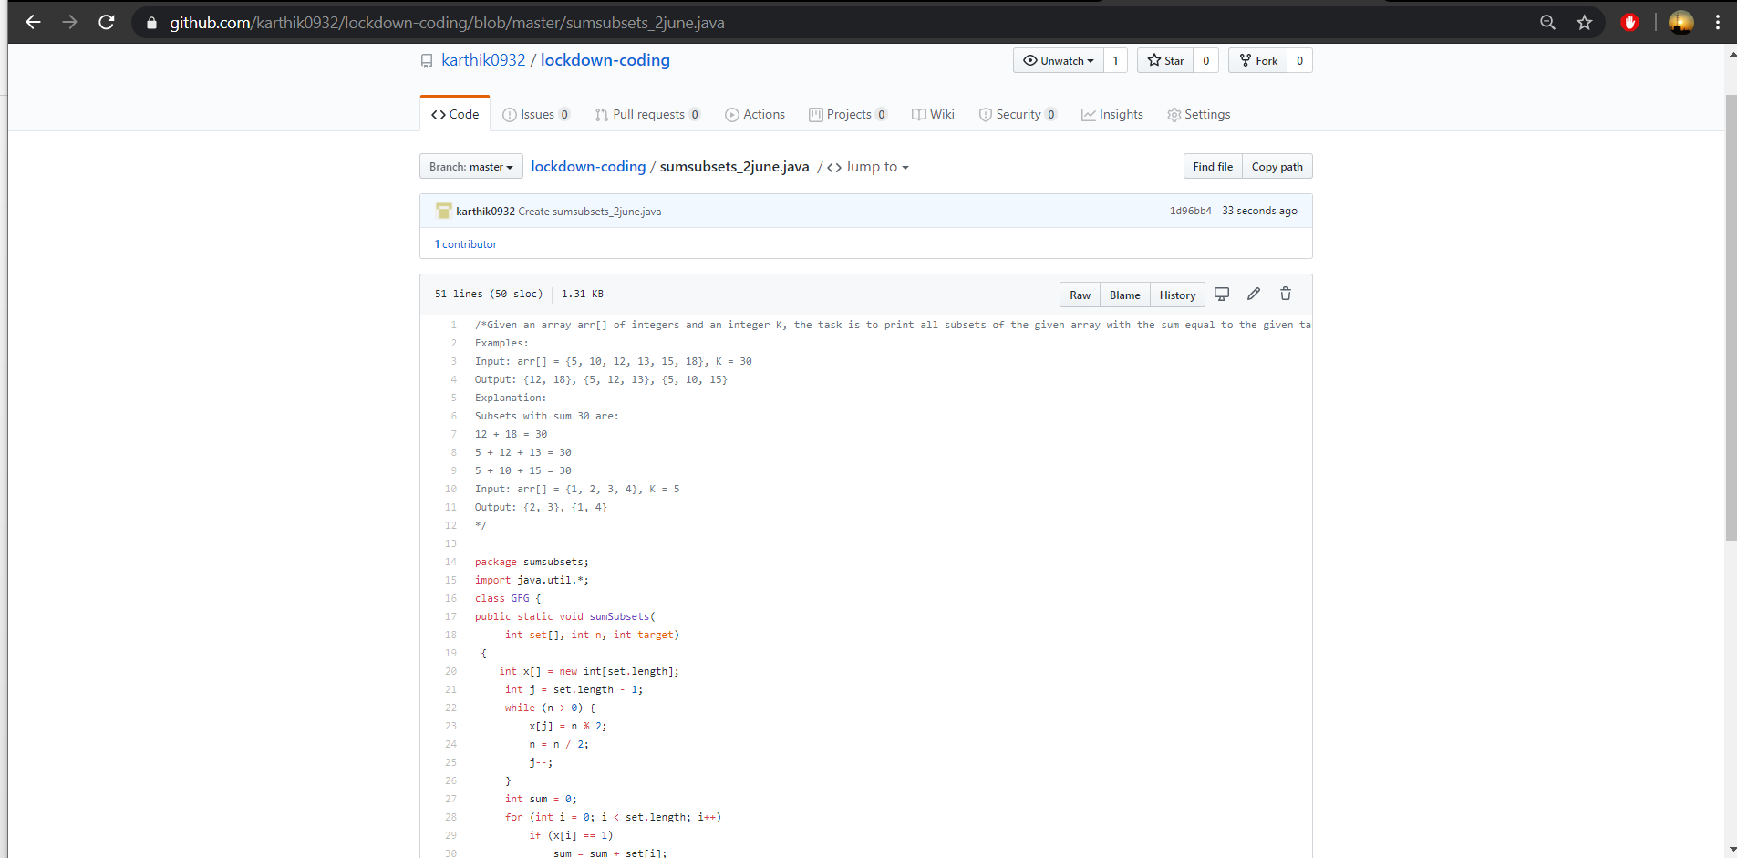

**The question I took to code is:**

**Given an array arr[] of integers and an integer K, the task is to print all subsets of the given array with the sum equal to the given target K.**

**Examples:**

**Input: arr[] = {5, 10, 12, 13, 15, 18}, K = 30 Output: {12, 18}, {5, 12, 13}, {5, 10, 15} Explanation:**

**Subsets with sum 30 are:**

**12 + 18 = 30**

**5 + 12 + 13 = 30**

**5 + 10 + 15 = 30**

**Input: arr[] = {1, 2, 3, 4}, K = 5**

**Output: {2, 3}, {1, 4}**

**Solution: The above snapshot is the code which I have uploaded in my**

**Github repository**