**DAILY ONLINE ACTIVITIES SUMMARY**

|  |  |  |  |  |  |  |  |  |
| --- | --- | --- | --- | --- | --- | --- | --- | --- |
| **Date:** | **03/06/2020** | | | | | **Name:** | **Karthik S** | |
| **Sem & Sec** | **4th sem &A section** | | | | | **USN:** | **4AL18CS034** | |
| **Online Test Summary** | | | | | | | | |
| **Subject** | | **Object oriented concepts** | | | | | | |
| **Max. Marks** | | **30** | | **Score** | | | **15** | |
| **Certification Course Summary** | | | | | | | | |
| **Course** | **Detecting and mitigating cyber threads and attacks** | | | | | | | |
| **Certificate Provider** | | | **Coursera** | | **Duration** | | | **5 weeks** |
| **Coding Challenges** | | | | | | | | |
| **Problem Statement: write a java program to find last digit of a^b (a to the power b) for large numbers.** | | | | | | | | |
| **Status: completed** | | | | | | | | |
| **Uploaded the report in Github** | | | | | **yes** | | | |
| **If yes Repository name** | | | | | <https://github.com/karthik0932/lockdown-coding> | | | |
| **Uploaded the report in slack** | | | | | **yes** | | | |

**Online Test Details: (Attach the snapshot and briefly write the report for the same)**

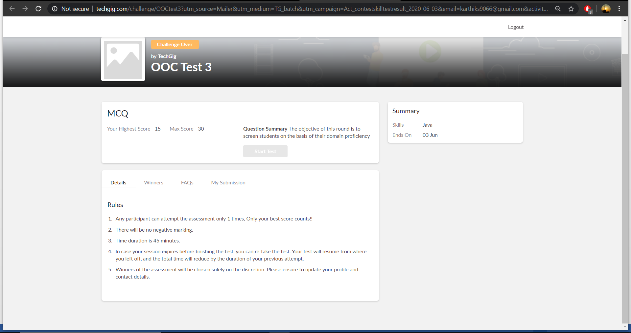

**Object oriented concepts internals was conducted today. A total of 30 questions which is of mcq. Started at 9:15 AM and ended at 10:00 AM each carries one mark. It is on the topic of object oriented concepts.**

**The above snapshot is the result sheet which was sent to us by the Techgig team.**

**Certification Course Details: (Attach the snapshot and briefly write the report for the same)**

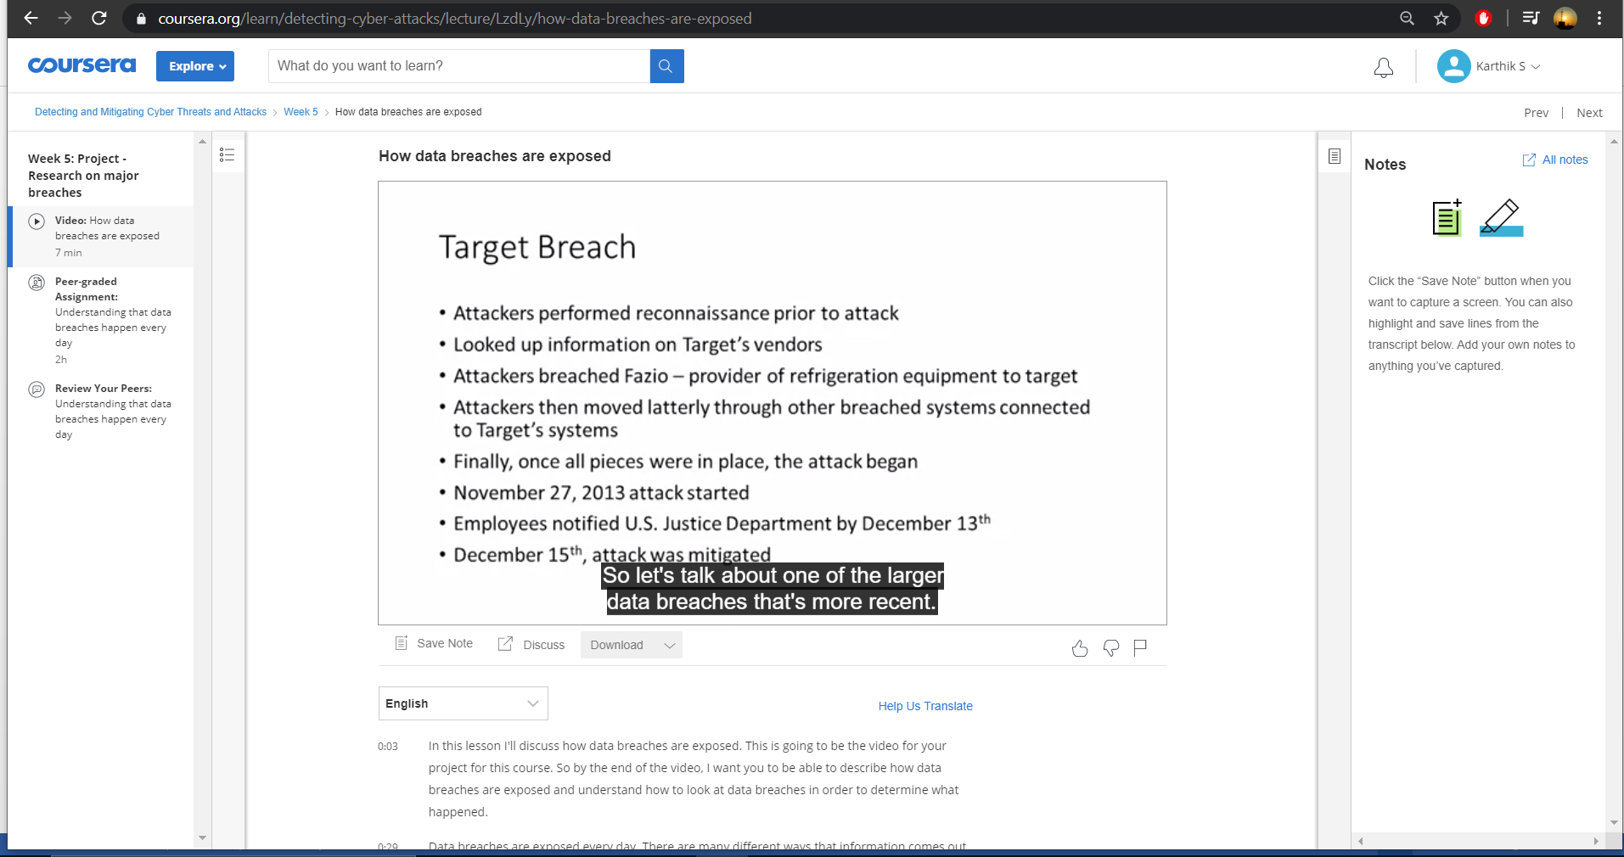

**The course I have chosen during the lockdown period is Detecting and mitigating cyber threads and attacks. Since I had learned about basics of cyber security last time so I am continuing this course.to know more about the securities**

**Coding Challenges Details: (Attach the snapshot and briefly write the report for the same)**

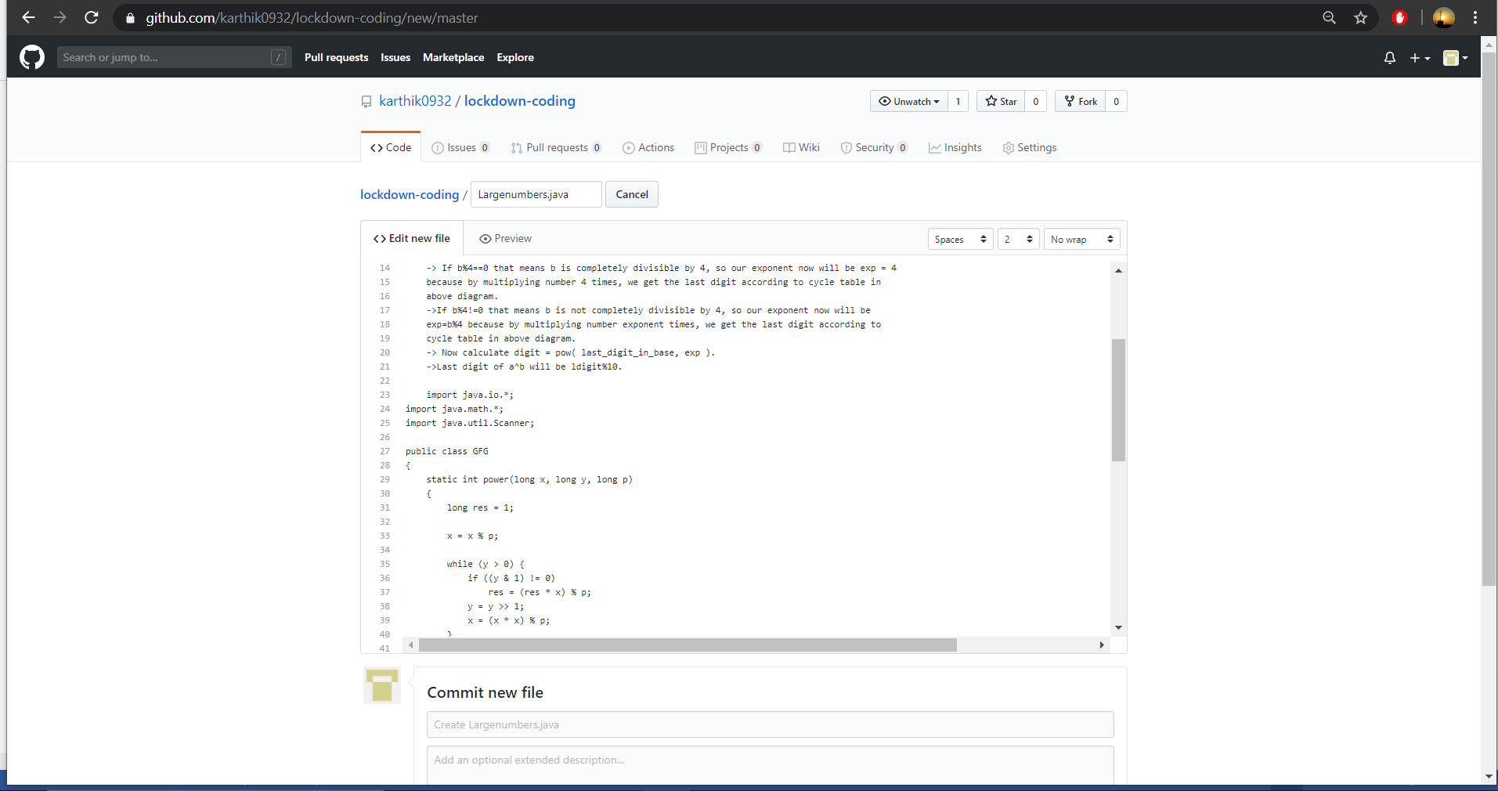

The question we had received today was :

Write a Java program to find Last Digit of a^b (a to the power b) for Large Numbers

You are given two integer numbers, the base a (number of digits d, such that 1 <= d <= 1000) and the index b (0 <= b <= 922*10^15). You have to find the last digit of a^b.

Examples:

Input : 3 10

Output : 9

Input : 6 2

Output : 6