**DAILY ONLINE ACTIVITIES SUMMARY**

|  |  |  |  |  |  |  |  |  |
| --- | --- | --- | --- | --- | --- | --- | --- | --- |
| **Date:** | **04/06/2020** | | | | | **Name:** | **Karthik S** | |
| **Sem & Sec** | **4th sem &A section** | | | | | **USN:** | **4AL18CS034** | |
| **Online Test Summary** | | | | | | | | |
| **Subject** | | **Micro-controller Embedded systems** | | | | | | |
| **Max. Marks** | | **20** | | **Score** | | | **16** | |
| **Certification Course Summary** | | | | | | | | |
| **Course** | **Detecting and mitigating cyber threads and attacks** | | | | | | | |
| **Certificate Provider** | | | **Coursera** | | **Duration** | | | **5 weeks** |
| **Coding Challenges** | | | | | | | | |
| **Problem Statement: Given an array C of size N-1 and given that there are numbers from 1 to N with one element missing, the missing number is to be found.**  **Input: The first line of input contains an integer T denoting the number of test cases. For each test case first line contains N(size of array). The subsequent line contains N-1 array elements.** | | | | | | | | |
| **Status: completed** | | | | | | | | |
| **Uploaded the report in Github** | | | | | **yes** | | | |
| **If yes Repository name** | | | | | <https://github.com/karthik0932/lockdown-coding> | | | |
| **Uploaded the report in slack** | | | | | **yes** | | | |

**Online Test Details: (Attach the snapshot and briefly write the report for the same)**

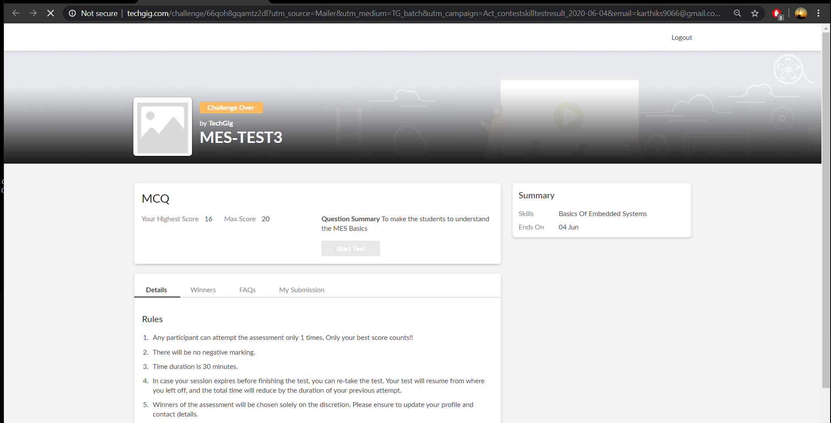

**MES internals was conducted today .A total of 20 questions which is of mcq. Started at 2:00 PM and ended at 2:30 each carries one mark.**

**The above snapshot is the result sheet which was sent to us by the Techgig team.**

**Course Details: (Attach the snapshot and briefly write the report for the same)**



**The course I have chosen during the lockdown period is Detecting and mitigating cyber threads and attacks. Since I had learned about basics of cyber security last time so I am continuing this course.to know more about the securities**

**Coding Challenges Details: (Attach the snapshot and briefly write the report for the same)**

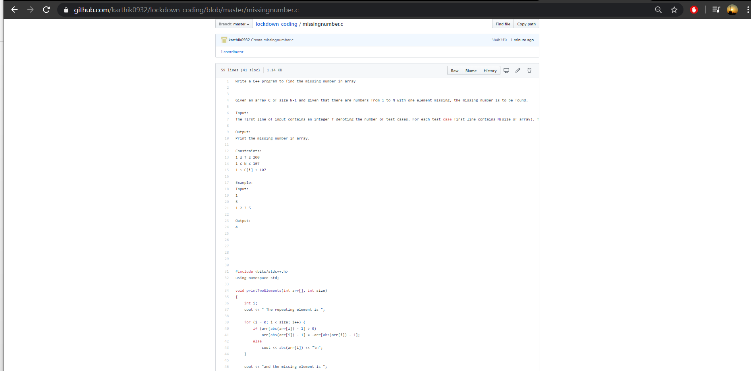

**The question we had received today was**

**Write a C++ program to find the missing number in array**

**Given an array C of size N-1 and given that there are numbers from 1 to N with one element missing, the missing number is to be found.**

**Input:  
The first line of input contains an integer T denoting the number of test cases. For each test case first line contains N(size of array). The subsequent line contains N-1 array elements.**

**Output:  
Print the missing number in array.**

**Constraints:  
1 ≤ T ≤ 200  
1 ≤ N ≤ 107  
1 ≤ C[i] ≤ 107**

**Example:  
Input:  
1  
5  
1 2 3 5**

**Output:  
4**

**Code:The above snapshot is the code which I have uploaded in my github repository.**