**DAILY ONLINE ACTIVITIES SUMMARY**

|  |  |  |  |  |  |  |  |
| --- | --- | --- | --- | --- | --- | --- | --- |
| **Date:** | **05/06/2020** | | | | **Name:** | **Karthik S** | |
| **Sem & Sec** | **4th sem A section** | | | | **USN:** | **4AL18CS034** | |
| **Online Test Summary** | | | | | | | |
| **Subject** | | **-** | | | | | |
| **Max. Marks** | | **-** | | **Score** | | **-** | |
| **Certification Course Summary** | | | | | | | |
| **Course** | **Cyber crimes and its preventive measures** | | | | | | |
| **Certificate Provider** | | | **Udemy** | **Duration** | | | **2 hours** |
| **Coding Challenges** | | | | | | | |
| **Problem Statement:**  **A user will input two strings, and we find if one of the strings is a sub sequence of the other. Program prints “yes” if either the first string is a sub sequence of the second string or the second string is a sub sequence of the first string. Assume that, the length of the first string is smaller than or equal to the length of the second string.** | | | | | | | |
| **Status: Completed** | | | | | | | |
| **Uploaded the report in Github** | | | | **YES** | | | |
| **If yes Repository name** | | | | <https://github.com/karthik0932/lockdown-coding> | | | |
| **Uploaded the report in slack** | | | | **YES** | | | |

**Certification Course Details: (Attach the snapshot and briefly write the report for the same)**

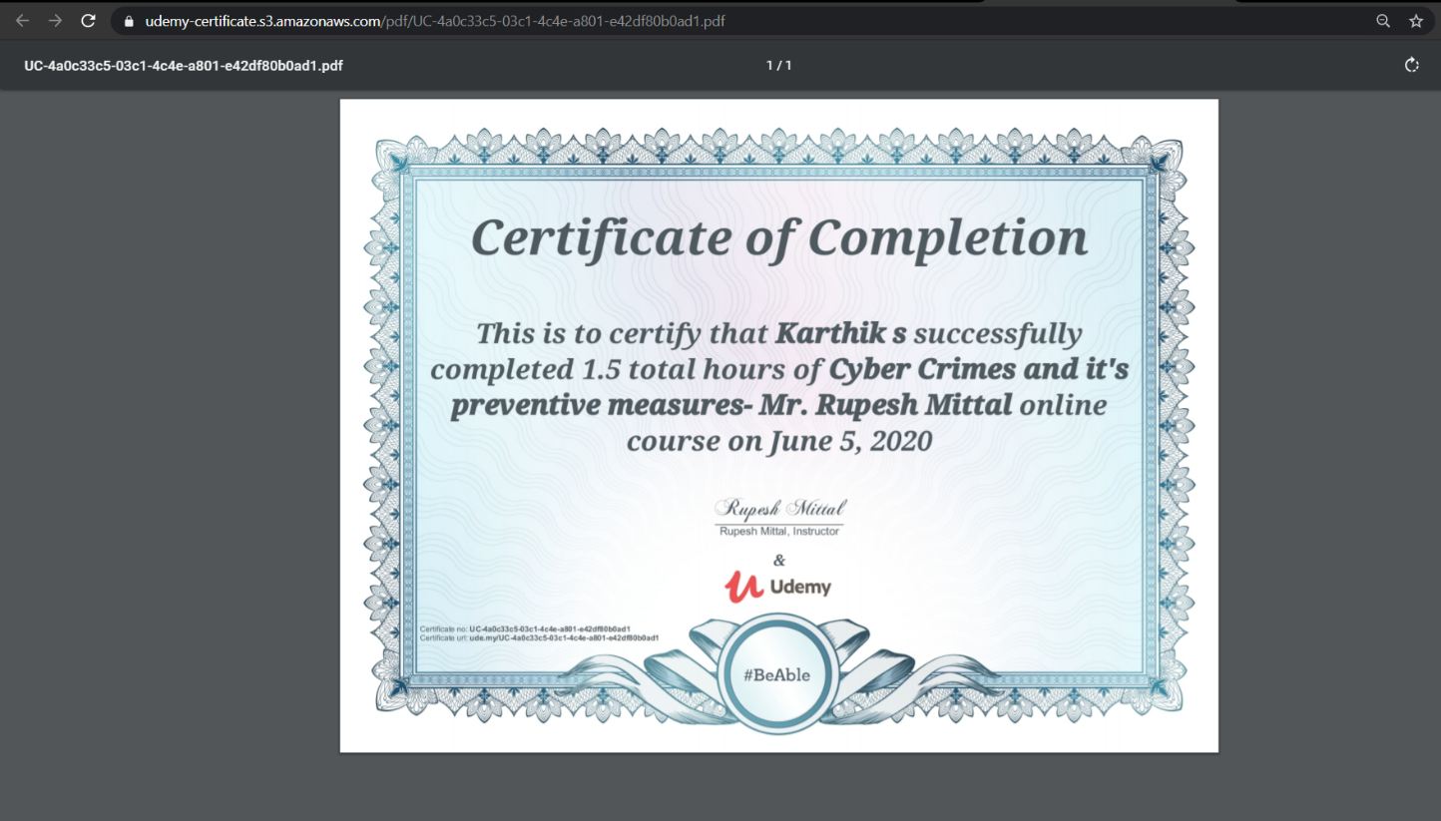

**This course gives an overview of cybercrime, which deals with all the criminal activities done either in cyberspace or targeted at computer resources, computer networks, and the Internet. This course further gives insights on various categories of cybercrime and further elaborates on the various new kinds and manifestations of interpersonal cybercrime and how cyber law frameworks are dealing with the same, across the world.**

**Coding Challenges Details: (Attach the snapshot and briefly write the report for the following)**

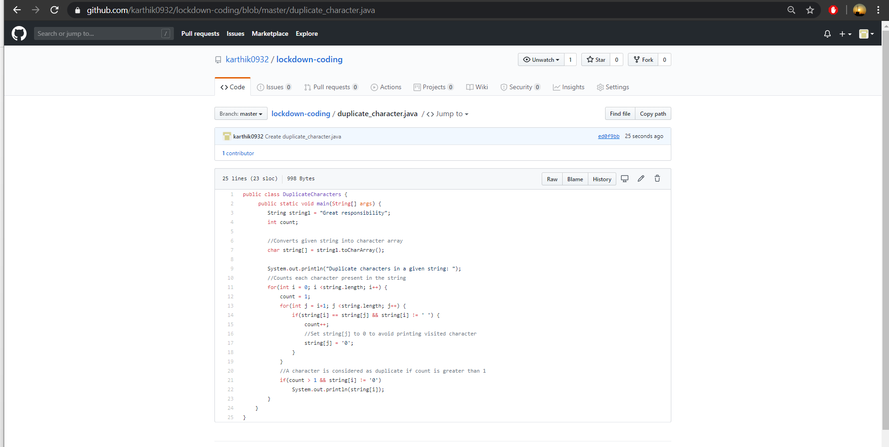

**Solution: The above snapshot is the code which I have uploaded in my**

**Github repository**