**DAILY ONLINE ACTIVITIES SUMMARY**

|  |  |  |  |  |  |  |  |  |
| --- | --- | --- | --- | --- | --- | --- | --- | --- |
| **Date:** | **07/07/2020** | | | | | **Name:** | **Karthik S** | |
| **Sem & Sec** | **4th sem &A section** | | | | | **USN:** | **4AL18CS034** | |
| **Online Test Summary** | | | | | | | | |
| **Subject** | | **-** | | | | | | |
| **Max. Marks** | | **-** | | **Score** | | | **-** | |
| **Certification Course Summary** | | | | | | | | |
| **Course** | **Stay anonymous online** | | | | | | | |
| **Certificate Provider** | | | **udemy** | | **Duration** | | | **4 hours** |
| **Coding Challenges** | | | | | | | | |
| **Problem Statement:** . **–--** | | | | | | | | |
| **Status: completed** | | | | | | | | |
| **Uploaded the report in Github** | | | | | **yes** | | | |
| **If yes Repository name** | | | | | __ | | | |
| **Uploaded the report in slack** | | | | | **yes** | | | |

**Course Details: (Attach the snapshot and briefly write the report for the same)**

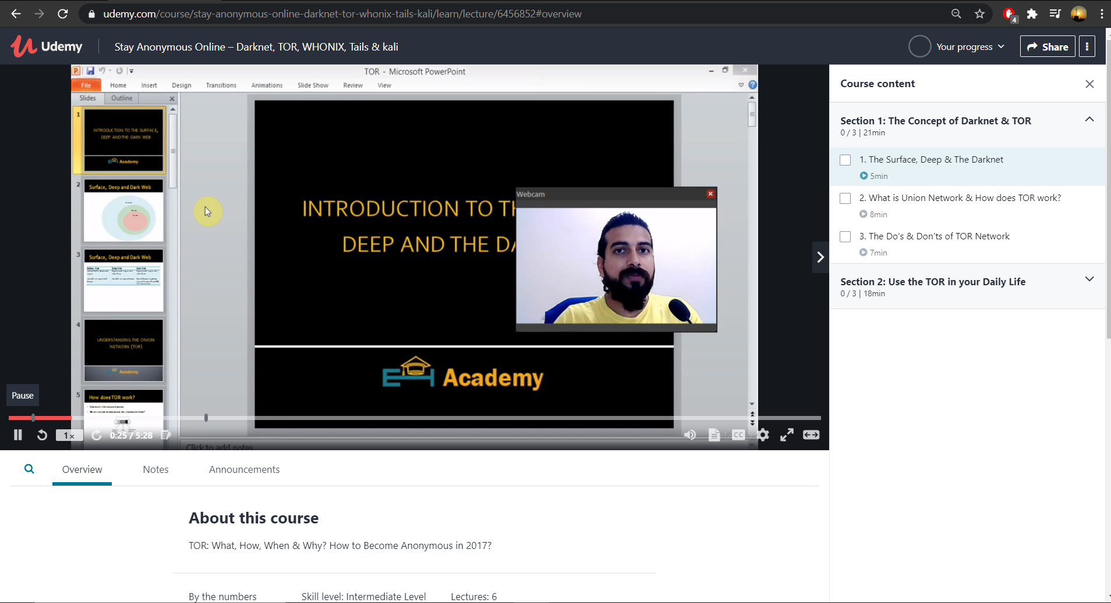

Darknet is not a mystery at all, most people know about it and the rest of them wants to know about it. If you are a security professional and has no idea what darknet is, then believe me you are not good at what you are doing. This training program is a crash course which builds the **foundation about the darknet**.

**Coding Challenges Details: (Attach the snapshot and briefly write the report for the same)**

**Probem Statement :**

**No coding problems**

**Code:The above snapshot is the code which I have uploaded in my github repository.**