**DAILY ONLINE ACTIVITIES SUMMARY**

|  |  |  |  |  |  |  |  |  |
| --- | --- | --- | --- | --- | --- | --- | --- | --- |
| **Date:** | **08/07/2020** | | | | | **Name:** | **Karthik S** | |
| **Sem & Sec** | **4th sem &A section** | | | | | **USN:** | **4AL18CS034** | |
| **Online Test Summary** | | | | | | | | |
| **Subject** | | **Design and analysis of algorithm.(descriptive test)** | | | | | | |
| **Max. Marks** | | **30** | | **Score** | | | **-** | |
| **Certification Course Summary** | | | | | | | | |
| **Course** | **Stay anonymous online** | | | | | | | |
| **Certificate Provider** | | | **udemy** | | **Duration** | | | **4 hours** |
| **Coding Challenges** | | | | | | | | |
| **Problem Statement: Java program to find whether given strings are anagram or not.** | | | | | | | | |
| **Status: completed** | | | | | | | | |
| **Uploaded the report in Github** | | | | | **yes** | | | |
| **If yes Repository name** | | | | | <https://github.com/karthik0932/lockdown-coding> | | | |
| **Uploaded the report in slack** | | | | | **yes** | | | |

**Online Test Details: (Attach the snapshot and briefly write the report for the same)**

Today I have attended the written test on Design Analysis of Algorithms at morning from 9:40 to 11 .I have submitted the written test papers copy as a pdf.

**Course Details: (Attach the snapshot and briefly write the report for the same)**

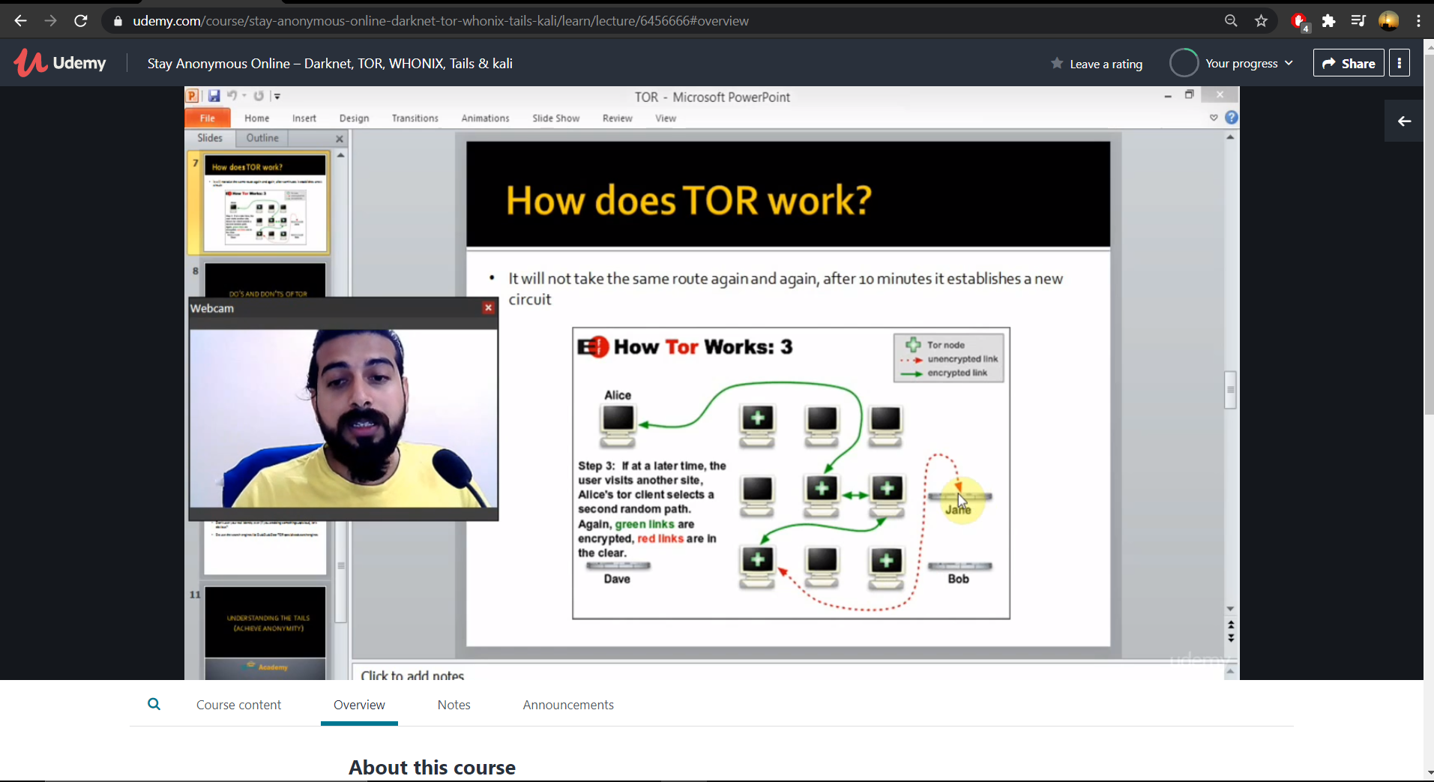

Darknet is not a mystery at all, most people know about it and the rest of them wants to know about it. If you are a security professional and has no idea what darknet is, then believe me you are not good at what you are doing. This training program is a crash course which builds the **foundation about the darknet**.

**Coding Challenges Details: (Attach the snapshot and briefly write the report for the same)**

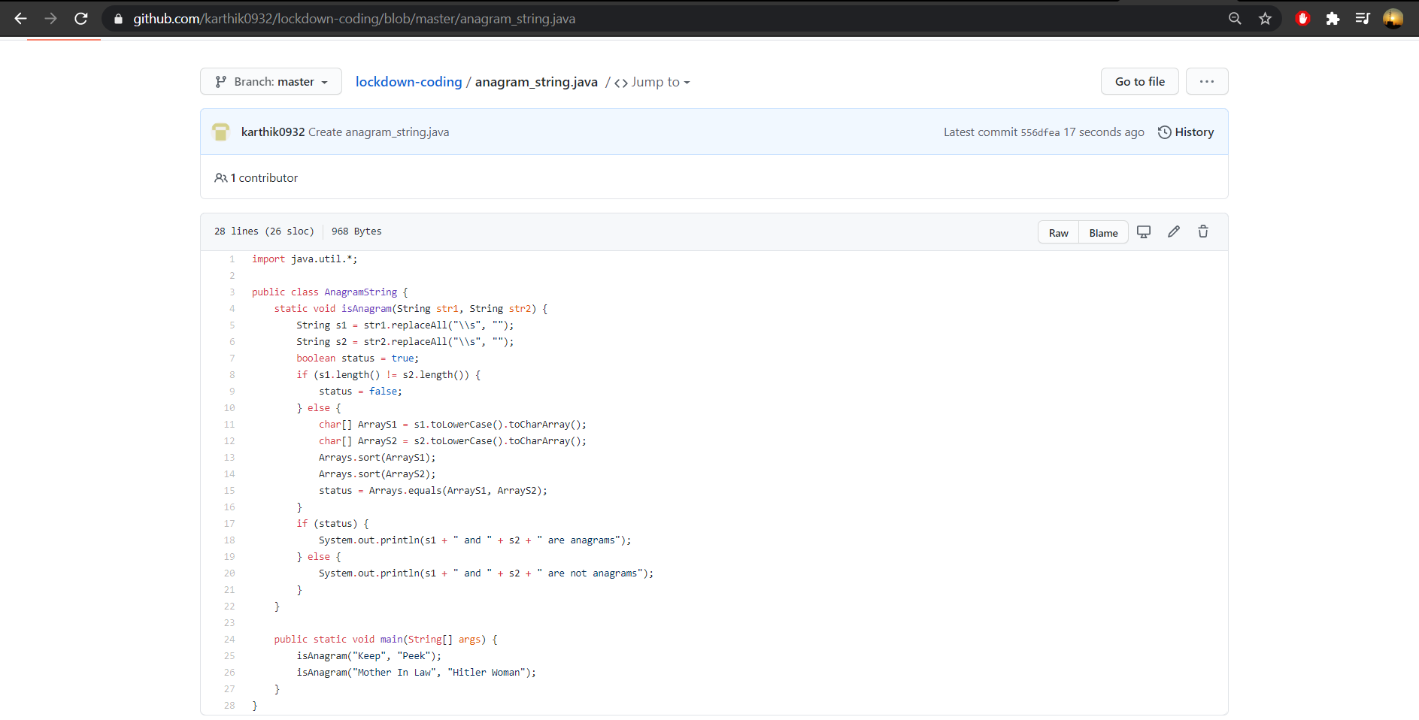

**Probem Statement :**

**Given two strings a and b consisting of lowercase characters. The task is to check whether two given strings are anagram of each other or not. An anagram of a string is another string that contains same characters, only the order of characters can be different. For example, “act” and “tac” are anagram of each other.**

**Code:The above snapshot is the code which I have uploaded in my github repository.**