**DAILY ONLINE ACTIVITIES SUMMARY**

|  |  |  |  |  |  |  |  |  |
| --- | --- | --- | --- | --- | --- | --- | --- | --- |
| **Date:** | **09/07/2020** | | | | | **Name:** | **Karthik S** | |
| **Sem & Sec** | **4th sem &A section** | | | | | **USN:** | **4AL18CS034** | |
| **Online Test Summary** | | | | | | | | |
| **Subject** | | **-** | | | | | | |
| **Max. Marks** | | **-** | | **Score** | | | **-** | |
| **Certification Course Summary** | | | | | | | | |
| **Course** | **Learn amazon web services(AWS) the complete introduction** | | | | | | | |
| **Certificate Provider** | | | **udemy** | | **Duration** | | | **7 hours** |
| **Coding Challenges** | | | | | | | | |
| **Problem Statement: --** | | | | | | | | |
| **Status: completed** | | | | | | | | |
| **Uploaded the report in Github** | | | | | **yes** | | | |
| **If yes Repository name** | | | | | <https://github.com/karthik0932/lockdown-coding> | | | |
| **Uploaded the report in slack** | | | | | **yes** | | | |

**Online Test Details: (Attach the snapshot and briefly write the report for the same)**

**Dint conduct any Internals**

**Course Details: (Attach the snapshot and briefly write the report for the same)**

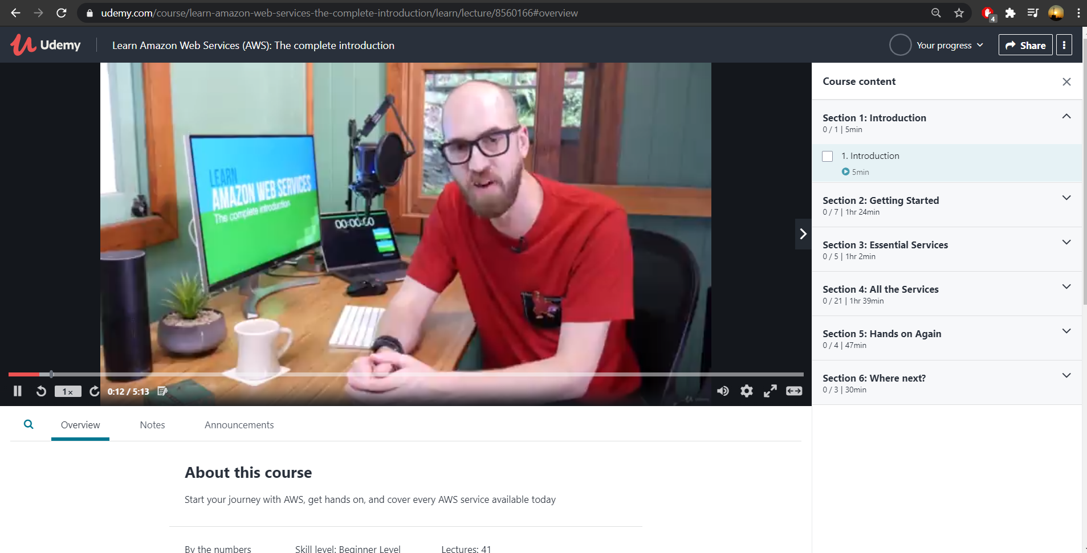

**This course is designed for anyone with a basic understanding of Information Technology to be able to take advantage of the amazing power offered by AWS.**

**In this course I cover: The true definition of Cloud Computing**

**How AWS fits into the Cloud model**

**Where AWS is located in the world**

**Coding Challenges Details: (Attach the snapshot and briefly write the report for the same)**

**Probem Statement :**

**No coding problem statement given today**