**DAILY ONLINE ACTIVITIES SUMMARY**

|  |  |  |  |  |  |  |  |  |
| --- | --- | --- | --- | --- | --- | --- | --- | --- |
| **Date:** | **16/07/2020** | | | | | **Name:** | **Karthik S** | |
| **Sem & Sec** | **4th sem &A section** | | | | | **USN:** | **4AL18CS034** | |
| **Online Test Summary** | | | | | | | | |
| **Subject** | | **No Internal Conducted** | | | | | | |
| **Max. Marks** | | **--** | | **Score** | | | **-** | |
| **Certification Course Summary** | | | | | | | | |
| **Course** | **AWS Developer Associate Training** | | | | | | | |
| **Certificate Provider** | | | **udemy** | | **Duration** | | | **8 hours** |
| **Coding Challenges** | | | | | | | | |
| **Problem Statement:** ___ | | | | | | | | |
| **Status: completed** | | | | | | | | |
| **Uploaded the report in Github** | | | | | **yes** | | | |
| **If yes Repository name** | | | | | <https://github.com/karthik0932/lockdown-coding> | | | |
| **Uploaded the report in slack** | | | | | **yes** | | | |

**Online Test Details: (Attach the snapshot and briefly write the report for the same)**

**No Internal Conducted**

**Course Details: (Attach the snapshot and briefly write the report for the same)**

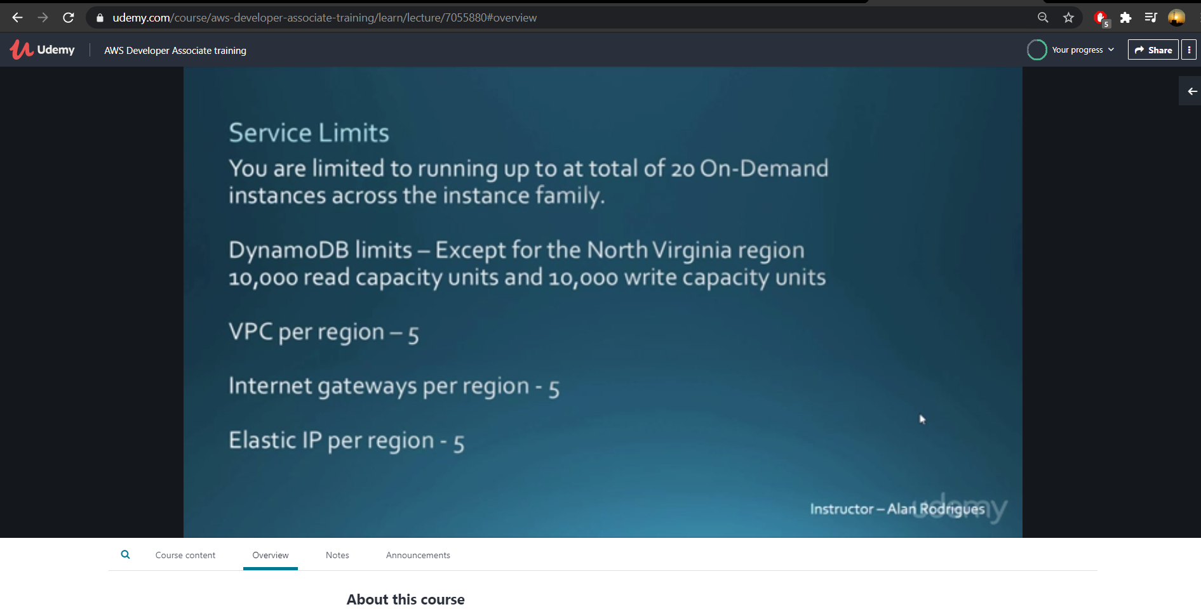

**Amazon Web services is one of the most widely adopted cloud platforms in the world today. The variety of services provided by AWS is what makes it one of the widely popular cloud platforms there is.**

**This course aims at training students on the various aspects of the AWS Cloud platform from a developer perspective**

**Coding Challenges Details: (Attach the snapshot and briefly write the report for the same)**

**Probem Statement :**

**No problem statement given today.**