**DAILY ONLINE ACTIVITIES SUMMARY**

|  |  |  |  |  |  |  |  |  |
| --- | --- | --- | --- | --- | --- | --- | --- | --- |
| **Date:** | **18/07/2020** | | | | | **Name:** | **Karthik S** | |
| **Sem & Sec** | **4th sem &A section** | | | | | **USN:** | **4AL18CS034** | |
| **Online Test Summary** | | | | | | | | |
| **Subject** | | **--** | | | | | | |
| **Max. Marks** | | **--** | | **Score** | | | **--** | |
| **Certification Course Summary** | | | | | | | | |
| **Course** | **Python for Machine Learning** | | | | | | | |
| **Certificate Provider** | | | **Great Learning** | | **Duration** | | | **6 hours** |
| **Coding Challenges** | | | | | | | | |
| **Problem Statement: C program to check for palindrome** | | | | | | | | |
| **Status: completed** | | | | | | | | |
| **Uploaded the report in Github** | | | | | **yes** | | | |
| **If yes Repository name** | | | | | <https://github.com/karthik0932/lockdown-coding> | | | |
| **Uploaded the report in slack** | | | | | **yes** | | | |

**Online Test Details: (Attach the snapshot and briefly write the report for the same)**

**Not conducted**

**Course Details: (Attach the snapshot and briefly write the report for the same)**

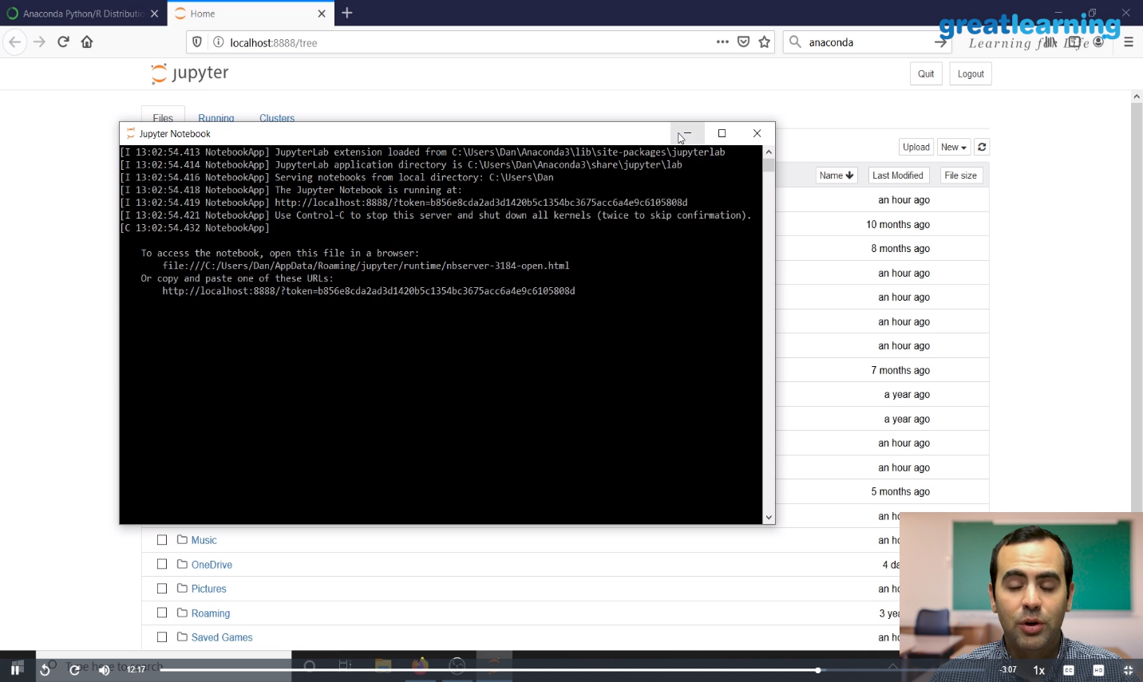

**This course dives into the basics of machine learning using an approachable, and well-known programming language, Python.**

**In this course, we will be reviewing two main components: First, you will be learning about the purpose of Machine Learning and where it applies to the real world. Second, you will get a general overview of Machine Learning topics such as supervised vs unsupervised learning, model evaluation, and Machine Learning algorithms.**

**Coding Challenges Details: (Attach the snapshot and briefly write the report for the same)**

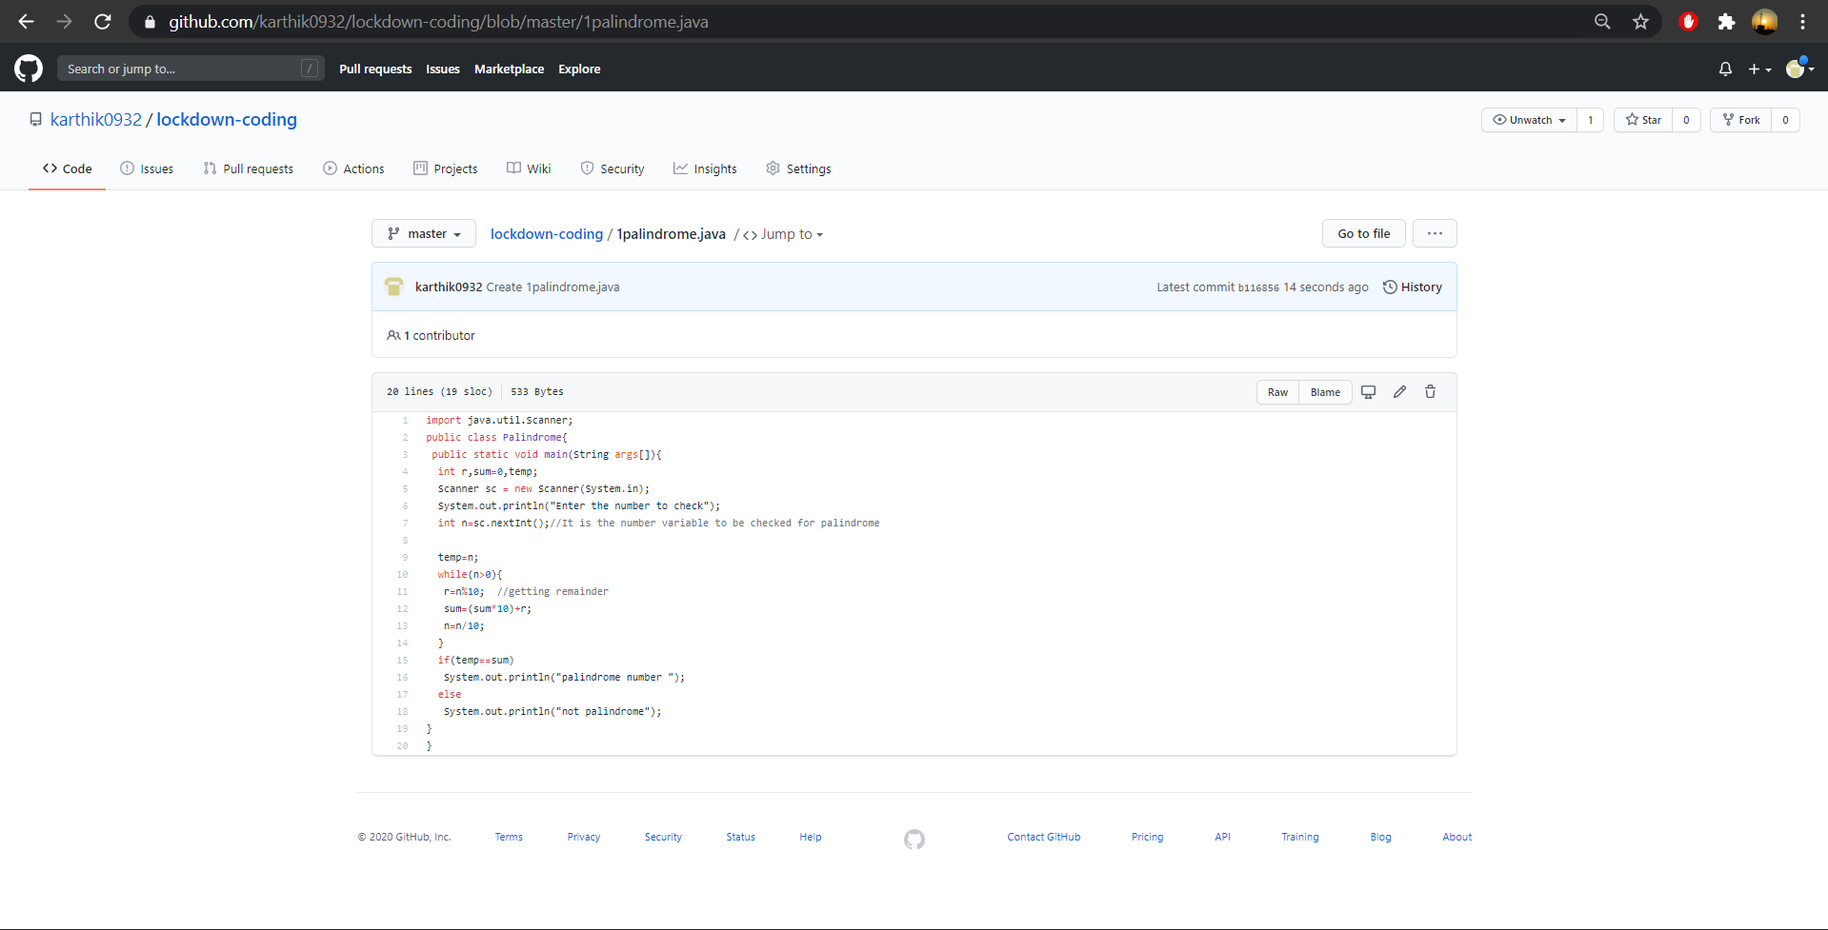

**Probem Statement :**

**C program to check for palindrome**

**Code:The above snapshot is the code which I have uploaded in my github repository.**