**DAILY ONLINE ACTIVITIES SUMMARY**

|  |  |  |  |  |  |  |  |  |
| --- | --- | --- | --- | --- | --- | --- | --- | --- |
| **Date:** | 18/05/2020 | | | | | **Name:** | Karthik S | |
| **Sem & Sec** | 4th sem A sec | | | | | **USN:** | 4AL18CS034 | |
| **Online Test Summary** | | | | | | | | |
| **Subject** | | Complex Analysis, probability and statistical methods | | | | | | |
| **Max. Marks** | | 30 | | **Score** | | | Result not announce | |
| **Certification Course Summary** | | | | | | | | |
| **Course** | Detecting and mitigating cyber threads and attacks | | | | | | | |
| **Certificate Provider** | | | Coursera | | **Duration** | | | 5 weeks |
| **Coding Challenges** | | | | | | | | |
| **Problem Statement:** 1. Frequency of each letters in a string  2. Printing odd and even numbers using threads  3. To check whether given two strings are anagrams | | | | | | | | |
| **Status:** Completed | | | | | | | | |
| **Uploaded the report in Github** | | | | | yes | | | |
| **If yes Repository name** | | | | | <https://github.com/karthik0932/lockdown-coding> | | | |
| **Uploaded the report in slack** | | | | | yes | | | |

Online Test Details: (Attach the snapshot and briefly write the report for the same)

The online test was from module 4 which was about curve fitting and statistical method. There were 30 questions and the duration was 30 minutes. The questions were optimal and were easy. The score for the test was not displayed after the test for some reason

**Snapshot :** not taken

Certification Course Details: (Attach the snapshot and briefly write the report for the same)

Name of course : Detecting and mitigating cyber threads and attacks

Today I have learn about the fire walls and got to know  three different kinds of firewalls The Windows Firewall is configured almost in the exact same way although we have a GUI for this. Now, in Linux systems, if you have a GUI on your Linux system, there are ways to put a GUI based firewall on your Linux system

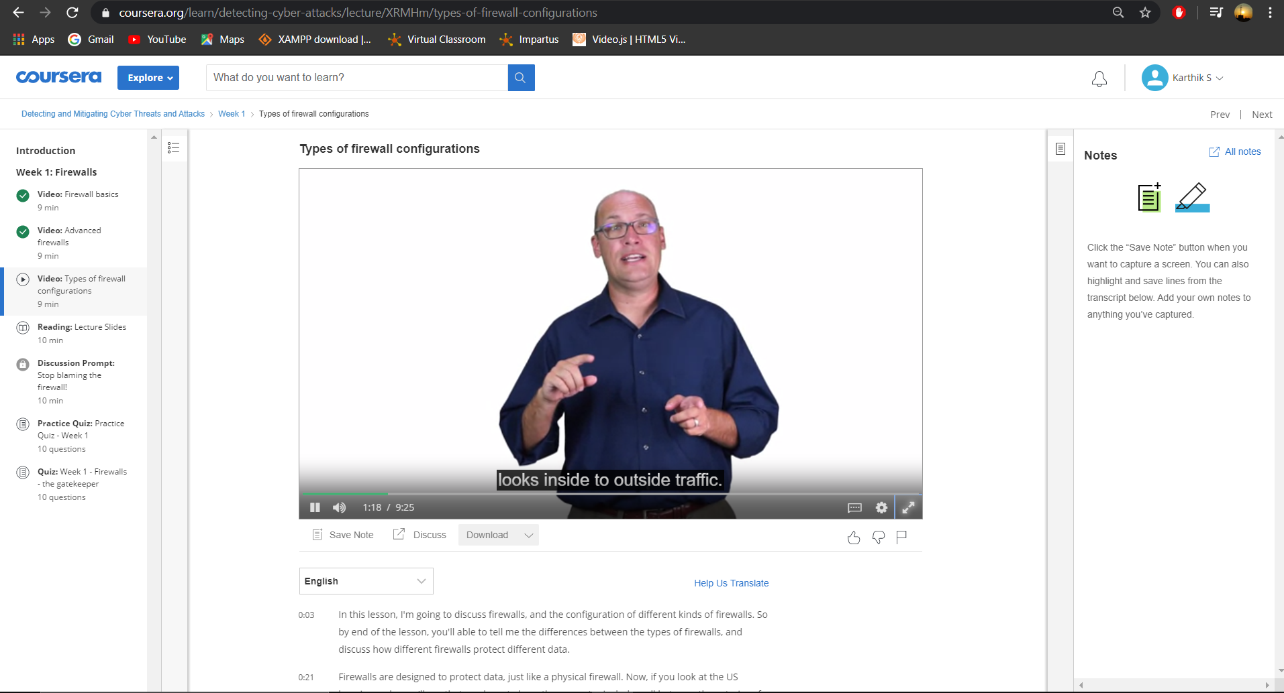

Coding Challenges Details: (Attach the snapshot and briefly write the report for the same)

**Problem 1:** (using C language) Check whether the two given strings are anagram or not.

**Solution:** uploaded in github

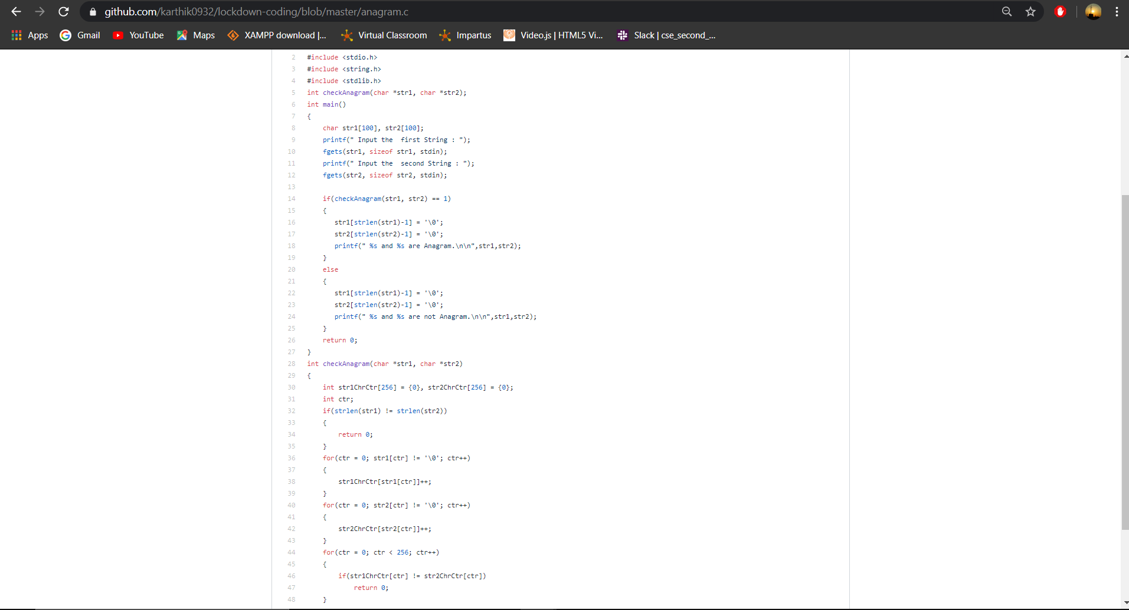

Thank You