**DAILY ONLINE ACTIVITIES SUMMARY**

|  |  |  |  |  |  |  |  |  |
| --- | --- | --- | --- | --- | --- | --- | --- | --- |
| **Date:** | 19/5/2020 | | | | | **Name:** | Karthik S | |
| **Sem & Sec** | 4th Sem A sec | | | | | **USN:** | 4AL18CS034 | |
| **Online Test Summary** | | | | | | | | |
| **Subject** | | Design analysis and algorithm | | | | | | |
| **Max. Marks** | | 30 | | **Score** | | | 15 | |
| **Certification Course Summary** | | | | | | | | |
| **Course** | Detecting and mitigating cyber threads and attacks | | | | | | | |
| **Certificate Provider** | | | Coursera | | **Duration** | | | 5 weeks |
| **Coding Challenges** | | | | | | | | |
| **Problem Statement:** :A user will input two strings, and we find if one of the strings is a  sub sequence of the other. Program prints “yes” if either the first string is a sub sequence of the second string or the second string is a sub sequence of the first string.Assume that, the length of the first string is smaller than or equal to the length of the second string | | | | | | | | |
| **Status:** Completed | | | | | | | | |
| **Uploaded the report in Github** | | | | | yes | | | |
| **If yes Repository name** | | | | | <https://github.com/karthik0932/lockdown-coding> | | | |
| **Uploaded the report in slack** | | | | | yes | | | |

Online Test Details: (Attach the snapshot and briefly write the report for the same)

18CS42 test was scheduled from 9:15 am to 9:55 am and the test scores are not yet received .The portion for the IA was 4 th module there were 25 questions and the time assigned was 40 minutes the questions were mcq type. But there was an issue with the time mentioned, so that we got only 30mins. to finish the test. The time was not sufficient to answer all the questions. There were 20 questions of 1 marks and 5 questions of 2 marks respectively.

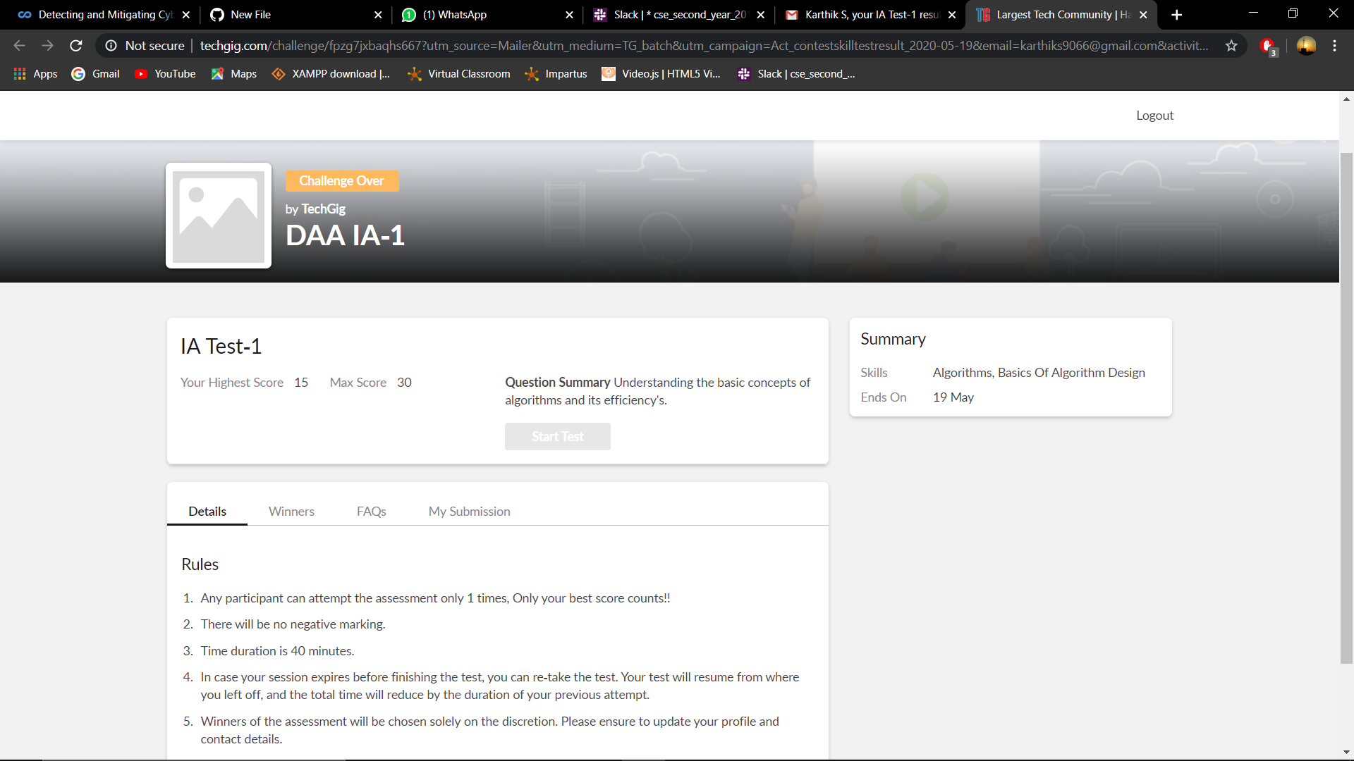

Certification Course Details: (Attach the snapshot and briefly write the report for the same)

Intrusion Prevention Systems.Intrusion Prevention Systems are almost like intrusion detection, except, well, they're preventing something from happening rather than just detecting it.The definition is going to be, detecting actions and events that attempt to compromise confidentiality, integrity and availability of assets and resources, and then take action based off these signatures. This can be network-based, host-based or physically-based as well, just like Intrusion Detection Systems.

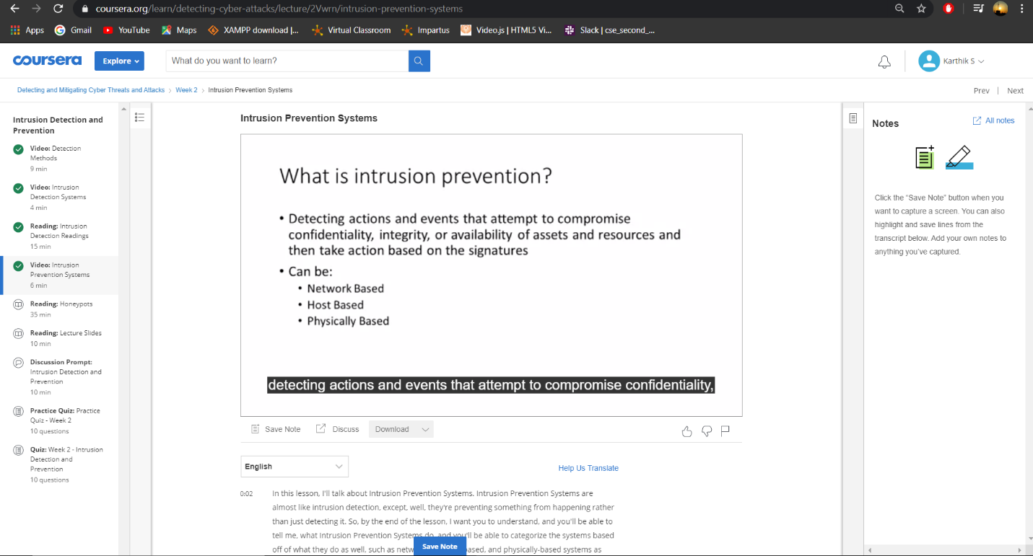

Coding Challenges Details: (Attach the snapshot and briefly write the report for the same)

Today I had received one program from prof.Venkatesh CSE Dept. The programs is mentioned above in the coding challenges I have also uploaded it to my Github repository.

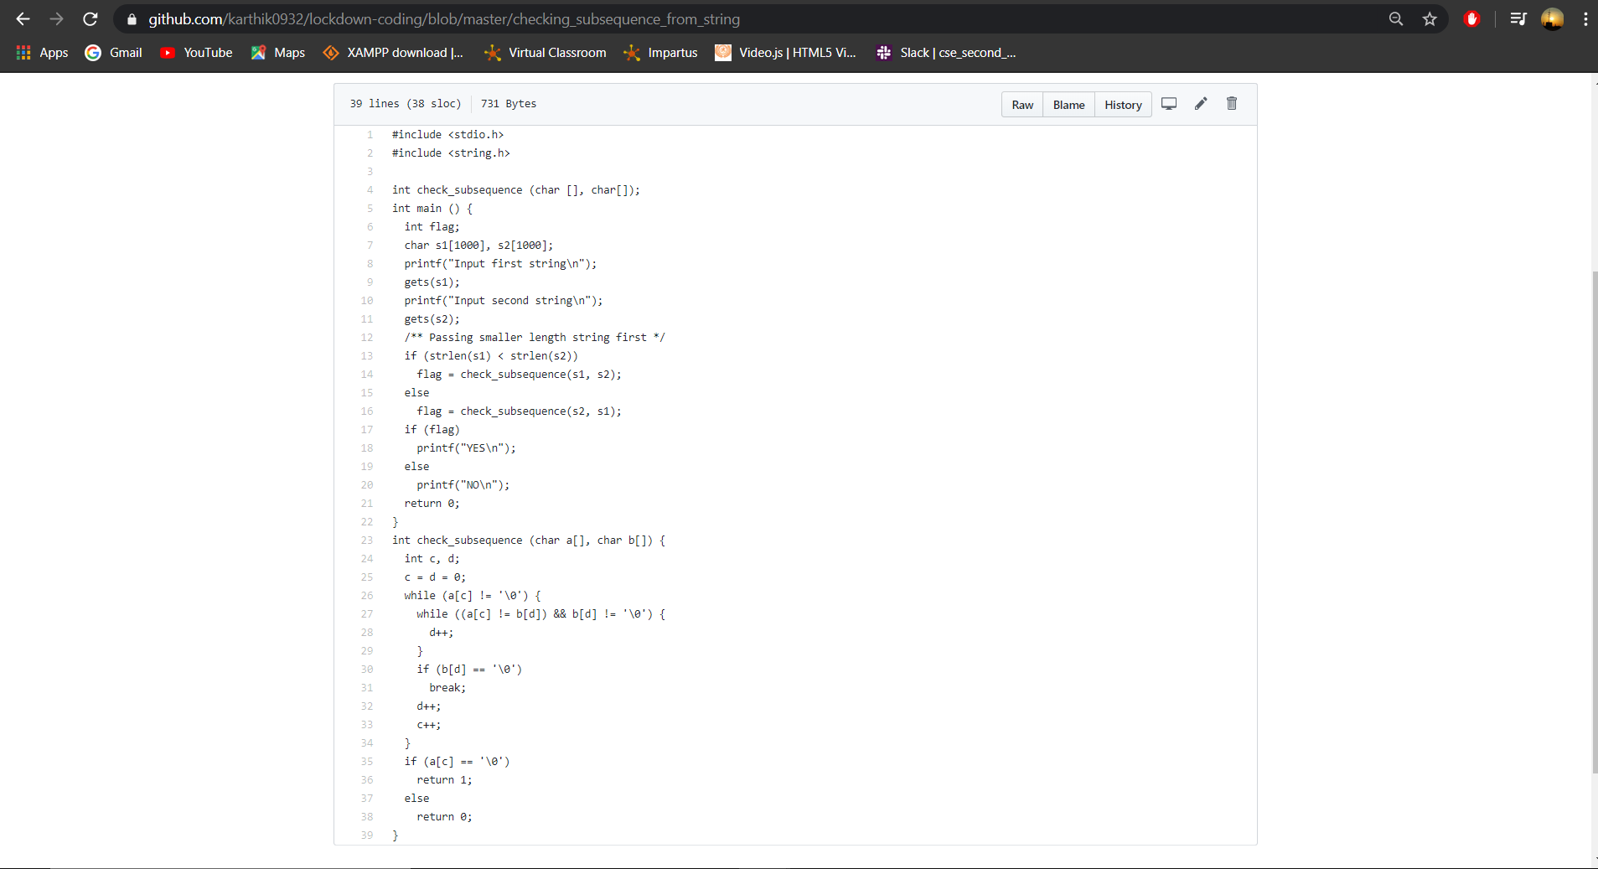

It is the snap shot of my program.