**DAILY ONLINE ACTIVITIES SUMMARY**

|  |  |  |  |  |  |  |  |  |
| --- | --- | --- | --- | --- | --- | --- | --- | --- |
| **Date:** | **20/5/2020** | | | | | **Name:** | **Karthik S** | |
| **Sem & Sec** | **4th sem A sec** | | | | | **USN:** | **4AL18CS034** | |
| **Online Test Summary** | | | | | | | | |
| **Subject** | | **Object oriented concepts** | | | | | | |
| **Max. Marks** | | **30** | | **Score** | | | **18** | |
| **Certification Course Summary** | | | | | | | | |
| **Course** | **Detecting and mitigating cyber threads and attacks** | | | | | | | |
| **Certificate Provider** | | | **coursera** | | **Duration** | | | **5 weeks** |
| **Coding Challenges** | | | | | | | | |
| **Problem Statement:** **Given an array a[] of size n which contains elements from 0 to n-1,write a program print Duplicates which prints the duplicate elements of the given array. If no duplicate element is found print -1.** | | | | | | | | |
| **Status: Completed** | | | | | | | | |
| **Uploaded the report in Github** | | | | | **yes** | | | |
| **If yes Repository name** | | | | | <https://github.com/karthik0932/lockdown-coding> | | | |
| **Uploaded the report in slack** | | | | | **yes** | | | |

Online Test Details: (Attach the snapshot and briefly write the report for the same)

The online test was about Introduction To Object Oriented Concepts.There were 30 questions and the duration :40 minutes. The questions are mcq type and also 10 questions on to predict the output of given program.

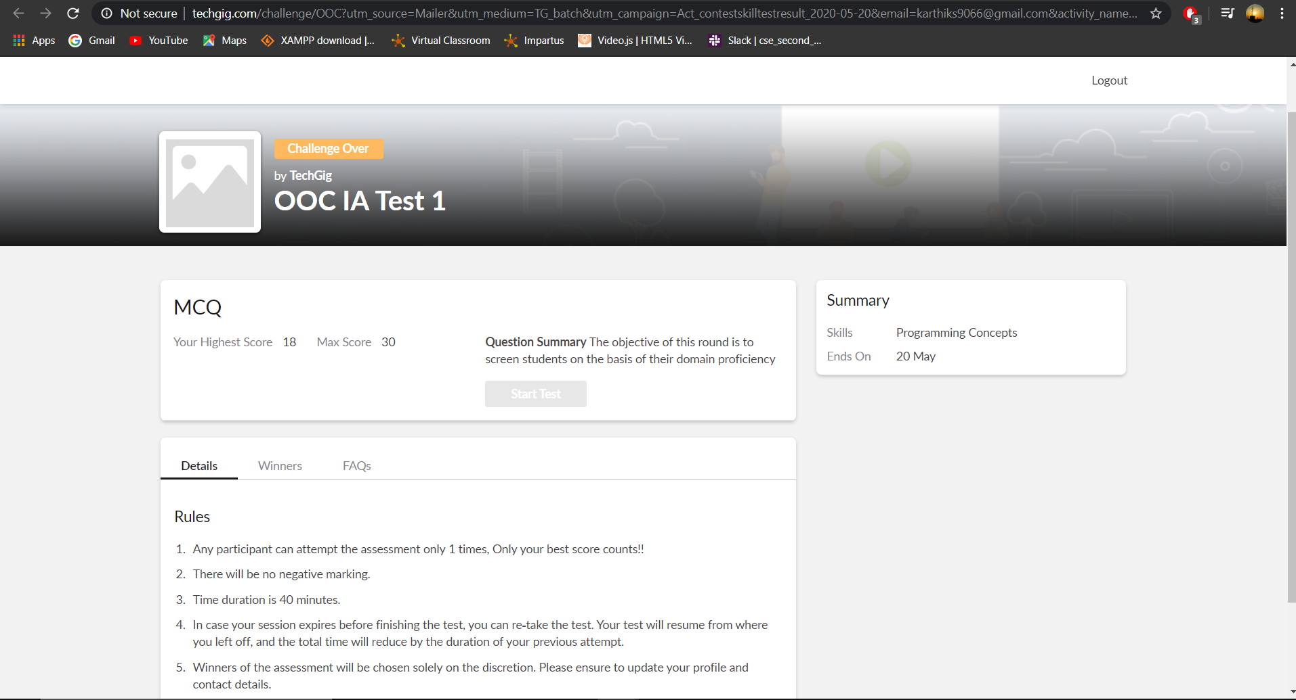

Certification Course Details: (Attach the snapshot and briefly write the report for the same)

Today I learnt about the history of anti-malware and antivirus because it'll help you understand where we've come throughout the years. In order to understand what antivirus or anti-malware does,

we really have to define what malware is. So, according to the computer security resource center definition, it is a program that is inserted into a system, usually covertly, with the intent of compromising the confidentiality, integrity or availability of the victim's data, applications or operating system, or otherwise, annoying or disrupting the victim.



Coding Challenges Details: (Attach the snapshot and briefly write the report for the same)

Given an array a[] of size n which contains elements from 0 to n-1, write a program print Duplicates which prints the duplicate elements of the given array. If no duplicate element is found print -1.

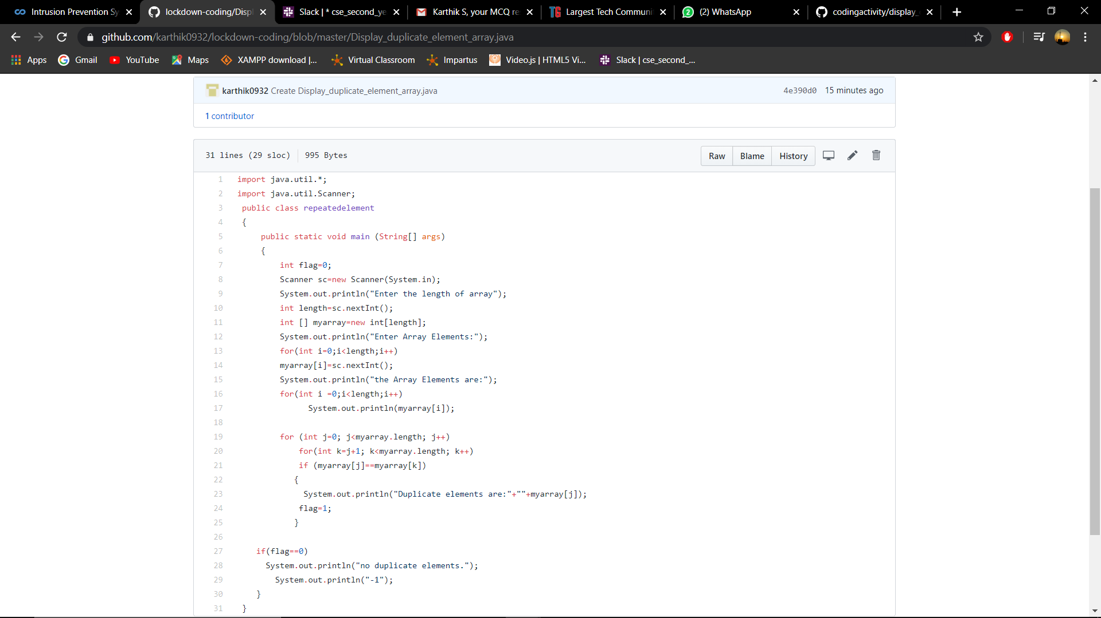

**Code:** The above snapshot is the code which I have uploaded in my Github repository.

Thank you